

Computer Programming for Engineering

Python Project Report 2

Name: Khadijatu Nayi Alhassan

Student ID: 73692022

Date due: March 27, 2019.

**Introduction:**

Aims and Objectives:

To apply concepts learned in python programming to make life simpler or to solve a challenge.

To understand how to package code into modules for purposes of re-use.

To explore and understand the use of various concepts taught in class.

**Abstract/Summary:**

This project is based on calculating probability using the Normal distribution, Poisson, Exponential and Geometric distribution.

**Background:**

As a student who studied A-level statistics, I understood the mathematics behind the use of the Normal, Poisson, Exponential and Geometric distributions. All these distributions had peculiar instances of when they were useful, and the probabilities are interpreted differently. For example, normal distribution is extremely useful in modelling data in which we have few extremes values and the majority near the average value, which is seen in instances like age analysis of a population. Poisson distribution is discrete and used to model situations in which events occur randomly, singly and independent of each other. This can be used to study situations like the arrival of calls at a customer care unit of a company, or arrival of cars at a filling station. Exponential distribution is applied in studying the growth of organisms like bacteria in food or algae in water. Geometric distributions are used to predict how many attempts are likely for a success to be obtained and can be applied in various field like birth analysis, population modelling etc. It is because of the usefulness of these concepts that triggered me to find a way of making the calculation of probability of these distributions simpler, with the application of python programming language.

**Procedure/Methodology:**

**Algorithms:**

For the normal distribution, I wrote two methods: normal1and normal 2. Finding the probability using normal distribution is finding the area under the standard normal distribution curve, which is bell-like in shape. The area applies to a region, thus the probability at a value equals zero. Normal1 takes one parameter whiles Normal2 takes two parameters. They both work the same way just that in Normal2, the probability(area) is specifies between two boundaries whiles I Normal1, the area starts from one value to the end of the curve.

Below is an illustration of the logic behind Normal1 and Normal2:

Normal1:

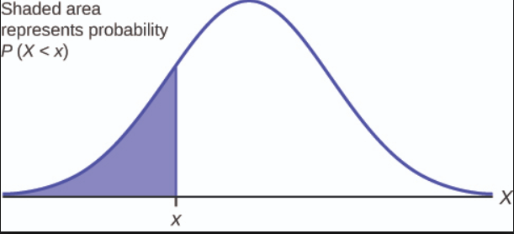

Normal2:

A close up of a device

Description generated with high confidence

Both Normal1 and Normal2 take mean and standard deviation and a one value as parameters, with Normal2 taking an extra value as the fourth parameter.

Both Normal1 and Normal2 use the formula:

Z = [ Value – mean / standard deviation] to calculate the z-value. This value is now passed as a parameter to the method phi, and the probability is read from the standard normal distribution table. Whiles evaluating Normal 1and Normal 2, I made use of dictionaries from chapter and the math module.

The next method, poisson, takes the mean of the Poisson distribution and the value for which the probability is to be calculated for as parameters. The probability calculated using Poisson distribution uses the formula:

P (x; μ) = (e-μ) (μx) / x! , where x is the value and μ is the mean of the Poisson distribution.

The function does not just calculate the probability of obtaining exactly x, but also probability of obtaining at least and at most x. Furthermore, the expected value and variance of the Poisson distribution is calculated. In implementing this method, I made use of for loops in chapter.

The third method is called exponential and takes the mean of an exponential distribution and a value / values as parameter(s). The general formula for calculating the probability of an exponential distribution is :

𝑃(𝑋 < 𝑥) = 1 − e−λx where lambda is the mean of the exponential distribution and x is the value and the formula changes depending on whether the probability is greater than, less than or between two limits of values. The method also calculates the expectation and variance of the exponential distribution.

The final method is geo, is used to find the number of trials required to obtain the first success. It takes two parameters, probability of success and number of trials. The general formula for finding the probability of a geometric distribution is:

Challenges:

Lessons Learnt:

Areas of Improvement:

Conclusion: