1. Design objective
The objective of this report is to determine the W/L ratio of every MOS transistor in the two-stage CMOS op-amp so that the circuit satisfies the required gain, UGB, phase margin, slew rate, and power constraints. Besides the first-pass hand calculation, the design is tuned again using simulation results before the final sizing is chosen.

2. Specifications and transistor model
Specification | Target value
Supply voltage | VDD = 1.8 V
DC gain | About 70 dB
UGB | About 8 MHz
Phase margin | About 60°
Slew rate | About 10 V/us
Power | Less than or around 500 uW
Miller capacitor | Cc = 3 pF
Load capacitor | CL = 10 pF
Transistor models used in the schematic: NMOS: vto = 0.169 V, lambda = 0.04, kp = 296u; PMOS: vto = -0.136 V, lambda = 0.05, kp = 167u.

3. Chosen topology
- The circuit uses a two-stage CMOS op-amp with Miller compensation. This topology is suitable because it can provide higher gain than a single-stage structure, while UGB and phase margin can still be adjusted through Cc and the transconductance of the second stage.
- M3-M4 form the NMOS differential pair. M5-M6 act as PMOS active loads in current-mirror form to convert the differential signal into a single-ended signal. M7-M8 build the second gain stage, and Cc is used for frequency compensation.
- With this topology, the practical design flow is to lock the major targets first, namely slew rate, UGB, and bias current, and then fine-tune W/L so that gain and phase margin match the simulation results more closely.

4. First-pass hand calculation

4.1. Tail current from the slew-rate requirement
Because the circuit uses Miller compensation, the first estimate of the slew rate can be taken from the charge and discharge current of Cc. Therefore, the tail current of the differential pair is obtained from the following expression:
I_tail = SR . Cc = 10 V/us . 3 pF = 30 uA

4.2. First-stage gm from the UGB requirement
For a two-stage op-amp with Miller compensation, the unity-gain bandwidth can be approximated by gm1/(2*pi*Cc). From this relation, the required transconductance of the input pair is:
gm1 = 2 . pi . UGB . Cc ≈ 2 . pi . 8 MHz . 3 pF ≈ 150.8 uS
When the circuit is balanced, each transistor M3 and M4 carries about half of the tail current, which is approximately 15 uA.

4.3. Sizing M1 and M2
The overdrive voltage of the NMOS mirror branch is chosen around 0.2 V so that the transistors remain well biased without consuming too much headroom. Using the first-order saturation-current equation:
Id = 1/2 . kp . (W/L) . Vov^2
Substituting Id = 30 uA, kp_n = 296 uA/V^2, and Vov = 0.2 V gives (W/L)1,2 ≈ 5.07.

4.4. Sizing M3 and M4
If only the small-signal equations are used, M3 and M4 could be chosen larger. However, after checking the simulation, a larger size shifts the DC bias of the second stage in an unfavorable way and pushes the circuit away from the target specifications. For that reason, M3 and M4 are reduced to a moderate value that still keeps UGB near 8 MHz while improving both phase margin and the DC operating point.
The final tuned value is W/L = 0.90/1 for both M3 and M4. This is an important difference between the first-pass hand calculation and the final design.

4.5. Sizing M5 and M6
M5 and M6 are the PMOS active loads of the first stage. Keeping the overdrive around 0.2 V and using a branch current of about 15 uA gives (W/L)5,6 close to 4.49. This value also behaves well in simulation, so only minor tuning is needed.

4.6. Sizing M7 and M8 for the second stage
At first, I tried increasing M8 strongly to improve the phase margin, but the simulation showed that if this is done without balancing M7, M8 can easily leave the saturation region. When that happens, the gain drops significantly even though the theoretical expressions may still look reasonable.
After several tuning iterations, the more suitable final values are M7 = 18/1 and M8 = 31/1. This combination keeps the DC operating point more stable and brings gain, UGB, and phase margin close to the target values.

5. Final W/L table
MOS | W (um) | L (um) | Role
M1 | 5.07 | 1 | Diode-connected NMOS used to generate the reference current
M2 | 5.07 | 1 | NMOS current mirror that provides the tail current path
M3 | 0.90 | 1 | Left-side input NMOS transistor
M4 | 0.90 | 1 | Right-side input NMOS transistor
M5 | 4.49 | 1 | Diode-connected PMOS active load for the differential pair
M6 | 4.49 | 1 | PMOS mirror load for the first stage
M7 | 18 | 1 | NMOS current sink for the second stage
M8 | 31 | 1 | PMOS second-stage transistor, strongly affecting gain and phase margin

6. Comments on the tuning process
- It is not enough to rely only on the UGB and gm equations when fixing W/L, because a two-stage op-amp is also strongly affected by the DC operating point of the second gain stage.
- M8 is the most sensitive device in this design. If M8 is made too large compared with M7, the DC output voltage rises, the transistor may enter triode, and the gain can collapse.
- M3 and M4 also affect the bias of the second-stage control node quite a lot. In simulation, reducing M3 and M4 to 0.9/1 gives a better overall result than simply keeping them large.
- Because the transistor model used here is still a simple model, the final design should follow the simulation result more than the first hand calculation alone.
- With Iref = 30uA, Gain, UGB and PM are match the spec but SR was just about 6V/us, so in order to increase SR, I need to increase Iref or Cc, since tuning Cc might affect PM, I decided to increase Iref. With Iref = 40uA, SR was about 7V/us, with Iref = 45uA, SR now about 10V/us. The reason SR was lower than spec might be because current for Cc not enough.

7. Final result from simulation
Metric | Result after tuning
Gain | About 70 dB
UGB | Close to 8 MHz
Phase margin | Close to 60°
Slew rate | Around 10 V/us
Power | Below the 500 uW requirement

Simulation result:
Gain/UGB/PM
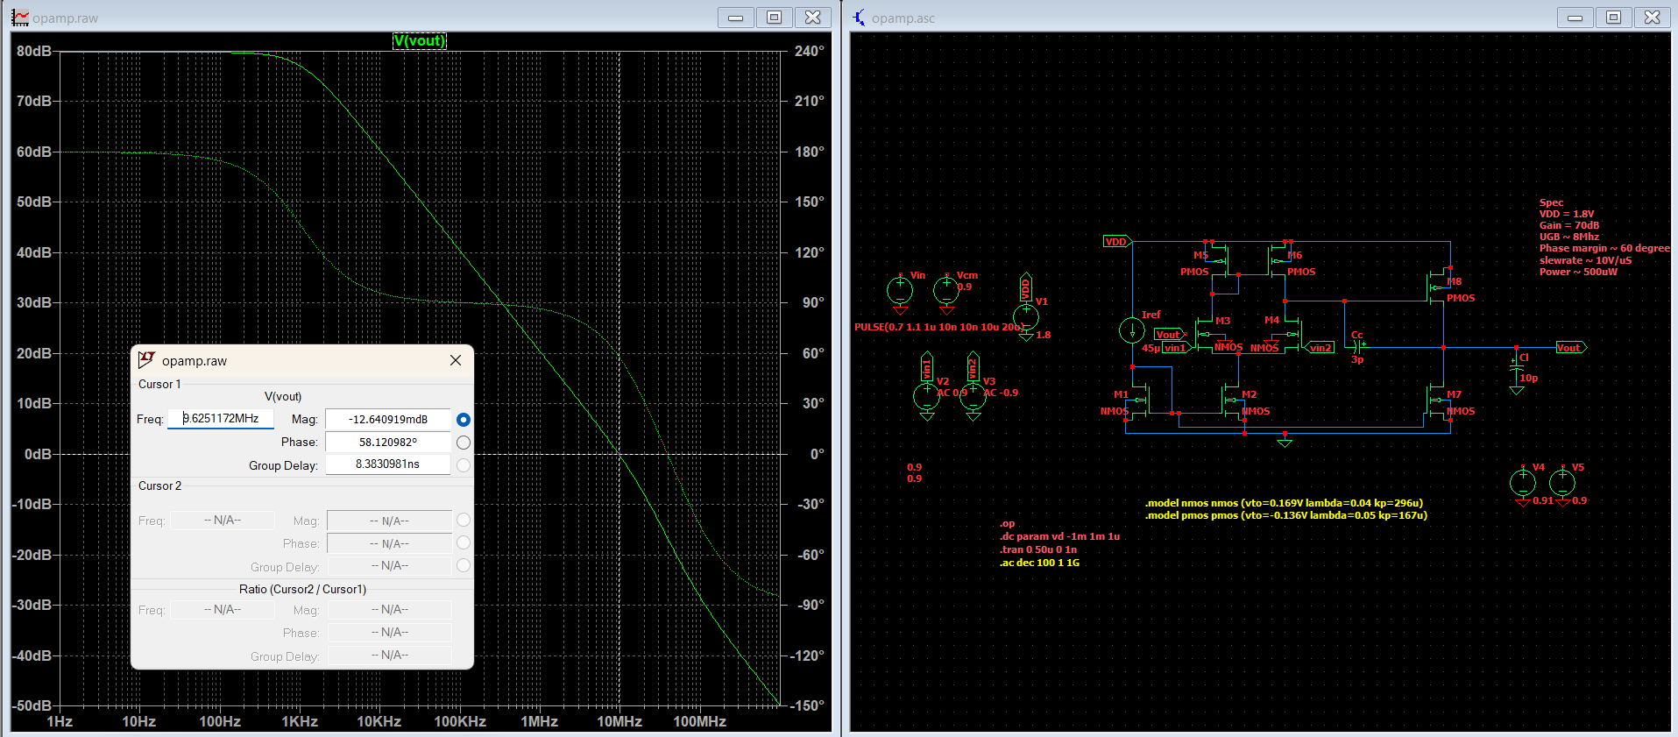
Slew rate
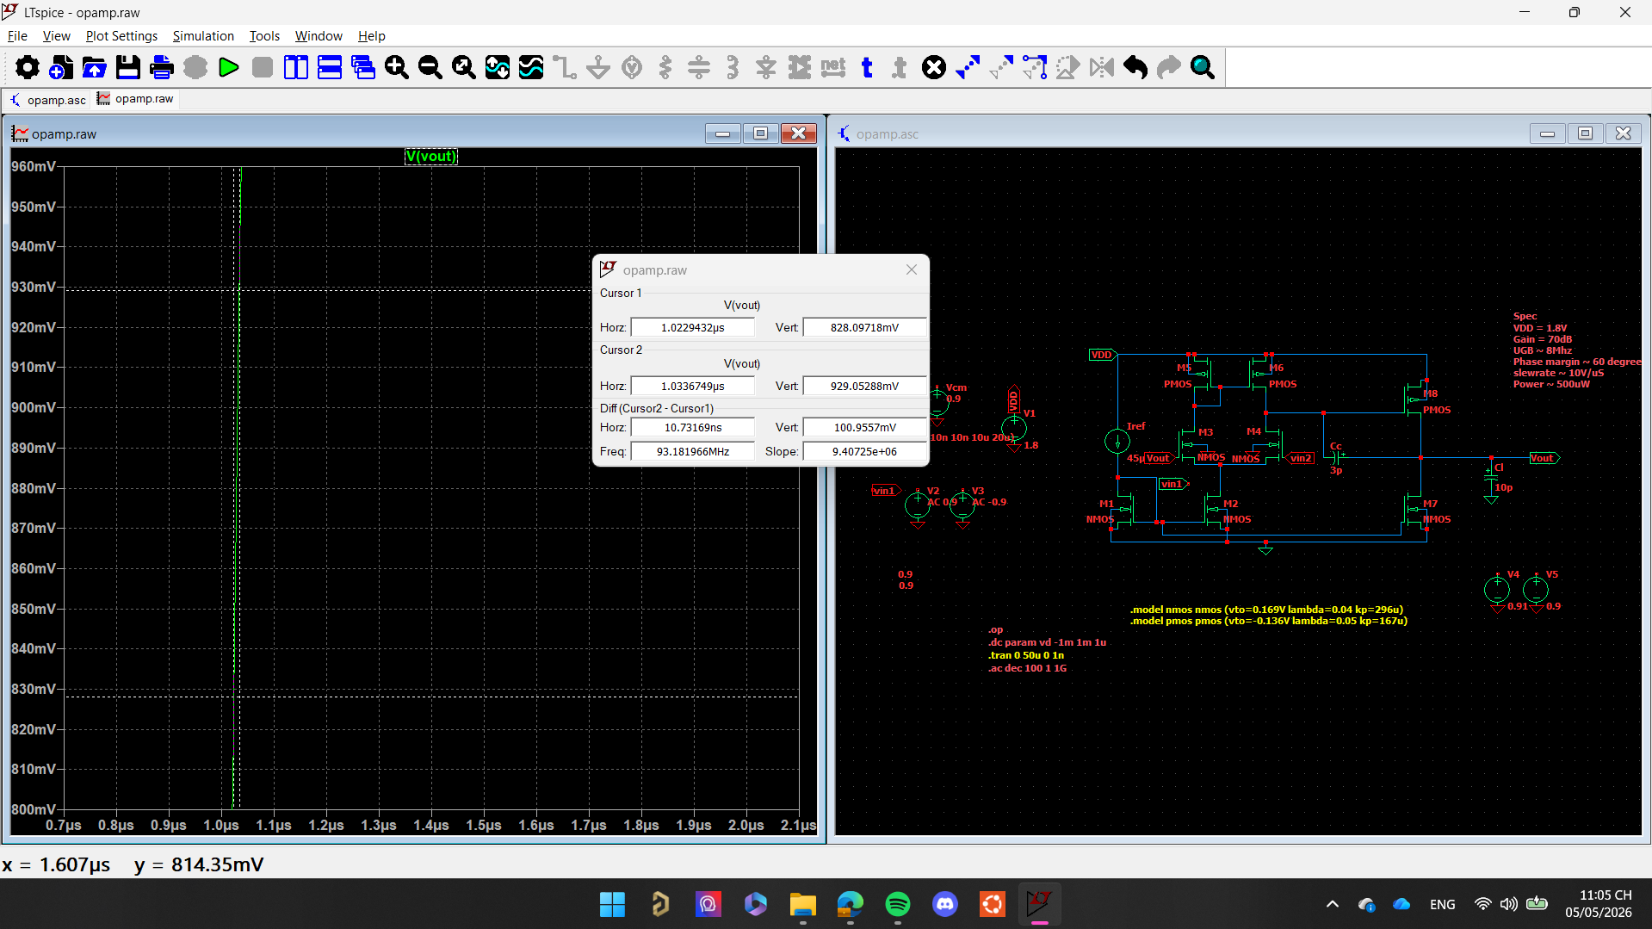
Power
Power=-VDD*I(V1)~450uW

8. Conclusion
After combining hand calculation with LTspice tuning, the final W/L set for the two-stage op-amp is obtained and matches the required specification well. The main lesson from this work is that hand analysis is useful for finding a good starting point, but the final design still has to be verified through the DC operating point and the frequency response in simulation.

