Nama : Khafizd Arizal Khanan

Nim : 5160411309

1. Nilai rata-rata

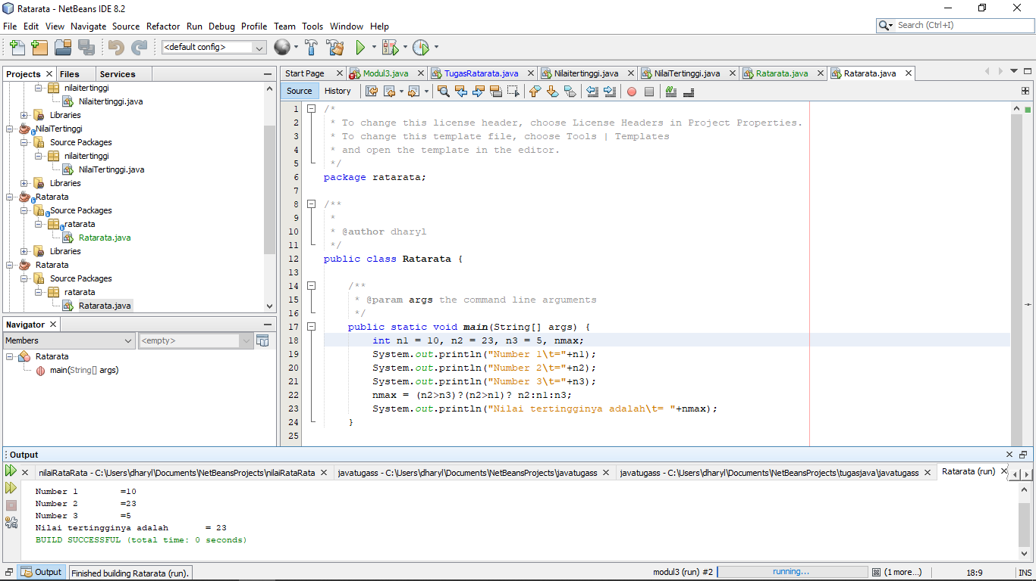

1. Int n1=10,n2=20,n3=45

N1 tipe integer nilai 10

N2 tipe integer nilai 20

N3 tipe integer nilai 45

1. System.out.println(“number1\t=”n1)

Cetak nilai 1

1. System.out.println(“number2\t=”n2)

Cetak nilai 2

1. System.out.println(“number3\t=”n3)

Cetak nilai 3

1. Rata =(n1+n2+n3)/3;

Menghitung rata-rata

1. d. System.out.println(“rata-rata\t=”+rata)

cetak rata-rata

1. Nilai tertinggi

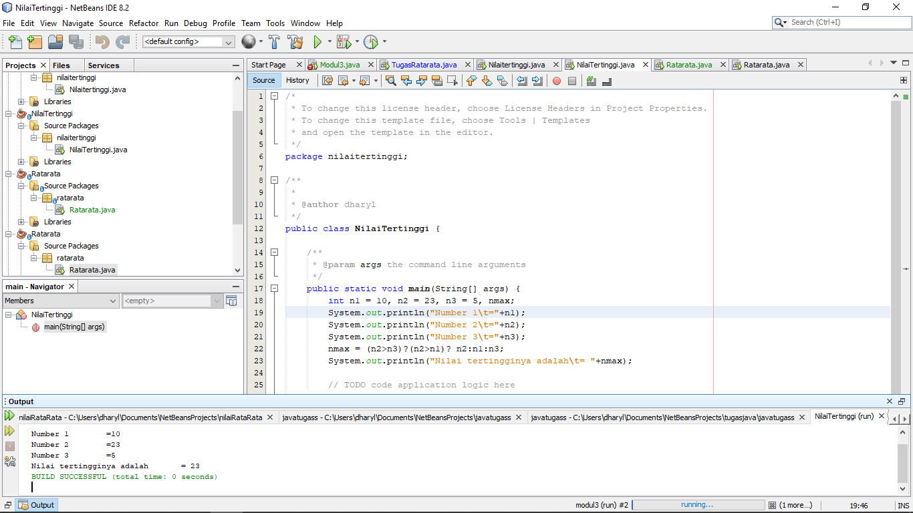

1. Int n1=10,n2=23,n3=5

N1 tipe integer nilai 10

N2 tipe integer nilai 23

N3 tipe integer nilai 5

1. System.out.println(“number1\t=”n1)

Cetak nilai 1

1. System.out.println(“number2\t=”n2)

Cetak nilai 2

1. System.out.println(“number3\t=”n3)

Cetak nilai 3

1. Nmax=(n2>n3)?(n2>n1)?n2:n1:n3;

Cari nilai tertinggi antara 3 angka diatas

1. d. System.out.println(“Nilai tertinggi adalah\t=”+nmax);

etak nilai tertinggi