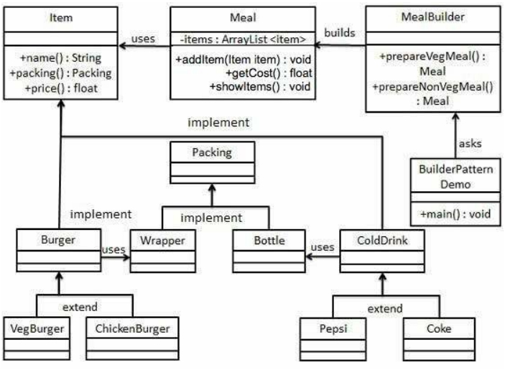

DESIGN PATTERNS - BUILDER PATTERN

<http://www.tutorialspoint.com/design_pattern/builder_pattern.htm> Copyright © tutorialspoint.com

Builder pattern builds a complex object using simple objects and using a step by step approach. This type of design pattern comes under creational pattern as this pattern provides one of the best ways to create an object.

A Builder class builds the final object step by step. This builder is independent of other objects.

**Implementation**

We have considered a business case of fast-food restaurant where a typical meal could be a

burger and a cold drink. Burger could be either a Veg Burger or Chicken Burger and will be packed by a wrapper. Cold drink could be either a coke or pepsi and will be packed in a bottle.

We are going to create an *Item* interface representing food items such as burgers and cold drinks and concrete classes implementing the *Item* interface and a *Packing* interface representing packaging of food items and concrete classes implementing the *Packing* interface as burger would be packed in wrapper and cold drink would be packed as bottle.

We then create a *Meal* class having *ArrayList* of *Item* and a *MealBuilder* to build different types of *Meal* objects by combining *Item*. *BuilderPatternDemo*, our demo class will use *MealBuilder* to build a *Meal*.

**Step 1**

Create an interface Item representing food item and packing. *Item.java*

public interface Item { public String name(); public Packing packing(); public float price();

}

*Packing.java*

public interface Packing {

public String pack();

}

**Step 2**

Create concrete classes implementing the Packing interface. *Wrapper.java*

public class Wrapper implements Packing {

@Override

public String pack() {

return "Wrapper";

}

}

*Bottle.java*

public class Bottle implements Packing {

@Override

public String pack() {

return "Bottle";

}

}

**Step 3**

Create abstract classes implementing the item interface providing default functionalities. *Burger.java*

public abstract class Burger implements Item {

@Override

public Packing packing() {

return new Wrapper();

}

@Override

public abstract float price();

}

*ColdDrink.java*

public abstract class ColdDrink implements Item {

@Override

public Packing packing() {

return new Bottle();

}

@Override

public abstract float price();

}

**Step 4**

Create concrete classes extending Burger and ColdDrink classes *VegBurger.java*

public class VegBurger extends Burger {

@Override

public float price() {

return 25.0f;

}

@Override

public String name() {

return "Veg Burger";

}

}

*ChickenBurger.java*

public class ChickenBurger extends Burger {

@Override

public float price() {

return 50.5f;

}

@Override

public String name() {

return "Chicken Burger";

}

}

*Coke.java*

public class Coke extends ColdDrink {

@Override

public float price() {

return 30.0f;

}

@Override

public String name() {

return "Coke";

}

}

*Pepsi.java*

public class Pepsi extends ColdDrink {

@Override

public float price() {

return 35.0f;

}

@Override

public String name() {

return "Pepsi";

}

}

**Step 5**

Create a Meal class having Item objects defined above. *Meal.java*

import java.util.ArrayList; import java.util.List;

public class Meal {

private List<Item> items = new ArrayList<Item>();

public void addItem(Item item){

items.add(item);

}

public float getCost(){

float cost = 0.0f;

for (Item item : items) {

cost += item.price();

}

return cost;

}

public void showItems(){

for (Item item : items) {

System.out.print("Item : " + item.name()); System.out.print(", Packing : " + item.packing().pack()); System.out.println(", Price : " + item.price());

}

}

}

**Step 6**

Create a MealBuilder class, the actual builder class responsible to create Meal objects. *MealBuilder.java*

public class MealBuilder {

public Meal prepareVegMeal (){ Meal meal = new Meal(); meal.addItem(new VegBurger()); meal.addItem(new Coke()); return meal;

}

public Meal prepareNonVegMeal (){ Meal meal = new Meal(); meal.addItem(new ChickenBurger()); meal.addItem(new Pepsi());

return meal;

}

}

**Step 7**

BuiderPatternDemo uses MealBuider to demonstrate builder pattern. *BuilderPatternDemo.java*

public class BuilderPatternDemo {

public static void main(String[] args) { MealBuilder mealBuilder = new MealBuilder(); Meal vegMeal = mealBuilder.prepareVegMeal();

System.out.println("Veg Meal"); vegMeal.showItems();

System.out.println("Total Cost: " + vegMeal.getCost());

Meal nonVegMeal = mealBuilder.prepareNonVegMeal(); System.out.println("\n\nNon-Veg Meal");

nonVegMeal.showItems();

System.out.println("Total Cost: " + nonVegMeal.getCost());

}

}

**Step 8**

Verify the output.

Veg Meal

Item : Veg Burger, Packing : Wrapper, Price : 25.0 Item : Coke, Packing : Bottle, Price : 30.0

Total Cost: 55.0

Non-Veg Meal

Item : Chicken Burger, Packing : Wrapper, Price : 50.5 Item : Pepsi, Packing : Bottle, Price : 35.0

Total Cost: 85.5