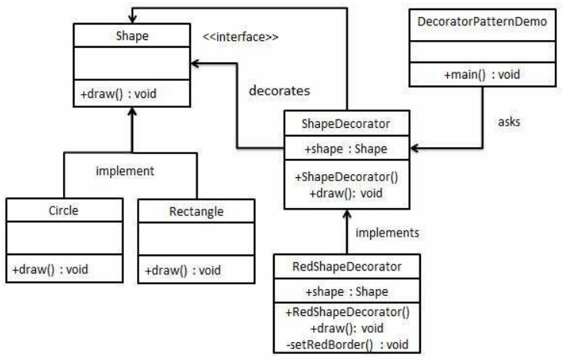

DESIGN PATTERNS - DECORATOR PATTERN

<http://www.tutorialspoint.com/design_pattern/decorator_pattern.htm> Copyright © tutorialspoint.com

Decorator pattern allows a user to add new functionality to an existing object without altering its structure. This type of design pattern comes under structural pattern as this pattern acts as a wrapper to existing class.

This pattern creates a decorator class which wraps the original class and provides additional functionality keeping class methods signature intact.

We are demonstrating the use of decorator pattern via following example in which we will decorate a shape with some color without alter shape class.

**Implementation**

We're going to create a *Shape* interface and concrete classes implementing the *Shape* interface. We will then create an abstract decorator class *ShapeDecorator* implementing the *Shape* interface and having *Shape* object as its instance variable.

*RedShapeDecorator* is concrete class implementing *ShapeDecorator*.

*DecoratorPatternDemo*, our demo class will use *RedShapeDecorator* to decorate *Shape* objects.

**Step 1**

Create an interface. *Shape.java*

public interface Shape {

void draw();

}

**Step 2**

Create concrete classes implementing the same interface. *Rectangle.java*

public class Rectangle implements Shape {

@Override

public void draw() {

System.out.println("Shape: Rectangle");

}

}

*Circle.java*

public class Circle implements Shape {

@Override

public void draw() {

System.out.println("Shape: Circle");

}

}

**Step 3**

Create abstract decorator class implementing the *Shape* interface. *ShapeDecorator.java*

public abstract class ShapeDecorator implements Shape {

protected Shape decoratedShape;

public ShapeDecorator(Shape decoratedShape){

this.decoratedShape = decoratedShape;

}

public void draw(){

decoratedShape.draw();

}

}

**Step 4**

Create concrete decorator class extending the *ShapeDecorator* class. *RedShapeDecorator.java*

public class RedShapeDecorator extends ShapeDecorator {

public RedShapeDecorator(Shape decoratedShape) {

super(decoratedShape);

}

@Override

public void draw() { decoratedShape.draw(); setRedBorder(decoratedShape);

}

private void setRedBorder(Shape decoratedShape){

System.out.println("Border Color: Red");

}

}

**Step 5**

Use the *RedShapeDecorator* to decorate *Shape* objects. *DecoratorPatternDemo.java*

public class DecoratorPatternDemo {

public static void main(String[] args) {

Shape circle = new Circle();

Shape redCircle = new RedShapeDecorator(new Circle());

Shape redRectangle = new RedShapeDecorator(new Rectangle()); System.out.println("Circle with normal border"); circle.draw();

System.out.println("\nCircle of red border"); redCircle.draw();

System.out.println("\nRectangle of red border"); redRectangle.draw();

}

}

**Step 6**

Verify the output.

Circle with normal border Shape: Circle

Circle of red border Shape: Circle

Border Color: Red

Rectangle of red border Shape: Rectangle

Border Color: Red