Ex_02

1. Load the data in Weka Explorer. Select the Associate tab. How many different associations rule mining algorithms are available? 3
2. Choose FPGrowth algorithm with the following parameters (which you can select by clicking on the chosen algorithm: support threshold = 15% (lowerBoundMinSupport = 0.15), confidence threshold = 90% (metricType = confidence, minMetric = 0.9), number of rules = 50 (numRules = 50). After starting the algorithm, how many rules do you find? Could you use the regular weather dataset to get the results? Explain why.

* How many rules do you find? 1
* Could you use the regular weather dataset to get the results? Explain why. 🡪 Yes because in the context of association rule mining, the FPGrowth algorithm is typically used to discover frequent itemsets in transaction datasets. This algorithm efficiently finds patterns that occur together frequently in the data.

1. Paste a screenshot of the Explorer window showing at least the first 20 rules

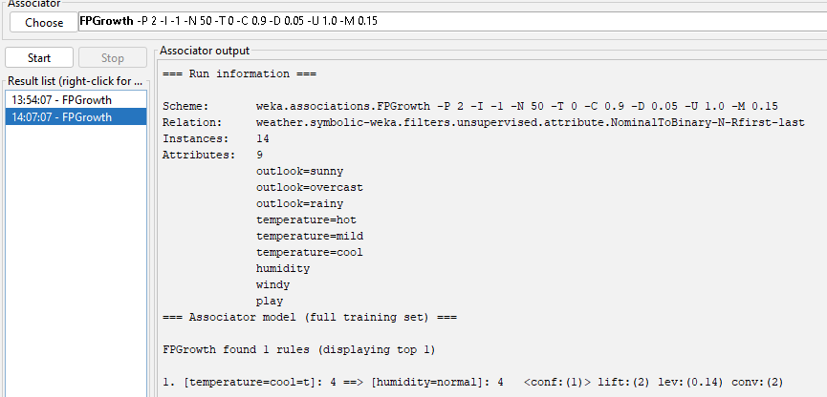

1. Based on the output, what is the support for this item set?

outlook = rainy humidity = normal windy = FALSE play = yes

1. Apriori algorithm generates association rules from frequent itemsets. How many itemsets of size 4 were found? Which rule(s) have been generated from itemset of size 4 (temperature=mild, windy=false, play=yes, outlook=rainy)? List their numbers in the list of rules.
2. What is the total number of possible rules for the weather data for each combination of values in the following table?

|  |  |  |
| --- | --- | --- |
| Minimun confidence | Minimum support | Number of rules |
| 0.9 | 0.3 |  |
| 0.9 | 0.2 |  |
| 0.9 | 0.1 |  |
| 0.8 | 0.3 |  |
| 0.8 | 0.2 |  |
| 0.8 | 0.1 |  |
| 0.7 | 0.3 |  |
| 0.7 | 0.2 |  |
| 0.7 | 0.1 |  |

Ex_04