Bai 1
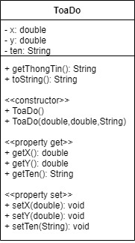
Bai 2
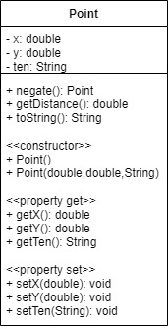

Bai 3
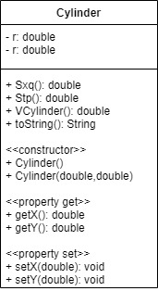
Bai 4
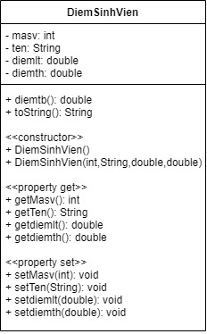

Bai 5
HinhTamGiac
- ma: double
- mb: double
- mc: double
+ checkTamGiac(): String
+ toString(): String

<<constuctor>>
+ HinhTamGiac()
+ HinhTamGiac(double,double,double)

<<property get>>
+ getma(): double
+ getmb(): double
+ getmb(): double

<<property set>>
+ setma(double): void
+ setmb(double): void
+ setmc(double): void

