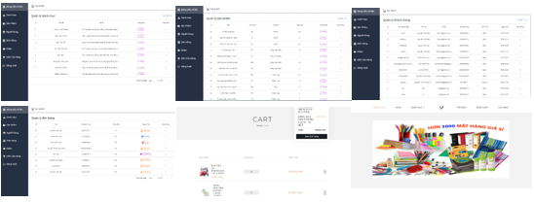

REASON AND TARGET

**1. To help the store owner have a website selling stationery**

**2. To help the customer and the seller to buy and sell stationery**

**3. To helps store owners access online sales and delivery methods more quickly**

REASON

TARGET

**2. Building a website with main functions including: shopping cart management, search, order management, ect…**

**1. Building a useful website which can help the store owner to sell his stationeries**

RESEARCH METHODS

* Research electronic websites
* Research sellers with similar products
* Research consumer needs
* Research stationery products
* Research transportation methods
* Determine the scope of this application: users, main functions
* Collect requirements: consult with other store owners and consumers to get detailed information
* Collect information about stationery websites from the Internet
* Refer to websites selling online stationery such as FAST, Hong Ha, etc…
* Outline the blueprint of the application and identify the technologies used to develop the website
* Refer to and apply technologies to develop applications
* Application development
* Develop test suites to check results

METHODS OF IMPLEMENTATION

APPLIED TECHNOLOGIES

THE MAIN FUNCTIONS HAVE BEEN DEVELOPED

SUMMARIZE

**RESULT**

* Building a successful stationery website
* Store owners can use their main functions such as: selling products, managing invoices and orders, and managing store customers.
* Customers can easily buy products through the website and manage their orders
* All data can be saved to the database after action

**LIMITATION**

* The user interface is not really friendly
* Some functions still have bugs
* The sales statistics have not yet been designed

WAY FOR IMPROVEMENT

1. Design the user interface to be more user-friendly
2. Fix potential bugs in some function
3. Quickly complete the sales statistics function

**Nguyen Van Khai, Email: thaodk246@gmail.com**

**HANOI UNIVERSITY OF INDUSTRY**

FACULTY OF INFORMATION TECHNOLOGY

**WEBSITE SELLING STATIONERY**

**Instructor: ThS Vu Duc Huy. Performer: Nguyen Van Khai**