VIETNAM GENERAL CONFEDERATION OF LABOR

**INFORMATION TECHNOLOGY FACULTY**



**FINAL REVIEW**

**FINAL REPORT**

**SOFTWARE ENGINEERING**

*Instructor*: master PHẠM THÁI KỲ TRUNG

*Students*: **HỒ TUẤN KIỆT – 520H0380 GROUP 7**

**NGUYỄN ĐOÀN MINH KHẢI – 520H0539 GROUP 6**

Class **: 20H50201**

Courses Year  **: 24**

**HỒ CHÍ MINH CITY , YEAR 2022**

VIETNAM GENERAL CONFEDERATION OF LABOR

**TÔN ĐỨC THẮNG UNIVERSITY**

**INFORMATION TECHNOLOGY FACULTY**



**FINAL REVIEW**

**FINAL REPORT**

**SOFTWARE ENGINEERING**

*Instructor:* **master PHẠM THÁI KỲ TRUNG**

*Executor:* **HỒ TUẤN KIỆT– 520H0380 GROUP 7**

**NGUYỄN ĐOÀN MINH KHẢI – 520H0539 GROUP 6**

Class : **20H50201**

Courses year  **: 24**

**HỒ CHÍ MINH CITY , YEAR 2022**

**ACKNOWLEDGEMENT**

Starting with our sincere respect, all the credits are for our instructor Phạm Thái Kỳ Trung who is devoted and enthusiastic about his profession. He passed on his knowledge which improved our understanding of the inside concepts of software engineering. In this review, we have achieved a basic understanding of UML as well as requirements specifications applied to this field of work. Therefore, with the knowledge we received thanks to his devotion, we can complete this final report.

**THE ESSAY IS COMPLETED AT TON DUC THANG UNIVERSITY**

We guarantee that this is our working product under the instruction of master Phạm Thái Kỳ Trung. All research contents, and results in this essay are honest and have never been published in any form before. Figures in tables are to serve the analysis, remarks, and assessment by the author collected from other sources mentioned in reference materials.

Furthermore, the essay has some comments, appraisements, and other data from different authors, and organizations who have been given credits and noted their sources.

**If any fraud is found, we are strongly responsible for my project content.** Tôn Đức Thắng university is not related to any copyright offense which we committed in our working process (in case of fraud commitment).

*Hồ Chí Minh city , day 12 month 12 the year 2022*

*Author*

*(sign and write full name)*

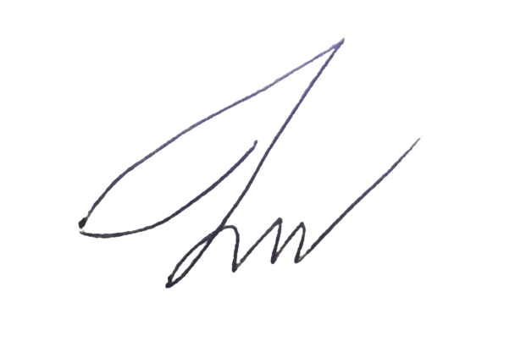

*Hồ Tuấn Kiệt*

**CONFIRMATION AND JUDGEMENT OF LECTURER**

**Confirmation part for instructor**

_______________________________________________________________________________________________________________________________________________________________________________________________________________________________________________________________________________________________________________________________________________________________________________________________________________

Hồ Chí Minh city, day month year

(sign and write full name)

**Judgement of examiner**

_______________________________________________________________________________________________________________________________________________________________________________________________________________________________________________________________________________________________________________________________________________________________________________________________________________

Hồ Chí Minh city, day month year

(sign and write full name)

**SUMMARIZE**

In this final report, the goal is to understand what is in need of a system selling Supplement Facts products to Agents. There are many functions required for each accountant and agent to interact with the system. First of all, we will identify the use case for each type of user alongside functional and non-functional requirements. In this final report, we build the Winform application for accountants to import goods into the database, Webform for agents to place orders of items. Having a good understanding of the MVC model as well as many helpful frameworks will help accelerate the process.

**Index**

**1.** **Introduction** 7

**1.1.** **Purpose and Scope:** 7

**1.2.** **Product Overview:** 7

**1.3.** **Structure of the Document** 8

**1.4.** **Terms, Acronyms, and Abbreviations** 8

**2.** **Project Management Plan** 9

**2.1.** **Project Organization** 9

**2.2.** **Lifecycle Model Used** 9

**2.3.** **Risk Analysis** 9

**2.4.** **Hardware and Software Resource Requirements** 10

**2.5.** **Deliverables and Schedule** 10

**2.6.** **Monitoring, Reporting, and Controlling Mechanisms** 11

**2.7.** **Professional Standards** 11

**2.8.** **Evidence all the artifacts have been placed under configuration management** 11

**2.9.** **Impact of the project on individuals and organizations** 11

**3.** **Requirement Specifications** 12

**3.1.** **Stakeholders for the system** 12

**3.2.** **Use case model** 12

**3.2.1.** **Graphical use case model** 12

**3.2.2.** **Textual Description for each use case** 13

**3.3.** **Functional requirements** 14

**3.4.** **Non-functional** **requirements** 15

**4.** **Architecture** 15

**4.1.** **Architectural style(s) used** 15

**4.2.** **Architectural model** 15

**4.3.** **Technology, software, and hardware used** 16

**4.4.** **Rationale** 16

**5.** **Design** 16

**5.1.** **Database design** 16

**5.2.** **Static model – class diagrams** 17

**5.3.** **Dynamic model – sequence diagrams** 18

**5.4.** **Rationale** 21

**5.5.** **Traceability from requirements to detailed design model** 21

**REFFERENCES** 22

**1** **APPENDIX** 23

1. **Introduction**
   1. **Purpose and Scope:**

**Purpose:** The goal of this document is to give an insight idea and throughout understanding of how a system selling Supplement Facts products will behave and mostly increase labor productivity for accountants. This document contains various UML graphs to visualize the process of building a system through database design and requirements analysis which plays important roles in later implementation.

**Scope:** the scope of this document is revolving around the functionality, reliability of the system as a whole. The interaction between the user, the UI and the database are the main components in building a system.

* 1. **Product Overview:**

**Capabilities:** The system is capable of storing important data related to Supplement Facts products, helping accountants interact with the system through functions such as warehousing, importing and exporting goods to the database. Moreover, accountants can publish the reports each month, the system will automatically calculate the total prices of products entered. Making it easier for accountants to manipulate the system without having to use mass calculations and programming knowledge (SQL command). On the agent’s side, they’ll be able to add favorite products to the cart and store it there for later orders.

**Scenarios:** The system is provided for companies that wish to deal with items related to Supplements and resell them to dealers. Our system is in use when the company imports a large number of Supplements and accountants are assigned to handle importation which needs fast computation and manipulation. Furthermore, monthly income and incoming/outgoing information can be published and printed out for visualization. When Supplements are sufficient in the warehouse, agents can start to make orders.

* 1. **Structure of the Document**

In this document, we will walk through all the essential steps before implementing the system. First of all, we will discuss our plan for project management, then we will look into details of requirement specifications (draw models). In the last two steps, we will choose Architecture and design our database based on the plan and requirement analysis that we make at the beginning of this document.

* 1. **Terms, Acronyms, and Abbreviations**

|  |  |  |
| --- | --- | --- |
| **#** | **Item** | **Description** |
| 1 | MVC | Model-View-Controller |
| **2** | HTTP | Hypertext-Transfer Protocol |
| **3** | HTML | File CSHTML in C# |
| **4** | EF6 | Entity framework |
| **5** | RDLC | Report Definition Language Client-side an extension of the report file created by  using Microsoft reporting technology |
| **6** | ERD | Entity Relationship Diagram |

1. **Project Management Plan**
   1. **Project Organization**

We perform “database first”, so we will start with identifying the number of tables in the database, the attributes needed in the tables. Also, all of our team members are assigned in the “class diagram” process because we consider this step as the most important step. I, Kiệt, contribute the most in the database design because I am experienced in ERD while Khải contributes the most in the document references, information relating to Supplements.

In the implementation, Khải implements function for accountants in Winform because he’s accustomed to C# while I build the Webform for agents as I can deal with framework precisely. However, we both help each other out when facing difficult problems.

* 1. **Lifecycle Model Used**

We used the Waterfall model because we tend to think beforehand. We attempt to handle all the error possibilities or functional limitations that can happen while our system is public. By going through the stages of Software Engineering step by step, we can perform a very strict system and very detailed document of requirements needed for the Supplements company.

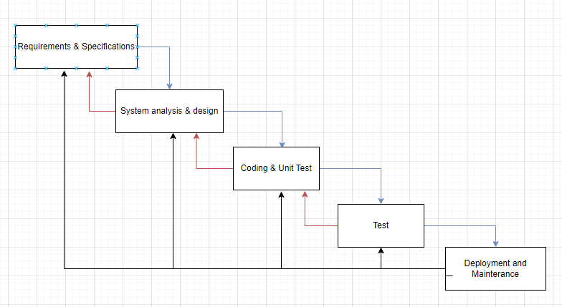

* 1. **Risk Analysis**

There can be some risks in our system while in use, but some of them can be easily identified and fixed immediately while implementation and testing. However, there are hidden or outside risks that can harm our system badly. We can list a set of risks that we face while testing, for example, when Agents make a purchase, the quantity purchased may be more than the number of goods left in the warehouse, or Accountants or Agents enter the ID of the agent, and the product code that does not exist while using the system. And the most common one is a query error in a database which forces the system to stop immediately. The factors are mostly technical problems or users who do not know to use the system. Our reduction strategies are testing during implementation so that we can point out errors at once.

* 1. **Hardware and Software Resource Requirements**

For hardware, we use Intel ® Core(TM) i5, AMD Ryzen 5 4600H with 500 GB storage and 8G RAM. For software, we use mostly Visual Studio 2022 C#,Microsoft SQL Server Management Studio 2018.

Through this project, we learn more about Model-View-Controller framework and be able to work on many helpful tools such as RDLC.

* 1. **Deliverables and Schedule**

-Functional requirements, Non-functional requirements, Database design, Static model – class diagrams, Dynamic model – sequence diagrams, (20/10/2022 🡪 25/10/2022)

-Usecase Model, Graphical use case model, Architectural model (25/10/2022🡪27/10/2022)

-Database: Khải, Kiệt (27/10/2022🡪30/10/2022)

-Winform,webform: Khải, Kiệt(1/11/2022🡪30/11/2022)

* 1. **Monitoring, Reporting, and Controlling Mechanisms**

- Create a checklist to fulfill the requirements of the proposal

- When there is a problem, video call to solve it together

-Always plan what to do for future video calls.

- Always on time

* 1. **Professional Standards**

-A meeting will be scheduled to assess the situation and find a solution. If a team member is dismissed, their grade will be reduced according to the number of weeks they were a part of the group.

-Maintain devotion and commitment through the whole project.

-Actively work on the project.

* 1. **Evidence all the artifacts have been placed under configuration management**

- Create folders containing data

- Job assignment

- Discussion to handle work

- Get the job done

* 1. **Impact of the project on individuals and organizations**

The system helps the programmer's individual understand more about how the system works and how it impacts the business. Most importantly, this project is useful for accountants and agents.

1. **Requirement Specifications**
   1. **Stakeholders for the system**

Companies, dealers and retailers that want to sell or buy supplements.

* 1. **Use case model**
     1. **Graphical use case model**

**Accountants:**

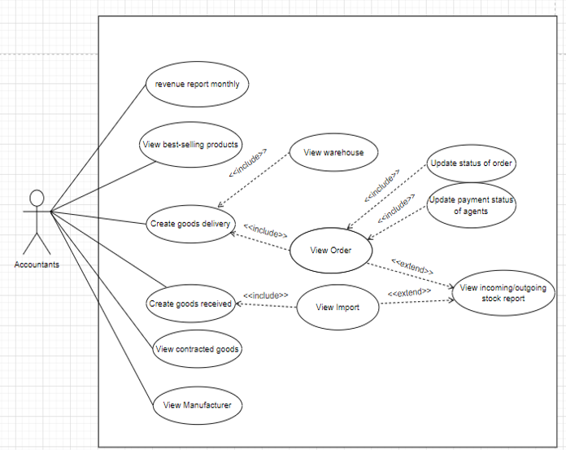

**Agents:**

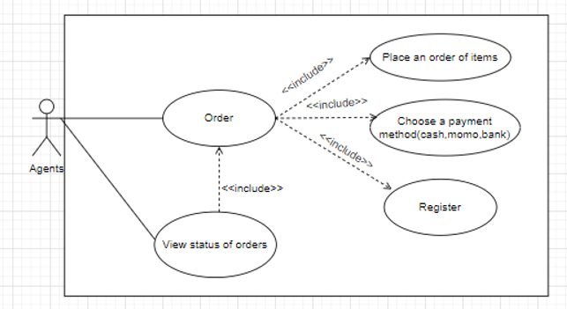

* + 1. **Textual Description for each use case**

|  |  |  |
| --- | --- | --- |
| **Actor** | **Use case** | **Description** |
| **Accountants** | Create goods received | When company imports goods, accountants shall be able to create Receipt information relating to goods and the quantity of goods imported |
|  | Create goods delivery | When agents contact to company or accountant themselves to make order, accountant shall be able to create an Export relating to information of goods and quantity of goods that agents order. |
|  | Update status of order | Accountant shall be able to update the delivery of the order. Either it’s delivered or not. |
|  | Update payment status of agents | Accountant shall be able to update the payment status of agents. Either it’s online or transfer. |
|  | View Best Selling | View the best-selling product of the company. |
|  | View incoming/outcoming | View the all the import/order. |
|  | Monthly revenue | View the income from all the orders made based on month and year |
|  | View contracted goods | View the goods that company have contract of |
|  | View warehouse | View the quantity of the goods |
|  | View Order | View all the orders made from Agents |
|  | View Import | View all the imports |
|  | View Manufacturer | View the cooperating Manufacturer that produce goods |
| **Agents** | Register | Register to buy products |
|  | View status of order | View the status of order including date, charge status, delivery status |
|  | Order | Make an order of items |
|  | Choose a payment method | Choose transfer, cash or online payment method |

* 1. **Functional requirements**

-In SE_FinalProject_ENG_HK1_2223.pdf the requirements don’t contain Login and Register. Should we create a page for those as authentication?

-In SE_FinalProject_ENG_HK1_2223.pdf the requirement contains an Import function for accountant but doesn’t go into detail what happen when accountant successfully import a product. I recommend the option: Show a message box to inform accountant that they successfully import a product.

-In SE_FinalProject_ENG_HK1_2223.pdf the requirement says that Accountant shall be able to update status of order, but it doesn’t describe how to inform the accountant that they have updated successfully. I recommend the option: Show a message box to inform accountant that they successfully update the order.

-In SE_FinalProject_ENG_HK1_2223.pdf have description of viewing orders. Should we create a “delete” function for orders that we don’t want to make anymore?

* 1. **Non-functional** **requirements**

-Is the UI eye-catching?

-Does it take a long time to log in to your account, add products and pay for products?

-If I forget my password, is it complicated to get it back?

-The hotline of the website is available 24/7?

-How long would it take for the website to recover after crashes?

1. **Architecture**
   1. **Architectural style(s) used**

Data-centered architecture is used in this project. The idea of this architecture is that data is designed first and applications are then designed to create and use it. Our system will access data at source. The commercial model is supported where application providers can gain rewards for adding values.

* 1. **Architectural model**

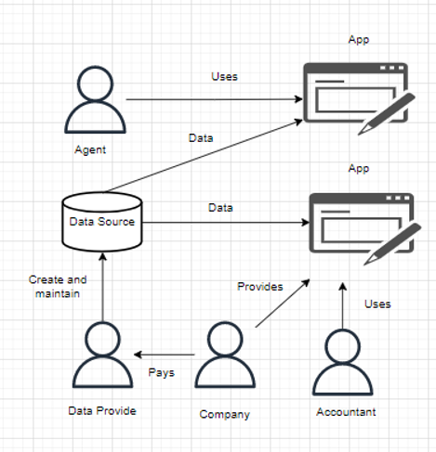

* 1. **Technology, software, and hardware used**

For hardware, we use Intel ® Core(TM) i5, AMD Ryzen 5 4600H with 500 GB storage and 8G RAM. For software, we use draw.io and SQL Server Management Studio 2018.

* 1. **Rationale**

Because in our database, Supplements goods and manufacturers existed even before the application of ours, company must have contract of goods and manufacturers. From the existing data, company pays the programmers to make applications for agents and accountants to make use of it.

1. **Design**
   1. **Database design**

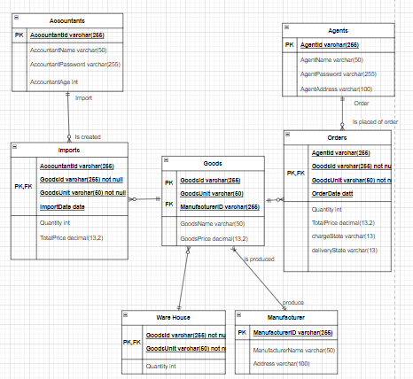

* 1. **Static model – class diagrams**

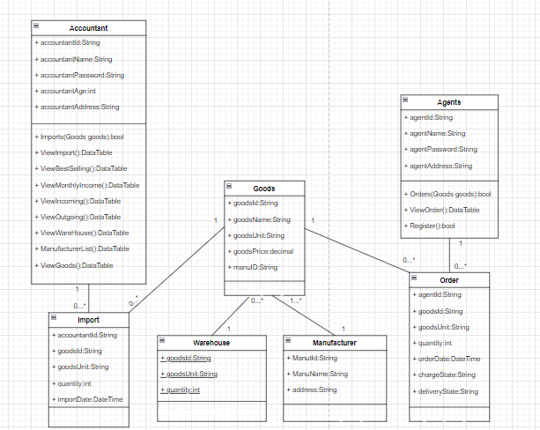

* 1. **Dynamic model – sequence diagrams**

**Agent**

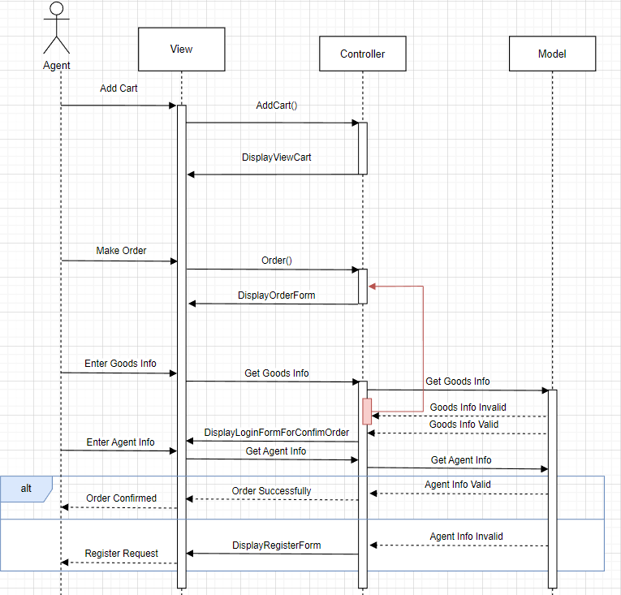

**Accountant**

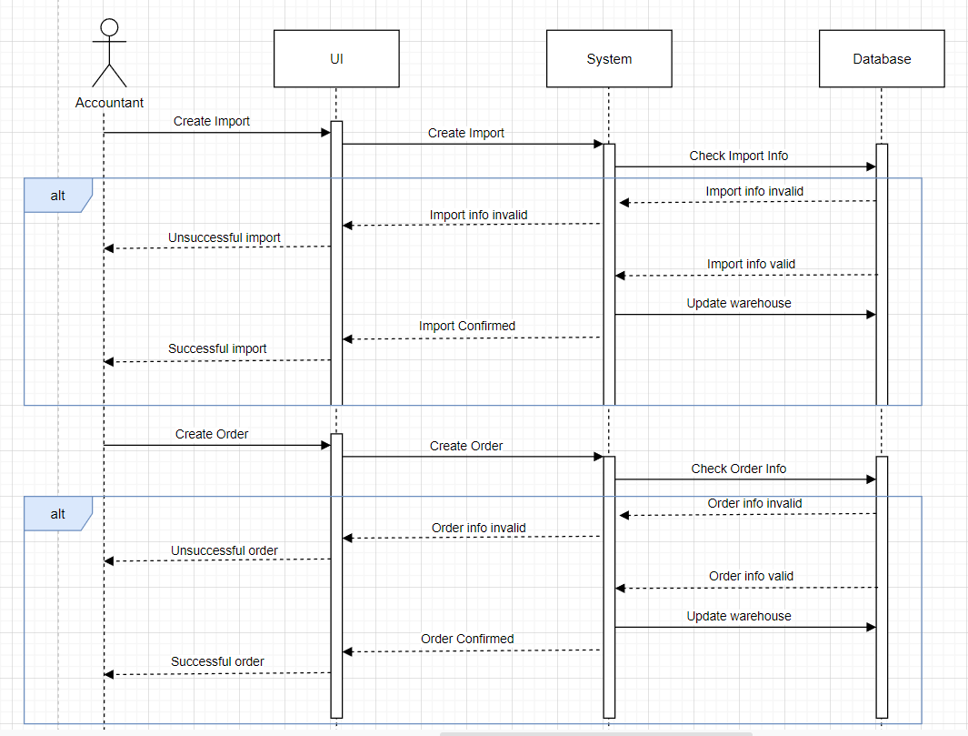

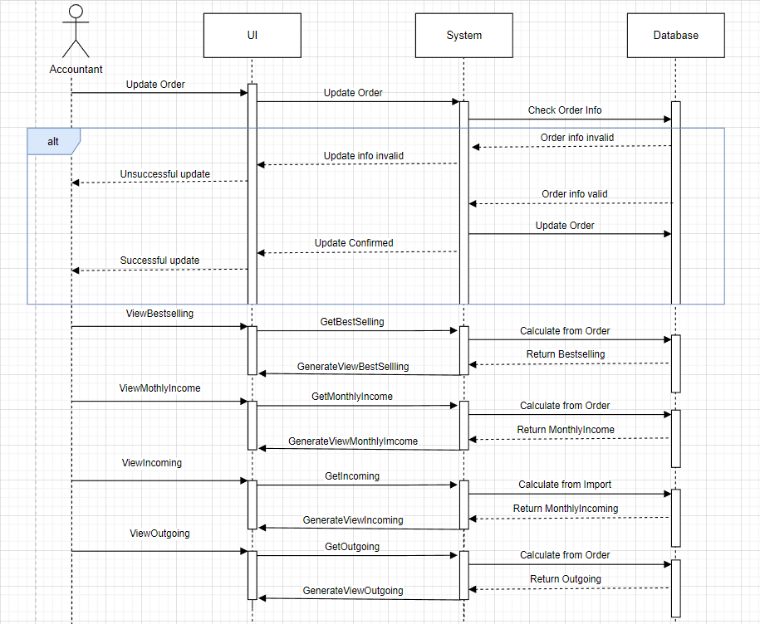

* 1. **Rationale**

-Import table has accountant id and import date which act as ID of Receipt

-Order table has agent id and order date which acts as id of Order.

-Goods table have attribute manufacturer id referenced to manufacturer table because one manufacturer can produce many products but a product can only belong to one manufacturer.

-One warehouse can store many products while products can only belong to one warehouse.

-One accountant can make zero or many imports but an import can only made by one accountant. One agent can make zero or many orders but an orders can only be made by one agent.

* 1. **Traceability from requirements to detailed design model**

There are a lot of existing manufacturers that produce supplements and each product has their unique code in the world’s market. That’s why we have two table first such as manufacturer and goods so that we can get data from the internet and dump it in our database. For other tables like accountant and agent, we set id for accountants and id for agent so that we can include role-based authorization in our system. And in order to make import, it’s ideal to have “date import” so that accountant can make report for monthly income. Warehouse tables are created to store the quantity of goods that available so agents can decide whether to buy or not.

# **REFFERENCES**

**[4]** [Data-Centered Architecture (lacibus.net)](https://lacibus.net/info/pages/dca)

**[5]** <https://youtu.be/pCK6prSq8aw>

**[7]** <https://youtu.be/dwewr_SDnyk>

# **APPENDIX**