Hà Nội, tháng 9 năm 2024



**ĐẠI HỌC BÁCH KHOA HÀ NỘI**

**TRƯỜNG CÔNG NGHỆ THÔNG TIN VÀ TRUYỀN THÔNG**

**---**

**o0o**

**--**

**-**

BÁO CÁO THỰC HÀNH

IT3103-744527-2024.1

**BÀI THỰC HÀNH – LAB01**

**Họ và tên: Lê Quang Khải**

**MSSV: 20225638**

**Lớp: VN03-K67**

**GVHD: Lê Thị Hoa**

**HTGD: Đặng Mạnh Cường**

Contents

BÁO CÁO THỰC HÀNH LAB 1 3

The Very First Java Programs 3

*2.2.1* Write, compile the first Java application: 3

*2.2.2* Write, compile the first dialog Java program 4

*2.2.3* Write, compile the first input dialog Java application 4

*2.2.4* Write, compile, and run the following example: 5

*2.2.5* Calculate 2 double numbers 6

*2.2.6* Write a program to solve Exercise: 7

**TABLE OF FIGURES**

Figure 1. The First Java Application 3

Figure 2. The First Dialog Java Application 4

Figure 3. The First Input dialog Java Application 4

Figure 4. Java Application showing two entered numbers and their sum 5

Figure 5. Source code CaculateTwoNumbers 6

Figure 6. Kết quả CaculateTwoNumbers 7

Figure 7. Source code EquationSolver 9

Figure 8. Kết quả EquationSolver 11

# BÁO CÁO THỰC HÀNH LAB 1

# The Very First Java Programs

## *2.2.1* Write, compile the first Java application:

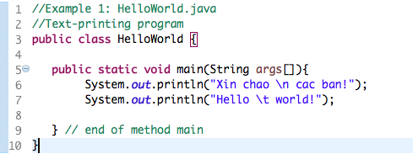

Kết quả:

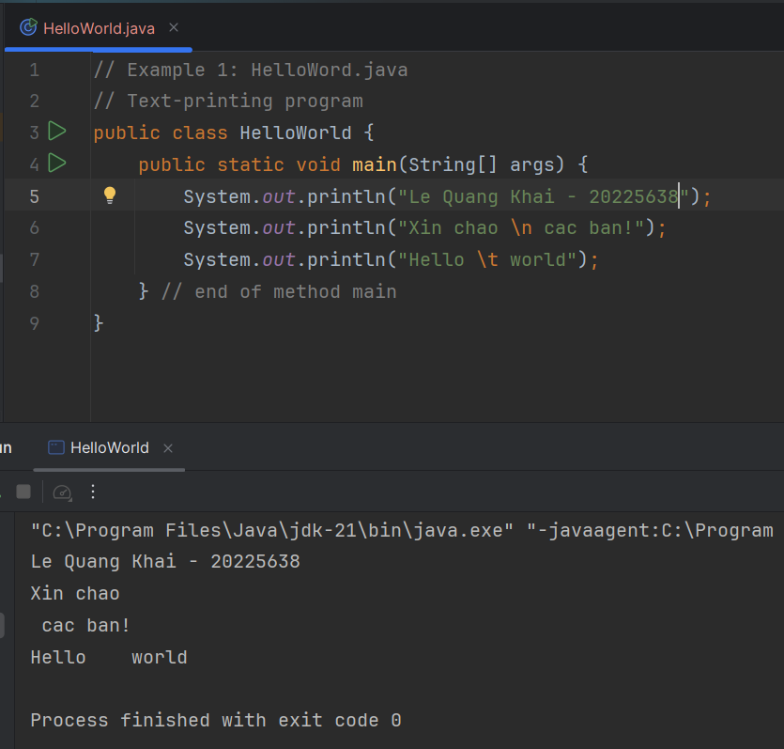

Figure 1. The First Java Application

## *2.2.2* Write, compile the first dialog Java program

Kết quả:

Figure 2. The First Dialog Java Application

## *2.2.3* Write, compile the first input dialog Java application

Kết quả:

Figure 3. The First Input dialog Java Application

## *2.2.4* Write, compile, and run the following example:

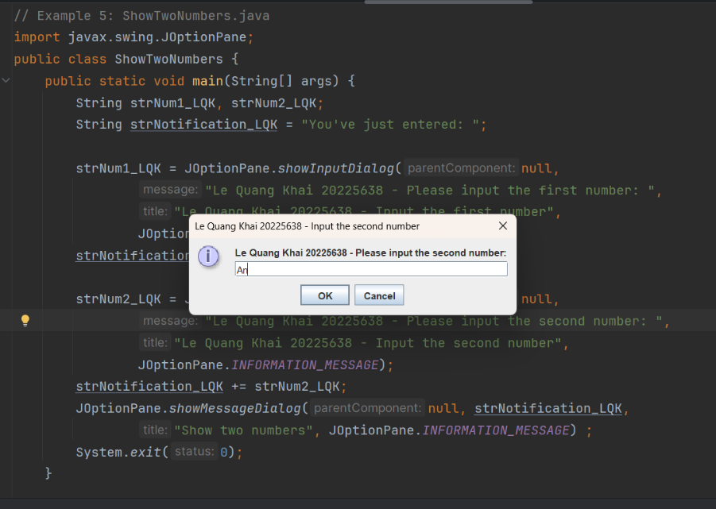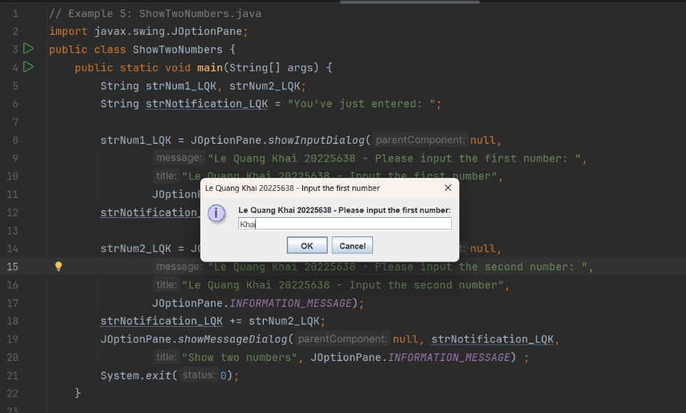Kết quả:

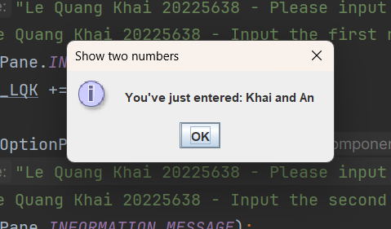

Figure 4. Java Application showing two entered numbers and their sum

## *2.2.5* Calculate 2 double numbers

Kết quả:

Figure 5. Source code CaculateTwoNumbers

num1 = 19, num2 = 9

Figure 6. Kết quả CaculateTwoNumbers

## *2.2.6* Write a program to solve Exercise:

Kết quả:

Figure 7. Source code EquationSolver

Figure 8. Kết quả EquationSolver

# Exercises

## Write, compile and run the ChoosingOption program:

Source code:

Figure 9. Source code ChoosingOption

Kết quả chạy:

Figure 10. Kết quả chạy ChoosingOption

* Khi người dùng chọn "Cancel" trong hộp thoại JOptionPane.showConfirmDialog, giá trị trả về là JOptionPane.CANCEL_OPTION. Tuy nhiên, trong đoạn mã hiện tại, câu thông báo sẽ coi "Cancel" như là "No" vì điều kiện chỉ kiểm tra nếu người dùng chọn JOptionPane.YES_OPTION. Do đó, khi người dùng chọn "Cancel" hoặc "No", chương trình sẽ hiển thị thông báo là "No".

## 6.2 Write a program for input/output from keyboard

Source code:

Figure 11. Source code InputFromKeyboard

Kết quả:

Figure 12. Kết quả InputFromKeyboard

## 6.3 Write a program to display a triangle with a height of n stars (*), n is entered by users.

Source code:

Figure 13. Source code Ex6.3

Kết quả:

Figure 14. Kết quả Ex6.3

## 6.4 Write a program to display the number of days of a month, which is entered by users (both month and year). If it is an invalid month/year, ask the user to enter again.