Hà Nội, tháng 9 năm 2024



**ĐẠI HỌC BÁCH KHOA HÀ NỘI**

**TRƯỜNG CÔNG NGHỆ THÔNG TIN VÀ TRUYỀN THÔNG**

**---**

**o0o**

**--**

**-**

BÁO CÁO THỰC HÀNH

IT3103-744527-2024.1

**BÀI THỰC HÀNH – LAB01**

**Họ và tên: Lê Quang Khải**

**MSSV: 20225638**

**Lớp: VN03-K67**

**GVHD: Lê Thị Hoa**

**HTGD: Đặng Mạnh Cường**

Contents

BÁO CÁO THỰC HÀNH LAB 1 4

2. The Very First Java Programs 4

*2.2.1* Write, compile the first Java application: 4

*2.2.2* Write, compile the first dialog Java program 5

*2.2.3* Write, compile the first input dialog Java application 5

*2.2.4* Write, compile, and run the following example: 6

*2.2.5* Calculate 2 double numbers 7

*2.2.6* Write a program to solve Exercise: 8

6. Exercises 12

6.1 Write, compile and run the ChoosingOption program 12

6.2 Write a program for input/output from keyboard 13

6.3 Write a program to display a triangle with a height of n stars (*). 14

6.4 Write a program to display the number of days of a month. 16

6.5 Write a Java program to sort a numeric array, and calculate the sum and average value of array elements. 18

6.6 Write a Java program to add two matrices of the same size. 20

**TABLE OF FIGURES**

Figure 1. The First Java Application 4

Figure 2. The First Dialog Java Application 5

Figure 3. The First Input dialog Java Application 5

Figure 4. Java Application showing two entered numbers and their sum 6

Figure 5. Source code CaculateTwoNumbers 7

Figure 6. Kết quả CaculateTwoNumbers 8

Figure 7. Source code EquationSolver 10

Figure 8. Kết quả EquationSolver 12

Figure 9. Source code ChoosingOption 12

Figure 10. Kết quả chạy ChoosingOption 13

Figure 11. Source code InputFromKeyboard 13

Figure 12. Kết quả InputFromKeyboard 14

Figure 13. Source code Ex6.3 14

Figure 14. Kết quả Ex6.3 15

Figure 15. Source code Ex6.4 DaysOfAMonthYear 16

Figure 16. Kết quả Ex6.4 DaysOfAMonthYear 17

Figure 17. Source code Ex6.5 18

Figure 18. Kết quả Ex6.5 19

Figure 19. Source code Ex 6.6 Calculate Matrix Same Size 20

Figure 20. Kết quả Ex 6.6 Calculate Matrix Same Size 20

# BÁO CÁO THỰC HÀNH LAB 1

# 2. The Very First Java Programs

## *2.2.1* Write, compile the first Java application:

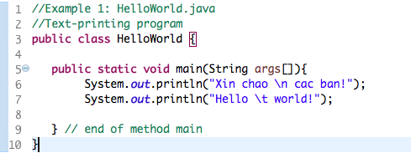

Kết quả:

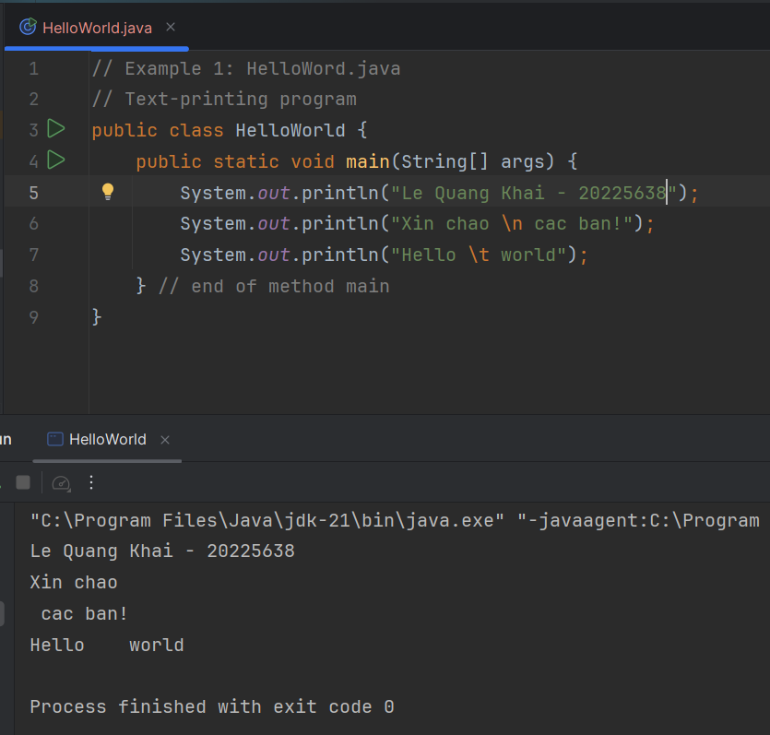

Figure 1. The First Java Application

## *2.2.2* Write, compile the first dialog Java program

Source code + Kết quả:

Figure 2. The First Dialog Java Application

## *2.2.3* Write, compile the first input dialog Java application

Source code + Kết quả:

Figure 3. The First Input dialog Java Application

## *2.2.4* Write, compile, and run the following example:

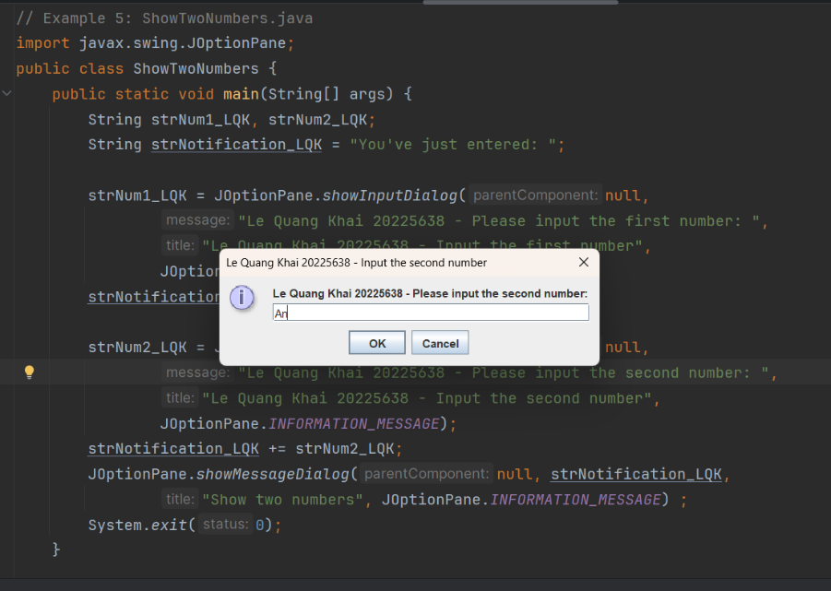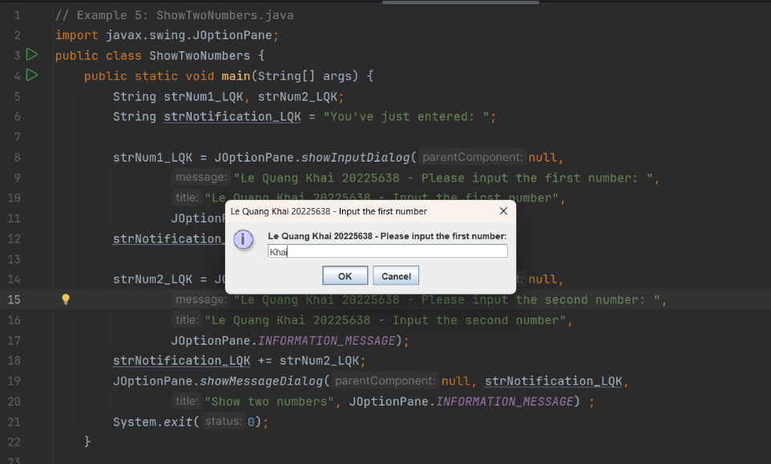Source code + Kết quả:

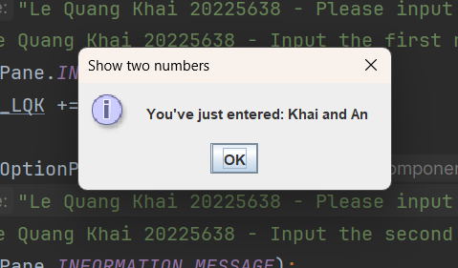

Figure 4. Java Application showing two entered numbers and their sum

## *2.2.5* Calculate 2 double numbers

Kết quả:

Figure 5. Source code CaculateTwoNumbers

num1 = 19, num2 = 9

Figure 6. Kết quả CaculateTwoNumbers

## *2.2.6* Write a program to solve Exercise:

Source code + Kết quả:

Figure 7. Source code EquationSolver

Figure 8. Kết quả EquationSolver

# Exercises

## 6.1 Write, compile and run the ChoosingOption program

Source code:

Figure 9. Source code ChoosingOption

Kết quả chạy:

Figure 10. Kết quả chạy ChoosingOption

* Khi người dùng chọn "Cancel" trong hộp thoại JOptionPane.showConfirmDialog, giá trị trả về là JOptionPane.CANCEL_OPTION. Tuy nhiên, trong đoạn mã hiện tại, câu thông báo sẽ coi "Cancel" như là "No" vì điều kiện chỉ kiểm tra nếu người dùng chọn JOptionPane.YES_OPTION. Do đó, khi người dùng chọn "Cancel" hoặc "No", chương trình sẽ hiển thị thông báo là "No".

## 6.2 Write a program for input/output from keyboard

Source code:

Figure 11. Source code InputFromKeyboard

Kết quả:

Figure 12. Kết quả InputFromKeyboard

## 6.3 Write a program to display a triangle with a height of n stars (*), n is entered by users.

Source code:

Figure 13. Source code Ex6.3

Kết quả:

Figure 14. Kết quả Ex6.3

## 6.4 Write a program to display the number of days of a month, which is entered by users (both month and year). If it is an invalid month/year, ask the user to enter again.

Source code:

Figure 15. Source code Ex6.4 DaysOfAMonthYear

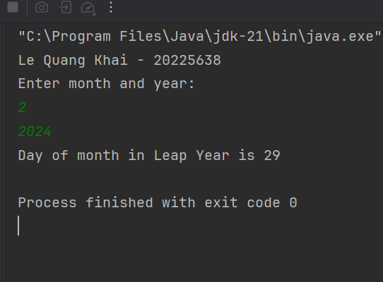Kết quả:

Figure 16. Kết quả Ex6.4 DaysOfAMonthYear

## 6.5 Write a Java program to sort a numeric array, and calculate the sum and average value of array elements.

Source code:

Figure 17. Source code Ex6.5

Kết quả:

Figure 18. Kết quả Ex6.5

## 6.6 Write a Java program to add two matrices of the same size.

Source code:

Figure 19. Source code Ex 6.6 Calculate Matrix Same Size

Kết quả:

Figure 10. Kết quả Ex 6.6 Calculate Matrix Same Size