**Logistic Regression**

**&**

**Support Vector Machines**

Khai Nguyen

1. **Design**
   1. **Core functions**
      1. **train_classifier**(train_x, train_y, learn_rate, loss, lambda_val=None, regularizer=None):
         * initialize delta_weight vector
         * calculate current_loss
         * loop through length of delta_weight
           + calculate temp_loss (h) for each index of delta_weight
           + calculate delta_weight[index] = (temp_loss - current_loss)/h
         * return weight vector
      2. **test_classifier**(w, test_x)
         * take dot product of weight_vector and each row of testX
         * return predictY
      3. **normalize**(trainX,testX)
         * normalize data based on “mean” and “stdev”
      4. **compute_accuracy**(test_y, pred_y)
   2. **Logistic Regression**
      1. **logistic_loss**(train_y, pred_y):
         * log_loss = log(1 + exp( -yy’ ))
      2. **weight_vector_logistic** = train_classifier(trainX,trainY,0.001,logistic_loss)
   3. **SVM**
      1. **hinge_loss**(train_y, pred_y)
         * hinge_lossVector = max(0,1 – yy’)
      2. **l2_reg(w)**
      3. **weight_vector_SVM** = train_classifier(trainX,trainY,0.1,hinge_loss,0.001, l2_reg)
   4. **main()**
      * + 5-fold splitting
        + Normalize
        + Compute weight vector for Logistic Regression & SVM
        + Compute pred_y for Logistic Regression & SVM
        + Compute accuracy
2. **Results**

Below is the table showing the result (with 5-fold validation)

|  |
| --- |
| 0 th iteration  Accuracy is of Logistic Regression  0.6092592592592593  Accuracy is of SVM  0.6129629629629629  1 th iteration  Accuracy is of Logistic Regression  0.5962962962962963  Accuracy is of SVM  0.6018518518518519  2 th iteration  Accuracy is of Logistic Regression  0.7240740740740741  Accuracy is of SVM  0.7240740740740741  3 th iteration  Accuracy is of Logistic Regression  0.45555555555555555  Accuracy is of SVM  0.45555555555555555  4 th iteration  Accuracy is of Logistic Regression  0.6370370370370371  Accuracy is of SVM  0.6425925925925926 |

1. **Discussion:**

Looking at the results for both algorithms, most sup-samples in the 5-fold cross validation have the same accuracy. Therefore, Logistic Regression and SVM both have similar performance as classifiers.

For one experiment with logistic regression, a plot of the loss vs. the number of iterations is displayed below.

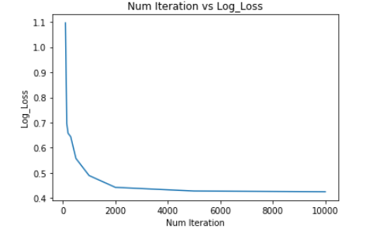

In addition, by plotting the curve between **Accuracy** vs. **Number of Iterations**, we can see that after around 800 iterations, the value of accuracy stabilizes. Therefore, we can choose any number of iterations larger than 800, but for the purpose of not creating extra computation time but and ensuring the loss function is also stabilized (around **2000**), we can pick **2000** as the number of iterations.

