Ma

Quantitative and Functional Imaging

BME 4420/7450

Project #6

Measuring arterial blood flow

The goal of this project is to measure blood flow in the aorta using phase contrast MRI data. As in the previous projects, you are free to get your results in some other way—these procedures are just one (not necessarily optimal) method. MATLAB commands are given in *italics* for easy reference. Use *help <command>* (for example, *help roipoly*) or the MATLAB Help pages for more details on any MATLAB function.

1. Load the data file proj6_arterialFlowData_qfi.mat into your MATLAB workspace. There are six variables in the file:

mag_3d An array (256 x 256 x 20) of magnitude images of a single slice through the aorta **for 20 time points (equally spaced in the cardiac cycle).**

phase_3d An array (256 x 256 x 20) of phase images, where **phase angle** is proportional to **spin velocity** (same pixel locations as in mag_3d).

time_v An array (1 x 20) of **time points** (in ms) at which the magnitude and phase data were acquired.

venc **Velocity (in cm/s) corresponding to a phase angle of /2 (the ‘encoding velocity’).**

dx Pixel size (in mm) in the x direction.

dy Pixel size (in mm) in the y direction.

The indices of the mag_3d and phase_3d arrays are (row, column, timeIndex). The individual images (the pages of the 3D arrays) are given in time order, i.e., phase_3d(:,:,1) is the first phase image, phase_3d(:,:,2) is the second, and so on.

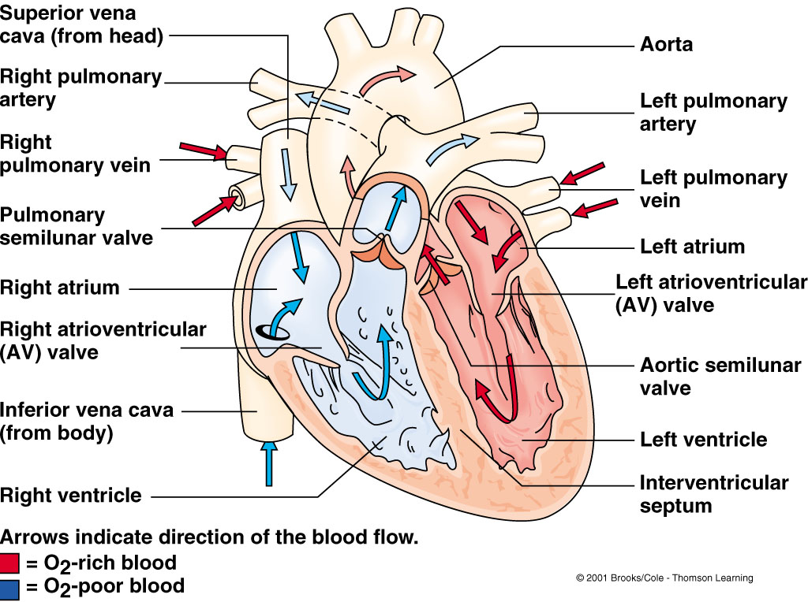

Approximate location of image slice

1. Calculate the **mean magnitude image** (over time) and display it.
2. Make a binary mask (a matrix of 1’s and 0’s) showing where **the mean image intensity (mean over times) is at least 10%** of the maximum pixel intensity. Call this matrix ‘bodyMask_m’.
3. Convert the magnetization phase angle to velocity using the equation



venc is the ‘**encoding’ velocity** (defined as the **velocity corresponding to a phase angle of $π/2$** ). The subscript indicates that the velocity is normal (i.e., orthogonal) to the imaging plane. Store the **velocities** in the array vz_3d.

1. Make a movie of blood flow versus time across the cardiac cycle:

*% Show a movie of velocity versus time. Red is flow toward head,*

*% blue is toward feet:*

*nTimes = length(time_v);*

*maxVz = max(vz_3d(:));*

*minVz = min(vz_3d(:));*

*figure*

*for timeIndex = 1:nTimes*

*imagesc(bodyMask_m .* vz_3d(:, :, timeIndex))*

*axis image*

*axis off*

*% Set color limits to visualize slow and fast flow:*

*set(gca, 'CLim', [minVz, maxVz]/2)*

*drawnow*

*m(timeIndex) = getframe;*

*end*

*nLoops = 2;*

*fps = 2; % Frames per second.*

*movie(m, nLoops, fps)*

Use your knowledge of anatomy and the movie to identify the

* **ascending aorta** (the vessel with largest **positive vz**) and
* **descending aorta** (the vessel with the most negative vz),
* the trunk of the **pulmonary arteries** and
* the **superior vena cava.** Label these in your **mean magnitude image**.

1. Calculate the maximum vz value at each pixel position and display it in an image:

*maxVz_m = max(vz_3d, [], 3);*

*figure;*

*imagesc(maxVz_m .* bodyMask_m)*

*axis image*

*axis off*

*colorbar*

*title('Maximum Vz across time')*

Use the command

*[aaMask_m, aaX_v, aaY_v] = roipoly;*

to define a mask for the ascending aorta (“*aa*”). Use the *line* command (with the variables aaX_v and aaY_v) to draw the boundary of your region of interest (you can control the **color** and **linewidth** of the bounding polygon with the ‘Color’ and ‘LineWidth’ attributes of the *line* command).

1. Repeat for the descending aorta. Start by calculating the **minimum vz** value at each pixel position and displaying it in an image. Use the command

*[daMask_m, daX_v, daY_v] = roipoly;*

to define a mask for the descending aorta (“*da*”) and use the *line* command to draw the outline of the vessel.

1. Calculate the mean blood velocity in the ascending and descending aorta (aaVz_v and daVz_v, respectively) as a function of time:

*nTimes = length(time_v);*

*aaVz_v = zeros(1, nTimes);*

*daVz_v = zeros(1, nTimes);*

*for timeIndex = 1:nTimes*

*% Insert your code to calculate the mean velocity*

*% in each vessel at the current time point:*

*aaVz_v(timeIndex) = …;*

*daVz_v(timeIndex) = …;*

*end*

Use the *plot* command to display aaVz_v and daVz_v as functions of time. Label your plot and add a figure legend with the *legend* command (don’t forget the units!).

1. The volume of blood flowing through the image plane in time *t* can be approximated using the expression



where *A* is the cross-sectional area of the vessel and  is the mean blood velocity (normal to the image plane). Calculate the total **volume of blood passing through the image plane over the entire cardiac cycle**, both for the ascending and descending aorta. **Name the variables for the ascending and descending volumes aaVol and daVol, respectively.**

1. Calculate the fractional difference between the ascending and descending aorta blood volumes. Express the result as a percentage:

*fracDiff = 100 * (aaVol – daVol) / aaVol;*

**For Graduate Credit (undergrad extra credit)**

1. **Measure blood velocity** in the **ascending aorta** as a function of **distance from the center of the vessel.** Use the data from the time point with **maximum mean velocity** in the aorta. One way to do this is to calculate the coordinates of the center of the vessel, then find the distance from each pixel in the vessel to the center. Average the **velocities of pixels** at similar distances to find the *mean velocity profile* as a function of radius from the center. Is the velocity profile parabolic in the ascending aorta when the flow rate is highest?

# Questions

1. What is the total volume of blood pumped through the ascending aorta in one cardiac cycle? What is the total volume passing through the descending aorta?
2. How does the total volume pumped through the ascending aorta compare to your results in Project 2? How should these quantities be related?
3. If the total volumes of blood flowing in the ascending and descending aorta are not the same, why do you think they are different? Where is the ‘missing’ blood flowing?

**For Graduate Credit (undergrad extra credit)**

1. Is the velocity profile parabolic at high flow rates?

# Assignment

Create a Word document that includes

1. A figure showing the mean magnitude image. Label the **superior vena cava**, the t**runk of the pulmonary** arteries, and the ascending and descending aorta.
2. **Both velocity maps** showing the outlines of the **ascending** and **descending** aorta.
3. Your plot of **mean velocity versus time for the ascending and descending aorta.**
4. Your plot of mean velocity versus radius in the ascending aorta (for graduate credit/undergrad extra credit).
5. Your answers to the questions above.
6. Your MATLAB code.

Please save your report as a PDF file, name it “Project6…” (adding your name), and submit it on Brightspace by Thursday, Nov. 17. Each group can submit one report—just make sure all group members are named on the report.

References

L. Sherwood, *Human Physiology: From Cells to Systems* (5th ed., Thomson; 2004).