NOZOMI: A GPU-Accelerated Monte-Carlo Numerical Approach for Microstructure Diffusion Imaging
TuanKhai NguyenTran^{1,2}, Mark D. Does^{1,2,3,4}, Kevin D. Harkins^{1,2,4}
¹Department of Biomedical Engineering, Vanderbilt University, Nashville, Tennessee, USA,
²Vanderbilt University Institute of Imaging Science, Nashville, Tennessee, USA,
³Department of Electrical Engineering, Vanderbilt University, Nashville, Tennessee, USA
⁴Department of Radiology and Radiological Sciences, Vanderbilt University Medical Center, Nashville, Tennessee, USA
Correspondence
Kevin D. Harkins,
Vanderbilt University Medical Center, Department of Radiology and Radiological Sciences, Nashville, TN 37240, USA.
Email: kevin.d.harkins@vumc.org

Funding information
National Institute of Biomedical Imaging and Bioengineering, Grant/Award Number: R01-EB031954
Word count: 3491
- ABSTRACT:
Purpose: To develop a computational framework for generating realistic white matter substrates for Monte Carlo diffusion MRI simulations that capture microstructure continuity across substrate boundaries.

Methods: A) A novel substrate generation algorithm was developed that ensures microstructure continuity across boundaries, by adding reciprocal axons for boundary-crossing items during substrate generation. B) A GPU-accelerated Monte Carlo diffusion simulation engine was included, with multi-threaded CUDA implementation and simulation domain segmentation for computational efficiency. C) Validation and calibration experiments were done to demonstrate geometric continuity, analytical agreement, and guide simulation configuration choices. D) Diffusion time dependent axial and radial diffusivity across substrates with varying mean axon diameters and orientation dispersions were evaluated to demonstrate the utility of the framework.

Results: The framework successfully constructed complex biomimetic white matter substrates achieving high packing densities with controlled diameter distributions, orientation dispersions, and beading. Monte-Carlo simulations revealed that, in both intra and extra-axonal spaces, axon diameter primarily influenced time-dependent radial diffusion, while fiber orientation dispersion primarily affected axial diffusion.

Conclusion: Compared to existing tools, the developed framework provides approximately 4 times faster substrate generation, while being the first 3D white matter simulation framework to implement periodic boundary conditions for Monte-Carlo simulations without effects of geometric discontinuity, to facilitate ground-truth controlled studies of microstructure-diffusion relationships.

Keywords: Monte Carlo simulation, diffusion MRI, diffusion time dependence, numerical phantoms, virtual histology, white matter microstructure
- INTRODUCTION:
Despite its clinical importance, the relationship between DWI measurements and underlying tissue microstructure remains unclear. Analytical models can provide closed form approximations to diffusion‑weighted measurements; however, these models can be mathematically complex and may not be valid for biologically realistic geometries that deviate from simple planes, spheres, and cylinders^{1–3}. One approach to bridge this gap is computational modeling of DWI signals combined with numerical substrates of characterized structures—especially Monte‑Carlo Diffusion Simulation (MCDS), which provides a powerful alternative for investigating DWI sensitivity to specific white matter (WM) microstructural features like axonal shape⁴, packing arrangements⁵, and compartment-specific diffusion characteristics^{6,7}. Early frameworks were developed to construct WM numerical phantoms and perform MCDS^{8–13}, including tools like MCell¹⁴, Camino^{15–17} and others with spherical, cylindrical, or 2D representations of WM microstructures^{18–22}. More recently, packages like MEDUSA²³, ConFiG²⁴, CACTUS²⁵, and CATERPillar²⁶ were introduced to better capture the complexity of 3D WM.
Still, boundary conditions imposed by existing tools can result in unrealistic WM geometries, cause microstructure discontinuities, and/or reduce computational efficiency of the simulation environment^{27,28}. Microstructure discontinuities can require simulation to sample molecules from only a central portion of the substrate^{15,17,29}, thereby reduces the usable phantom volume, as in Figure 1 middle row. A mirroring/reflective boundary condition has been combined with the central portion sampling approach above to ensure geometric continuity^{5,26,29,30}, as in RMS³¹, MEDUSA²³, and CATERPillar²⁶, in which the numerical phantom is extended by its reflective copies across substrate boundaries^{4,5,30}, as in Figure 1 bottom row. However, this results in unrealistic WM structures and causes the original substrate to be 2x times larger in each spatial dimension²⁷, increasing computational complexity.
This study addresses these limitations by introducing NOZOMI (Numerically OptimiZed periOdic Microstructures for diffusion Imaging)—a three-dimensional computational framework for a) building axonal substrates that ensure geometric continuity across substrate boundaries, and b) enabling GPU-accelerated multi-compartment MCDS for microstructure imaging studies. NOZOMI preserves geometric continuity with periodic boundary conditions (PBC), a technique previously demonstrated in 2D diffusion simulations^{7,8,17,32}, but to date unrealized for 3D WM phantoms. PBC effectively expands the finite phantom to an infinite domain¹⁷, and maintains geometric continuity for both intra- and extra-axonal environments. Motivated by previous WM studies of diffusion-time dependent measurements^{5–7,33–44}, we demonstrate NOZOMI’s utility to create complex arenas of periodically-bounded substrates and provide a preliminary investigation on the influence of microstructure variations on time-dependent diffusion measurements in both intra-and extra-axonal spaces.
- METHODS:

Substrate Generation Procedure:
NOZOMI generates 3D WM substrates by modeling axons as chains of overlapping spheres within a Cartesian coordinate domain. Each substrate is characterized by key microstructural parameters including axon diameter distribution, orientation dispersion, volume fraction, and beading. Substrate design parameters are detailed in Table 1. The generation process ensures PBC across all simulation boundaries to maintain geometric continuity for MCDS and consists of three stages: Initialization, Axon Meshing, and Geometric Optimization, as in Figure 2.
Stage 1: Initialization: (Figure 2A) Given an axonal volume fraction $V_{in}$ and the number of axons, axon diameters are sampled from a generalized extreme value (GEV) distribution⁴⁵. Similar to 2D PBC substrates^{7,17,46,47}, 3D substrates encapsulates PBC at the $x$-, $y$-boundaries by replicating axons that cross or are near $x$-, $y$-boundaries onto the opposite boundary (Figure 2A, middle panel). Axon start points are seeded at the bottom of the simulation cube, while axon end points are determined by sampling the axons’ orientation from a Watson distribution with concentration parameter $κ$ ^{48–50}. To ensure PBC in the $z$-direction, a reciprocal axon is added whose start/end points are derived from the end/start points of the original axon (Figure 2A, right panel). Since each axon needs a reciprocal axon to achieve PBC in 3D, axons’ start/end points are projected on the 2D $xy$-plane as pairs of disks. Then, illustrated by Figure 2A left and middle panels, overlaps are fully removed by a limited-memory Broyden-Fletcher-Goldfarb-Shanno (L-BFGS) iterative algorithm^{51,52} outlined in Supporting Information.
Stage 2: Axon Meshing: (Figure 2B) NOZOMI meshes each axon as a set of overlapping spheres⁵³, spaced at half the axon's radius^{25,29,54,55}. The current study assumes negligible myelin influence^{35,56,57} including myelin water and thickness⁷, although future studies on myelin effects could be considered if necessary. Longitudinal variation in axon diameter, or beading, is controlled by distributions on bead amplitude $R_{amp}\sim N\left(μ_{R_{amp}},σ_{R_{amp}}^{2}\right)$ and bead spacing $Lognormal \left(μ_{spacing}, σ_{spacing}^{2}\right)$, demonstrated in this work with values from histology-informed studies^{4,40}.
Stage 3: Geometric Optimization: (Figure 2C) After meshing, overlaps between spheres of different axons are removed with an L-BFGS procedure inspired by previous works^{25,55} that balances overlap removal, curvature regularization, and length preservation. The algorithm terminates when no overlaps remain. Details of this procedure are included in Supporting Information.

Monte-Carlo Diffusion Simulation:
Three-dimensional Brownian motion of random walkers is discretized into multiple timesteps where molecular diffusion is subjected to interactions with substrate’s geometric boundaries. Intra- and extra-axonal compartments are modeled with distinct intrinsic diffusivities.

Acceleration Strategy
Multi-thread GPU Parallelization: Computations are performed on an NVIDIA RTX A5000 GPU with an AMD EPYC 7513 32-core CPU. Substrate generation and optimization utilizes PyTorch, while Monte-Carlo diffusion simulation is accelerated using PyCUDA gpuarray with a multi-threaded CUDA engine.
Simulation Domain Segmentation: In simulation, collision detection of each molecule with all spheres in the domain is computationally expensive. An acceleration approach inspired from ray-tracing^{58,59} is used to partition the domain along the $x$-, $y$-, $z$-directions into a 3D grid of segments. A segmentation table is precomputed to cache all the spheres belonging to each segment, thus limiting collision detection to the spheres inside a local segment.

Simulation Pipeline
Step 1: Initialization: To study compartment-specific diffusion characteristics, molecule positions are randomly initialized into specific compartments, i.e. intra- or extra-axonal, with their initial locations stored for later calculation of overall displacements.
Step 2: Simulation loop: Trajectory tracking for each molecule is handled by a CUDA thread. Molecular interactions with impermeable membrane boundaries are modeled using a multi-step collision detection algorithm. For each time step, the algorithm first generates a normally distributed 3D displacement vector with standard deviation $\sqrt{2D_{0}∙dt}$.
Step 2.1: Molecule-Membrane Interaction Search: Subsequently, the algorithm evaluates potential membrane interactions by computing collision distances between the molecule jump trajectory and all spheres within the localized simulation segment, and identifying the sphere(s) that the molecule interacts with. To find where the molecule intersects the sphere, an analytic ray-sphere intersection equation is used. Details are included in Supporting Information.
Step 2.2: Molecule-Membrane Interaction: For this work, exchange between the intra and extra-axonal compartments is assumed to be negligible^{60,61}, with axon membranes acting as impermeable barriers. When a molecule approaches a membrane, its step is truncated, the molecule scatters, and the remaining jump distance is scaled to preserve Brownian motion variance. Conversely, if no membrane is encountered, the molecule continues in its initial direction.
Step 2.3: Advance the molecule: The molecule proceeds based on the calculated jump trajectory. Step 2.1 repeats until the remaining jump is less than a tolerance.
Step 3: Molecule-Boundary Interaction: The substrate boundary is periodic such that molecules that leave a substrate edge will re-enter on the opposite side. When such a periodic wrap occurs, the molecule’s initially seeded location is updated for accurate displacement calculation.
Step 4: Calculate Diffusion Coefficient: The time-dependent diffusion coefficient per-direction is calculated, from the mean squared displacement
$$\begin{aligned}D_{d}\left(t\right)=\frac{〈{\left[{\left(r\left(t\right)-r\left(0\right)\right)}^{\text{T}}∙d\right]}^{2}〉}{2∙t},\#[1]\end{aligned}$$
where $r$ is the position vector and $d$ is the direction vector diffusion is being measured. This is equivalent to the apparent diffusion coefficient from DWI in the Gaussian phase distribution and short gradient pulse approximation. Axial Diffusivity ($D_{∥}$)^{5,30} and Radial Diffusivity ($D_{⊥}$)^{4,6,30} are both investigated, which represent diffusivity longitudinal and perpendicular to the main direction of the fiber section, respectively. $D_{∥}$ is calculated from displacements along $z$-axis, and $D_{⊥}$ is calculated from the average of $x$- and $y$-axis displacements,
$$\begin{aligned}D_{∥}\left(t\right)=D_{z}\left(t\right), D_{⊥}\left(t\right)=\frac{D_{x}\left(t\right)+D_{y}\left(t\right)}{2}.\#[2, 3]\end{aligned}$$

Simulation Validation and Calibration:
A set of experiments was defined to evaluate the reliability, accuracy, precision, and computation time of the developed MCDS framework:
Free diffusion in an empty simulation arena: All molecules should remain inside the simulation arena, and the estimated diffusion coefficient should be approximately equal to the free diffusivity $D_{0}$.
Intra- and extra-axonal compartmentation: Axons are represented as a set of spheres, molecules inside axons do not pass outside, and vice versa.
Periodic boundary conditions in $x$, $y$, $z$: Fibers spanning $z$- and crossing the boundary in the $x$- or $y$-direction were created. At the end of simulation, all molecules should remain in the compartment initially assigned.
Number of Molecules and Time Step Calibration: As established previously^{17,20,62,63}, this optimizes the molecule number and simulation time step configuration to trade off accuracy, precision, and computation time. Simulations were performed for combinations of $dt$ = 0.0001, 0.0002, 0.0005, 0.001, 0.002, 0.005, 0.01 ms and $N_{molecules}$ = 10⁴, 5×10⁴, 10⁵, 5×10⁵, 10⁶. An analytical solution for intra-axonal diffusion perpendicular to the cylinder^{3,35,64} under the Gaussian Phase Approximation (GPA)^{1,2,65} was used to validate our numerically-simulated MCDS. In contrast, no analytical expression exists for extra-axonal water diffusion due to the geometrically complex and tortuous nature of extra-axonal space. A calibration substrate consisting of a cylinder built from overlapping spheres with radius 0.5 μm was used, with intrinsic intra-axonal diffusivity of $D_{0,i}=$ 2.0 μm²/ms. Diffusion time was 100 ms. Accuracy was quantified via the mean absolute error (MAE) between the MCDS-derived radial diffusivity $D_{⊥, MC}$, and known analytical solution $D_{⊥, GPA}$ for radial diffusion inside a perfect cylinder^{3,35,64}, calculated as
$$\begin{aligned}MAE=\frac{1}{N_{reps}}\sum_{k=1}^{N_{reps}}{\frac{1}{N_{t}}\sum_{i=1}^{N_{t}}{{|D}_{⊥, MC}\left(t_{i}\right)-D_{⊥, GPA}\left(t_{i}\right)|}},\#[4]\end{aligned}$$
where $N_{reps}$ is the number of simulation repetitions, and $N_{t}$ is the number of time steps. Both $D_{⊥}$ metrics are in the narrow-pulse regime. Precision was quantified as the standard deviation of MAE from 10 repetitions for each molecule-number / time-step combination. A low standard deviation guarantees reproducibility of our simulated metrics. To validate diffusion behavior across all time scales, $D_{⊥, MC}$ and $D_{⊥, GPA}$ will be presented alongside the long-time asymptotic limit $D_{⊥, t→∞ }\left(t\right)≈a^{2}/4t$ (as derived in Eq. C.2, and Figure C.1. of ³⁵), and $D_{⊥,t→0}\left(t\right)$ to illustrate the short-time surface-to-volume ratio regime.
Simulation Domain Segmentation Calibration: The influence of segmentation number on computation time and reproducibility of simulated metrics was evaluated. A substrate was generated with 2236 fibers, GEV-distributed $\overline{d}$ of 1.75 μm, $κ$ = 200, and $V_{in}$ = 66%. 5×10⁵ molecules were simulated with a time step of 0.002 ms and up to a diffusion time of 100 ms, for both the intra- and extra-axonal compartments. Here, $D_{0,i}=$ 2.25 μm²/ms ⁶⁶, and $D_{0,e}$ = 2.0 μm²/ms ⁶⁷. $D_{∥}\left(t\right)$ and $D_{⊥}\left(t\right)$ were calculated assuming narrow-pulse and low b-value diffusion weighting. The simulation domain was partitioned into 5, 10, 25, 20, 25, 30, or 35 segments along the $x$-, $y$-, $z$-axes.

Technical Demonstration:
To demonstrate the developed framework, we a) evaluate the biophysical properties of NOZOMI substrates, and b) investigate the influence of microstructure variations in $\overline{d}$ and $κ$ on the diffusion-time-dependent $D_{∥}$ and $D_{⊥}$. Substrates representing healthy WM with orientationally-coherent and dispersed fibers were created, with different $\overline{d}$ of 1.68 $±$ 0.45, 2.58 $±$ 0.69, 3.5 $±$ 0.94, and 4.5 $±$ 1.20 μm spanning diameter ranges observed in previous studies of macaque brain⁶⁸, human brain^{69–71}, rat WM tracts⁷², and human spinal cord^{73,74}. Axon orientation was varied with $κ$ = [10, 20, 200], due to its variations across the brain⁷⁵ and spinal cord³⁸. Target $V_{in}$ was 0.65. Axonal beading amplitude and spacing were held constant across all substrates. To account for sampling variability inherent in simulations that results in varying substrate properties even with identical design parameters, 4 repetitions of substrate generation and MCDS were done for each combination of $\overline{d}$ and $κ$. Simulation settings were chosen similar to the Segmentation Calibration.
- RESULTS:

Simulation Validation and Calibration:

Geometric Continuity:
Given zero-permeability axon membranes, Figure 3A validates that molecules remained inside a periodically-wrapped axon.

Molecule Number and Time Step Calibration:
Mean computation time for each molecule number / time step combination is shown in Figure 3B. Figure 3C demonstrates lower MAE at smaller time steps as well as lower variability with increasing number of molecules. From Figure 3B and 3C, a configuration of 5 × 10⁵ molecules and a 0.002 ms time step was selected as the optimal trade-off between accuracy, precision, and computational efficiency—achieving an MAE of 7×10⁻⁵ $±$ 1.48×10⁻⁶ µm²/ms. This agrees with previous studies where ~10⁵ molecules^{8,32,35,36,76,77} and time step of ~0.001 – 0.005 ^{39,62,77,78} were used.
Figure 3D demonstrates agreement between the $D_{⊥,GPA}\left(t\right)$(blue) and MCDS-simulated $D_{⊥,MC}\left(t\right)$(red), here for a smaller time step of 0.0001 ms to illustrate the diffusion time range over which our MCDS framework remains accurate, even though using a larger step of 0.002 ms shows comparable MAE and standard deviation (Figure 3C). It is worth noting that, while this experiment is limited to an analytical solution for intra-axonal diffusion, our validation provides confidence in the underlying framework to study both intra- and extra-axonal diffusion using the same Monte Carlo principles. In addition, while we acknowledge the analytical model represents an approximation rather than an absolute reference standard, it provides a tool to identify molecules/time step combinations where simulation performance is poor.

Simulation Domain Segmentation Calibration
For our design, the total computation time consists of the tabulation time—the time to precompute the segmentation table—and the simulation time, where molecule-membranes interactions are modeled. Figure 4 demonstrates how total computation, simulation, and tabulation time vary with the number of segments. Result shows that 20 - 25 segments along each of the $x$-, $y$-, $z$-axis is the optimal range for total computation time. The plots on the right demonstrate high reproducibility for both $D_{∥}$ (top) and $D_{⊥}$ (bottom). The curves show values averaged across all segment choices, with standard deviations normalized by compartmental intrinsic diffusivity yielding 0.15% for $D_{∥}$ and 0.04% for $D_{⊥}$.

Technical Demonstration

Numerical Substrate Properties
Similar to earlier results⁷⁹, axon diameter distribution, coefficient of variation (CV), and along axon diameter variations comparable to previously observed in mice^{4,5,40} and humans³⁰ microscopy are shown in Figure S1 and S2. Figure S3 shows different degrees of Fiber Orientation Distribution (FOD) achieved.

Diffusion-Time Dependence Experiments
Axial Diffusivity $D_{∥}$:
Figure 5 shows normalized $D_{∥}$ for both intra- and extra-axonal water as a function of $1/\sqrt{t}$, to demonstrate the characteristic power-law relationship^{37,80}, with the range in 0.1 - 1.0 ms^{-1/2} corresponding to diffusion time of 1 - 100 ms.
Orientation-dependent effects: Overall, higher orientation dispersions reduce $D_{∥}$. This agrees with previous studies investigating diffusion inside axons segmented from electron microscopy⁵, showing a decrease in $D_{∥}$ with increasing Watson distributed dispersion angles. Additionally, our study shows that orientation dispersion also influences extra-axonal diffusion, with higher dispersion reducing $D_{∥}$in the extra-axonal space.
Along-axon diameter variation effects: Longitudinal variation in axon diameter also contributes to axial diffusivity changes. With our design to fix axonal beading amplitude and bead spacing across all substrates, beading causes proportionally stronger restrictions in smaller diameter axons, reflected by lower $D_{∥}$ at $1/\sqrt{t}≈$ 0.1 ms^{-1/2} or $t≈$ 100 ms.
Radial Diffusivity $D_{⊥}$:
Figure 6 shows $D_{⊥}$ with respect to diffusion time $t$. Note the differences in the $y$-axis scale for Figure 5 and 6.
Diameter-dependent effects: Figure 6 demonstrates that $D_{⊥}\left(t\right)$ in substrates with smaller axons disperse towards the asymptotic limit faster than substrates with larger axons. This behavior is observed for both the intra-axonal space, which asymptotes to zero due to the restrictive nature of diffusion inside axons, as well as for extra-axonal space, where water diffusion is hindered and asymptotes to a value greater than zero. It is worth noting that at diffusion times 1-10 ms, $D_{⊥}$ profiles reflect separate values for substrates with different $\overline{d}$, whereas at 70-100 ms such differences are not clearly seen. Thus, further simulations can design gradient pulses to target short diffusion times that maximize such microstructural contrast.
Orientation-dependent effects: In addition to diameter-dependent effects, our study adds insights on the influence of orientation dispersion towards the asymptotic limit at the long diffusion time tail. Looking across different orientation dispersions in the intra-axonal compartment for each mean diameter (Figure 6, middle row), lower orientation dispersion leads to faster decay of $D_{⊥, i}$ and lower asymptotic values, reflecting the more spatially-constrained intra-axonal space. Conversely, in the extra-axonal space (Figure 6, bottom row), higher orientation dispersion results in faster decay of $D_{⊥, e}$ to asymptotic values. Despite this effect on $D_{⊥, e}$ being less pronounced compared to $D_{⊥, i}$, such signature can be attributed to enhanced tortuosity and geometric complexity created by intersecting fiber directions. Collectively, opposite responses of $D_{⊥, e}$ and $D_{⊥, i}$ stemming from the same orientation changes might indicate a compensatory relationship between the two compartments as the tissue trends towards being more dispersed, and can provide insights for diffusion-time dependent multi-compartment modeling for separating these compensatory responses.
- DISCUSSION

Technical Innovation with Periodic Boundary Condition Design
Ex vivo microscopy have enabled reconstruction of complex 2D^{72,81} and 3D^{4,5,82,83} axon geometries for MCDS. However, this involves labor-intensive segmentation⁴⁰, susceptibility to shrinkage^{16,84}, and alterations^{30,85,86} due to chemical preparation. NOZOMI offers a fast, inexpensive and complementary alternative via numerical bio-mimicking substrates. To our knowledge, NOZOMI is the first toolbox for three-dimensional substrate generation and diffusion simulation to include 3D periodic boundary conditions, which maintains microstructure continuity while alleviating a) the computational cost from generating oversized substrates then using only central portions for simulation, and b) geometric distortions from the mirroring boundary. Importantly, our design does not compromise substrate quality, as NOZOMI still achieves packing densities of approximately 70% and microstructural realism comparable to existing MEDUSA, ConFiG, and CATERPillar frameworks.

Algorithmic Convergence and Computational Efficiency
While MEDUSA achieves remarkable computational efficiency, its repulsion-based stopping criterion²³ can leave residual inter-fiber overlaps that may bias molecule-membrane interactions during MCDS. Alternatively, growth-based frameworks (e.g., ConFiG, CATERPillar) and ultra-high-density approaches (CACTUS) can require > 6 hours runtimes due to computationally intensive growth/overlap-removal steps. In contrast to previous methods, NOZOMI's enables periodic boundary condition handling and computational efficiency, requiring only ~1.5 hours for a 69 μm³ substrate of ~2000 fibers, combined with accelerated MCDS via optimized domain segmentation with a cached segmentation table to reduce diffusion-interaction checks.

Microstructure Insights from Time-Dependent Simulations
Diffusion-time-dependent DWI offers new microstructural insights beyond conventional single long-diffusion-time measurements, where only the asymptotic behavior is captured and important restriction effects are course-grained^{87,88}.
Diffusion time dependence in the extra-axonal space: Broadly, diffusion time dependence is observed in both compartments, where $D_{∥}\left(t\right)$ and $D_{⊥}\left(t\right)$ decrease with diffusion time. In extra-axonal space, the time dependence found agrees with previous studies confirming that non-Gaussian diffusion exists even in the space surrounding axons due to random packing geometry^{6,35,36,67,80}. In addition, since extra-axonal space’ contribution to diffusion measurements has been reported to be non-negligible^{5,7,35–37,40,89}, our findings show NOZOMI’s potential to supplement existing multi-compartment modeling frameworks^{16,90} and simulation studies^{5,83} that have not previously accounted for extra-axonal diffusion time dependence.
For $D_{∥}\left(t\right)$, our simulated intra-axonal $D_{∥}\left(t\right)$ demonstrates a range that corresponds to the established $1/\sqrt{t}$ scaling relationship^{5,37,80,82}, confirming the expected intra-axonal time-dependent $D_{∥}$, thus provides confidence for future time-dependent microstructure studies using our simulation framework.
For $D_{⊥}$, earlier studies such as AxCaliber⁹⁰, ActiveAx¹⁶ and others^{6,7,33,34,91} have shown the feasibility of mapping axon diameter with diffusion time dependence. Our sigmoidal diameter-dependent $D_{⊥}$ reaching asymptotic behavior more rapidly for smaller axons confirms the expected inverse relationship between restriction effects and compartment size⁸⁸, agrees with a separate frequency-dependent simulation experiment spanning short and long diffusion time regimes⁹², and aligns with a previous temporal diffusion spectroscopy study in rat spinal cord showing axon diameter’s influence on both intra and extra-axonal frequency-dependence diffusion^{67,72}.
Design rationale on capturing Orientation Dispersion versus Undulation: Our 100 ms diffusion time result in a $\sqrt{2Dt}$ ≈ 21 μm $z$-direction mean squared displacement, smaller than the substrate dimensions of 69 μm. Thus, the PBC primarily facilitates sampling orientation dispersion effects rather than axon undulation, since molecules will not periodically cross the $z$-boundaries multiple times. NOZOMI can be adapted to probe axon undulation or tortuosity by using longer diffusion times or smaller substrates.

Limitations and Future Directions
Several limitations of the current NOZOMI implementation should be acknowledged. Unlike fiber growth-based approaches such as ConFiG and CATERPillar that incorporate biologically motivated rules and biological features such as glial cells implemented in other frameworks^{26,54}, NOZOMI's sphere-packing prioritizes computational efficiency over fiber interactions in substrate development. Additionally, while the current PBC design models isotopically-dispersed single WM fiber populations, future developments will be needed for complex crossing or fanning fibers prevalent across the brain⁷⁵. Finally, although NOZOMI's computational scalability to larger substrates for improved simulation accuracy^{25,62,93} remains to be systematically evaluated, substrates with sufficient complexity for our simulation purposes should remain feasible on consumer hardware.
- CONCLUSION
NOZOMI is the first 3D WM numerical phantom generation and MCDS framework to use periodic boundary conditions to address artificial restrictions associated with geometric discontinuities. Our diffusion-time-dependent experiments demonstrated NOZOMI’s potential to facilitate ground-truth controlled studies for investigating microstructural contributions to DWI measurements and to enhance clinical interpretation of DWI.
- CODE AVAILABILITY STATEMENT
NOZOMI source code is available at https://doi.org/10.5281/zenodo.18809114.
- ACKNOWLEDGEMENTS
The author would like to acknowledge Dr. Kurt Schilling and Dr. Adam Anderson for discussions on spherical harmonics, Dr. Junzhong Xu for boundary conditions and simulation discussions, and Ngoc N. Tran for optimization guidance.

- REFERENCES
1. Neuman CH. Spin echo of spins diffusing in a bounded medium. The Journal of Chemical Physics. 1974;60(11):4508-4511. doi:10.1063/1.1680931
2. Vangelderen P, Despres D, Vanzijl PCM, Moonen CTW. Evaluation of Restricted Diffusion in Cylinders. Phosphocreatine in Rabbit Leg Muscle. Journal of Magnetic Resonance, Series B. 1994;103(3):255-260. doi:10.1006/jmrb.1994.1038
3. Callaghan PT. Pulsed-Gradient Spin-Echo NMR for Planar, Cylindrical, and Spherical Pores under Conditions of Wall Relaxation. Journal of Magnetic Resonance, Series A. 1995;113(1):53-59. doi:10.1006/jmra.1995.1055
4. Lee HH, Jespersen SN, Fieremans E, Novikov DS. The impact of realistic axonal shape on axon diameter estimation using diffusion MRI. NeuroImage. 2020;223:117228. doi:10.1016/j.neuroimage.2020.117228
5. Lee HH, Papaioannou A, Kim SL, Novikov DS, Fieremans E. A time-dependent diffusion MRI signature of axon caliber variations and beading. Commun Biol. 2020;3(1):1. doi:10.1038/s42003-020-1050-x
6. Grussu F, Ianuş A, Tur C, et al. Relevance of time‐dependence for clinically viable diffusion imaging of the spinal cord. Magn Reson Med. 2019;81(2):1247-1264. doi:10.1002/mrm.27463
7. Harkins KD, Beaulieu C, Xu J, Gore JC, Does MD. A simple estimate of axon size with diffusion MRI. NeuroImage. 2021;227:117619. doi:10.1016/j.neuroimage.2020.117619
8. Harkins KD, Does MD. Simulations on the influence of myelin water in diffusion-weighted imaging. Phys Med Biol. 2016;61(13):4729. doi:10.1088/0031-9155/61/13/4729
9. Fieremans E, Novikov DS, Jensen JH, Helpern JA. Monte Carlo study of a two-compartment exchange model of diffusion. NMR Biomed. 2010;23(7):711-724. doi:10.1002/nbm.1577
10. Balls GT, Frank LR. A simulation environment for diffusion weighted MR experiments in complex media. Magnetic Resonance in Medicine. 2009;62(3):771-778. doi:10.1002/mrm.22033
11. Budde MD, Frank JA. Neurite beading is sufficient to decrease the apparent diffusion coefficient after ischemic stroke. Proceedings of the National Academy of Sciences. 2010;107(32):14472-14477. doi:10.1073/pnas.1004841107
12. Neher PF, Laun FB, Stieltjes B, Maier-Hein KH. Fiberfox: Facilitating the creation of realistic white matter software phantoms. Magnetic Resonance in Medicine. 2014;72(5):1460-1470. doi:10.1002/mrm.25045
13. Lin M, He H, Schifitto G, Zhong J. Simulation of changes in diffusion related to different pathologies at cellular level after traumatic brain injury. Magnetic Resonance in Medicine. 2016;76(1):290-300. doi:10.1002/mrm.25816
14. Stiles JR, Van Helden D, Bartol TM, Salpeter EE, Salpeter MM. Miniature endplate current rise times less than 100 microseconds from improved dual recordings can be modeled with passive acetylcholine diffusion from a synaptic vesicle. Proc Natl Acad Sci USA. 1996;93(12):5747-5752. doi:10.1073/pnas.93.12.5747
15. Cook PA, Bai Y, Nedjati-Gilani S, et al. Camino: Open-Source Diffusion-MRI Reconstruction and Processing.
16. Alexander DC, Hubbard PL, Hall MG, et al. Orientationally invariant indices of axon diameter and density from diffusion MRI. NeuroImage. 2010;52(4):1374-1389. doi:10.1016/j.neuroimage.2010.05.043
17. Hall MG, Alexander DC. Convergence and parameter choice for Monte-Carlo simulations of diffusion MRI. IEEE Trans Med Imaging. 2009;28(9):1354-1364. doi:10.1109/TMI.2009.2015756
18. Sen PN, Basser PJ. A Model for Diffusion in White Matter in the Brain. Biophys J. 2005;89(5):2927-2938. doi:10.1529/biophysj.105.063016
19. Baxter GT, Frank LR. A computational model for diffusion weighted imaging of myelinated white matter. Neuroimage. 2013;75:204-212. doi:10.1016/j.neuroimage.2013.02.076
20. Landman BA, Farrell JAD, Smith SA, Reich DS, Calabresi PA, van Zijl PCM. Complex geometric models of diffusion and relaxation in healthy and damaged white matter. NMR in Biomedicine. 2010;23(2):152-162. doi:10.1002/nbm.1437
21. Szafer A, Zhong J, Gore JC. Theoretical Model for Water Diffusion in Tissues. Magnetic Resonance in Medicine. 1995;33(5):697-712. doi:10.1002/mrm.1910330516
22. Ford JC, Hackney DB. Numerical model for calculation of apparent diffusion coefficients (ADC) in permeable cylinders—comparison with measured ADC in spinal cord white matter. Magnetic Resonance in Medicine. 1997;37(3):387-394. doi:10.1002/mrm.1910370315
23. Ginsburger K, Matuschke F, Poupon F, Mangin JF, Axer M, Poupon C. MEDUSA: A GPU-based tool to create realistic phantoms of the brain microstructure using tiny spheres. NeuroImage. 2019;193:10-24. doi:10.1016/j.neuroimage.2019.02.055
24. Callaghan R, Alexander DC, Palombo M, Zhang H. ConFiG: Contextual Fibre Growth to generate realistic axonal packing for diffusion MRI simulation. NeuroImage. 2020;220:117107. doi:10.1016/j.neuroimage.2020.117107
25. Villarreal-Haro JL, Gardier R, Canales-Rodríguez EJ, et al. CACTUS: a computational framework for generating realistic white matter microstructure substrates. Front Neuroinform. 2023;17:1208073. doi:10.3389/fninf.2023.1208073
26. Nguyen-Duc J, Brammerloh M, Cherchali M, et al. CATERPillar: a flexible framework for generating white matter numerical substrates with incorporated glial cells. Medical Image Analysis. 2026;110:103946. doi:10.1016/j.media.2026.103946
27. Fieremans E, Lee HH. Physical and numerical phantoms for the validation of brain microstructural MRI: A cookbook. NeuroImage. 2018;182:39-61. doi:10.1016/j.neuroimage.2018.06.046
28. Russell G, Harkins KD, Secomb TW, Galons JP, Trouard TP. A finite difference method with periodic boundary conditions for simulations of diffusion-weighted magnetic resonance experiments in tissue. Physics in medicine and biology. 2012;57(4):N35. doi:10.1088/0031-9155/57/4/N35
29. Callaghan R, Alexander DC, Palombo M, Zhang H. ConFiG: Contextual Fibre Growth to generate realistic axonal packing for diffusion MRI simulation. NeuroImage. 2020;220:117107. doi:10.1016/j.neuroimage.2020.117107
30. Lee HH, Tian Q, Sheft M, et al. The effects of axonal beading and undulation on axonal diameter estimation from diffusion MRI: Insights from simulations in human axons segmented from three-dimensional electron microscopy. NMR in Biomedicine. 2024;37(4):e5087. doi:10.1002/nbm.5087
31. Lee HH, Fieremans E, Novikov DS. Realistic Microstructure Simulator (RMS): Monte Carlo simulations of diffusion in three-dimensional cell segmentations of microscopy images. Journal of Neuroscience Methods. 2021;350:109018. doi:10.1016/j.jneumeth.2020.109018
32. Fieremans E, De Deene Y, Delputte S, et al. Simulation and experimental verification of the diffusion in an anisotropic fiber phantom. Journal of Magnetic Resonance. 2008;190(2):189-199. doi:10.1016/j.jmr.2007.10.014
33. Tétreault P, Harkins KD, Baron CA, Stobbe R, Does MD, Beaulieu C. Diffusion time dependency along the human corpus callosum and exploration of age and sex differences as assessed by oscillating gradient spin-echo diffusion tensor imaging. Neuroimage. 2020;210:116533. doi:10.1016/j.neuroimage.2020.116533
34. Warner W, Palombo M, Cruz R, et al. Temporal Diffusion Ratio (TDR) for imaging restricted diffusion: Optimisation and pre-clinical demonstration. NeuroImage. 2023;269:119930. doi:10.1016/j.neuroimage.2023.119930
35. Burcaw LM, Fieremans E, Novikov DS. Mesoscopic structure of neuronal tracts from time-dependent diffusion. NeuroImage. 2015;114:18-37. doi:10.1016/j.neuroimage.2015.03.061
36. De Santis S, Jones DK, Roebroeck A. Including diffusion time dependence in the extra-axonal space improves in vivo estimates of axonal diameter and density in human white matter. NeuroImage. 2016;130:91-103. doi:10.1016/j.neuroimage.2016.01.047
37. Fieremans E, Burcaw LM, Lee HH, Lemberskiy G, Veraart J, Novikov DS. In vivo observation and biophysical interpretation of time-dependent diffusion in human white matter. NeuroImage. 2016;129:414-427. doi:10.1016/j.neuroimage.2016.01.018
38. Jespersen SN, Olesen JL, Hansen B, Shemesh N. Diffusion time dependence of microstructural parameters in fixed spinal cord. NeuroImage. 2018;182:329-342. doi:10.1016/j.neuroimage.2017.08.039
39. Aggarwal M, Smith MD, Calabresi PA. Diffusion-time dependence of diffusional kurtosis in the mouse brain. Magnetic Resonance in Medicine. 2020;84(3):1564-1578. doi:10.1002/mrm.28189
40. Lee HH, Yaros K, Veraart J, et al. Along-axon diameter variation and axonal orientation dispersion revealed with 3D electron microscopy: implications for quantifying brain white matter microstructure with histology and diffusion MRI. Brain Struct Funct. 2019;224(4):1469-1488. doi:10.1007/s00429-019-01844-6
41. Horsfield MA, Barker GJ, McDonald WI. Self-diffusion in CNS tissue by volume-selective proton NMR. Magnetic Resonance in Medicine. 1994;31(6):637-644. doi:10.1002/mrm.1910310609
42. Clark CA, Hedehus M, Moseley ME. Diffusion time dependence of the apparent diffusion tensor in healthy human brain and white matter disease. Magnetic Resonance in Medicine. 2001;45(6):1126-1129. doi:10.1002/mrm.1149
43. Dan G, Sun K, Luo Q, Zhou XJ. Time-dependent diffusion MRI using multiple stimulated echoes. Magnetic Resonance in Medicine. 2023;90(3):910-921. doi:10.1002/mrm.29677
44. Aggarwal M, Jones MV, Calabresi PA, Mori S, Zhang J. Probing Mouse Brain Microstructure Using Oscillating Gradient Diffusion Magnetic Resonance Imaging. Magn Reson Med. 2012;67(1):98-109. doi:10.1002/mrm.22981
45. Sepehrband F, Alexander DC, Clark KA, Kurniawan ND, Yang Z, Reutens DC. Parametric Probability Distribution Functions for Axon Diameters of Corpus Callosum. Front Neuroanat. 2016;10. doi:10.3389/fnana.2016.00059
46. Russell G, Harkins KD, Secomb TW, Galons JP, Trouard TP. A finite difference method with periodic boundary conditions for simulations of diffusion-weighted magnetic resonance experiments in tissue. Phys Med Biol. 2012;57(4):N35. doi:10.1088/0031-9155/57/4/N35
47. Xu J, Does MD, Gore JC. Numerical study of water diffusion in biological tissues using an improved finite difference method. Phys Med Biol. 2007;52(7):N111-N126. doi:10.1088/0031-9155/52/7/N01
48. Zhang H, Schneider T, Wheeler-Kingshott CA, Alexander DC. NODDI: practical in vivo neurite orientation dispersion and density imaging of the human brain. Neuroimage. 2012;61(4):1000-1016. doi:10.1016/j.neuroimage.2012.03.072
49. Watson GS. Equatorial Distributions on a Sphere. Biometrika. 1965;52(1/2):193-201. doi:10.2307/2333824
50. Mardia KV, Jupp PE. Directional Statistics. John Wiley & Sons; 2009.
51. Nocedal J, Wright SJ. Numerical Optimization. Springer; 1999.
52. Liu DC, Nocedal J. On the limited memory BFGS method for large scale optimization. Mathematical Programming. 1989;45(1):503-528. doi:10.1007/BF01589116
53. Altendorf H, Jeulin D. Random-walk-based stochastic modeling of three-dimensional fiber systems. Phys Rev E Stat Nonlin Soft Matter Phys. 2011;83(4 Pt 1):041804. doi:10.1103/PhysRevE.83.041804
54. Ginsburger K, Matuschke F, Poupon F, Mangin JF, Axer M, Poupon C. MEDUSA: A GPU-based tool to create realistic phantoms of the brain microstructure using tiny spheres. NeuroImage. 2019;193:10-24. doi:10.1016/j.neuroimage.2019.02.055
55. Close TG, Tournier JD, Calamante F, Johnston LA, Mareels I, Connelly A. A software tool to generate simulated white matter structures for the assessment of fibre-tracking algorithms. NeuroImage. 2009;47(4):1288-1300. doi:10.1016/j.neuroimage.2009.03.077
56. Andrews TJ, Osborne MT, Does MD. Diffusion of myelin water. Magnetic Resonance in Medicine. 2006;56(2):381-385. doi:10.1002/mrm.20945
57. Rafael-Patino J, Girard G, Truffet R, Pizzolato M, Thiran JP, Caruyer E. The Microstructural Features of the Diffusion-Simulated Connectivity (DiSCo) Dataset. In: Cetin-Karayumak S, Christiaens D, Figini M, et al., eds. Computational Diffusion MRI. Springer International Publishing; 2021:159-170. doi:10.1007/978-3-030-87615-9_14
58. Glassner AS. Space subdivision for fast ray tracing. IEEE Computer Graphics and Applications. 1984;4(10):15-24. doi:10.1109/MCG.1984.6429331
59. Fujimoto A, Tanaka T, Iwata K. ARTS: Accelerated Ray-Tracing System. IEEE Computer Graphics and Applications. 1986;6(4):16-26. doi:10.1109/MCG.1986.276715
60. Deoni SCL, Rutt BK, Arun T, Pierpaoli C, Jones DK. Gleaning multicomponent T1 and T2 information from steady-state imaging data. Magnetic Resonance in Medicine. 2008;60(6):1372-1387. doi:10.1002/mrm.21704
61. Lampinen B, Szczepankiewicz F, van Westen D, et al. Optimal experimental design for filter exchange imaging: Apparent exchange rate measurements in the healthy brain and in intracranial tumors. Magnetic Resonance in Medicine. 2017;77(3):1104-1114. doi:10.1002/mrm.26195
62. Rafael-Patino J, Romascano D, Ramirez-Manzanares A, Canales-Rodríguez EJ, Girard G, Thiran JP. Robust Monte-Carlo Simulations in Diffusion-MRI: Effect of the Substrate Complexity and Parameter Choice on the Reproducibility of Results. Front Neuroinform. 2020;14:8. doi:10.3389/fninf.2020.00008
63. Fieremans E, Lee HH. Physical and numerical phantoms for the validation of brain microstructural MRI: A cookbook. NeuroImage. 2018;182:39-61. doi:10.1016/j.neuroimage.2018.06.046
64. Stepišnik J. Time-dependent self-diffusion by NMR spin-echo. Physica B: Condensed Matter. 1993;183(4):343-350. doi:10.1016/0921-4526(93)90124-O
65. Douglass DC, McCall DW. Diffusion in Paraffin Hydrocarbons. J Phys Chem. 1958;62(9):1102-1107. doi:10.1021/j150567a020
66. Dhital B, Reisert M, Kellner E, Kiselev VG. Intra-axonal diffusivity in brain white matter. NeuroImage. 2019;189:543-550. doi:10.1016/j.neuroimage.2019.01.015
67. Xu J, Li H, Harkins KD, et al. Mapping mean axon diameter and axonal volume fraction by MRI using temporal diffusion spectroscopy. Neuroimage. 2014;103:10-19. doi:10.1016/j.neuroimage.2014.09.006
68. Caminiti R, Carducci F, Piervincenzi C, et al. Diameter, Length, Speed, and Conduction Delay of Callosal Axons in Macaque Monkeys and Humans: Comparing Data from Histology and Magnetic Resonance Imaging Diffusion Tractography. J Neurosci. 2013;33(36):14501-14511. doi:10.1523/JNEUROSCI.0761-13.2013
69. Tang Y, Nyengaard JR, Pakkenberg B, Gundersen HJG. Age-Induced White Matter Changes in the Human Brain: A Stereological Investigation. Neurobiology of Aging. 1997;18(6):609-615. doi:10.1016/S0197-4580(97)00155-3
70. Aboitiz F, Scheibel AB, Fisher RS, Zaidel E. Fiber composition of the human corpus callosum. Brain Research. 1992;598(1-2):143-153. doi:10.1016/0006-8993(92)90178-C
71. Liewald D, Miller R, Logothetis N, Wagner HJ, Schüz A. Distribution of axon diameters in cortical white matter: an electron-microscopic study on three human brains and a macaque. Biol Cybern. 2014;108(5):541-557. doi:10.1007/s00422-014-0626-2
72. Xu J, Li H, Li K, et al. Fast and simplified mapping of mean axon diameter using temporal diffusion spectroscopy. NMR in Biomedicine. 2016;29(4):400-410. doi:10.1002/nbm.3484
73. Saliani A, Perraud B, Duval T, Stikov N, Rossignol S, Cohen-Adad J. Axon and Myelin Morphology in Animal and Human Spinal Cord. Front Neuroanat. 2017;11:129. doi:10.3389/fnana.2017.00129
74. Duval T, McNab JA, Setsompop K, et al. In vivo mapping of human spinal cord microstructure at 300 mT/m. NeuroImage. 2015;118:494-507. doi:10.1016/j.neuroimage.2015.06.038
75. Schilling KG, Janve V, Gao Y, Stepniewska I, Landman BA, Anderson AW. Histological validation of diffusion MRI fiber orientation distributions and dispersion. NeuroImage. 2018;165:200-221. doi:10.1016/j.neuroimage.2017.10.046
76. Ianuş A, Siow B, Drobnjak I, Zhang H, Alexander DC. Gaussian phase distribution approximations for oscillating gradient spin echo diffusion MRI. Journal of Magnetic Resonance. 2013;227:25-34. doi:10.1016/j.jmr.2012.11.021
77. Ning L, Setsompop K, Westin CF, Rathi Y. New insights about time-varying diffusivity and its estimation from diffusion MRI. Magnetic Resonance in Medicine. 2017;78(2):763-774. doi:10.1002/mrm.26403
78. Nielsen JS, Dyrby TB, Lundell H. Magnetic resonance temporal diffusion tensor spectroscopy of disordered anisotropic tissue. Sci Rep. 2018;8(1):2930. doi:10.1038/s41598-018-19475-y
79. Nguyen T. Histologically Informed Periodic Axon Substrate Generator for Time-Dependent Diffusion MRI. Accessed February 20, 2026. https://archive.ismrm.org/2025/4042.html
80. Novikov DS, Jensen JH, Helpern JA, Fieremans E. Revealing mesoscopic structural universality with diffusion. Proceedings of the National Academy of Sciences. 2014;111(14):5088-5093. doi:10.1073/pnas.1316944111
81. Chin CL, Wehrli FW, Hwang SN, Takahashi M, Hackney DB. Biexponential diffusion attenuation in the rat spinal cord: Computer simulations based on anatomic images of axonal architecture. Magnetic Resonance in Medicine. 2002;47(3):455-460. doi:10.1002/mrm.10078
82. Lee HH, Fieremans E, Novikov DS. Realistic Microstructure Simulator (RMS): Monte Carlo simulations of diffusion in three-dimensional cell segmentations of microscopy images. J Neurosci Methods. 2021;350:109018. doi:10.1016/j.jneumeth.2020.109018
83. Nguyen KV, Hernández-Garzón E, Valette J. Efficient GPU-based Monte-Carlo simulation of diffusion in real astrocytes reconstructed from confocal microscopy. Journal of Magnetic Resonance. 2018;296:188-199. doi:10.1016/j.jmr.2018.09.013
84. Korogod N, Petersen CC, Knott GW. Ultrastructural analysis of adult mouse neocortex comparing aldehyde perfusion with cryo fixation. Häusser M, ed. eLife. 2015;4:e05793. doi:10.7554/eLife.05793
85. Thelwall PE, Shepherd TM, Stanisz GJ, Blackband SJ. Effects of temperature and aldehyde fixation on tissue water diffusion properties, studied in an erythrocyte ghost tissue model. Magnetic Resonance in Medicine. 2006;56(2):282-289. doi:10.1002/mrm.20962
86. Shepherd TM, Thelwall PE, Stanisz GJ, Blackband SJ. Aldehyde fixative solutions alter the water relaxation and diffusion properties of nervous tissue. Magnetic Resonance in Medicine. 2009;62(1):26-34. doi:10.1002/mrm.21977
87. Does MD, Parsons EC, Gore JC. Oscillating gradient measurements of water diffusion in normal and globally ischemic rat brain. Magn Reson Med. 2003;49(2):206-215. doi:10.1002/mrm.10385
88. Novikov DS, Fieremans E, Jespersen SN, Kiselev VG. Quantifying brain microstructure with diffusion MRI: Theory and parameter estimation. NMR in Biomedicine. 2019;32(4):e3998. doi:10.1002/nbm.3998
89. Lee HH, Fieremans E, Novikov DS. What dominates the time dependence of diffusion transverse to axons: Intra- or extra-axonal water? Neuroimage. 2018;182:500-510. doi:10.1016/j.neuroimage.2017.12.038
90. Assaf Y, Blumenfeld-Katzir T, Yovel Y, Basser PJ. Axcaliber: A method for measuring axon diameter distribution from diffusion MRI. Magnetic Resonance in Medicine. 2008;59(6):1347-1354. doi:10.1002/mrm.21577
91. Alderson HE, Does MD, Hutchinson EB, Harkins KD. Evaluation of diffusion time–dependent changes in radial diffusivity as a surrogate for axon diameter. Magnetic Resonance in Medicine. n/a(n/a). doi:10.1002/mrm.30538
92. Lam WW, Jbabdi S, Miller KL. A model for extra-axonal diffusion spectra with frequency-dependent restriction. Magn Reson Med. 2015;73(6):2306-2320. doi:10.1002/mrm.25363
93. Voxel size matter: an analysis of the sampling bias in Monte Carlo simulation and realistic synthetic substrates using CACTUS. Accessed October 14, 2025. https://archive.ismrm.org/2024/2410.html
94. Kunz N, da Silva AR, Jelescu IO. Intra- and extra-axonal axial diffusivities in the white matter: Which one is faster? NeuroImage. 2018;181:314-322. doi:10.1016/j.neuroimage.2018.07.020

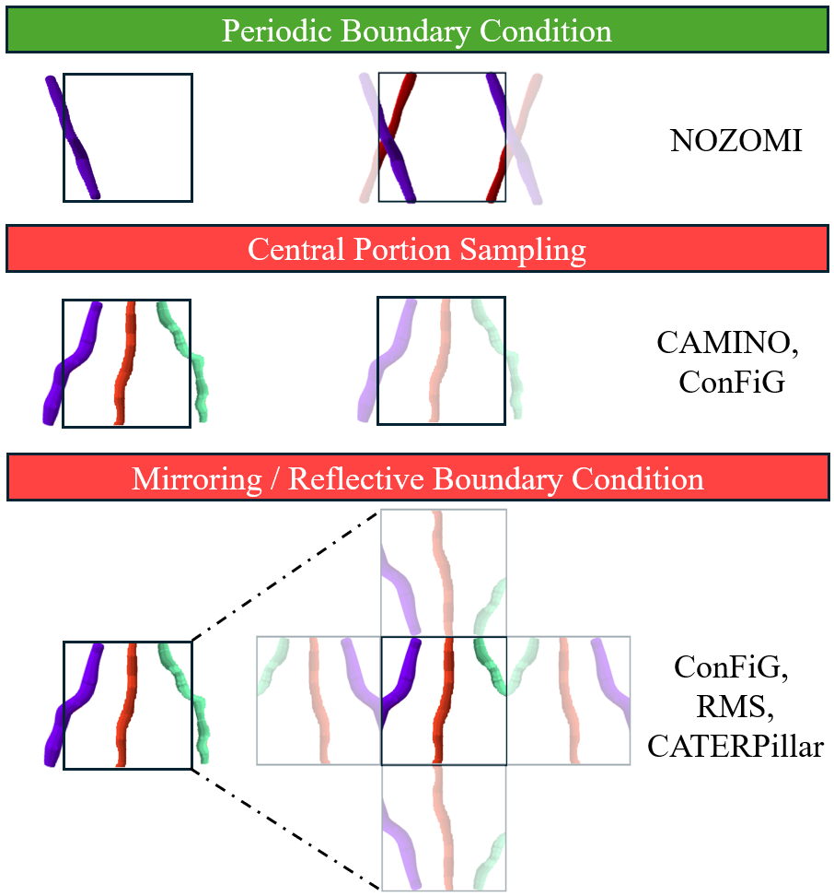
Figure 1. Comparison between different approaches to handle microstructure discontinuities at simulation boundaries, including Periodic Boundary Condition, Central Portion Sampling, and Mirroring / Reflective Boundary Condition.

Table 1: Substrate and Simulation parameters. Substrates were designed with different mean axon diameters, orientation dispersion (as anatomical variations), and volume fractions (to model healthy and pathological WM). Beaded morphology was included. The bold substrate parameters indicate the substrate properties that were varied in the diffusion-time-dependent experiments of this study.
Substrate parameters | Practical range tested
Axonal Volume Fraction $V_{\text{in}}$ | (0.3, 0.7)
Number of axons | [30, 1000]
Axon Diameter GEV Mean | [0.5, 6] μm
Axon Diameter GEV Standard Deviation | [0.1, 1] μm
Watson Distribution concentration parameter $κ$ | [8, 200]
Beading Amplitude $R_{\text{amp}}$Mean $μ_{R_{\text{amp}}}$ | [0, 1.5] μm
Beading Amplitude $R_{\text{amp}}$ Standard Deviation $σ_{R_{\text{amp}}}$ | [0, 0.8] μm
Beading Spacing Mean $μ_{\text{spacing}}$ | [4.0, 6.0] μm
Beading Spacing Standard Deviation $σ_{\text{spacing}}$ | [2.0, 3.0] μm
Spread of the bead along the axon $σ_{\text{bead}}$ | 2.3 μm
Sphere spacing factor | [0.2, 0.5]
Minimum radius | 0.15 μm
Simulation parameters
Number of molecules $N_{\text{molecules}}$ | [1e5, 1e6]
Time step $dt$ | [0.001, 0.0001]
Total diffusion time / Echo time $\text{TE}$ | 100 ms
Number of segments in each axis $N_{x},N_{y},N_{z}$ | [5 - 35]
Compartment selection | Intra/Extra-axonal
Compartment diffusivities $D_{\text{0,i}}$ and $D_{\text{0,e}}$ | [1 - 3] μm²/ms

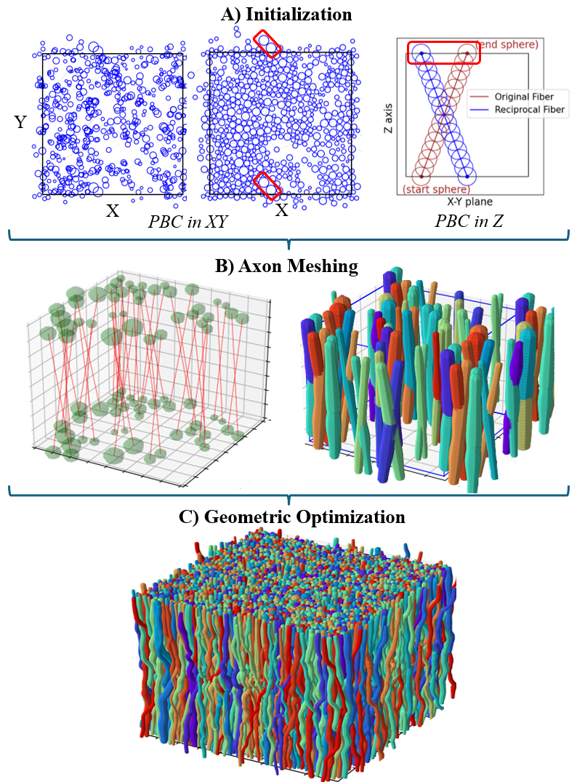
Figure 2. Substrate Generation Procedure: A) Initialization step densely packs the two ends of the simulation box. B) Axon Meshing starts by turning the 2D initialization plane to 3D, illustrated as the 3D volume with the start and end spheres of axons. Then axons are built as chains of overlapping spheres with control for axonal beading. Periodic axons are shown. C) Geometric Optimization removes overlapping spaces between spheres of different axons while adding reciprocal axons periodically for axons that cross boundaries during overlap removal.
Figure 3. A) Snapshot of molecule positions at the end of a geometric continuity test. Here, molecules stay in their assigned axon while able to cross periodic boundaries in $x$ and $z$. B) Mean computation time with respect to number of molecules, plotted for each $dt$ time step choice, showing longer mean computation time for larger molecule numbers and smaller $dt$. C) MAE as a function of $dt$ for different numbers of molecules, showing lower MAE with smaller $dt$ and reduced variability with increasing molecule numbers. For both panels B) and C), each point represents the average for 10 simulation repetitions, with shaded band in C) indicating standard deviation. Based on panels B) and C), 5 × 10⁵ molecules with $dt$ = 0.002 ms was selected as the optimal configuration that balances accuracy, precision, and computational efficiency. D) Agreement of the MCDS-derived (red) and analytical (blue) time-dependent radial diffusivity for diffusion inside a perfect cylinder. Towards long diffusion times, $D_{⊥,MC}\left(t\right)$reaches its asymptotic limit $D_{⊥, t→∞ }\left(t\right)$ (yellow). The short-time $D_{⊥,t→0}(t)= D_{0}\left(1-\frac{4}{6\sqrt{π}}\frac{S}{V}\sqrt{D_{0}t}\right)$ (green) is also included for comparison with the surface-to-volume ratio regime.
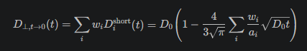

Figure 4. Computational cost and reproducibility across different segment choices. Left: Total computation time—including both simulation time and tabulation time—with respect to number of segments for diffusion simulation of 5×10⁵ molecules, time step of 0.002 ms, and a simulation time of 100 ms. The example substrate has 2236 fibers with mean axon diameter of 1.75 μm, $κ$ = 200, and axonal volume fraction 66%. Right: Reproducibility of $D_{∥}$ and $D_{⊥}$ across seven different segment choices. Each colored curve represents the averaged $D_{∥}$ (top) and $D_{⊥}$ (bottom) across the 7 segment choices, separately for intra- and extra-axonal simulations on the substrate. The curves demonstrate low standard deviation, with values averaged across all diffusion time points and normalized by intrinsic diffusivity of each compartment: ~0.15% for $D_{∥}$ and ~0.04% for $D_{⊥}$. This confirms that segment choice does not significantly influence the diffusivity values in either intra-axonal or extra-axonal compartments.
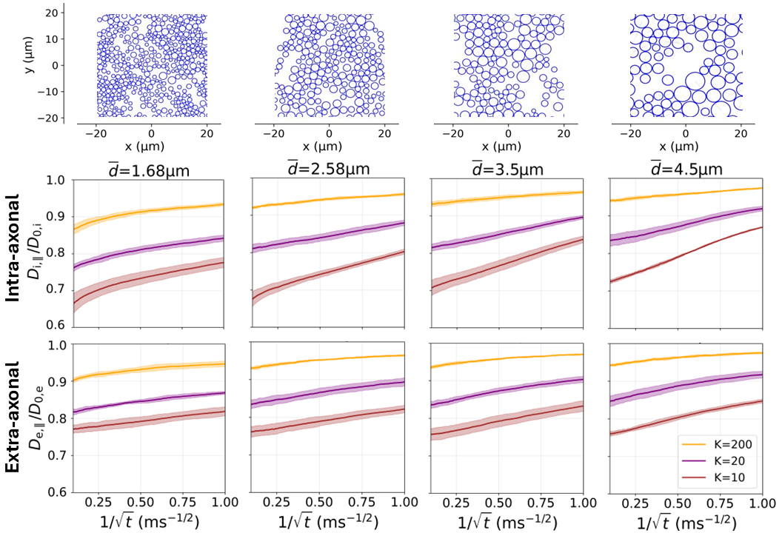
Figure 5. Substrates with different orientation dispersions exhibit distinct $D_{∥}$ signatures. The top row shows example 40 × 40 µm² cross-sections demonstrating mean axon diameters of $\overline{d}$ = 1.68 to 4.5 μm in our generated substrates. The middle and bottom rows display the normalized $D_{∥}$ for intra- and extra-axonal water as a function of $1/\sqrt{t}$, where the range 0.1 - 1.0 ms^{-1/2} corresponds to diffusion times of 1 - 100 ms. The colored curves represent mean of 4 substrate generation and MCDS repetitions, with shaded bands indicating standard deviation. For each mean axon diameter value, higher orientation dispersions reduce $D_{∥}$ in both compartments. In addition, since axonal beading amplitude and bead spacing were fixed across all substrates, axonal beading causes proportionally stronger diffusion restrictions in smaller diameter axons, evidenced by reduced $D_{∥}$ at longer diffusion times at $t≈$ 100 ms, or $1/\sqrt{t}≈$ 0.1 ms^{-1/2}.
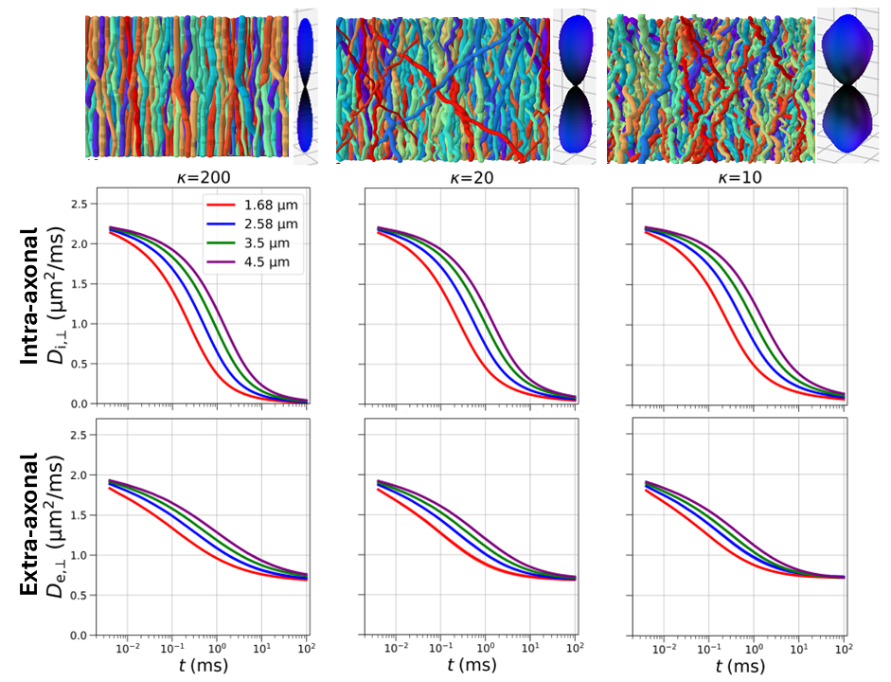
Figure 6. Substrates with different mean axon diameters exhibit distinct $D_{⊥}$ signatures, highlighted by the different colored curves. The top row shows example 3D substrates in the horizontal view, alongside 3D FOD glyphs fitted from spherical harmonic functions, that transition from coherently-oriented ($κ$ = 200) to increasingly dispersed ($κ$ = 10) fibers. The middle and bottom rows display $D_{⊥}$ as a function of diffusion time for the intra- and extra-axonal compartments, with logarithmically scaled $x$-axis. The colored curves, represent the means of 4 substrate generation and MCDS repetitions, with lower standard deviation compared to $D_{∥}$. For each choice of orientation dispersion $κ$, $D_{⊥}$ of substrates with smaller axons approach asymptotic limits faster than those with larger axons, with clear separation observed at short diffusion times (1 - 10 ms) but not at longer times (70 - 100 ms). In addition, changes in orientation dispersion produce subtle opposing responses between the two compartments. In the intra-axonal space, lower dispersion leads to faster decay and lower asymptotic values due to stronger radial geometric restrictions, while in the extra-axonal space, higher dispersion causes faster decay due to enhanced tortuosity from intersecting fiber directions. Note, here $D_{0,i}=$ 2.25 μm²/ms ⁶⁶, and $D_{0,e}$ = 2.0 μm²/ms ⁶⁷ to factor the existence of non-neuronal support cells such as astrocytes, micro-glia and oligodendrocytes in the extra-axonal space. The slightly lower extra-axonal diffusivity was chosen to reflect recent experimental findings^{38,94}.

Figure Captions
- Main manuscript figure captions:
- Figure 1. Comparison between different approaches to handle microstructure discontinuities at simulation boundaries, including Periodic Boundary Condition, Central Portion Sampling, and Mirroring / Reflective Boundary Condition.
- Figure 2. Substrate Generation Procedure: A) Initialization step densely packs the two ends of the simulation box. B) Axon Meshing starts by turning the 2D initialization plane to 3D, illustrated as the 3D volume with the start and end spheres of axons. Then axons are built as chains of overlapping spheres with control for axonal beading. Periodic axons are shown. C) Geometric Optimization removes overlapping spaces between spheres of different axons while adding reciprocal axons periodically for axons that cross boundaries during overlap removal.
- Figure 3. A) Snapshot of molecule positions at the end of a geometric continuity test. Here, molecules stay in their assigned axon while able to cross periodic boundaries in $x$ and $z$. B) Mean computation time with respect to number of molecules, plotted for each $dt$ time step choice, showing longer mean computation time for larger molecule numbers and smaller $dt$. C) MAE as a function of $dt$ for different numbers of molecules, showing lower MAE with smaller $dt$ and reduced variability with increasing molecule numbers. For both panels B) and C), each point represents the average for 10 simulation repetitions, with shaded band in C) indicating standard deviation. Based on panels B) and C), 5 × 10⁵ molecules with $dt$ = 0.002 ms was selected as the optimal configuration that balances accuracy, precision, and computational efficiency. D) Agreement of the MCDS-derived (red) and analytical (blue) time-dependent radial diffusivity for diffusion inside a perfect cylinder. Towards long diffusion times, $D_{⊥,MC}\left(t\right)$reaches its asymptotic limit $D_{⊥, t→∞ }\left(t\right)$ (yellow). The short-time $D_{⊥,t→0}(t)= D_{0}\left(1-\frac{4}{6\sqrt{π}}\frac{S}{V}\sqrt{D_{0}t}\right)$ (green) is also included for comparison with the surface-to-volume ratio regime.

- Figure 4. Computational cost and reproducibility across different segment choices. Left: Total computation time—including both simulation time and tabulation time—with respect to number of segments for diffusion simulation of 5×10⁵ molecules, time step of 0.002 ms, and a simulation time of 100 ms. The example substrate has 2236 fibers with mean axon diameter of 1.75 μm, $κ$ = 200, and axonal volume fraction 66%. Right: Reproducibility of $D_{∥}$ and $D_{⊥}$ across seven different segment choices. Each colored curve represents the averaged $D_{∥}$ (top) and $D_{⊥}$ (bottom) across the 7 segment choices, separately for intra- and extra-axonal simulations on the substrate. The curves demonstrate low standard deviation, with values averaged across all diffusion time points and normalized by intrinsic diffusivity of each compartment: ~0.15% for $D_{∥}$ and ~0.04% for $D_{⊥}$. This confirms that segment choice does not significantly influence the diffusivity values in either intra-axonal or extra-axonal compartments.

- Figure 5. Substrates with different orientation dispersions exhibit distinct $D_{∥}$ signatures. The top row shows example 40 × 40 µm² cross-sections demonstrating mean axon diameters of $\overline{d}$ = 1.68 to 4.5 μm in our generated substrates. The middle and bottom rows display the normalized $D_{∥}$ for intra- and extra-axonal water as a function of $1/\sqrt{t}$, where the range 0.1 - 1.0 ms^{-1/2} corresponds to diffusion times of 1 - 100 ms. The colored curves represent mean of 4 substrate generation and MCDS repetitions, with shaded bands indicating standard deviation. For each mean axon diameter value, higher orientation dispersions reduce $D_{∥}$ in both compartments. In addition, since axonal beading amplitude and bead spacing were fixed across all substrates, axonal beading causes proportionally stronger diffusion restrictions in smaller diameter axons, evidenced by reduced $D_{∥}$ at longer diffusion times at $t≈$ 100 ms, or $1/\sqrt{t}≈$ 0.1 ms^{-1/2}.

- Figure 6. Substrates with different mean axon diameters exhibit distinct $D_{⊥}$ signatures, highlighted by the different colored curves. The top row shows example 3D substrates in the horizontal view, alongside 3D FOD glyphs fitted from spherical harmonic functions, that transition from coherently-oriented ($κ$ = 200) to increasingly dispersed ($κ$ = 10) fibers. The middle and bottom rows display $D_{⊥}$ as a function of diffusion time for the intra- and extra-axonal compartments, with logarithmically scaled $x$-axis. The colored curves, represent the means of 4 substrate generation and MCDS repetitions, with lower standard deviation compared to $D_{∥}$. For each choice of orientation dispersion $κ$, $D_{⊥}$ of substrates with smaller axons approach asymptotic limits faster than those with larger axons, with clear separation observed at short diffusion times (1 - 10 ms) but not at longer times (70 - 100 ms). In addition, changes in orientation dispersion produce subtle opposing responses between the two compartments. In the intra-axonal space, lower dispersion leads to faster decay and lower asymptotic values due to stronger radial geometric restrictions, while in the extra-axonal space, higher dispersion causes faster decay due to enhanced tortuosity from intersecting fiber directions. Note, here $D_{0,i}=$ 2.25 μm²/ms ⁶⁶, and $D_{0,e}$ = 2.0 μm²/ms ⁶⁷ to factor the existence of non-neuronal support cells such as astrocytes, micro-glia and oligodendrocytes in the extra-axonal space. The slightly lower extra-axonal diffusivity was chosen to reflect recent experimental findings^{38,94}.
- Supporting Information figure captions:
- Figure S1. A) Side view of a representative substrate in an isotropic 69 × 69 × 69 µm³ arena with $κ$= 200 (low orientation dispersion), generated in < 1.5 hours. B) An example axial cross-section of the generated substrate in A), demonstrating packing density of ~70% C) The substrate’s axon diameter distribution with a mean $\overline{d}$ = 1.75 µm fitted to the generalized extreme value distribution. D) The Coefficient of Variation for the substrate radius is shown, with a value of 0.144 $±$ 0.048.
- Figure S2. NOZOMI’s control for axonal beading / along-axon variation by varying the radius along the length of the axons, ranging from no beading to high beading. Left: Side-views of the substrates are shown, shifted to the center of the FOV. Right: The along-axon radius distribution.
- Figure S3. A) Side view of substrates of diameter $\sim 2.1 ± 0.7$μm with $κ$= 200 (low dispersion), $κ$ = 20 (intermediate dispersion), and $κ$ = 7 (high dispersion). B) Fiber Orientation Distribution for axons segments in each fiber, computed as a histogram of extracted fiber orientation vectors connecting consecutive spheres belonging to a fiber, and displayed as a top-down projection on the unit sphere. C) 3D FOD glyphs generated by fitting the FOD in B) to spherical harmonics basis functions of even degrees up to l=20.

