VIETNAM NATIONAL UNIVERSITY, HANOI



INTERNATIONAL SCHOOL

**FINAL REPORT**

**DESIGN HEARTBEAT MONITORING CIRCUIT**

**Lecturer: Pham Ngoc Thanh Student: Vu Huy Khai**

**Nguyen Viet Ha**

**Subject code: INS3135 - INS313501**

**Group 3**

**Class: AAI2022**

# ACKNOWLEDGEMENT

We would like to send a special thanks to Dr. Pham Ngoc Thanh and those who have led us to the destination of completing the topic **“*Design Heartbeat Monitoring Circuit”***.

Thanks to their interest and help, we have gained more knowledge and found out the research direction for this research report.

Without their help, it would have been difficult for us to complete this research. Once again, we would like to express our deep gratitude to Dr. Pham Ngoc Thanh.

My team sincerely thank you!

*Hanoi, May* 27𝑡ℎ*, 2025*

**TABLE OF CONTENTS**

ACKNOWLEDGEMENT 1

TABLE OF FIGURE 4

ABSTRACT 5

CHAPTER I : PROJECT INFORMATION 6

1.1 Project Title and Team 6

1.1.1 Title of the project 6

1.1.2 Project type 6

1.1.3 Team members and roles 6

1.2 Project Duration and Tools 7

1.2.1 Start and End Dates 7

1.2.2 Software Used 7

1.3 Project Objective 7

1.3.1 Key goals and expected outcomes 7

1.3.2 Main Problems Addressed 7

CHAPTER II: INTRODUCTION 8

2.1 Background and Motivation 8

2.1.1 Why this topic is important 8

2.1.2 Practical relevance and applications 8

2.2 Objectives and Scope 8

2.2.1 Specific aims of the project 8

2.2.2 Scope and limitations 9

CHAPTER III : METHODOLOGY AND MILESTONES 10

3.1 Research Methodology 10

3.2 Implementation Steps 11

3.3 Task Distribution 13

CHAPTER IV: LITERATURE REVIEW 14

4.1 Overview of Related Concepts 14

4.1.1 ECG signal 14

4.1.2 Instrumentation Amplifier Stage 15

4.1.3 Filter Stage 16

4.1.4 Full– wave rectifier 17

4.1.5 Comparator Stage 18

4.2 Review of Existing Works 19

4.3 Novelty and Improvements 19

CHAPTER V: PROJECT OUTCOME 21

5.1 Circuit Design and Simulation 21

5.1.1 LTspice software applications 21

5.1.2 Design Detail 24

5.2 Simulation Result and Analysis 29

5.3 Practical Application 31

CHAPTER VI: PROJECT COST 32

CHAPTER VII: CONCLUSION 35

REFERENCES 36

**TABLE OF FIGURE**

Figure 1 A complete ECG cycle 14

Figure 2 INA Internal Stage Diagram 16

Figure 3 Typical bandpass filter circuit 16

Figure 4 Band- Stop Filter Response 17

Figure 5 Positive and negative full wave rectifiers 17

Figure 6 Full wave rectifier 18

Figure 7 Comparator circuit 18

Figure 8 Block Diagram 21

Figure 9 Logo Ltspice software 21

Figure 10 Ltspice software interface 22

Figure 11 Icon on Toolsbar 22

Figure 12 Main interface of the program 22

Figure 13 Component in Toolsbar 23

Figure 14 List library component 23

Figure 15 Delete component 24

Figure 16 Run Simulation 24

Figure 17 Input Sine Signal 25

Figure 18 Instrumentation amplifier 25

Figure 19 Result after amplifier 26

Figure 20 Band- pass filter 26

Figure 21 Notch filter 27

Figure 22 Full- wave rectifier 27

Figure 23 Comparator 28

Figure 24 Heartbeat Monitoring Full Circuit 29

Figure 25 Result through 2 filter layers 29

Figure 26 Frequency response of Band- stop filter 30

Figure 27 Frequency response of Band- pass filter 31

# ABSTRACT

This project focuses on the design and simulation of a heart rate monitoring circuit, which provides a solution for non-invasive health monitoring and early detection of cardiovascular irregularities. The study began with an investigation into the significance of heart rate measurement in medical diagnostics and daily health tracking. It continued with an in-depth analysis of the core components involved, amplification stages, filtering circuits, and signal conditioning blocks. The central part of the project involved using software to simulate the heart rate detection circuit, offering valuable insights into analog signal processing and noise reduction techniques. Simulation results confirmed the feasibility of the proposed design and emphasized the importance of proper signal amplification, filtering, and component selection to ensure reliable output. This project lays a solid foundation for understanding the principles and applications of heart rate sensing systems, contributing to the development of more accurate and accessible biomedical devices.

**Keywords: Heart rate monitoring, analog signal processing, biomedical circuit design, health monitoring**

# CHAPTER I : PROJECT INFORMATION

## 1.1 Project Title and Team

### **1.1.1 Title of the project**

***Title: “Design Heartbeat Monitoring Circuit”***

### **1.1.2 Project type**

* Kind of project: Engineering Project

### **1.1.3 Team members and roles**

* Team members: Vu Huy Khai: 22070035

Nguyen Viet Ha: 22070075

* The role of each member in the group:

|  |  |  |  |  |  |
| --- | --- | --- | --- | --- | --- |
| Members | Theoretical development | Circuit development | Circuit analysis | Slide | Final report |
| Vu Huy Khai | 50% | 50% | 50% | 50% | 50% |
| Nguyen Viet Ha | 50% | 50% | 50% | 50% | 50% |

## 1.2 Project Duration and Tools

### **1.2.1 Start and End Dates**

The project started on April 29, 2025 and was completed on May 28, 2025.

### **1.2.2 Software Used**

To design and simulate the heart rate monitoring circuit, the following software tools were usedLTspice software for analog circuit simulation, including amplification and filtering stages**.**

## 1.3 Project Objective

### **1.3.1 Key goals and expected outcomes**

The primary goal of this project is to design, simulate, and evaluate a heart rate monitoring circuit capable of accurately amplifying and filtering weak bio-signals from a pulse sensor. The expected outcomes include a functional circuit design that detects and amplifies heart rate signals. Simulation results that validate the design through waveform clarity and signal integrity. A better understanding of analog signal processing techniques for biomedical applications.

### **1.3.2 Main Problems Addressed**

- The project addresses several key problems:

- How to amplify extremely weak heart signals (~3mV) without excessive noise.

- How to remove unwanted noise and interference using appropriate filters.

- How to simulate real-world physiological signals in a controlled software environment.

# CHAPTER II: INTRODUCTION

**2.1 Background and Motivation**

**2.1.1 Why this topic is important**

In recent years, the demand for continuous and accurate heart rate monitoring has grown substantially due to the increasing prevalence of cardiovascular diseases [1] the leading cause of death globally, accounting for an estimated 17.9 million lives each [1]. Heart rate is one of the most fundamental physiological indicators, offering essential insights into an individual’s physical health, emotional stress levels, and overall well-being.

Designing a heart rate monitoring circuit not only helps in understanding biomedical signal acquisition but also deepens knowledge of analog signal processing skills that are vital in medical device development [2]. Furthermore, working with weak biosignals such as those from photoplethysmographic (PPG) or infrared sensors trains students and engineers in practical noise handling, signal isolation, and real-world circuit implementation. This kind of project bridges the gap between theoretical knowledge and hands-on problem solving, which is especially critical in biomedical engineering education [3].

**2.1.2 Practical relevance and applications**

Heart rate measurement circuits have a wide range of practical applications, from fitness wearables and hospital grade monitoring systems to sports training tools and elderly care devices. In this project, a simulated environment using LTspice is used to model the behavior of a heart rate signal as it passes through amplification and filtering stages. The techniques and components used such as operational amplifiers, passive filters, and noise analysis are the same principles applied in commercial biomedical circuits.  
This project also enhances understanding of signal integrity issues, such as the impact of noise and DC offset, and explores how to mitigate them using proper circuit design strategies. Therefore, the project has direct relevance to both educational and applied biomedical electronics.

**2.2 Objectives and Scope**

**2.2.1 Specific aims of the project**

To design and simulate a heart rate monitoring circuit using operational amplifiers.

To amplify low-voltage pulse signals (~3 mV) for further processing.

To filter out noise and isolate the frequency band of heart rate signals (1.2–1.8Hz).

To evaluate the effectiveness of the circuit through output and frequency response.

**2.2.2 Scope and limitations**

This project focuses on the analog part of heart rate signal acquisition. It includes amplification, filtering, and simulation of input waveforms similar to real pulse signals. However, it does not include the actual hardware implementation or interfacing with microcontrollers

# CHAPTER III : METHODOLOGY AND MILESTONES

## 3.1 Research Methodology

***Literature review***

Heart rate monitoring is a crucial area in biomedical engineering, with applications ranging from daily fitness tracking to clinical diagnostics. The process of detecting and processing heart signals involves capturing very low-amplitude electrical signals generated by the body and filtering out various types of noise before any meaningful information can be extracted. [4]

Previous studies have shown the importance of analog signal processing in the early stages of ECG signal acquisition. These signals are typically weak and susceptible to interference from surrounding electrical devices and biological noise. As a result, many researchers emphasize the design of effective analog front-end circuits that include amplification, filtering, and signal conditioning stages.

A typical approach involves using operational amplifiers for signal amplification, along with high-pass, low-pass, or band-pass filters to isolate the frequency range of interest (usually between 0.5 Hz and 40 Hz for heart rate). After analog conditioning, the clean signal can then be digitized and processed further or visualized. [4]

Simulation tools such are widely used to model and evaluate these circuits before implementation. They allow researchers to test performance, adjust parameters, and predict real world behavior without the need for physical prototypes in the early stages. This not only saves time and resources but also improves the reliability of the final design.

***Ciruit design***

The heart rate measurement circuit is designed with multiple analog signal processing stages, each responsible for amplifying and conditioning the low-amplitude signals generated by the body. The process begins with a differential amplification stage using an operational amplifier, such as the LM324, to extract small voltage variations from a sine signal or sensor. To eliminate baseline drift and low-frequency motion artifacts, a high-pass filter is applied. This is followed by a band-pass filter that isolates the frequency range of interest, typically between 0.5 Hz and 4 Hz, which corresponds to normal heart rate variations in adults. The filtered signal is then processed by a comparator or a peak detector to convert the analog waveform into a digital pulse signal, which can be counted to determine the heart rate. Careful selection of component values, gain settings, and biasing is essential to maintain signal integrity throughout the circuit.

This design approach aligns with standard practices in biomedical signal processing, where weak bio-signals require both amplification and noise suppression before interpretation or digitization . [4]

***Simulation***

The designed heart rate detection circuit is simulated a robust and widely-used software for analog circuit analysis. The simulation process is divided into multiple stages to thoroughly evaluate the performance of each circuit block, including amplification, filtering, and signal shaping.

To replicate a realistic scenario, a small-amplitude sinusoidal waveform with a frequency of approximately 1.2 Hz corresponding to a heart rate of ~72 bpm, is used as the input signal. This waveform is superimposed with white noise to emulate real-world disturbances commonly found in physiological signals. This allows for testing the circuit's ability to preserve the desired signal while attenuating unwanted noise.

Transient analysis is performed to observe the behavior of the signal in the time domain as it passes through each stage of the circuit. This helps ensure that the signal is properly amplified, filtered, and converted into a clean, recognizable waveform suitable for digital processing.

Additionally, AC analysis is conducted to generate Bode plots, which illustrate the frequency response of the filtering stages. This confirms that the high-pass and band-pass filters are correctly designed to target the heart rate frequency band typically 0.5 Hz – 4 Hz while attenuating frequencies outside this range.

Simulation results are used to evaluate key performance metrics such as signal gain, phase shift, distortion, and clipping. This pre-implementation step is crucial, as it allows for adjustments to resistor and capacitor values, gain settings, and bias points to optimize circuit behavior and avoid saturation or performance loss in real-world applications***.***

## 3.2 Implementation Steps

The implementation of the heart rate detection system follows a systematic approach, starting from understanding signal characteristics to completing simulation and hardware testing. Each step contributes to ensuring the circuit accurately captures and processes biological signals.

***Requirement Analysis and Signal Understanding***

This process begins with a comprehensive study of the biosignal to be measured. In this project, the target is the heart rate signal, which is typically obtained electrically from a sine wave or from sensors. These sensors detect changes in blood volume through optical methods, typically generating a weak analog signal in the range of 0.3 mV to 5 mV and with a frequency of about 0.5 Hz to 4 Hz (corresponding to 30–240 beats per minute). Understanding these characteristics is important for determining appropriate parametric and tertiary filters in the design circuit.

This phase also includes reviewing studies and datasheets related to the signal acquisition circuit, filtering methods, and common issues such as baseline oscillation, power line noise (50/60 Hz), and motion artifacts.

***Analog Circuit Design***

Based on the signal characteristics, an analog front-end circuit is designed. This includes:

* An initial amplification stage using an operational amplifier to boost the weak input signal.
* A band-stop filter to eliminate DC offset and very low-frequency noise.
* A band-pass filter to isolate the heart rate frequency range.
* A comparator or pulse-shaping stage to convert the analog waveform into a digital pulse.

***Simulation***

The designed circuit is simulated using LTspice. A representative signal sinusoidal waveform with added noise is injected into the system to:

* Validate gain and frequency response.
* Verify the effectiveness of noise filtering.
* Analyze output clarity and ensure that the signal is within expected bounds*.*

***Testing verifies***

That the signal can be captured from a fingertip reliably. This noise is suppressed effectively while maintaining signal integrity. That the final output waveform is clean and follows the expected heart rate pattern. Adjustments may be required to resistor or capacitor values ​​to fine-tune the frequency response. Component tolerances, finger pressure on the sensor, and ambient light are all considered during this phase

***Performance Evaluation and Documentation***

The final step is to evaluate the performance of the system in terms of:

* Signal clarity
* Noise resilience
* Response stability over time

Limitations and potential improvements are noted, such as minimizing ambient interference or using better-grade components for tighter tolerances. After final verification, a full schematic, bill of materials (BOM), and test results are documented for academic or practical purposes.

## 3.3 Task Distribution

The project was conducted by a team of two members, with tasks divided equally to ensure a balanced and efficient workflow. Since the project focused on circuit design and simulation rather than physical implementation, both members contributed primarily to research, design, simulation, and documentation.

Member 1: Vu Huy Khai was responsible for researching the principles of heart rate detection, including biomedical signal characteristics and the theory behind amplification and filtering techniques. This member contributed to designing the initial circuit stages, selecting component values, and setting gain and frequency parameters. They also helped draft the literature review, creating the demonstration video, explaining the the circuit works and circuit design sections of the report.

Member 2: Nguyen Viet Ha took charge of implementing the circuit in software conducting simulations, and analyzing the results. This included running AC analysis to evaluate frequency response, simulating signal injection with added noise, and interpreting waveform outputs. This member also contributed to writing the simulation, testing, creating the demonstration video, explaining the the circuit works and implementation sections of the report.

Both members collaborated in preparing the project documentation, refining the presentation content, and ensuring that the report met academic standards. Regular discussions were held to review progress, verify results, and ensure coherence across all sections of the work.

# CHAPTER IV: LITERATURE REVIEW

**4.1 Overview of Related Concepts**

In the field of biosignal processing, especially rhythm signal processing, understanding the concepts and fundamental principles is essential to build an accurate and stable measurement system.

**4.1.1 ECG signal**

***What is an electroniccardiogram ?***

An electrocardiogram (ECG or EKG) is one of the simplest and fastest tests used to evaluate the heart. Electrodes (small, plastic patches that stick to the skin) are placed at certain spots on the chest, arms, and legs. The electrodes are connected to an ECG machine by lead wires. The electrical activity of the heart is then measured, interpreted, and printed out. No electricity is sent into the body. [5]

Natural electrical impulses coordinate contractions of the different parts of the heart to keep blood flowing the way it should. An ECG records these impulses to show how fast the heart is beating, the rhythm of the heart beats (steady or irregular), and the timing of the electrical impulses as they move through the different parts of the heart. Changes in an ECG can be a sign of many heart-related conditions. [5]

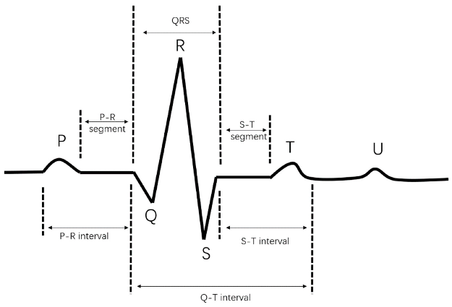

Figure A complete ECG cycle

***Parts of the ECG explained***

- P wave represent atrial depolarisation. In healthy individuals, these should be a P wave preceding each QRS complex.

- The PR interval begins at the start of the P wave and ends at the beginning of the Q wave. It represent the time for electrical activity to move between the atria and the ventricles.

- QRS complex is represents the depolarisation of the ventricles It appears as three closely related waves on the ECG (the Q, R and S wave).

- The ST segment starts at the end of the S wave and ends at the beginning of the T wave. - It is an isoelectric line representing the time between depolarisation and repolarisation of the ventricles.

- The T wave represents ventricular repolarisation. It appears as a small wave after the QRS complex.

- The RR interval begins at the peak of one R wave and ends at the peak of the next R wave. It represents the time between two QRS complexes

- The QT interval begins at the start of the QRS complex and finishes at the end of the T wave. It represents the time taken for the ventricles to depolarise and then repolarise. [6]

***Why we need an ECG ?***

Our heartbeats are controlled by electrical signals from the brain. By examining those signals in detail, we can tell a lot about the health of the heart and some of the underlying issues that might be going on inside it. There are many different reasons why we might be asked to take an ECG. Some common ones include: [7]

* Palpitation
* Dizziness
* Shortness of breath
* Weakness or fatigue
* Reduced ability to exercise
* Fainting
* Chest pain

**4.1.2 Instrumentation Amplifier Stage**

An instrumentation amplifier (INA) is a very special type of differential input amplifier; its primary focus is to provide differential gain and high common-mode rejection. INA offer high input impedance and low output impedance; newer devices will also offer low offset and low noise. [8]

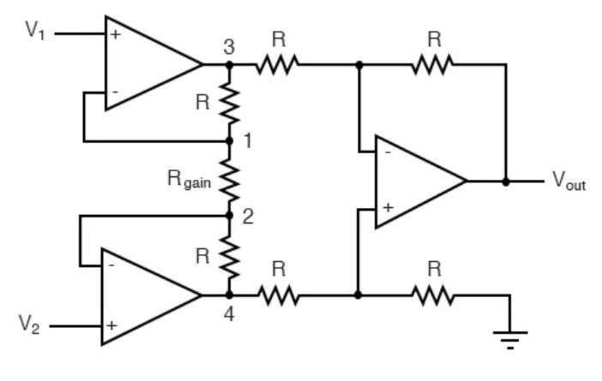

Figure INA Internal Stage Diagram

An instrumentation amplifier, it has the distinct advantages of possessing extremely high input impedances on the V1 and V2 inputs (because they connect straight into the noninverting inputs of their respective op-amps), and adjustable gain that can be set by a single resistor.

Manipulating the above formula a bit, we have a general expression for overall voltage gain in the instrumentation amplifier: [9]

It could still change the overall gain by changing the values of some of the other resistors, but this would necessitate balanced resistor value changes for the circuit to remain symmetrical. [9]

**4.1.3 Filter Stage**

***Band- pass Filter***

Band-pass filter is used to pass the frequencies of a particular band between and . If the 3-dB frequency of low-pass filter is higher than the 3-dB frequency of high pass filter, then cascading of high pass filter and low pass filter works as a bandpass filter [10]. The bandpass filter attenuates the noise which comes due to power line interference (PLI), muscle noise and baseline wander. [11]

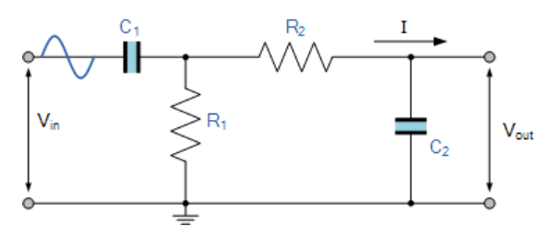

Figure Typical bandpass filter circuit

The “ideal” Band Pass Filter can also be used to isolate or filter out certain frequencies that lie within a particular band of frequencies, for example, noise cancellation. Band pass filters are known generally as second-order filters, (two-pole) because they have “two” reactive component, the capacitors, within their circuit design. [12] One capacitor in the low pass circuit and another capacitor in the high pass circuit.

Following the fomular to calculate for band- pass.

***Band- stop Filter***

By combining a basic RC low-pass filter with a RC high-pass filter we can form a simple band-pass filter that will pass a range or band of frequencies either side of two cut-off frequency points. But we can also combine these low and high pass filter sections to produce another kind of RC filter network called a Band Stop Filter which can block or at least severely attenuate a band of frequencies within these two cut-off frequency points. [13]

If this stop band is very narrow and highly attenuated over a few hertz, then the band stop filter is more commonly referred to as a notch filter, as its frequency response shows that of a deep notch with high selectivity (a steep-side curve) rather than a flattened wider band. [13]

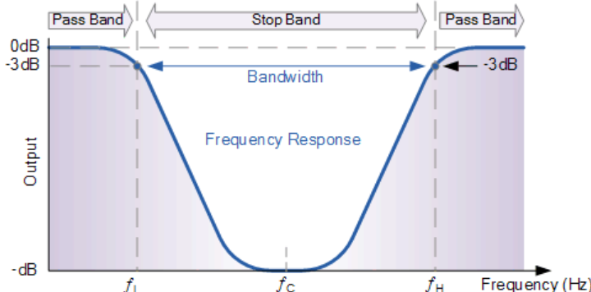

Figure Band- Stop Filter Response

The upper and lower cut-off frequency points for a band pass filter can be found using the same formula as that for both the low and high pass filters, For example:

### **4.1.4 Full– wave rectifier**

The Precision Full Wave Rectifier circuits accept an ac signal at the input, inverts either the negative or the positive half, and delivers both the inverted and noninverted halves at the output.

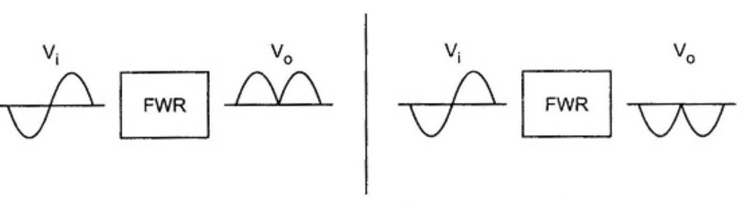

Figure Positive and negative full wave rectifiers

The operation of the positive full wave rectifier is expressed as :

and that of the negative rectifier as :

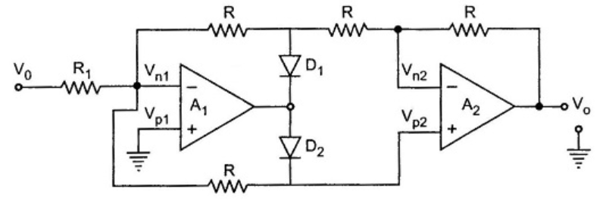

Figure Full wave rectifier

When  > 0, inverting side of A1 will force its output to swing negative, thus forward biasing D1 and reverse biasing D2. Since no current flows through resistance R connected between  and both are equipotential. [14]

### **4.1.5 Comparator Stage**

Once the signal has been amplified and cleaned of noise, the next step is to convert it into a square wave for easier processing or counting. To do this, we use a comparator circuit.

A comparator circuit compares two voltages and outputs either a 1 (the voltage at the plus side) or a 0 (the voltage at the negative side) to indicate which is larger. Comparators are often used, for example, to check whether an input has reached some predetermined value. In most cases a comparator is implemented using a dedicated comparator IC, but op-amps may be used as an alternative. Comparator diagrams and op-amp diagrams use the same symbols. [15]

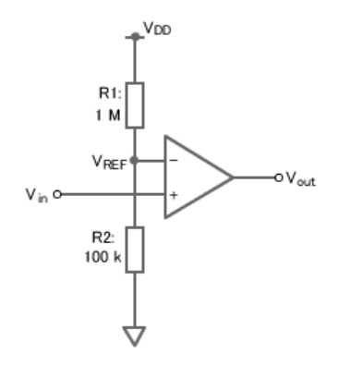

Figure Comparator circuit

The circuit amplifies the voltage difference between and , and outputs the result at . If is greater than , then voltage at will rise to its positive saturation level; that is, to the voltage at the positive side. If is lower than , then , will fall to its negative saturation level, equal to the voltage at the negative side. [15]

**4.2 Review of Existing Works**

Several previous studies have presented designs of heart rate measurement circuits using optical sensors or ECG electrodes. In [Rangayyan, 2002], the authors used a series of analog filters to remove noise and amplify the ECG signal, but did not clearly mention the ability to remove grid frequency noise. Another study by Gupta et al. (2020) used a differential amplifier circuit combined with a band-pass filter and a rectifier circuit to collect signals from a PPG sensor. In addition, papers such as [Nguyen et al., 2021] used Arduino and MAX30100 sensor to measure heart rate directly but did not simulate each amplifier stage in detail in the software environment..."

**4.3 Novelty and Improvements**

***Advanatges***

One of the highlights of the project is the completely analog circuit-based design without the need for a microcontroller. While modern heart rate measurement systems often use digital signal processors or microcontrollers to analyze data, this approach emphasizes the pure biological signal processing using pure components and linear amplifiers. This not only helps learners gain a deeper understanding of the principles of biological signal processing, but also significantly reduces the cost and complexity of the system.

In addition, the circuit is built according to a linear model, with each clear functional block including high-pass filtering, band-pass filtering, and signal comparison. This filtering chain is calculated to authenticate the frequency range of the human heart rate signal. Therefore, the circuit can eliminate noise such as low-frequency noise and noise from the power grid.

Another novelty lies in the use of circuit comparison to convert the filtered analog signal into a square pulse. This pulse can be counted directly to determine the heart rate without the need for an ADC or software processor. This method is both simple and effective, suitable for low-cost prototyping.

Finally, the entire circuit is thoroughly tested using simulation software before development, which helps to confirm the smoothing range, filtering efficiency and stability of the output signal. This ensures technical feasibility and helps to detect errors before actual production.

***Disadvantages***

The use of all analog hardware also has some limitations. Because there is no central controller or digital processing algorithm, the system cannot flexibly adapt to changing conditions such as user movement, weak signals or abnormal heart rate changes. In addition, the circuit only performs the basic function of detecting heart rate through the output pulse and does not support advanced functions such as data recording or wireless signal transmission.

Another limitation is that the project is only at the simulation level, not implementing a real circuit. Therefore, practical factors such as environmental noise, component errors, power supply stability and noise on the PCB have not been evaluated. This affects the authenticity of the results if implemented in real life.

In short, the main innovation of the project is in the minimalist approach but still ensures the function of detecting heart rate through a signal filtering chain and waveform conversion, without using software or microcontrollers. Although limited in extensibility and practicality, this design is educational in nature and could serve as a research and develop

# CHAPTER V: PROJECT OUTCOME

## 5.1 Circuit Design and Simulation

***Block Diagram of Heartbeat Monitoring***

Figure Block Diagram

**5.1.1 LTspice software applications**

LTspice is software used for simulating electronic circuits, commonly regarded as a tool for virtualizing electronic components on a computer. It allows users to easily interact with and analyze circuits without the need for physically connecting wires or using specialized hardware tools for hands-on practice.

LTspice focuses primarily on the simulation and analysis of analog and mixed-signal circuits. It enables users to:

- Draw circuit schematics.

- Perform various types of analysis such as transient , AC, and DC operating point analysis.

- View circuit responses through waveform plots and signal graphs



Figure Logo Ltspice software

**\*** **Brief introduction to using LTspice software**

**Step 1: Launch the LTspice software**

To start LTspice software, click on the Ltspice icon on your desktop or navigate to Windows >> Programs >> LTspice.

After the software launches, you will see its interface, which typically looks like this:

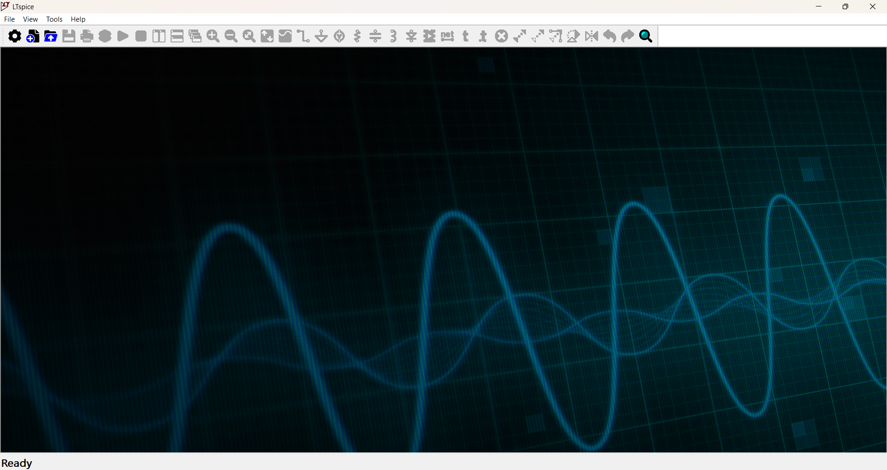

Figure Ltspice software interface

**Step 2: Start new schematic**

Click on the **New Schematic** icon on the of the LTspice interface or using **Ctrl+N** to create new schematic for project. This is where you can start designing and simulating your circuit schematics.



Figure Icon on Toolsbar

After a new schematic created, a workspace for circuit design will appear, as shown below.



Figure Main interface of the program

**Step 3: Select Components from the LTspice Library**

To choose components in LTspice, first click on the **Component** button or using **P** button on your keybroad. This allows you to access the component library to select the parts you need for your circuit design.

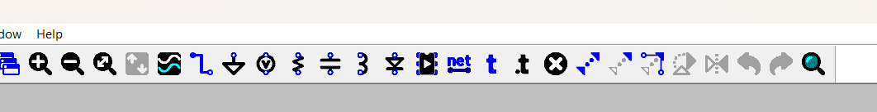

Figure Component in Toolsbar

When the library is opened, a window will appear as follows:

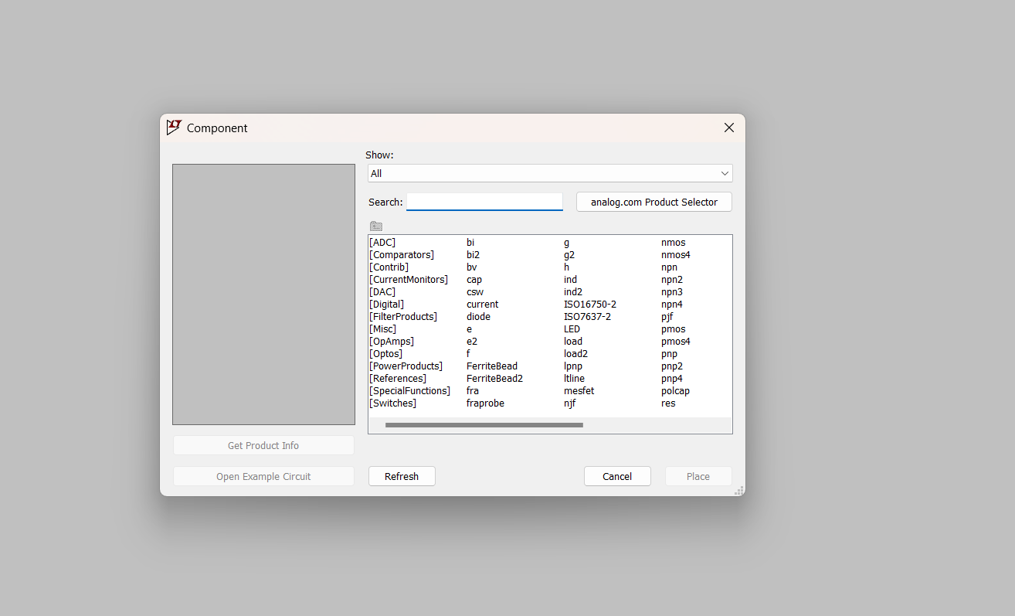

Figure List library component

**Step 4: Arrange and Organize Components Logically.**

Use the available commands in Ltspice , such as moving, rotating, or flipping components, to rearrange them into a logical and clear layout. This step ensures that your circuit schematic is neat and easy to understand as you proceed to the next steps of the design process.

**Step 5 : Wiring Components.**

After arranging the components as desired, proceed to connect the pins of the components to complete the circuit. Follow these steps:

Place the cursor over the pin of the component you want to connect. When a red square appears, click on the pin to start the wiring process.

Drag the cursor to the pin of the other component you want to connect, then click again to complete the connection.

Repeat this process for all connections until the circuit diagram is complete.

**To delete incorrect wiring or component:**

Go to delete mode by click icon on toolbar or press Backspace on keybroad then click to wire or component to delete it

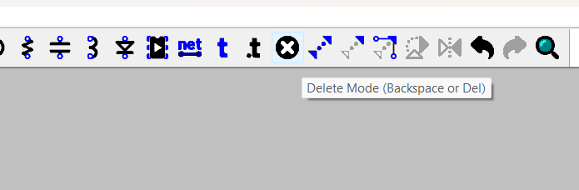

Figure Delete component

**Step 6 : Run the Circuit Schematic**

Checking the schematic after completing your circuit design is essential. Then run the schematic by click icon on toolbar or press **ALT+R** on keyboard to run it.

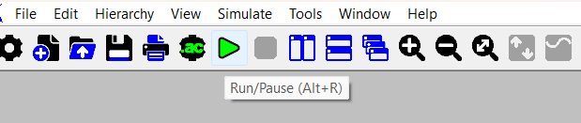

Figure Run Simulation

**5.1.2 Design Detail**

**Step 1: Create source**

In the simulation LTspice environment because a real electrocardiogram signal is not accessible, a sine wave is used as a substitute. This sine signal is chosen because its periodic and rhythmic nature closely resembles the regular pattern of a human heartbeat. By using this type of signal, we can simulate the general characteristics of an actual ECG without needing a live input.

To make the simulation more realistic and to better evaluate the robustness and effectiveness of the circuit design, artificial noise is intentionally added to the sine signal. This noise simulates the various types of interference and disturbances that typically affect ECG signals in real world scenarios, such as muscle activity, power line interference and movement artifacts. Including such noise in the simulation allows for a more thorough assessment of how well the circuit can filter out unwanted components and maintain signal integrity under less-than-ideal conditions.

So in here we set the input is 3mV and 1,2Hz suitable for body of human.

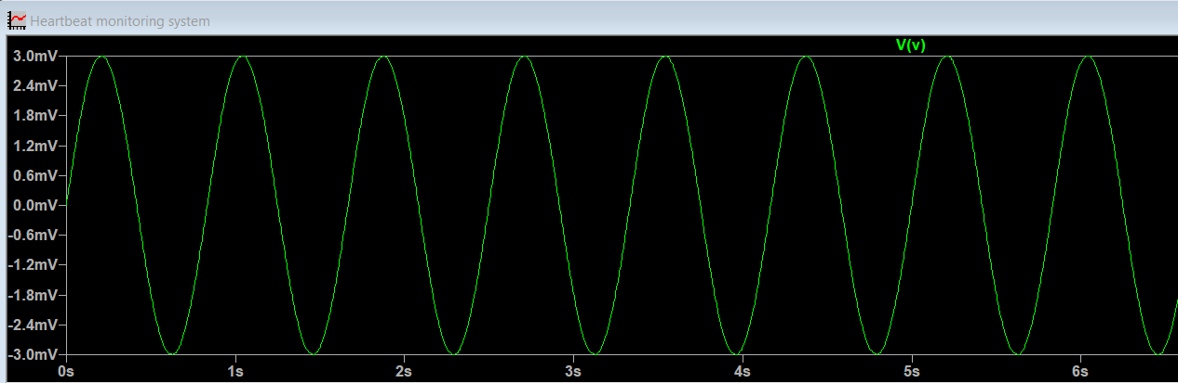

Figure Input Sine Signal

In here we can see the input signal is very small, difficult to observe and then we must be amplifier.

**Step 2: Building the Instrumentation Amplifier (INA**)

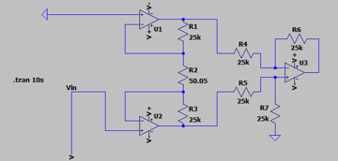

Figure Instrumentation amplifier

The first component of the full device was an instrumentation amplifier (INA) which can measure small signals found in noisy environments. In this case, an INA was made with a high gain (around 1,000) to allow for optimal results. A schematic of the INA with its respective resistor values is shown. The gain of this INA can be calculated theoretically to confirm that the setup was valid and that the resistor values were appropriate. Equation shows the equation used to calculate that the theoretical gain was 1,000, where R1 = R3, R4 = R5, and R6 = R7.

Gain =

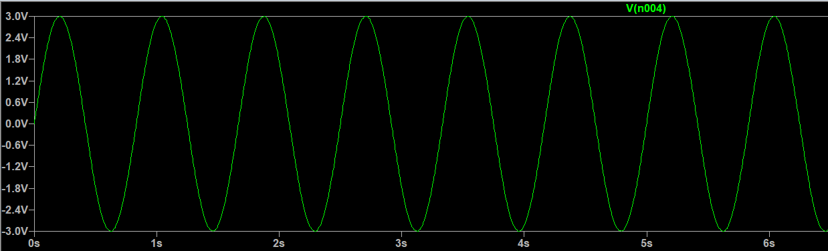

Figure Result after amplifier

After use block instrumentation amplifier we can see voltage upper from 0.3mV to the oscillation around -3V to 3V shows the efficiency of the circuit.

**Step 3: Building the Bandpass Filter**

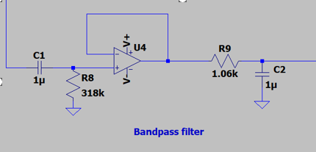

Figure Band- pass filter

A main source of noise includes electrical signals propagating through the body, so the industry standard is to include a bandpass filter with cutoff frequencies of 0.5 Hz and 150 Hz to remove the distortions from the ECG. This filter used a high pass and a low pass filter in series to eliminate signals outside of this frequency range. The schematic of this filter with its respective resistor and capacitor values is shown. The exact values of the resistors and capacitors were found using the formula shown in Equation. This formula was used twice, one for the high pass cutoff frequency of 0.5 Hz and one for the low pass cutoff frequency of 150 Hz. In each case, the capacitor value was set to 1 μF, and the resistor value was calculated.

**Step 4: Building the Notch Filter (Bandstop Filter)**

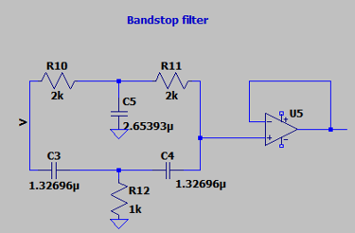

Figure Notch filter

Another common source of noise associated with the ECG is caused by power lines and other electronic equipment but was eliminated with a notch filter. This filtering technique utilized a high pass and a low pass filter in parallel to remove the noise specifically at 60 Hz. The schematic of the notch filter with its respective resistor and capacitor values is shown. The exact resistor and capacitor values were determined such that R10 = R11 = 2R12 and C5 = 2C3 =2C4. Then, to ensure a cutoff frequency of 60 Hz, R1 was set to 1 kΩ, and Equation was used to find the value of C5.

**Step 5: Building full-wave rectifier circuit**

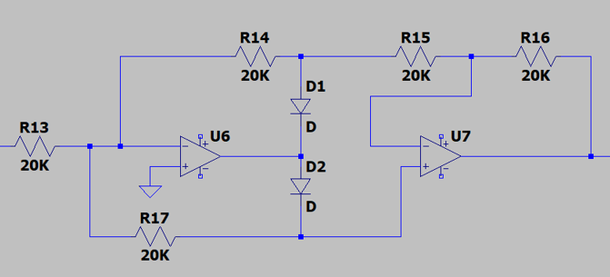

Figure Full- wave rectifier

In heart rate measurement systems using optical sensors, the signal obtained is typically a small-amplitude alternating current voltage signal that fluctuates around 0V. Direct processing of this signal is challenging due to its low amplitude and the presence of both positive and negative half-cycles. Therefore, a **precision rectifier circuit** is used to convert the small AC signal into a unidirectional (DC-pulsed) signal that is easier to process in later stages.

The precision rectifier circuit utilizes operational amplifiers in conjunction with diodes to accurately rectify low-amplitude signals without being affected by the forward voltage drop of the diode. The circuit shown consists of two main stages:

**+ Stage 1 (U6):** Functions as a **precision half-wave rectifier.**

**+ Stage 2 (U7):** Functions as a **full-wave rectifier and amplifier**.

**Precision Half-Wave Rectification**

In the first stage, the input signal ​ is processed as follows:

* When > 0V: the op-amp drives the diode D1 into conduction, resulting in an output =
* When < 0V: the diode does not conduct, and the output is blocked → = 0

This configuration allows even very small signals (in the millivolt range) to be rectified accurately, thanks to the high gain of the op-amp.

**Full-Wave Rectification and Amplification**

In the second stage, op-amp U7 works with diodes and resistors (R15, R16) to perform full-wave rectification:

* For > 0V: the signal follows the upper path and is amplified and rectified.
* For < 0V the signal flows through diode D2, is inverted and then amplified, producing a positive output.

Given the symmetrical resistor values (R13 = R14 = R15 = R16 = R17 = 20kΩ), the gain of the amplifier is:

The resulting output signal is:

=

**Step 6:** **Building Comparator Circuit**

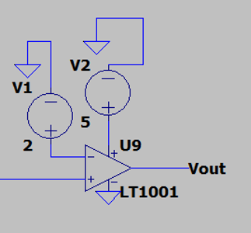

Figure Comparator

A comparator will be used to convert the pulsating DC signal to a binary digital output. Op amps functioning as comparators follow the rule that if V+ >V-, = + and V- > V + = In our ideal circuit, we aim our binary signal to be either 0 or 1. To generate a binary output where 0V= not crossing the threshold and 2V= crossing threshold, the Op-Amp terminals will be set to be = 5V and = 0V.

**5.2 Simulation Result and Analysis**

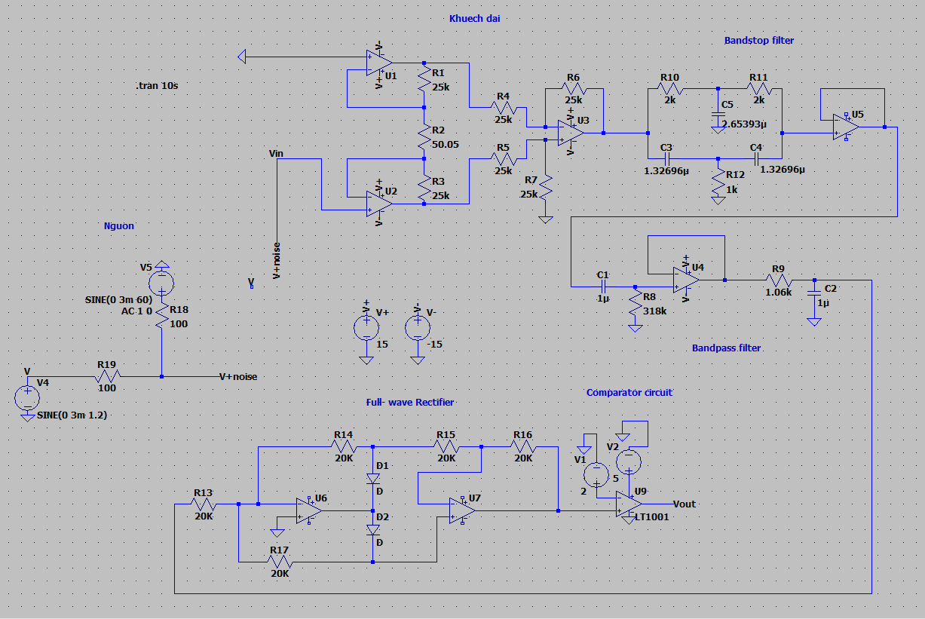

Figure Heartbeat Monitoring Full Circuit

***Result Simulation :***

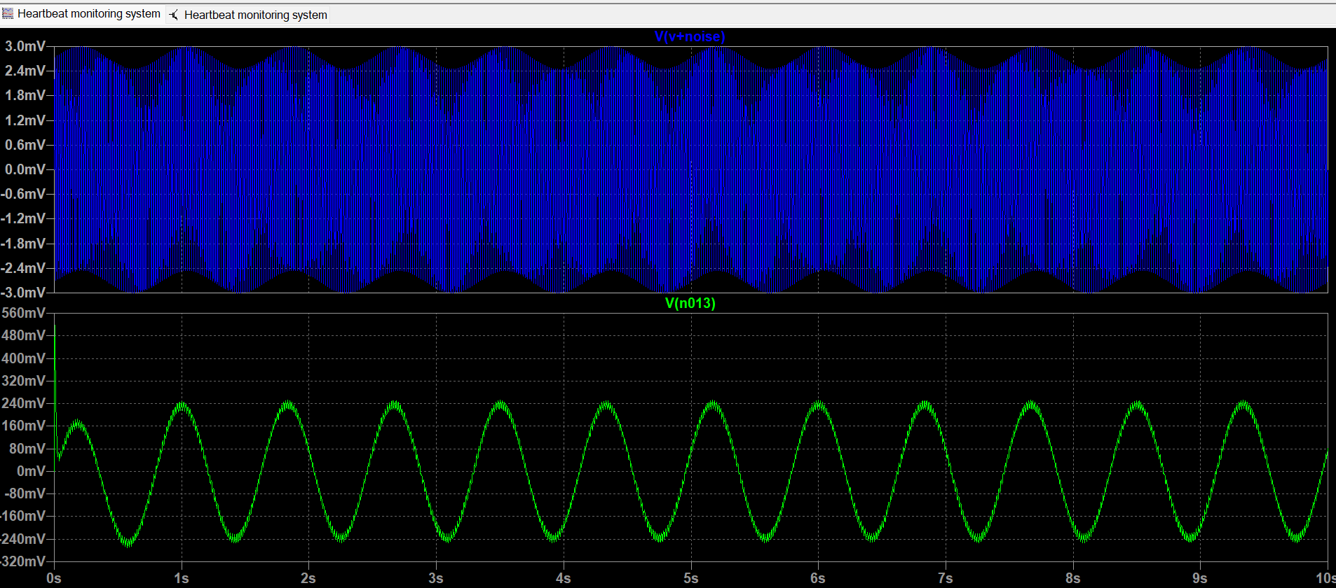

Figure Result through 2 filter layers

In the top plot, the sine wave is heavily affected by noise, causing strong fluctuations that obscure the original waveform. This situation closely resembles real-world signals such as heartbeat measurements, which are often contaminated by motion artifacts, electromagnetic interference, or ambient noise.

The bottom plot shows the result after applying a combination of filters. After filtering, the signal becomes significantly smoother, with high-frequency noise almost completely removed. The original sine wave shape is now much clearer. This demonstrates the effectiveness of signal processing in recovering the desired signal and eliminating unwanted noise, which is crucial for accurate and reliable measurement and analysis.

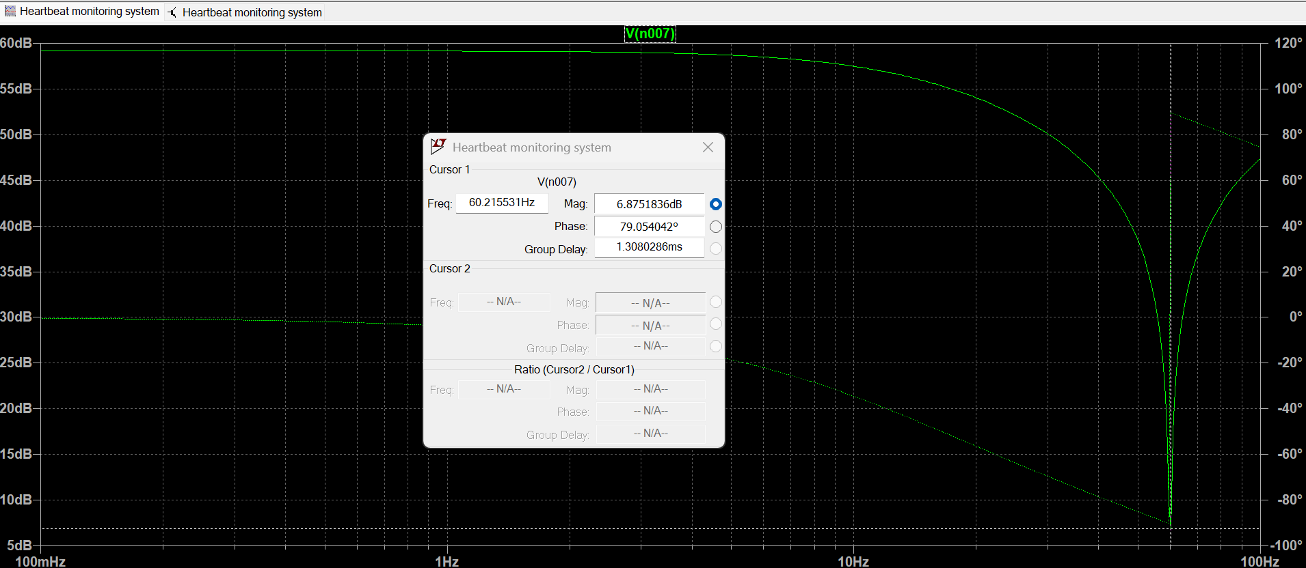

Figure Frequency response of Band- stop filter

The Bode response shows a very deep dip at around 50 Hz to 60 Hz which is typical of a notch filter. This indicates that the 50 Hz to 60 Hz signal, typically AC mains noise, is strongly attenuated. Outside this range, the filter allows the signal to pass through almost intact. The phase changes abruptly at the notch frequency but remains stable elsewhere. This result confirms that the filter is effective in removing mains noise without affecting the heart rate signal.

Compared to theoretical expectations, the simulation aligns well. A well-designed notch filter should provide sharp attenuation at a specific frequency while maintaining flat gain outside the notch range. The simulation plot demonstrates exactly this behavior, confirming that the practical filter design successfully meets its theoretical purpose of eliminating power line interference while preserving the useful biological signal.

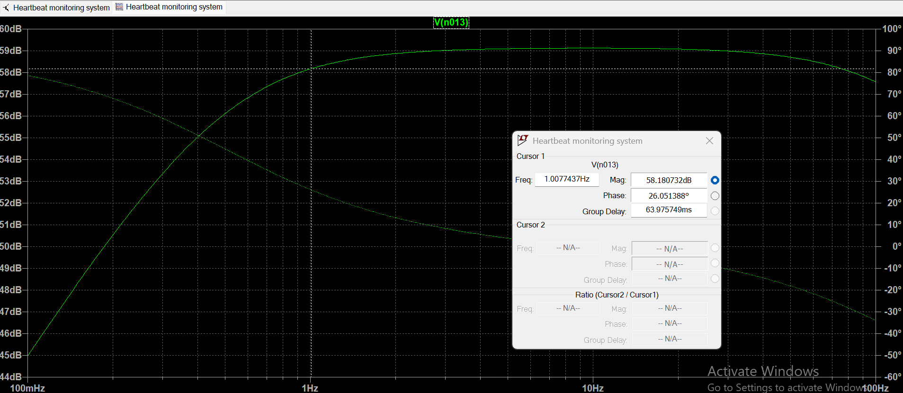

Figure Frequency response of Band- pass filter

The band-pass filter is effective in the range of 0.5 Hz to 4–10 Hz – this is the region where the heart rate signal is passed without significant attenuation. At low frequencies (< 0.1 Hz), the amplitude is sharply reduced, eliminating background noise and DC shift. At high frequencies (> 10 Hz), the amplitude is also reduced, eliminating noise from electrical equipment or the environment. The phase curve changes smoothly in the pass region, ensuring no signal distortion. Overall, the band- pass filter meets the requirements for noise rejection and heart rate signal retention.

## 5.3 Practical Application

This project demonstrates a practical method for detecting heartbeats using basic analog circuitry. The design is highly applicable in resource-constrained environments, where the use of microcontrollers or advanced digital processing may be limited. By relying on operational amplifiers and analog filters, the system can effectively isolate the heart rate signal from background noise, such as power line interference or motion artifacts.

Such a design can be applied in basic health monitoring tools, particularly for preliminary screening or educational purposes. For example, it can be used in rural clinics or schools for demonstrations of biomedical signal acquisition. Additionally, this circuit can serve as a frontend module for wearable devices or remote patient monitoring systems, where analog preprocessing of the signal is required before sending it to a digital system for analysis or wireless transmission.

Because the circuit is simple, cost-effective, and fully analog, it offers the potential for low-power, portable heart rate monitoring, which is ideal for field deployment or battery-operated health devices. The flexibility in component selection and filter design also allows the circuit to be adapted for other bio-signals such as respiration or muscle activity (EMG) with minor modifications.

# CHAPTER VI: PROJECT COST

The project cost for designing and simulating a fire alarm system for 2 people is calculated based on several factors below:

* Hourly rate: The hourly rate for each person involved in the project.
* Number of hours: The estimated number of hours required to complete the project.
* Other expenses: Any additional cost such as machining cost, requirement hardware, or miscellaneous expenses.

Consider these factors in terms of the project **“*Design Heartbeat Monitoring Circuit*”**

* Hourly rate per person: 70,000 VND
* Estimated number of hours: 50 hours (25 hours per person)

Other expenses: 200,000 VND

Hardware component

|  |  |  |  |  |  |  |  |  |  |  |  |  |
| --- | --- | --- | --- | --- | --- | --- | --- | --- | --- | --- | --- | --- |
| Circuit | Component | |  | | --- | |  |  |  | | --- | | Value | | |  | | --- | |  |  |  | | --- | | Suggested Part | | Reason | |  | | --- | |  |  |  | | --- | | Comparison | | Cost |
| Amplifier | Op-Amps U1,U2, U3 | TL072 | Low-noise, dual op-amp, affordable | Suitable for small-signal amplification | LM358 is cheaper but has higher noise | 12.000VND  (4.000x3) |
| Resistors R1–R7 | 25k, 50k | 1% metal film (E96 series) | Ensures precise gain setting | 5% resistors are cheaper but less accurate | 7.600VND  (7.10x10 +500) |
| Bandpass Filter | Op-Amp U4 | |  | | --- | |  |  |  | | --- | | TL071 | | Low noise, good bandwidth | Suitable for bandpass operation | LM324 is cheaper but poor bandwidth and noise performance | 5.000VND |
| R8 | 318k | 1% tolerance | Critical for cutoff frequency accuracy | Lower tolerance increases frequency error | 500VND |
| Capacitors C1, C2 | 1 µF | Polyester/film type | |  | | --- | |  |  |  | | --- | | Stable over time and temperature | | Electrolytic types should be avoided | 1.000VND  (500x2) |
| R9 | 1k | 1% tolerance | |  | | --- | |  |  |  | | --- | | Helps control filter Q-factor | | Could round to 1k if high accuracy is not required | 40VND |
| Bandstop Filter | Op-Amp U5 | TL071 or NE5534 | TL071: low noise, single op-amp | NE5534 has lower noise but is more expensive | TL071 is ideal for heatbeat frequencies | 5.000VND |
| Capacitors C3, C4, C5 | ≈1.33 µF | Polyester/film capacitors | Good thermal stability and low tolerance | Electrolytic types are not suitable due to leakage and poor accuracy | 21.000VND  (7.000x3) |
| Resistors R10, R11, R12 | 2k, 1k | 1% metal film | For precise frequency tuning | Carbon film is cheaper but less accurate | 120VND  (40x2+40) |
| Rectifier + Comparator | Op-Amps U6, U7 | TL072 | Accurate rectification, low noise | Good slew rate and bandwidth | LM358 is less accurate for precision tasks | 8.000VND  (4.000x2) |
| Diodes D1, D2 | 1N4148 | Fast-switching diode | Low forward voltage and fast response | 1N4001 is too slow and lossy for this task | 70.000VND |
| Comparator U9 | LM393 or LT1011 | LM393: low-cost, widely used | LT1011: more accurate threshold but higher cost |  | 3.000VND |
| Resistors R13–R17 | 20k | 1% tolerance metal film | Precision balance in the circuit | 5% resistors may lead to imbalance | 4.500VND  (900x5) |

Total component cost: 137.760 VND

The total cost for project

* Cost per person = Hourly rate per person * Number of hours per person
* Cost per person = 70,000 VND/hour * 25 hours = 1,750,000 VND
* Total cost for 2 people = Cost per person * Number of people

= 1,750,000 VND/person * 2 people = 3,500,000 VND

Total project cost = Total cost for 2 people + Total Component + Other expenses

= 3,500,000 VND + 137.760 VND + 200,000 VND

= 3,837,760 VND

Therefore, the estimated project cost for designing a heartbeat monitoring circuit for 2 people would be approximately 3,837,760 VND.

# CHAPTER VII: CONCLUSION

The project “***Design Heartbeat Monitoring Circuit***” aimed to develop an analog front-end system capable of detecting heart rate signals through effective amplification and filtering techniques. The study began with a review of fundamental biomedical signal principles, focusing on the characteristics of heart-related signals and the challenges associated with noise and signal clarity.

The circuit was designed using multiple analog stages including high-pass, low-pass, bandpass, and notch filters, to isolate the frequency range of the heartbeat and suppress unwanted noise such as power line interference. The comparator stage allowed the conversion of the analog waveform into a digital pulse, making it suitable for counting or further digital processing.

Simulation results confirmed that the proposed design could effectively extract and clean heart rate signals. The system showed stable gain in the desired frequency range (0.5–4 Hz) and significant attenuation at 50–60 Hz, as expected from a properly tuned notch filter. These findings emphasize the importance of analog preprocessing in biomedical applications, especially where low power and simplicity are prioritized.

In conclusion, this project provided valuable insights into analog circuit design for biomedical signal monitoring. It established a strong foundation for future developments in wearable or low-cost health monitoring systems, where real-time heart rate detection is essential.

# REFERENCES

|  |  |  |  |
| --- | --- | --- | --- |
| [1] |  |  | W. H. Organization, "Cardiovascular diseases," 2021. [Online].  Available: https://www.who.int/news-room/fact-sheets/detail/cardiovascular-diseases-(cvds). |
| [2] |  |  | J. G. Webster, Medical Instrumentation: Application and Design (4th ed.),  Wiley, 2009. |
| [3] |  |  | L. A. &. B. L. E. Geddes, Principles of Applied Biomedical Instrumentation,  Wiley-Interscience, 1989. |
| [4] |  |  | R. M. Rangayyan, "Biomedical Signal Analysis: A Case-Study Approach," IEEE Press, 2002. |
| [5] |  |  | J. Hopkins, "Electrocardiogram," Johns Hopkins Medicine, [Online].  Available: <https://www.hopkinsmedicine.org/health/treatment-tests-and-therapies/>  electrocardiogram. |
| [6] |  |  | G. MEDICS, "Understanding an ECG," [Online].  Available: https://geekymedics.com/understanding-an-ecg/. |
| [7] |  |  | J. Lyne, "What Is an ECG (Electrocardiogram) and Why Is It Important?," [Online].  Available: <https://heartrhythmcardiologist.com/what-is-ecg-electrocardiogram/#:~>  :text=Your%20ECG%20results%20help%20focus,%2C%20or%20irregularly%20  (an%20arrhythmia). |
| [8] |  |  | B. Hess, "What Is an Instrumentation Amplifier ?," [Online].  Available: https://www.ti.com/document-viewer/lit/html/SSZT428. |
| [9] |  |  | A. Circuit, "The Instrumentation Amplifier," [Online].  Available: <https://www.allaboutcircuits.com/textbook/semiconductors/>  chpt-8/the-instrumentation-amplifier/. |
| [10] |  |  | M. J. C. T. U.R.Acharya, "Automatic identification of cardiac health using  modeling techniques:  A comparative study," Information Sciences, 2008. |
| [11] |  |  | M. M. Varun Gupta, "ECG Signal Analysis: Past, Present and Future," IEEE, 2018. |
| [12] |  |  | E. Tutorials, "Passive Band Pass Filter," 2020. [Online].  Available: http://electronics-tutorials.ws/filter/filter_4.html. |
| [13] |  |  | E. Tutorials, "Band Stop Filter," 2020. [Online].  Available: https://www.electronics-tutorials.ws/filter/band-stop-filter.html. |
| [14] |  |  | EEEGUIDE.COM, "Precision Full Wave Rectifier,"  [Online]. Available: https://www.eeeguide.com/precision-full-wave-rectifier/. |
| [15] |  |  | C. C. Op-Amps, "Op-Amps: Ubiquitous ICs with Multiple Applications,"  [Online]. Available: <https://www.renesas.com/en/support/engineer-school/electronic-circuits->  03-op-amps-comparator-circuit?srsltid=AfmBOoqRyo6Y20PB32zSSAK477_cwP0PWGezH9_  Dhd4btVd-fFg-OSTy. |
| [16] |  |  | S. C. Encyclopedia, "Electrocardiogram Signal Denoising," [Online].  Available: https://encyclopedia.pub/entry/52174. |
| [17] |  |  | M. Signal, Composer, *Low pass, High pass, Band pass and Band stop filters explained.*  [Sound Recording]. 2024. |
| [18] |  |  | LinearTechnology, Composer, *LTspice IV: Noise Simulations.* [Sound Recording]. 2005. |
| [19] |  |  | T. h. đ. tử, Composer, *Cách thiết kế bộ lọc thông dải ứng dụng cho thiết bị đo nhịp tim.*  [Sound Recording]. 2020. |
| [20] |  |  | E. Circuit, Composer, *Introduction to LTSPICE for Simulating 741*  *Op-Amp Amplifier and Low pass Filter Circuits.* [Sound Recording]. 2021. |
| [21] |  |  | Technologist, Composer, *Active band pass filter Ltspice Simulation –*  *Band pass filter using*  *Op-amp ltspice.* [Sound Recording]. 2023. |
| [22] |  |  | Eduvance, Composer, *LTSpice Lecture 5 Analysis of Low Pass Filter.* [Sound Recording].  2016. |