Contents
ML Model Experiments Using a Local MLflow Server 1
Comparison of Ridge and Ordinary Multinomial Logistic Regression 1
The best model based on the experiment 2
Details of Ordinary Multinomial Logistic Regression 3
Details of Ridge Multinomial Logistic Regression 4
Application Using the Best-Performing Model 5

ML Model Experiments Using a Local MLflow Server

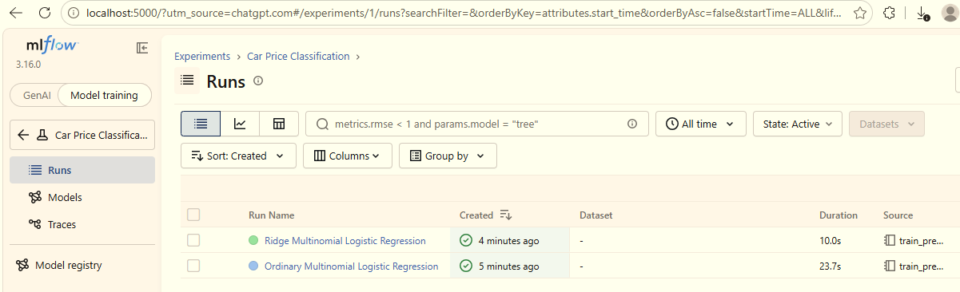

Comparison of Ridge and Ordinary Multinomial Logistic Regression
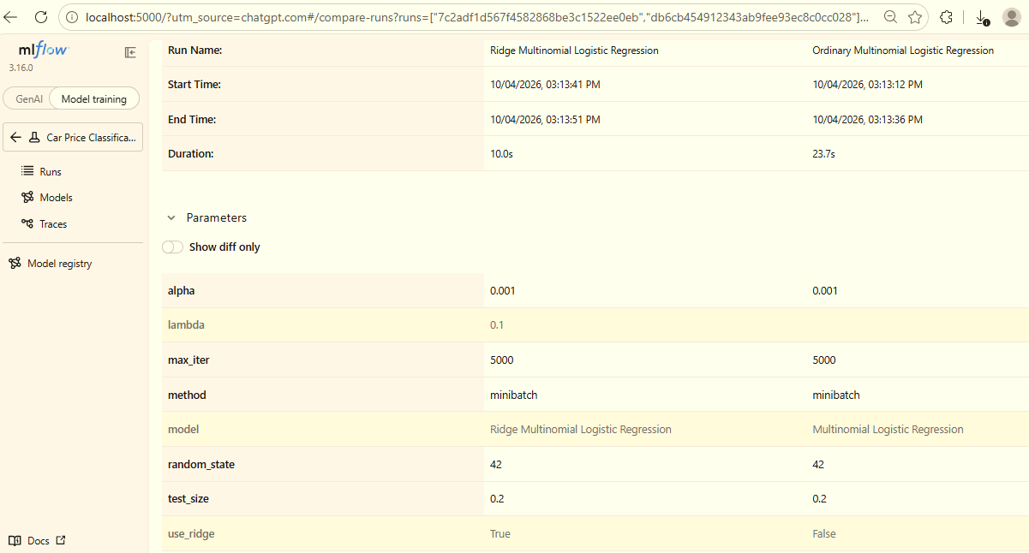
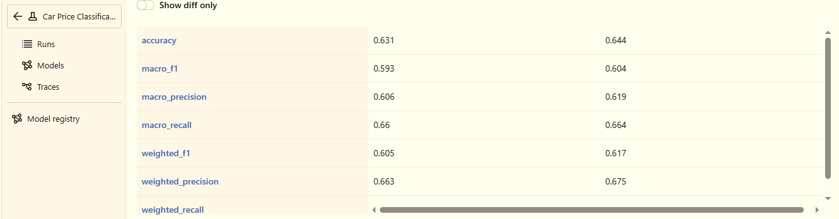

The best model based on the experiment
The standard Multinomial Logistic Regression is the best-performing model for this dataset. It achieved higher accuracy (64.33%), macro F1-score (60.19%), and weighted F1-score (61.76%) than the Ridge Logistic Regression model with λ = 0.1. Therefore, the standard model is the preferred choice under the current experimental setup.

Details of Ordinary Multinomial Logistic Regression
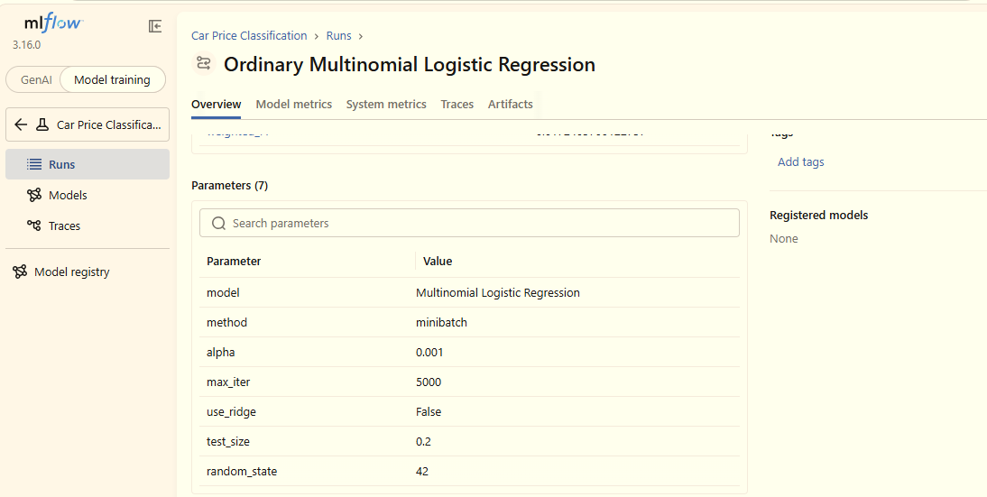

Details of Ridge Multinomial Logistic Regression
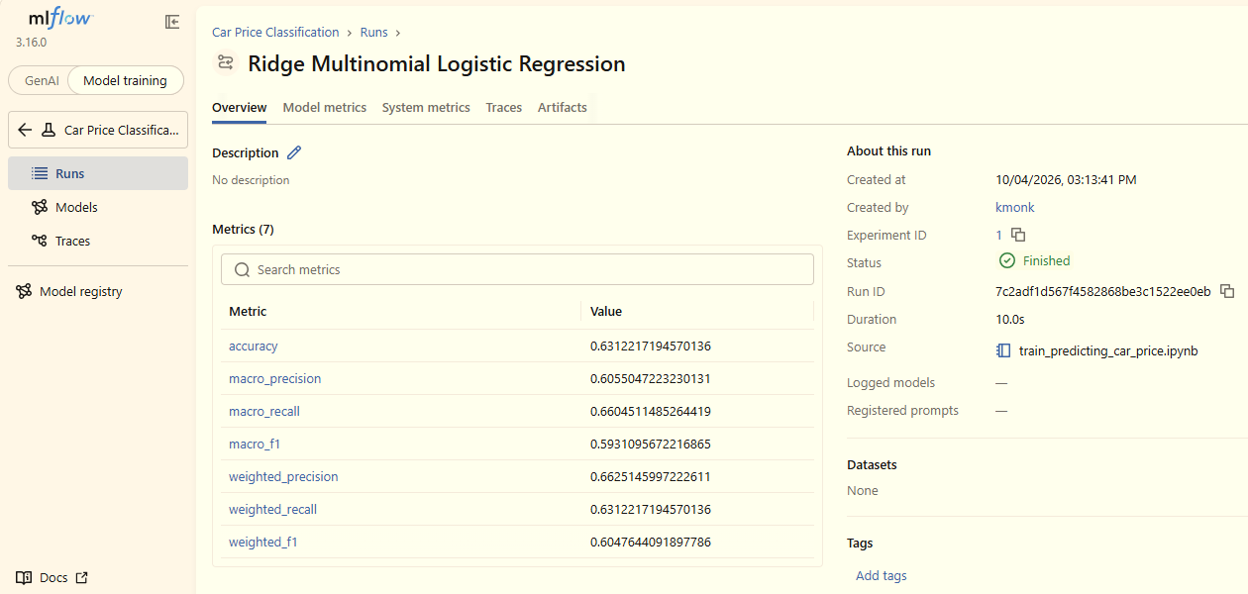

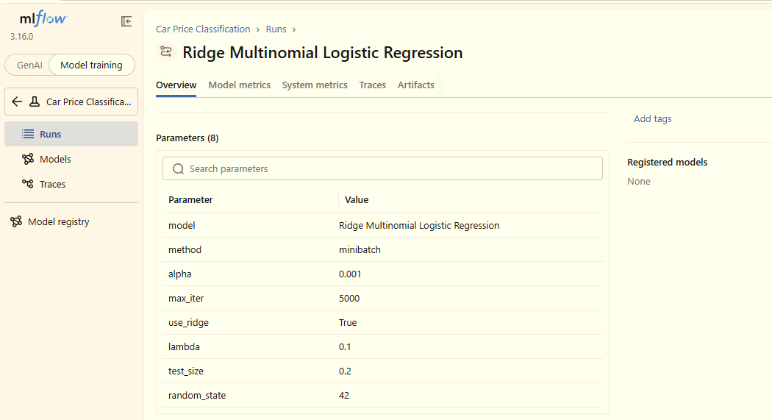

Application Using the Best-Performing Model



