1. We will need, all copper layouts plus drill file with Gerber format. A zip file is required to contain all gerber files:

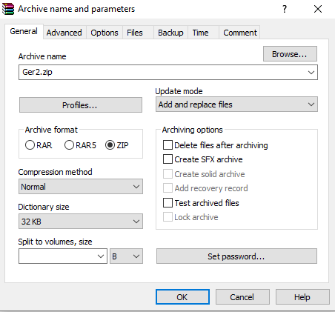

1. Import Zip of Gerbers

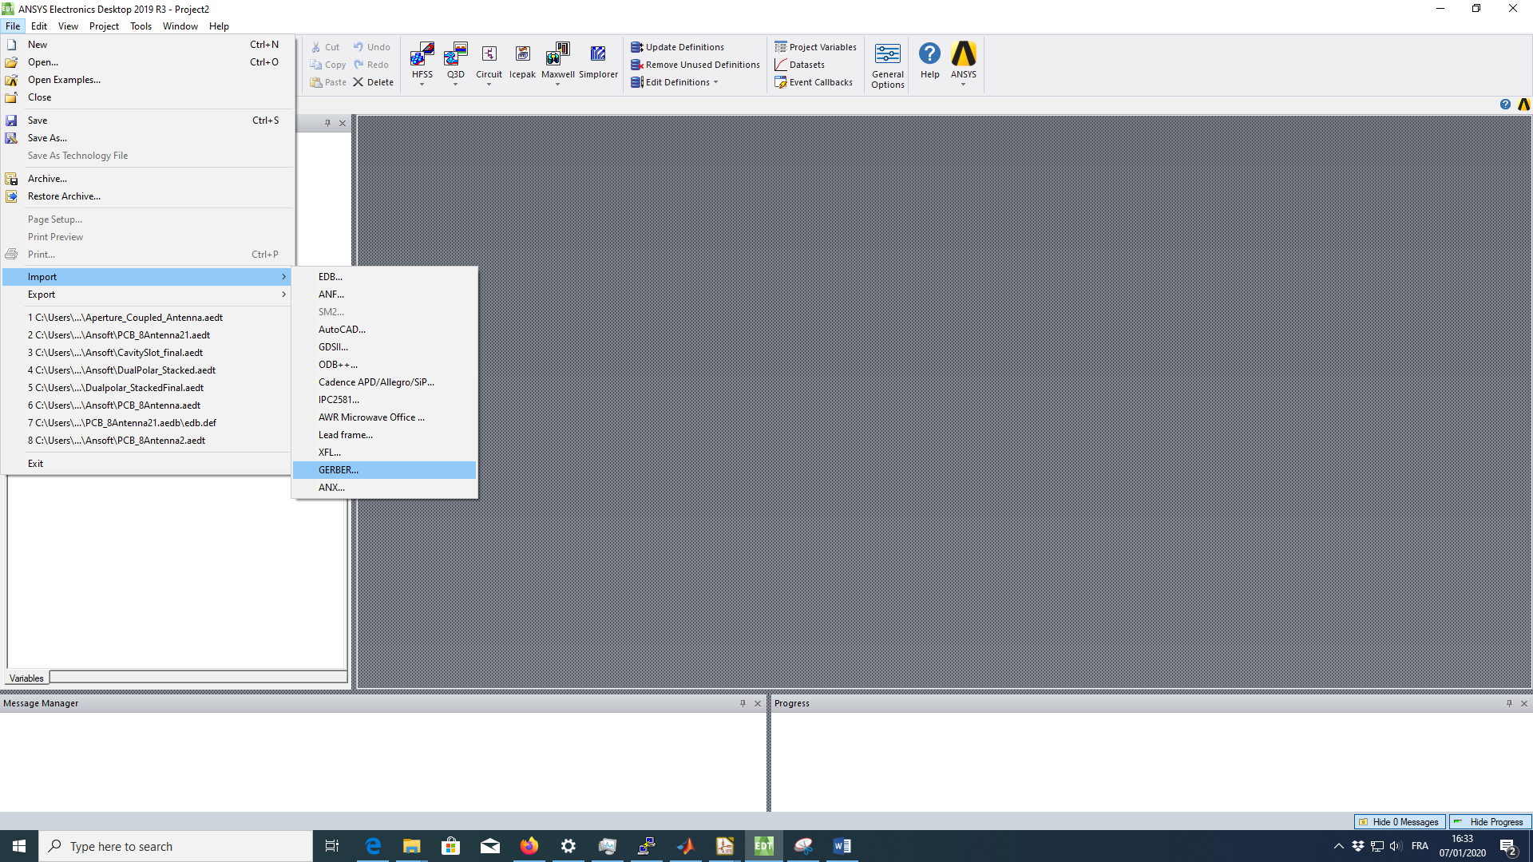

1. Choosing Ground layer. Power layer might be required in some cases:

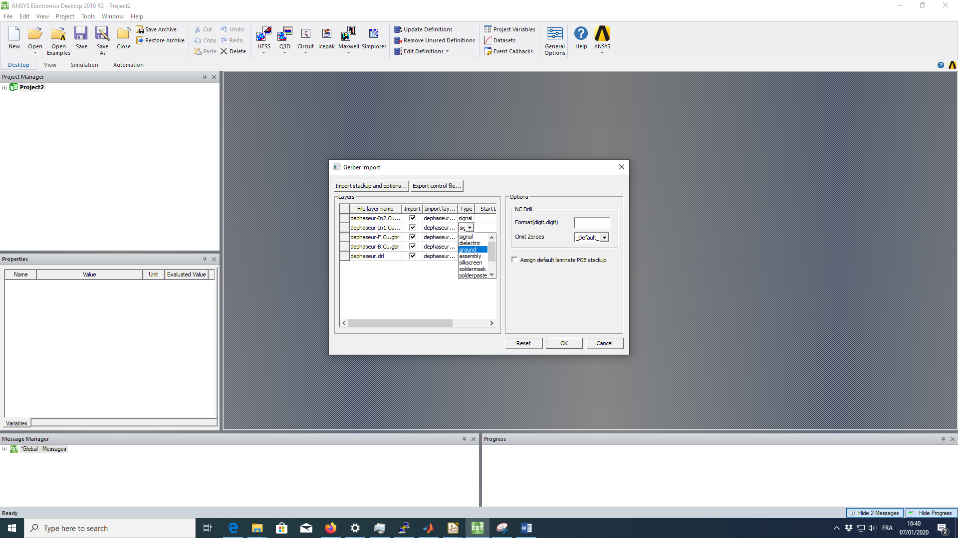

Imported PCB as following, containing only copper layers

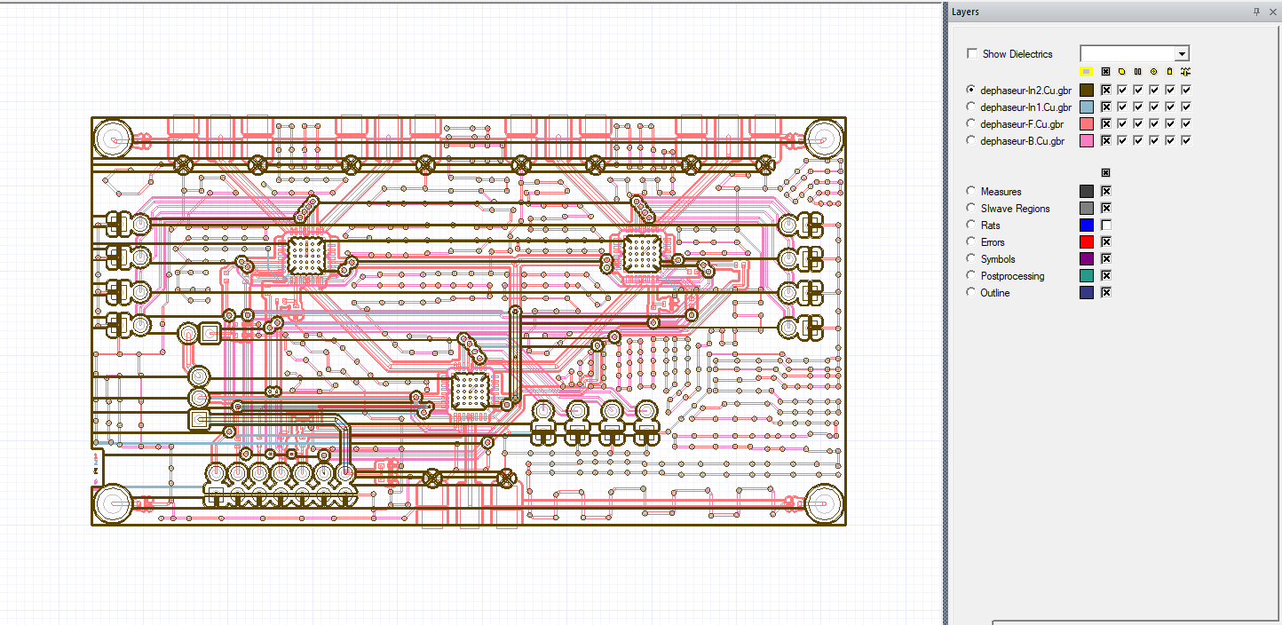

1. Add Dielectric layers and assign layers’ width

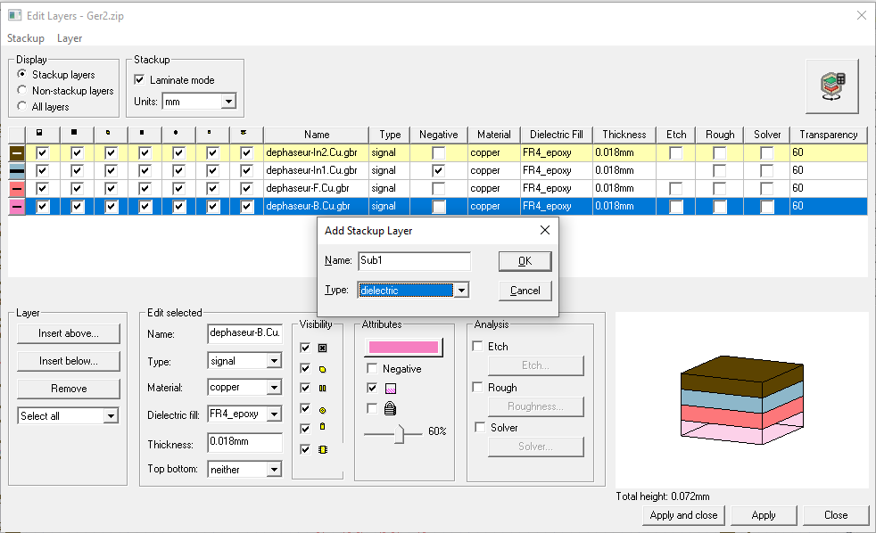

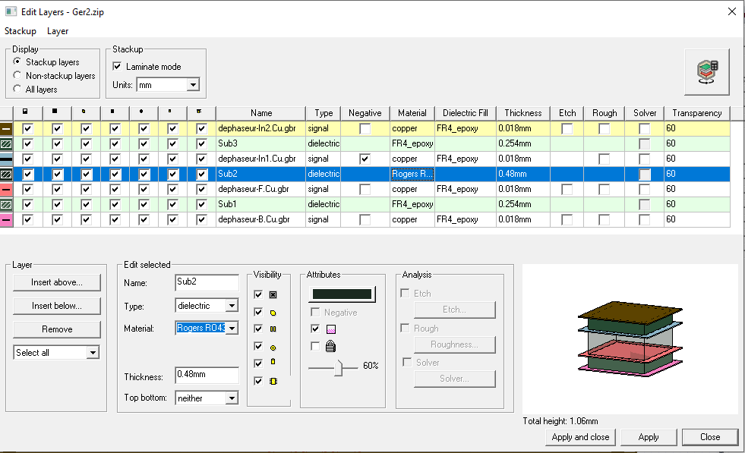

1. Assign EDGE ports and modify geometry

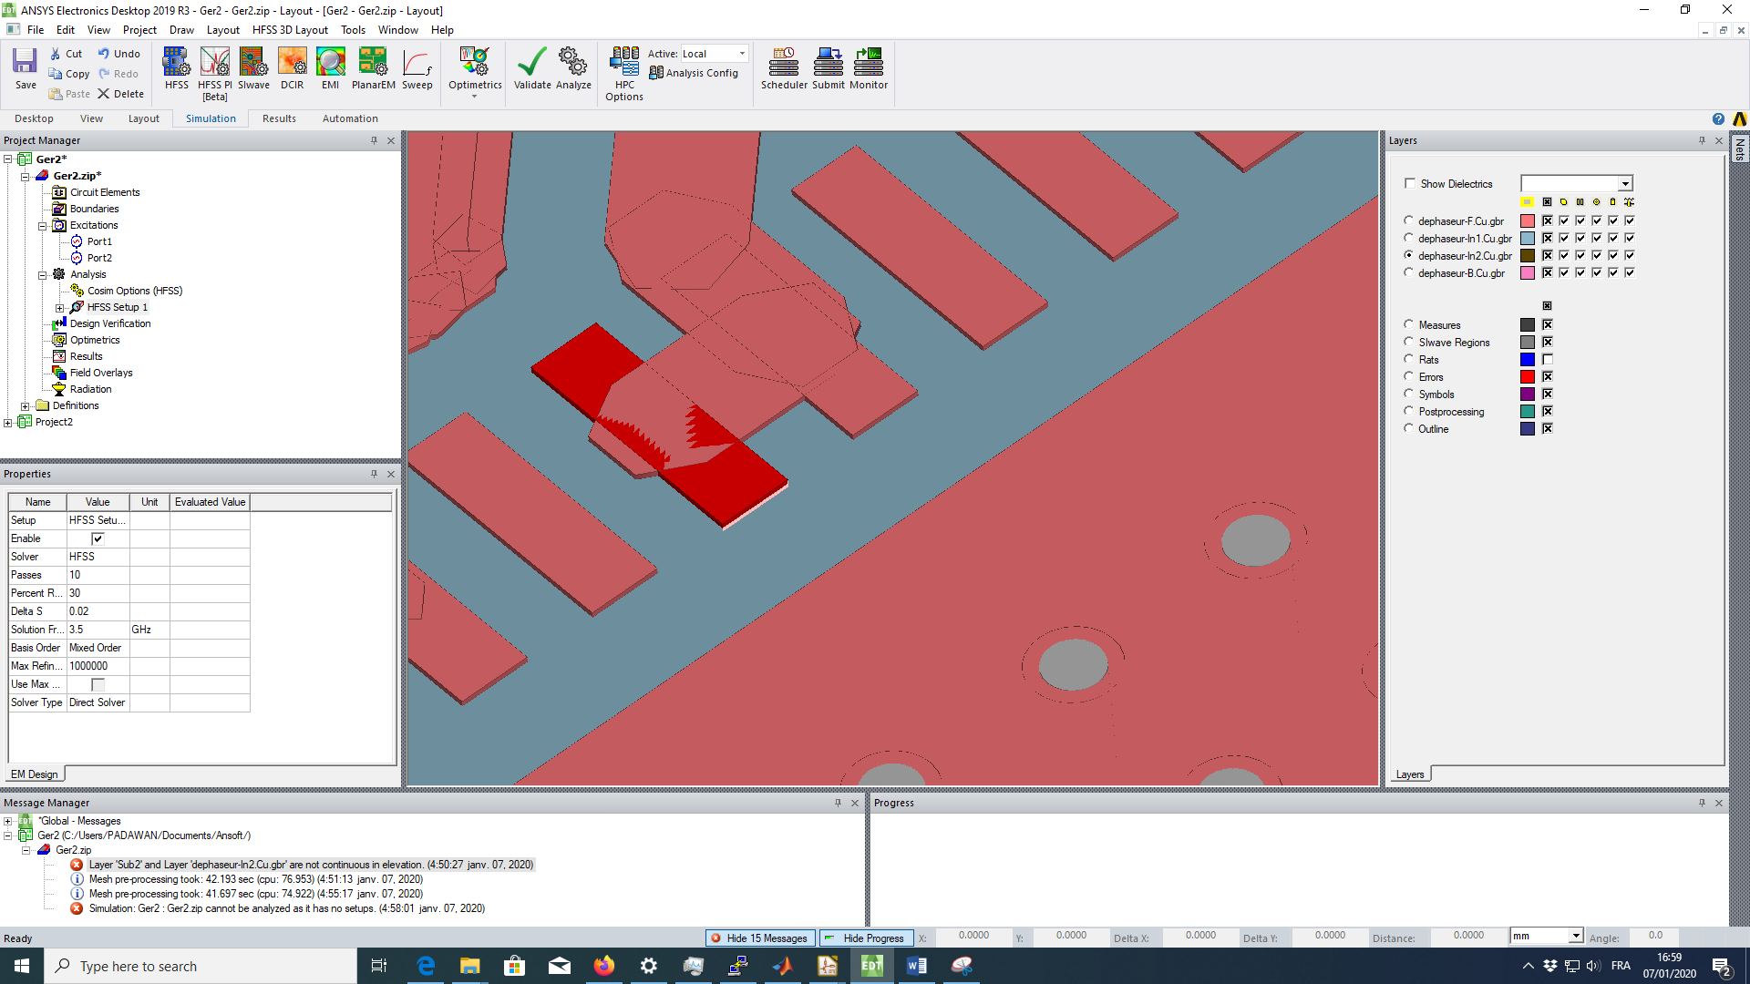

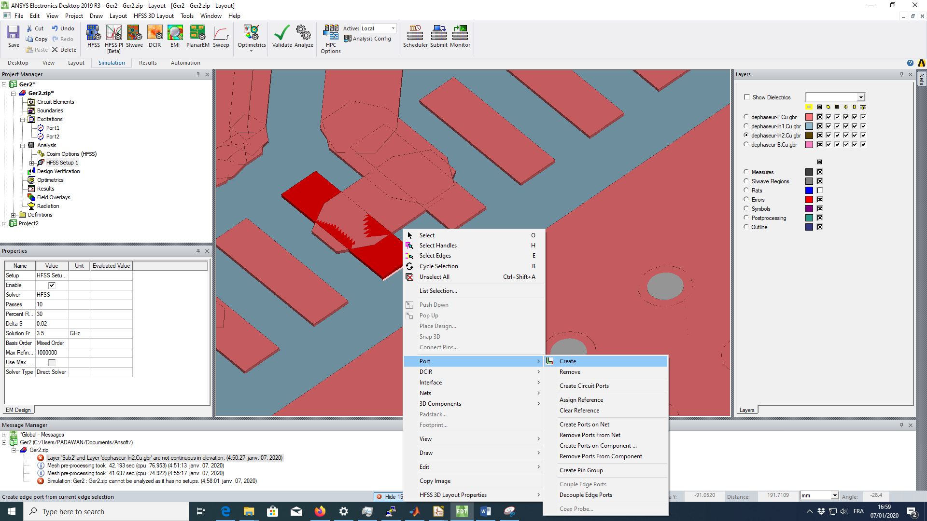

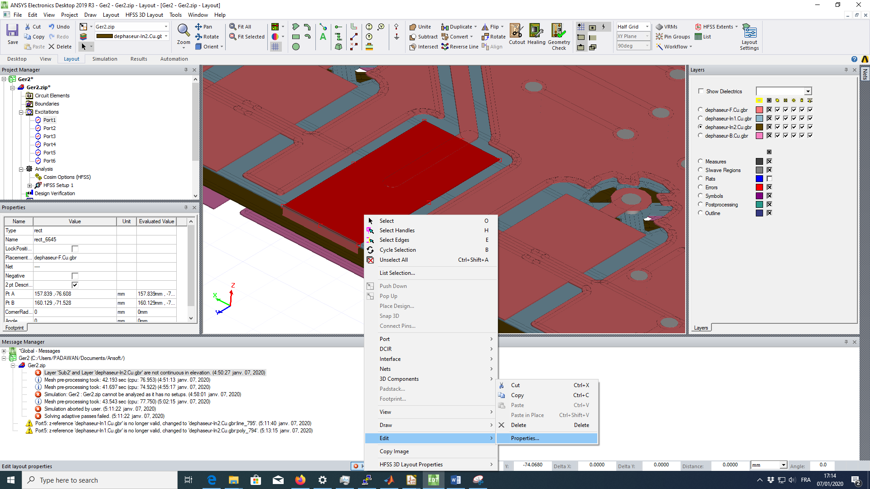

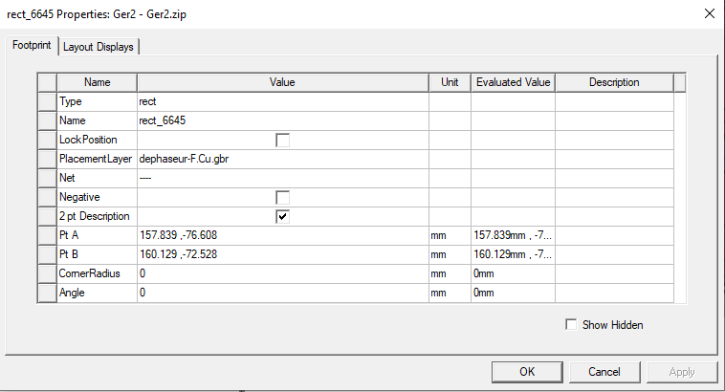

1. Analyze the design:

* Transmission

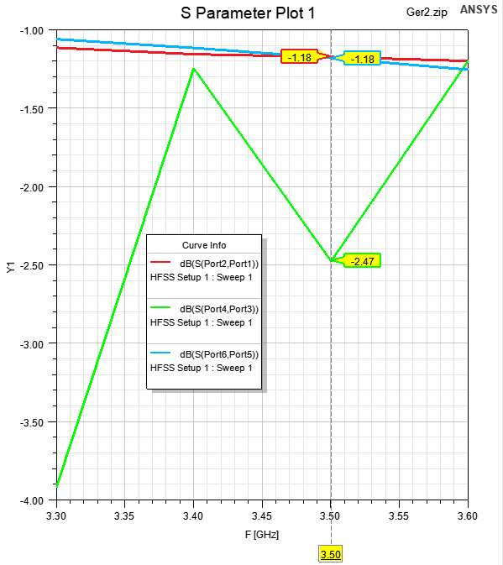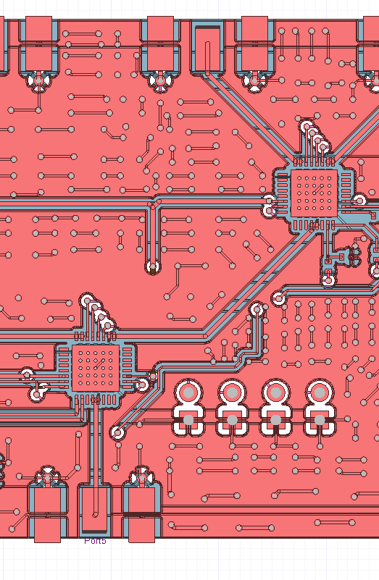

**6**

**5**

**4**

**3**

**2**

**1**

For every phase-shifter passed, there is 7.1dB loss. So, For this design, from port 6 to port 1:

LossTOT = 2*7.1 + 2*1.2 + 2.5 = 19.1 dB @3.5GHz

With 4 parallel ports:

LossIn-Out = LossTOT + 6dB = 13.1dB @3.5GHz

* Is the TM lines’ width optimal?
* 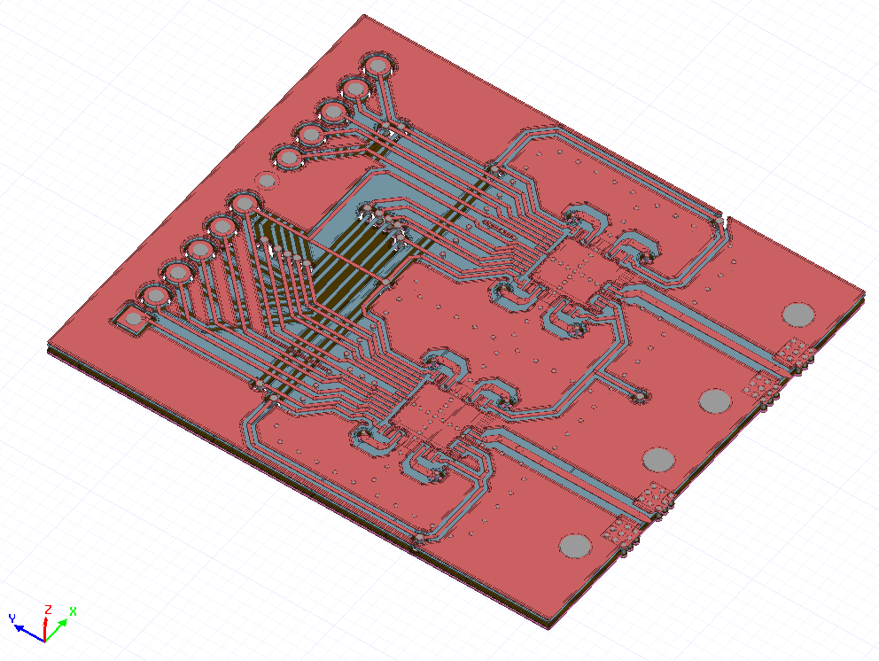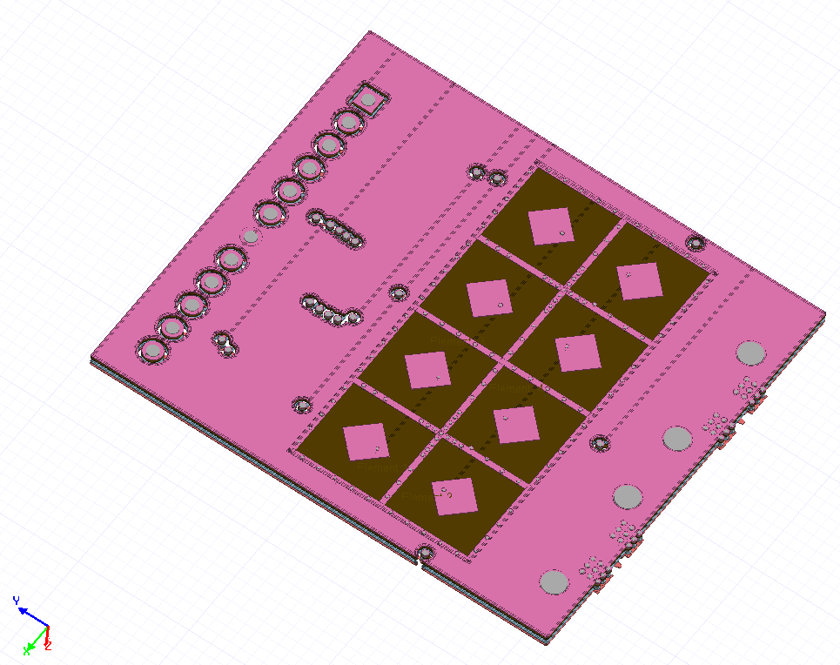Radiation

Top View

Bottom View

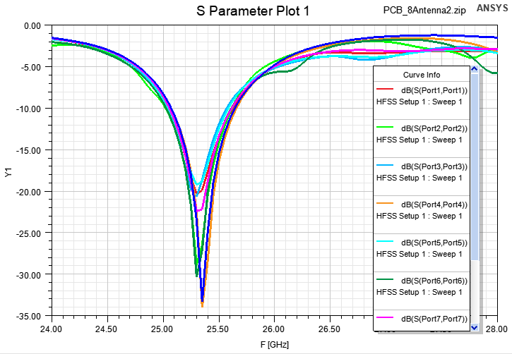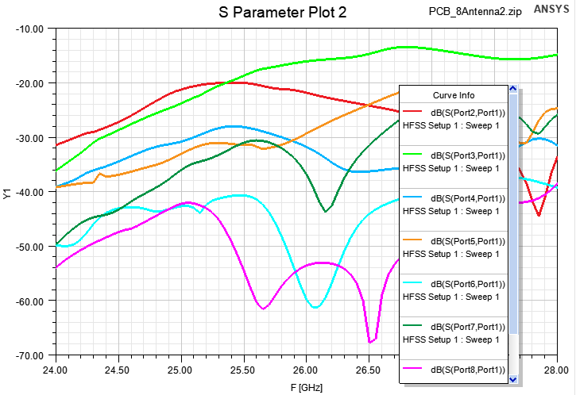

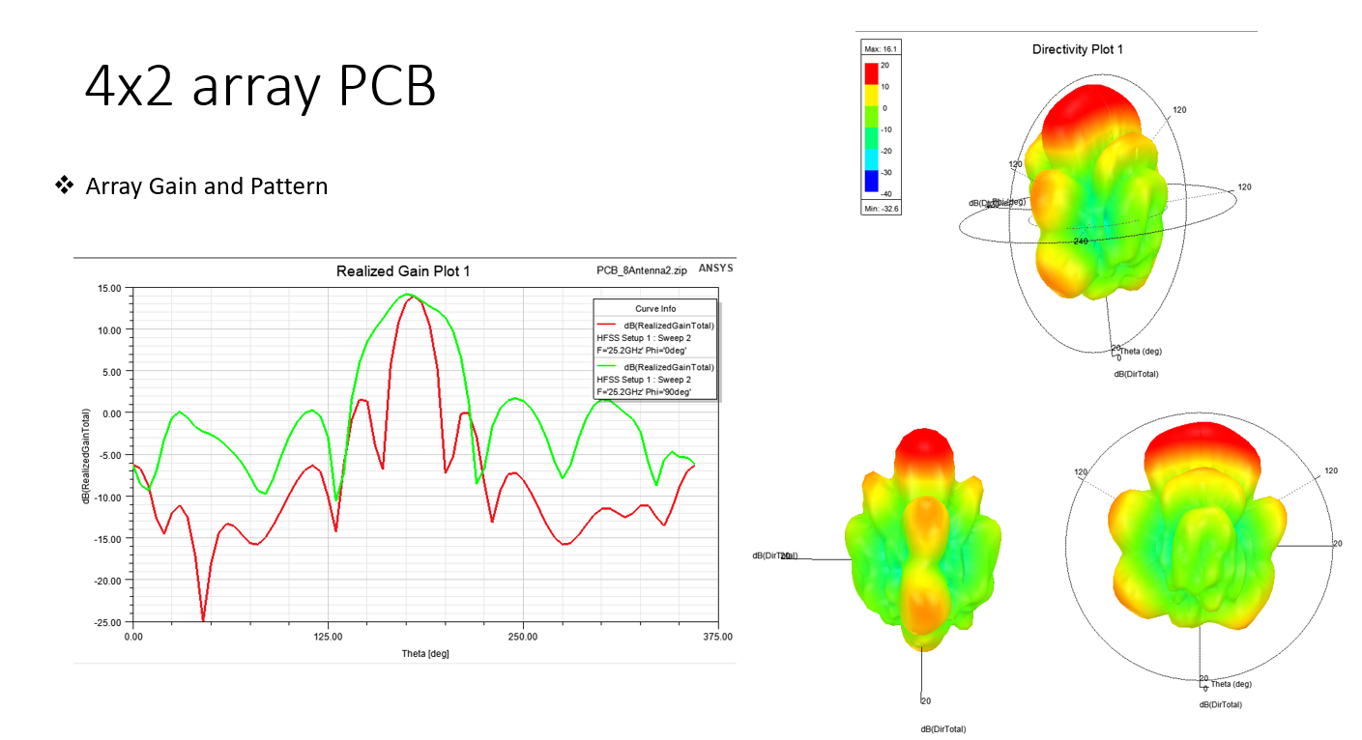

* Is frequency band large enough?