**Clustering:**

**K Means Clustering**

**Advantages:**

* Relatively simple to implement.
* Scales to large data sets.
* Guarantees convergence.
* Can warm-start the positions of centroids.
* Easily adapts to new examples.
* Generalizes to clusters of different shapes and sizes, such as elliptical clusters.

**Disadvantages:**

* Choosing K Manually
* Being Dependent on initial values
* Clustering data of varying sizes and density
* Clustering outliers
* Scaling with number of dimensions

**Fuzzy C Means**

**Advantages:**

* Gives best result for overlapped dataset and comparatively better than k-means algorithm
* Unlike K means where data point must exclusively belong to one cluster center here data point is assigned membership to each cluster as a result of which data point may belong to more than one cluster center.

**Disadvantages:**

* Apriori specification of the number of clusters
* Comparatively a slower algorithm because we have to compute the membership of each data point in each cluster
* Sensitive to initialization of the weight matrix
* With lower value of B we get better result but at the expense of more number of iteration
* Euclidean distance measures can unequally weight underlying factors

**Graph Based Clustering**

**Advantages**

**LightFM**

**Advantages:**

* LightFM can merge the content and collaborative filtering based recommendation to create a robust hybrid recommendation system
* LightFM is a Python implementation of a number of popular recommendation algorithms for both implicit and explicit feedback.

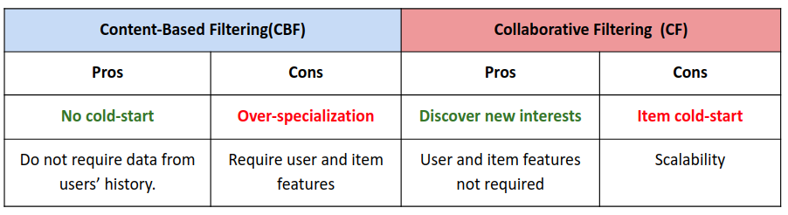

**Disadvantages**

* LightFM Hybrid can perform worse than the Pure collaborative filtering LightFM [1]

**[1] https://amanda-shu.medium.com/lightfm-performance-7515e57f5cfe**