# BUBT

**Bangladesh University of Business & Technology**



**Project proposal**

**Course Title:** Software Development-3

**Course Code:** CSE 300

**Project Name:** Online Rent Advertisement System

**SubmittedBy:**

Group Members are: **SubmittedTo:**

Khairul Anam Mubin Atia Habiba

ID:17182103286

Md. Sahrial Alam Department of CSE

ID:17182103334 BUBT

Iqbal Hassan

ID:17182103317

Md. Aminul Islam

ID:17182103319

Intake:38th , Section: 07

Program: B.Sc Engg. in CSE

**TABLE OF CONTENTS**

* Title of project
* Introduction
* Objectives
* Environment /Tools
* Target Audience/User
* Description of the project
* Diagram
* Conclusion

**Title of Project:**

Our Project is about **Online Rent Advertisement System**. It’s an online application or web-platform.

**Introduction:**

The primary aim of the system is to develop a better service that will help users driven information when they find any rental issues. It will change and develop our society. We know that when we are looking for any house for rent, car rent or something like that of all rental issue, sometimes we suffer most. We think, it is a system that will help to remove this kind of rental issues. So, People can easily find their rental things.

**Objectives:**

* Users can easily find their rental service what they need.
* To save time to find any rental things.
* User can easily find his tenant.
* User will find any rental thing where he wants wherever the location.
* This is an online base system. So, the program will update day by day so user can quickly rent his desire.
* People can easily rent their houses, transportations, commercial property, garage, store house, shops, occasionally decoration things, and others.

**Environment /Tools:**

# Functional/Non Functional Requirements:

* Operating System: Windows 7,8,10
* RAM 1GB required
* Language: HTML, CSS, PHP, JAVASCRIPT
* Database Management System: Xampp for local host database service with MySQL.

**2**.**Software Requirement:**

* XAMMP, PHPSTROME

**Target Audience/User:**

* A person who find any rental things.
* A person who wants to rent his building, Transportation, commercial property, occasionally decoration, ornaments, clothes, etc.

**Short Description of our Project:**

Rent, simply meaning to pay someone for the use of something typically property, land, or a car etc. There are big number of people regularly needs home rent for living and there are also big number of rents. Not only home, people also use to rent commercial properties, stores, garage , shop , cars , trucks , bus , decorations , ornaments and clothes etc.There are many types of rent available and that reason we need some digital advertisement for rent.So we are going to build a system and solution where everyone can advertise their things or properties. This system has Register and login system along with search and see rent advertises for visitors. A successful register can also update his information, search and see rent advertises, create, update and remove his own advertises, see his own advertises and can added those advertises to promotions. Promotions system need some payment to our system. It can be managed through any online payment system. The promotional advertises will get priority to the site visitors when anyone searching for the rents. In the site maintenance system, the admin will approve any advertise, verifies the payments and promotions.

**Data Flow Diagram (DFD):**

A **context diagram**, sometimes called a **level** 0 data-**flow diagram**, is drawn in order to define and clarify the boundaries of the software system. It identifies the flows of information between the system and external entities.

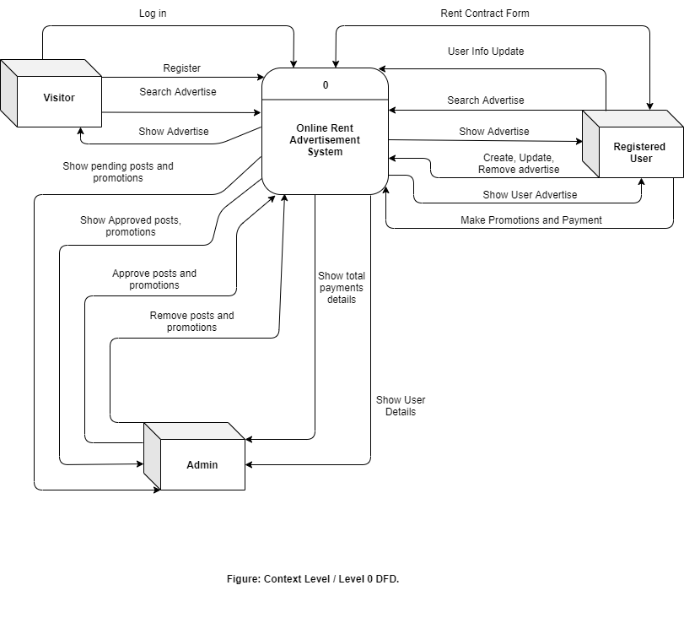

**Conclusion:**

Now a days most of people are connected in virtual life. Everything is going to under online and digitalized system. So, We think Online rent system is a stage that people can easily find any rental things and also can make their rent advertises. It saves our valuable time.