On-Device YOLOv8 for Classifying Fishers' Catch Species on Android

Juliana Sari¹, Angga Pratama², Veri Ilhadi³
Department of Information Systems, Faculty of Engineering, Universitas Malikussaleh, Lhokseumawe, Indonesia^{1,2,3}
xxxx@xxxx.xxx¹, xxx@xxxx.xxx², xxx@xxxx.xxx³

Article Info |  | ABSTRACT
Article history:  Received Okt 27, 2017  Revised Dec 21, 2017  Accepted Jan 3, 2018 |  | Small-scale fishers in Lhokseumawe recorded catch species by eye, which caused recording errors between similar species. This study built Fish Scan, an Android application that classified six catch species with YOLOv8. We collected 350 primary images in seven categories, including a Non Fish class, and expanded them to 768 images through Roboflow augmentation. We trained YOLOv8s for 100 epochs and converted the best weights to TensorFlow Lite for offline, on-device inference in Flutter. A dual confidence threshold dropped detections below 0.40, labeled detections from 0.40 to below 0.65 as Non Fish, and assigned a species label at 0.65 or higher. On validation data, the model reached 92.1% precision, 95.5% recall, 93.8% F1-score, 93.1% mAP50, and 86.3% mAP50-95. A manual check on 32 test images gave 97.3% recall but 67.9% precision, because the model marked 33 background regions as skipjack tuna. All 21 black-box test cases passed. The results showed that YOLOv8 on TensorFlow Lite ran offline on a mid-range Android phone and supported catch recording for small-scale fishers.
Keyword:
Android
Fish species classification
On-device inference
TensorFlow Lite
YOLOv8
 |  | © This work is licensed under a Creative Commons Attribution-ShareAlike 4.0 International License.
Corresponding Author:
Juliana Sari
Department of Information Systems, Faculty of Engineering
Universitas Malikussaleh
Lhokseumawe, Aceh, Indonesia
Email: [corresponding author email]

- INTRODUCTION
Indonesia has large marine fishery resources. The Ministry of Marine Affairs and Fisheries reported a national fish consumption of 56.39 kg per capita in 2020, up 3.47% from the previous year. In Lhokseumawe City, 2025 data from Statistics Indonesia (BPS) list 25 marine catch species. Eastern little tuna had the highest volume at 1,476,032 kg, followed by Indian mackerel at 952,496 kg and anchovy at 825,700 kg.
Small-scale fishers still lack a simple and reliable way to record their catch. The logbook obligation applies only to vessels above 5 GT [1]. Apps such as Buku Nelayanku [2] and NelayanKita [3] support digital recording. However, users still type the species name by hand after a visual check. This step invites recording errors, because several species share similar shapes and colors.
Many studies have applied image-based methods to fish. Rachmat and Mahendra used SVM with HOG and HSV features to classify marine fish [4]. Jerandu et al. used KNN with HSV color features to assess fish freshness [5]. Justam et al. deployed a CNN in an Android app [6]. Rakhmat and Haekal added Squeeze-and-Excitation blocks to MobileNetV3 and reached 68% accuracy [7]. These methods classify the whole image and do not locate the fish.
YOLO (You Only Look Once) performs detection and classification in a single stage. Kuswantori et al. reached 98.15% accuracy for eight species on a conveyor sorting system [8] and later improved the result with YOLOv8 [9]. Prameswari et al. achieved 98.2% mAP@0.5 on the Fish-gres dataset [10]. Wang added random mask attention to YOLOv8 for ten freshwater species [11]. Hindarto retrained a pretrained YOLOv8 on Indonesian native fish and reported 89.6% overall accuracy [12]. Saputra et al. used YOLOv8 to judge hairtail freshness from eye images with 0.976 precision [13]. Shah et al. added transformer blocks and a class-aware loss to YOLOv8 and reached 87.9% mAP50 on reef fish [14]. These studies ran on computers or servers. Effendi et al. showed that TensorFlow Lite can run object detection on Android without internet [15], but their case was face mask detection.
This study fills that gap with three contributions. First, we run YOLOv8s in TensorFlow Lite format fully on an Android device through Flutter. Second, we design a dual confidence threshold that rejects non-fish objects. Third, we train the model on primary images of six species caught by Lhokseumawe fishers and store detection history on the device as a catch record. Pratama et al. previously built an Android information system to locate shrimp pond raw materials in Lhokseumawe [16]. This study extends Android use to capture fisheries in the same region.
- RESEARCH METHOD
We used an applied research approach with an experimental method. Figure 1 shows the eight research stages: image collection, annotation, preprocessing and augmentation, training, evaluation, TensorFlow Lite conversion, app integration, and testing. When the evaluation result was not adequate, the process returned to training with new parameters.
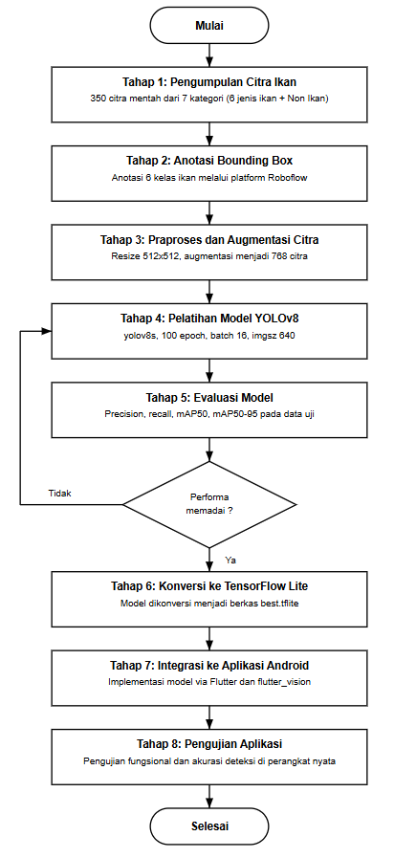
Figure 1. Research stages
2.1. Data Collection and Processing
We collected 350 primary images with a phone camera at a fish landing site. The data split evenly into seven categories of 50 images each. Six categories were target species: barramundi, red mullet (belanak merah), skipjack tuna (cakalang), white snapper (kakap putih), Indian mackerel (kembung), and sardine (sarden). The seventh category, Non Fish, contained hands, containers, tables, and other objects in the work area. We took the photos under natural and artificial light with varied backgrounds.
We labeled each fish with a bounding box in Roboflow using the YOLO format. Non Fish images received no box, so they served as negative background images. Figure 2 shows sample annotations. Preprocessing applied auto-orient to remove EXIF rotation and resized each image to 512 × 512 pixels with the stretch method.
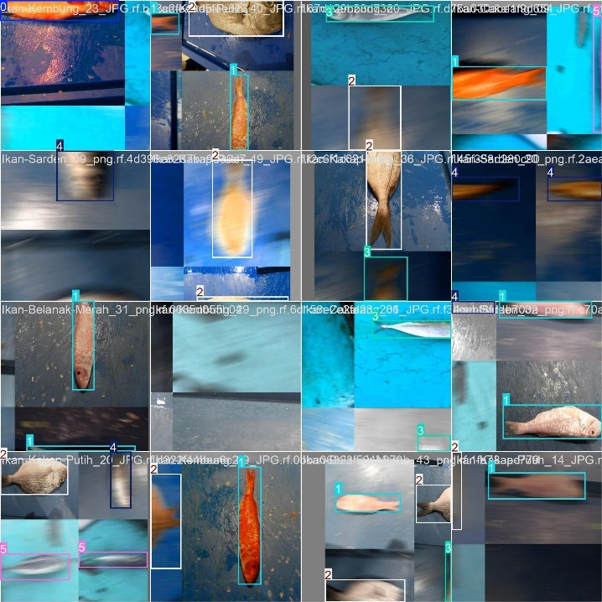
Figure 2. Sample bounding box annotations
Roboflow augmentation produced three versions of each source image. The techniques included horizontal and vertical flips, 90° rotation, grayscale on 15% of the images, ±25% saturation, ±15% brightness, ±10% exposure, blur up to 2.5 pixels, and motion blur. During training, YOLOv8 added dynamic augmentation: mosaic, HSV shifts, translation, scaling, random erasing, and RandAugment. The final dataset held 768 images. Table 1 shows the split.
Table 1. Dataset split
Subset | Images | Share
Training | 672 | 87.5%
Validation | 64 | 8.3%
Test | 32 | 4.2%
Total | 768 | 100%

2.2. YOLOv8 Architecture and Training
YOLOv8 has three parts: backbone, neck, and head [17]. The backbone extracts features with C2f modules. The neck fuses multiscale features through PAN-FPN. The head predicts classes and box coordinates separately without anchor boxes. We chose the YOLOv8s variant because it is light enough for mobile devices. We trained the model on Google Colab with a GPU, starting from the yolov8s.pt pretrained weights. Table 2 lists the main parameters. Training took about 1,608 seconds. We then exported the best weights (best.pt) to best.tflite.
Table 2. YOLOv8 training parameters
Parameter | Value | Parameter | Value
Model | yolov8s.pt | Momentum | 0.937
Epochs | 100 | Weight decay | 0.0005
Batch size | 16 | Warmup epochs | 3
Image size | 640 × 640 | Loss weights (box/cls/dfl) | 7.5 / 0.5 / 1.5
Optimizer | auto | NMS IoU | 0.7
lr0 / lrf | 0.01 / 0.01 | Close mosaic | 10 epochs

2.3. Evaluation Metrics
We measured performance with IoU, precision, recall, F1-score, and mAP [18]. IoU compares the predicted box with the ground truth box, as in (1). A prediction with IoU above the threshold counts as a true positive (TP).
$IoU=\frac{\text{Area of Overlap}}{\text{Area of Union}}$ | (1)
Equations (2) to (4) define precision, recall, and F1-score. A false positive (FP) is a wrong detection. A false negative (FN) is an object that the model missed.
$\text{Precision}=\frac{TP}{TP+FP}$ | (2)
$\text{Recall}=\frac{TP}{TP+FN}$ | (3)
$\text{F1}=2×\frac{\text{Precision×Recall}}{\text{Precision+Recall}}$ | (4)
mAP is the mean of the average precision (AP) over n classes, as in (5). We used mAP50 at IoU 0.5 and mAP50-95 over IoU 0.5 to 0.95. Several metrics together give a more objective picture than a single metric [19], [20].
$\text{mAP}=\frac{1}{n}\sum_{i=1}^{n}{{\text{AP}}_{i}}$ | (5)
2.4. Application Design and Dual Threshold
We built the Fish Scan app with Flutter and Dart [21], [22]. The app targets Android 8.0 (SDK 26) and above. The best.tflite model runs on the device CPU through the flutter_vision plugin, which we modified for the NCHW output tensor. The app offers two detection modes: image upload from the gallery or camera, and real-time detection. It saves every detection result and its photo in a history.json file.
The model has no box for the Non Fish class. The app therefore filters results with two confidence thresholds, as in Table 3. We chose the 0.65 identification threshold based on the F1-Confidence curve. For on-device inference, the IoU threshold for non-maximum suppression (NMS) is 0.45.
Table 3. Dual confidence threshold logic
Confidence range | System action
c < 0.40 | Drop the detection as no object
0.40 ≤ c < 0.65 | Show the object with the Non Fish label
c ≥ 0.65 | Assign one of the six species labels

- RESULTS AND ANALYSIS
3.1. Training Results
Figure 3 shows the loss and metric curves over 100 epochs. Box loss, classification loss, and DFL on the training data fell steadily. Validation loss fell in the same direction. This pattern shows no meaningful overfitting. Table 4 lists the values at selected epochs.
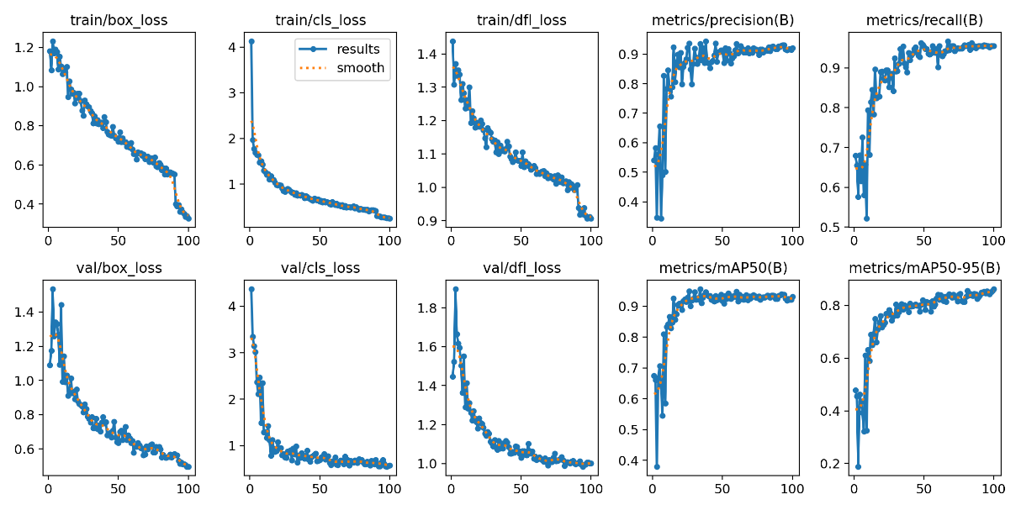
Figure 3. Loss and metric curves during training
Table 4. Loss and validation metrics per epoch
Epoch | Train box loss | Val box loss | Precision | Recall | mAP50 | mAP50-95
1 | 1.182 | 1.090 | 0.541 | 0.680 | 0.676 | 0.478
9 | 1.103 | 1.442 | 0.501 | 0.521 | 0.585 | 0.325
19 | 0.916 | 0.890 | 0.856 | 0.891 | 0.910 | 0.761
49 | 0.738 | 0.641 | 0.913 | 0.959 | 0.939 | 0.821
69 | 0.631 | 0.569 | 0.903 | 0.955 | 0.933 | 0.838
89 | 0.556 | 0.561 | 0.918 | 0.956 | 0.925 | 0.832
100 | 0.326 | 0.498 | 0.921 | 0.955 | 0.931 | 0.863

Performance dropped briefly at epoch 9. Precision fell to 0.501 and mAP50 fell to 0.585. After epoch 19, the metrics rose and stayed above 0.90. At epoch 100, the model reached 0.921 precision, 0.955 recall, 0.931 mAP50, and 0.863 mAP50-95. Based on (4), the F1-score was 0.938. The gap between mAP50 and mAP50-95 shows that box placement can still improve at strict IoU levels.
Figure 4 shows the Precision-Confidence and F1-Confidence curves. Precision rose toward 1.0 at high confidence. Recall fell, because fewer detections passed the threshold. The F1 curve guided our choice of the species identification threshold in the app.
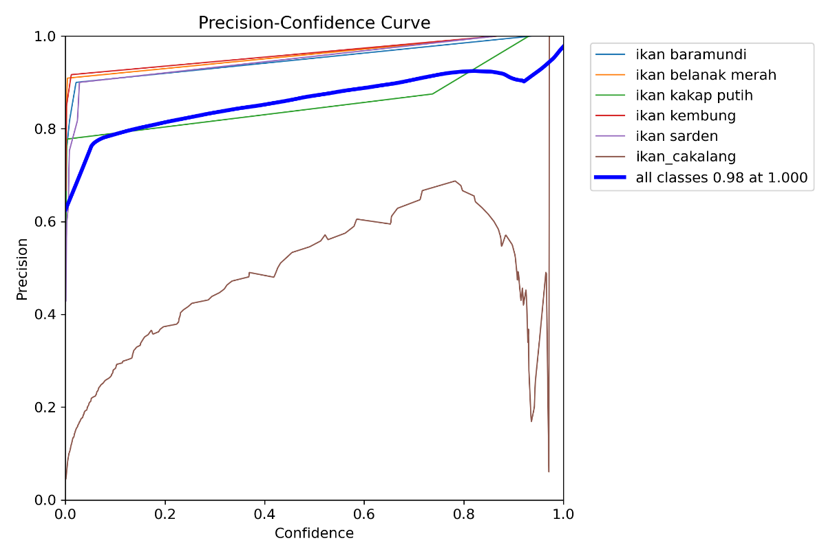  (a) | 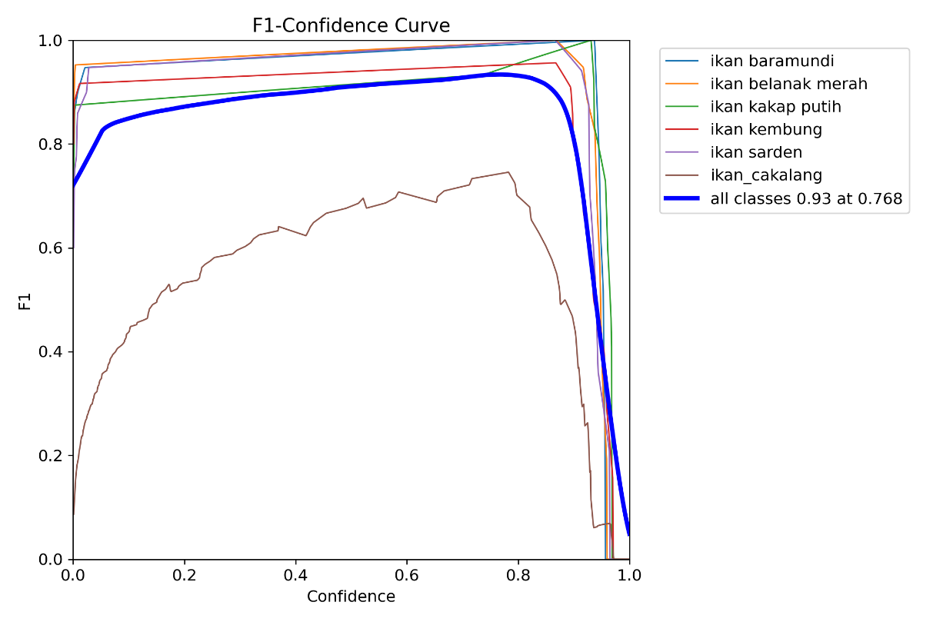  (b)
Figure 4. Evaluation curves: (a) Precision-Confidence, (b) F1-Confidence
3.2. Test Set Evaluation
Figure 5 shows the confusion matrix on 32 test images. Most predictions lie on the diagonal. The skipjack tuna class produced the largest error. The model read 33 background regions as skipjack tuna and missed one skipjack tuna. It also read one Indian mackerel as white snapper. Table 5 summarizes the manual calculation from this matrix.
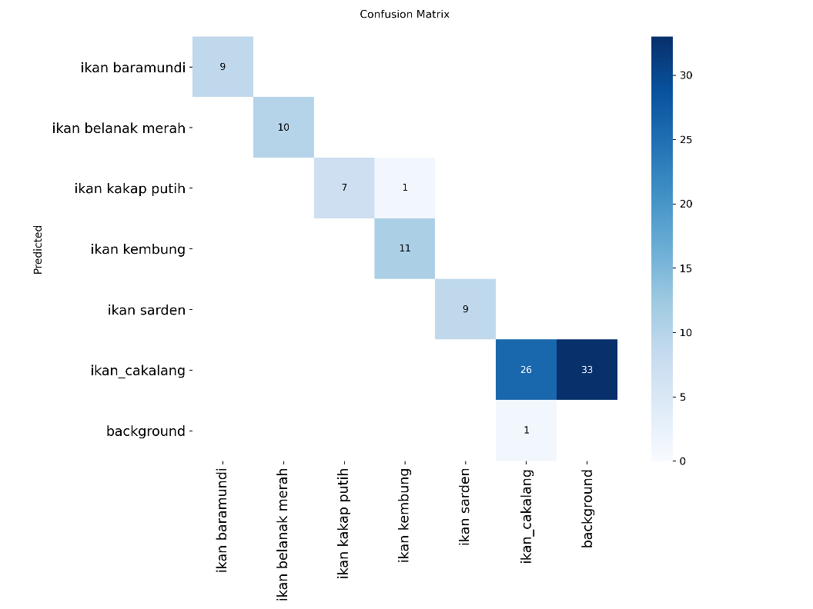
Figure 5. Confusion matrix on the test set
Table 5. Manual calculation from the confusion matrix
Item | Value | Description
TP | 72 | Sum of the diagonal (9+10+7+11+9+26)
FP | 34 | 33 background regions read as skipjack tuna, 1 Indian mackerel read as white snapper
FN | 2 | 1 Indian mackerel in the wrong class, 1 skipjack tuna missed
Accuracy | 66.67% | TP / (TP + FP + FN)
Precision | 67.92% | Equation (2)
Recall | 97.30% | Equation (3)
F1-score | 80.00% | Equation (4)

We computed accuracy without true negatives, because object detection does not label empty regions. Manual recall reached 97.30%, so the model rarely missed a fish. Manual precision was only 67.92% due to 33 false positives on skipjack tuna. This value is lower than the 92.1% precision in Table 4. The difference comes from different calculation bases. Ultralytics computes its metrics from the precision-recall curve on validation data, while the manual calculation uses one operating point on test data. We suspect that the more varied color pattern and texture of skipjack tuna caused these errors.
3.3. Application Implementation
Figure 6 shows the main screens of Fish Scan. In upload mode, the app draws a green box and shows the species name. It detected a red mullet with 96.2% confidence (Figure 6a). The detail page shows the morphology and habitat of the species (Figure 6b). In real-time mode, the camera locked on a white snapper with 88.4% confidence (Figure 6c). A drink bottle received the Non Fish label at 51.7% confidence (Figure 6d). A cartoon fish illustration also received the Non Fish label at 56.0% confidence. These results show that the dual threshold rejects objects that only resemble the shape of a fish.
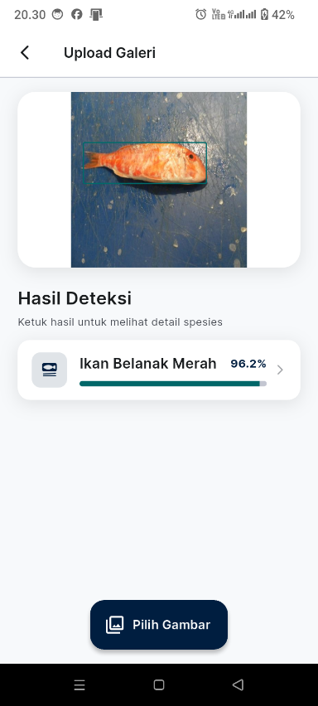  (a) | 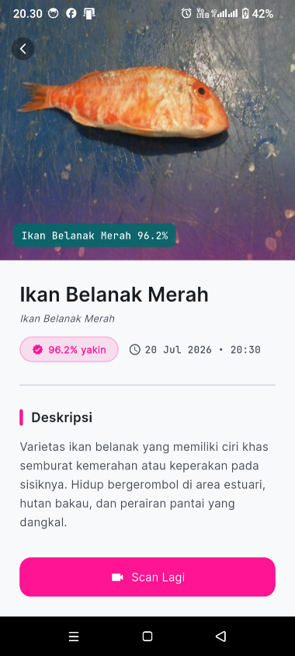  (b) | 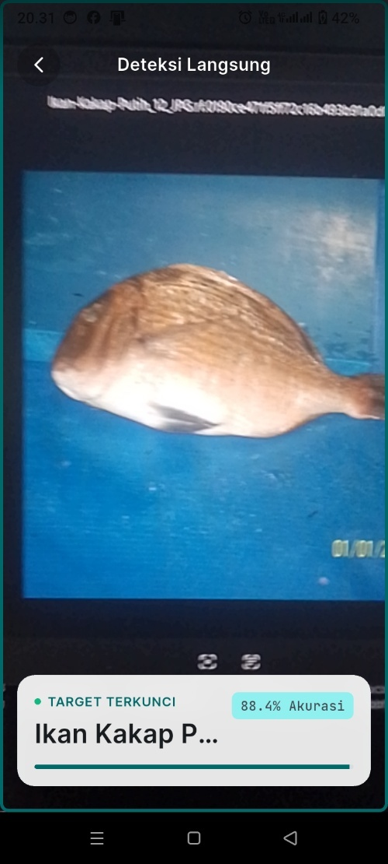  (c) | 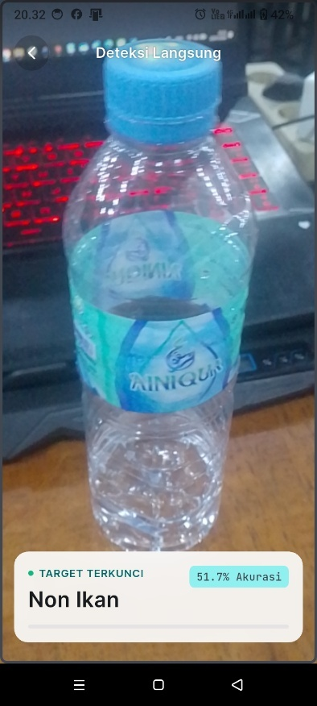  (d)
Figure 6. Fish Scan screens: (a) gallery upload result, (b) species detail, (c) real-time detection of white snapper, (d) Non Fish object
3.4. Black-Box Testing
We tested the app with the black-box method, using Equivalence Partitioning and Boundary Value Analysis. The tests ran on a Realme RMX3830 phone and an Android Emulator. Table 6 summarizes the results. All 21 test cases passed. Key cases covered camera permission denial, EXIF orientation correction, Non Fish relabeling between 0.40 and 0.65, automatic navigation after a stable 1.5-second detection, and history updates without an app restart.
Table 6. Black-box test summary
No | Test module | Cases | Passed
1 | Splash screen and main navigation | 2 | 2
2 | Upload detection (gallery and camera) | 7 | 7
3 | Real-time detection | 4 | 4
4 | Species detail and detection history | 5 | 5
5 | Settings (theme and language) | 3 | 3
 | Total | 21 | 21 (100%)

3.5. Discussion
Our 93.1% mAP50 sits below the 98.2% that Prameswari et al. reported with 2,000 images of four species [10]. It sits above the 87.9% mAP50 of YOLOv8-TF on underwater reef fish [14]. The datasets differ, so these figures mark a range rather than a direct ranking. Our dataset is smaller and comes from field photos. Unlike the server-based sorting systems [8], [9], Fish Scan keeps working without a cellular signal on the coast or at sea. The dual threshold also adds a filter without retraining the model.
This study has limits. We did not measure inference speed (FPS), memory use, or battery drain in numbers. We did not test the model under extreme light, such as night or direct sun. Fishers have not yet joined a user acceptance test.
- CONCLUSION
This study ran YOLOv8s in TensorFlow Lite format inside the Fish Scan Android app. The app recognized six species caught by Lhokseumawe fishers without an internet connection. On validation data, the model reached 92.1% precision, 95.5% recall, 93.8% F1-score, 93.1% mAP50, and 86.3% mAP50-95. The 0.40 and 0.65 thresholds consistently separated dropped detections, Non Fish labels, and species labels. All 21 black-box test cases passed, and the local detection history supported catch recording. The skipjack tuna class still produced many false positives on the test set. Future work should add skipjack tuna images, test the model under extreme light, measure device performance in numbers, apply model quantization, and run an acceptance test with fishers.
REFERENCES
[1] D. P. Yuwandana, E. Arifianto, S. H. Wisudo, J. E. Astarini, and D. Komarudin, “Conceptual design of the database system for small-scale fishers based on Android applications,” 2022.
[2] D. P. Yuwandana, E. Arifianto, S. H. Wisudo, J. E. Astarini, and D. Komarudin, “Desain konseptual sistem basis data untuk pendataan hasil tangkapan nelayan skala kecil berbasis Android,” 2023.
[3] L. Hakim, C. Al Kharraz, A. R. Maulida, S. P. Kristanto, D. H. Kusuma, and I. P. S. Mecha, “Pemanfaatan aplikasi NelayanKita untuk mendukung digitalisasi pengelolaan data nelayan di Kecamatan Muncar Banyuwangi,” Archive: Jurnal Pengabdian Kepada Masyarakat, vol. 2, no. 1, pp. 98-113, Dec. 2022, doi: 10.55506/arch.v2i1.53.
[4] N. Rachmat and A. Mahendra, “Klasifikasi jenis ikan laut menggunakan metode SVM dengan fitur HOG dan HSV,” vol. 8, no. 4, 2021. [Online]. Available: http://jurnal.mdp.ac.id
[5] C. Y. Jerandu, P. Batarius, and A. A. J. Sinlae, “Identifikasi kualitas kesegaran ikan menggunakan algoritma K-Nearest Neighbor berdasarkan ekstraksi ciri warna Hue, Saturation, dan Value (HSV),” Building of Informatics, Technology and Science (BITS), vol. 4, no. 3, Dec. 2022, doi: 10.47065/bits.v4i3.2613.
[6] J. Justam, M. N. Takbir, S. M. Umar, E. Erlita, and R. O. Lewa, “Sistem identifikasi kesegaran ikan berbasis Android menggunakan Convolutional Neural Network (CNN),” Jurnal Ilmiah Sistem Informasi dan Teknik Informatika (JISTI), vol. 7, no. 2, pp. 340-350, Oct. 2024, doi: 10.57093/jisti.v7i2.271.
[7] G. Ashari Rakhmat and M. Fikri Haekal, “Peningkatan performa MobileNetV3 dengan Squeeze-and-Excitation (studi kasus klasifikasi kesegaran ikan berdasarkan mata ikan),” MIND Journal, vol. 8, no. 1, pp. 27-41, 2023, doi: 10.26760/mindjournal.v8i1.27-41.
[8] A. Kuswantori, T. Suesut, W. Tangsrirat, G. Schleining, and N. Nunak, “Fish detection and classification for automatic sorting system with an optimized YOLO algorithm,” Applied Sciences, vol. 13, no. 6, Art. no. 3812, Mar. 2023, doi: 10.3390/app13063812.
[9] A. Kuswantori and D. J. Suroso, “Fish detection and classification using YOLOv8 for automated sorting systems,” Indonesian Journal of Artificial Intelligence and Data Mining, vol. 7, no. 2, p. 447, Jul. 2024, doi: 10.24014/ijaidm.v7i2.30967.
[10] F. Prameswari, H. Octafiani, and T. Haryanto, “You Only Look Once (YOLOv8) for fish species detection,” in IOP Conf. Ser.: Earth Environ. Sci., vol. 1359, no. 1, 2024, doi: 10.1088/1755-1315/1359/1/012023.
[11] X. Wang, “Freshwater fish detection based on the YOLOv8 model,” International Journal of Computer Science and Information Technology, vol. 5, no. 3, pp. 138-145, Apr. 2025, doi: 10.62051/ijcsit.v5n3.13.
[12] D. Hindarto, “Exploring YOLOv8 pretrain for real-time detection of Indonesian native fish species,” Sinkron: Jurnal dan Penelitian Teknik Informatika, vol. 8, no. 4, Oct. 2023, doi: 10.33395/sinkron.v8i4.13100.
[13] D. A. Saputra, I. Istiadi, and A. Y. Rahman, “Deteksi kesegaran ikan layur berdasarkan citra mata menggunakan YOLOv8,” JATI (Jurnal Mahasiswa Teknik Informatika), vol. 8, no. 5, Oct. 2024.
[14] C. Shah, M. M. Nabi, S. Y. Alaba, I. A. Ebu, J. Prior, M. D. Campbell, R. Caillouet, M. D. Grossi, T. Rowell, F. Wallace, J. E. Ball, and R. Moorhead, “YOLOv8-TF: Transformer-enhanced YOLOv8 for underwater fish species recognition with class imbalance handling,” Sensors, vol. 25, no. 6, Art. no. 1846, 2025, doi: 10.3390/s25061846.
[15] M. Makmun Effendi, A. Turmudi, and A. Arwan, “Design of mask detection application using TensorFlow Lite based on Android mobile,” Architecture and High Performance Computing, vol. 6, no. 3, 2024, doi: 10.47709/cnapc.v6i3.4329.
[16] A. Pratama, D. Yulisda, and R. Rafika, “Information system for searching nearest shrimp pond raw materials using Android-based Haversine algorithm case study Lhokseumawe,” Jurnal Tika, vol. 7, no. 3, pp. 256-264, 2022, doi: 10.51179/tika.v7i3.1572.
[17] R. Varghese and S. M., “YOLOv8: A novel object detection algorithm with enhanced performance and robustness,” IEEE, 2024.
[18] M. U. Nasution, L. S. Harahap, and F. Syakbani, “Tinjauan metode pengolahan citra digital untuk deteksi objek otomatis,” Jurnal Informatika dan Teknik Elektro Terapan, vol. 13, no. 3, Jul. 2025, doi: 10.23960/jitet.v13i3.7135.
[19] L. Kurniawati, D. Priyanto, N. S. Ningsih, M. Syahrir, and R. Rismayati, “Perbandingan metode berbasis decision tree dalam deteksi penyakit paru-paru,” Jurnal Bumigora Information Technology (BITe), vol. 7, no. 1, pp. 51-62, Jun. 2025, doi: 10.30812/bite.v7i1.4909.
[20] A. Rahman, V. Ilhadi, and I. Yurni, “Analysis of student satisfaction feasibility evaluation in learning materials with the K-Nearest Neighbor model,” Jurnal Tika, vol. 9, no. 1, pp. 68-92, 2024, doi: 10.51179/tika.v9i1.2746.
[21] E. Johnson and G. Wang, “Flutter framework mobile application development of gamified automotive reseller team management,” 2023. [Online]. Available: http://ejournal.seaninstitute.or.id/index.php/InfoSains
[22] A. Md Sattar, P. Soni, M. Kr Ranjan, A. Kumar, C. Sahu, S. Saxena, and P. Chaudhari, “Open source developments accelerating cross-platform development with Flutter framework,” 2023, doi: 10.37591/JoOSD.

