
System Requirement Finalization
MICR Cheque Printing

- User Login (Only for Admin)
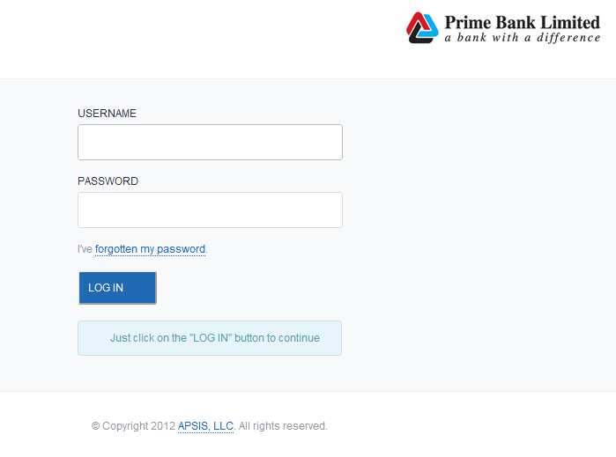
For any kind of edit or upload you have to login

- For Add New/Edit existing supplier (Admin user only)
For add New ➔MASTER DATA ➔ MANAGE SUPPLIER ➔Click Create New
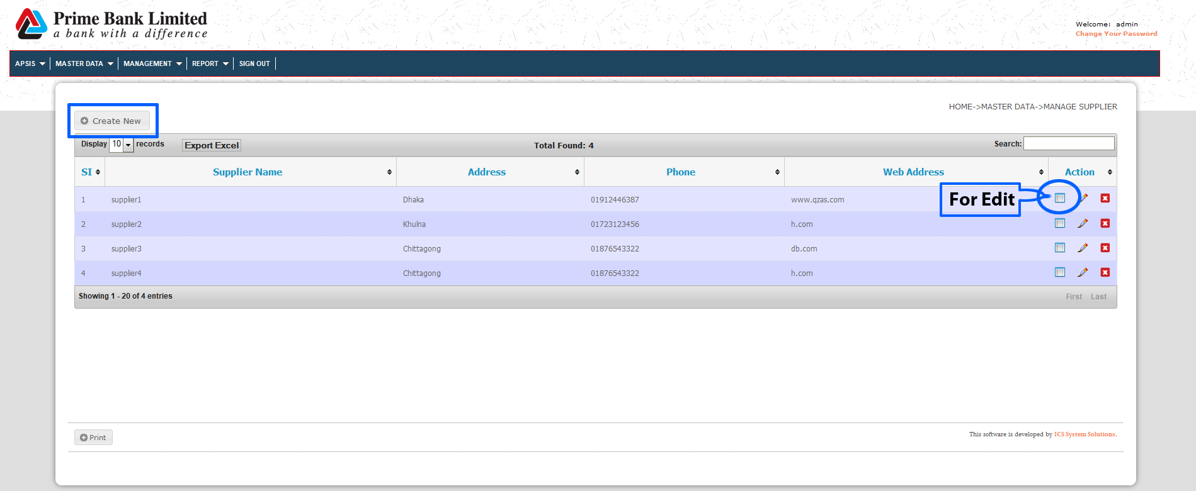
For Edit ➔MASTER DATA ➔ MANAGE SUPPLIER ➔ Click Edit Button

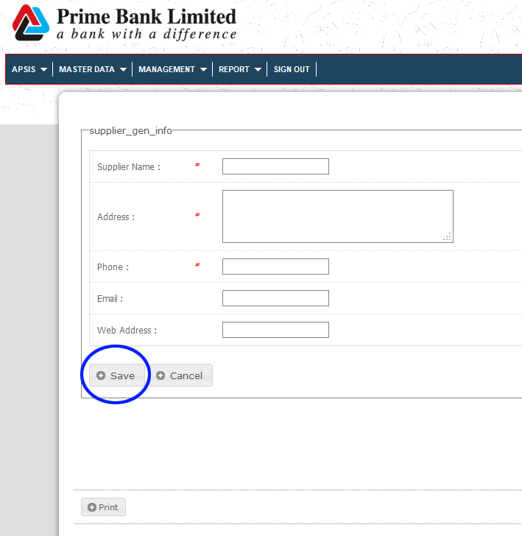
Create Page: Please fill up all fields (*) and click Save Button

Edit Page: After Editing click Update Button
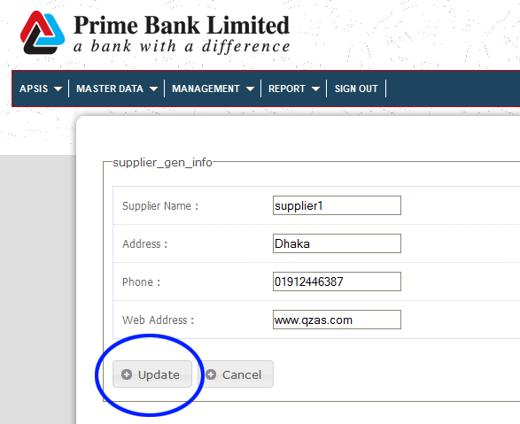
- For Add New/Edit existing Supplier Rate (Admin user only)

For add New ➔MASTER DATA ➔ SUPPLIER RATE ➔Click Create New

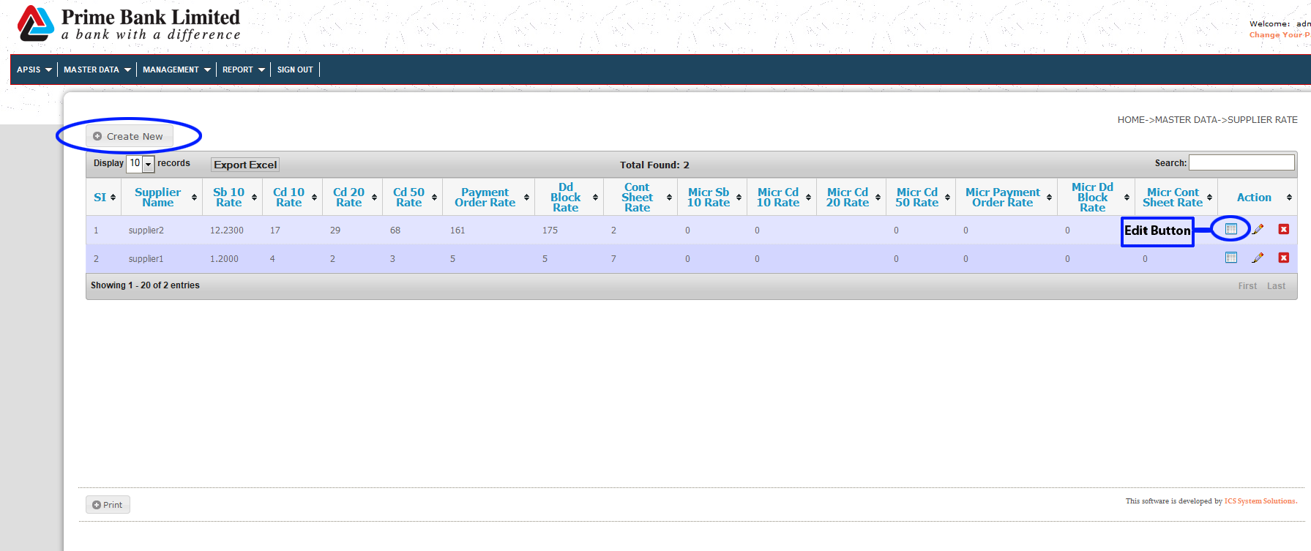
For Edit ➔MASTER DATA ➔ SUPPLIER RATE ➔Click Edit Button

Create Rate: Please fill up the fields (*) click Save Button
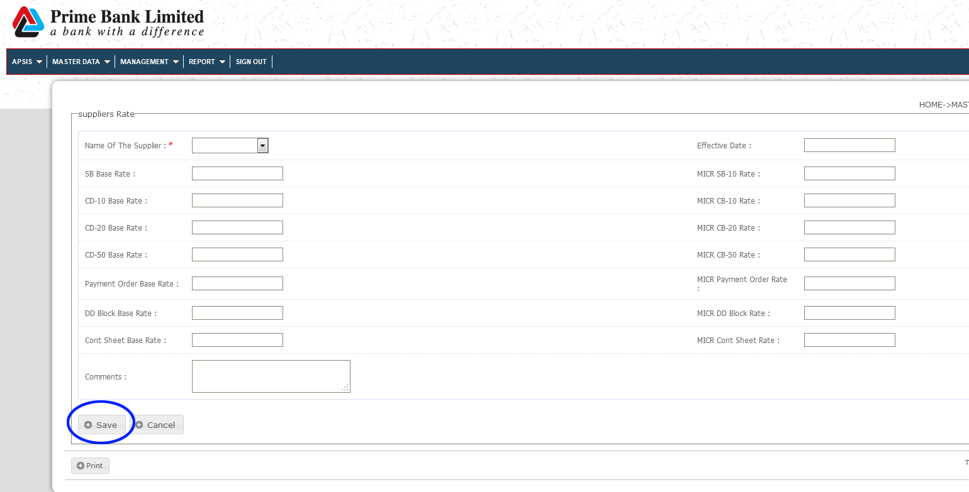
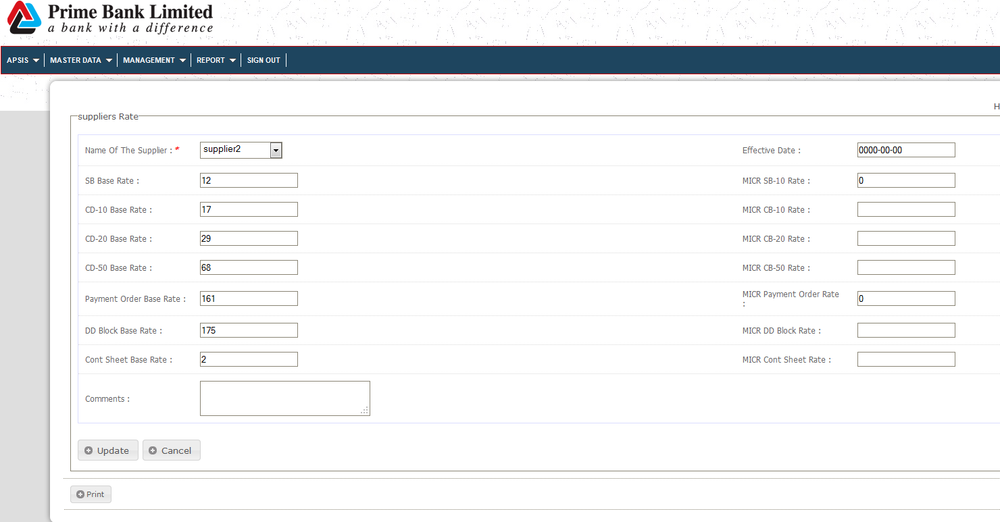
Edit Rate: After Editing click Update Button

- For Upload MICR Cheque Order Request File (All Users)

For Upload Order Request ➔MANAGEMENT ➔ Upload Order Request ➔ Click SELECET FILE button ➔ Upload your file and click Save Button
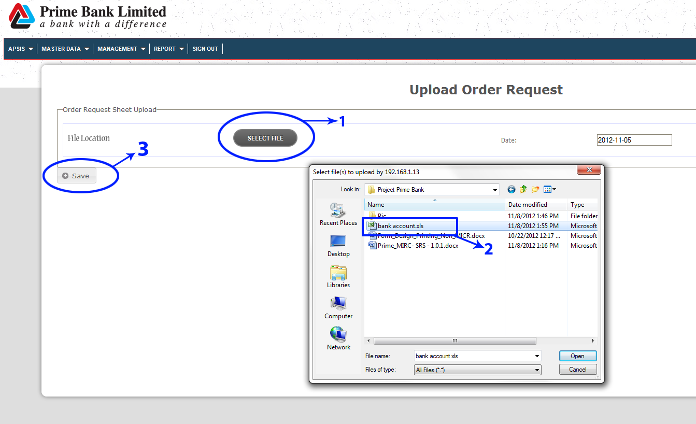
- For Issue MICR Cheque Order to Supplier (All Users)

For Issue Work Order to Supplier ➔ MANAGEMENT ➔ WORK ORDER ISSUE ➔ Fill up the respective field and Click SUBMIT button
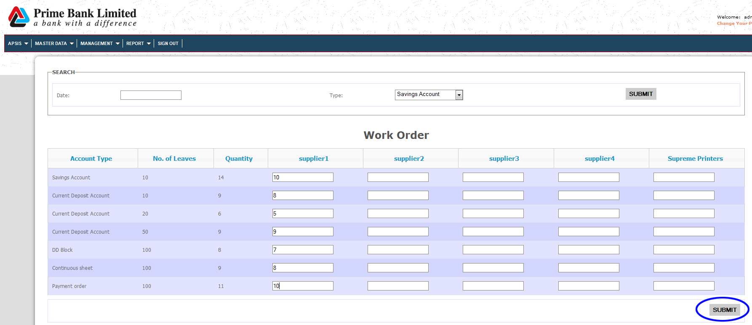

- Reports: (All Users)
- MICR ORDER INFO
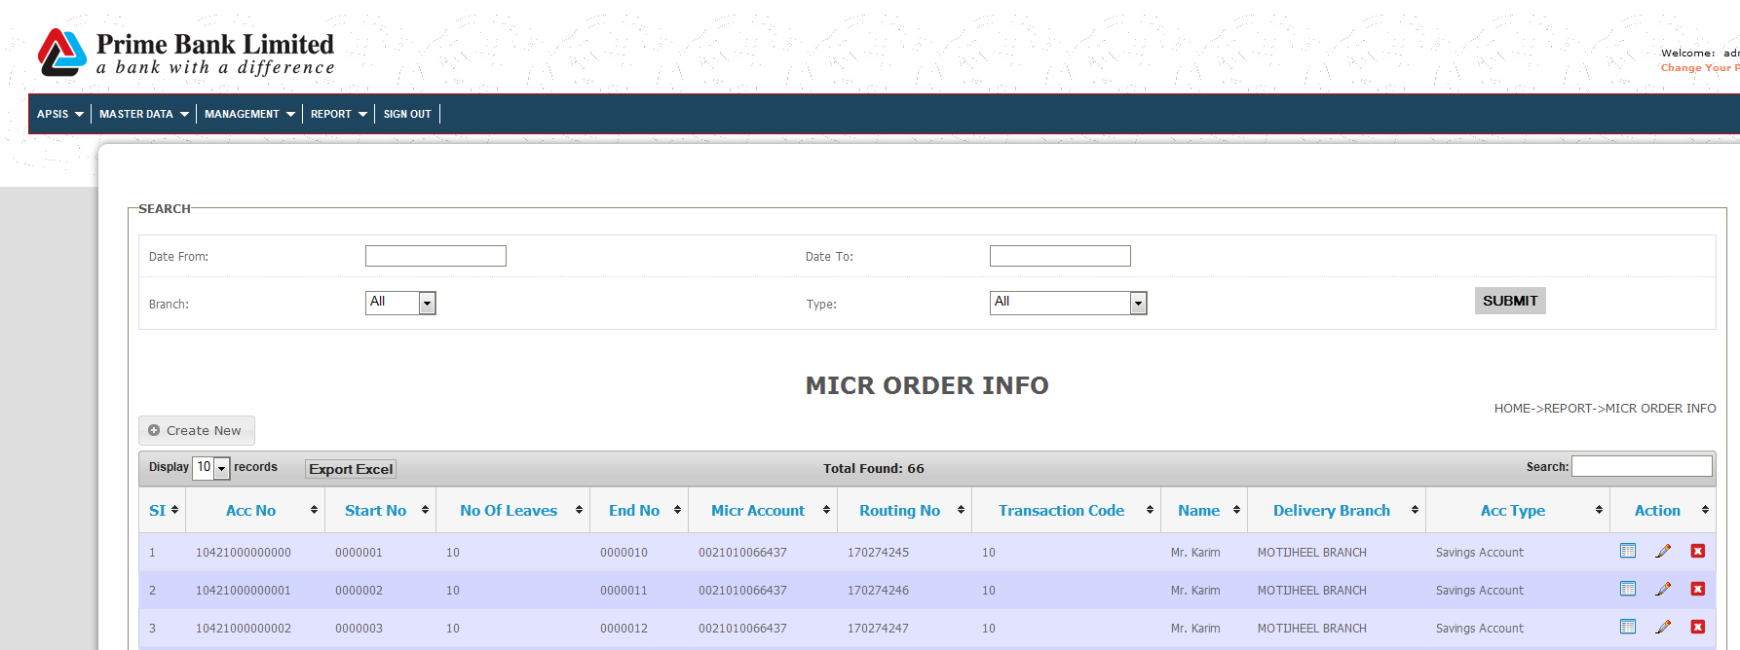
- BRANCH WISE DETAIL DEBIT REPORT
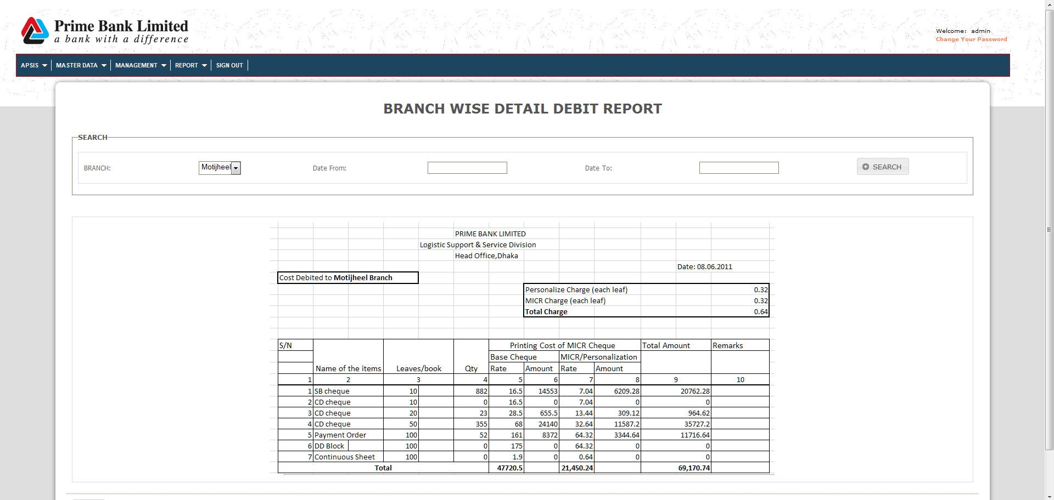

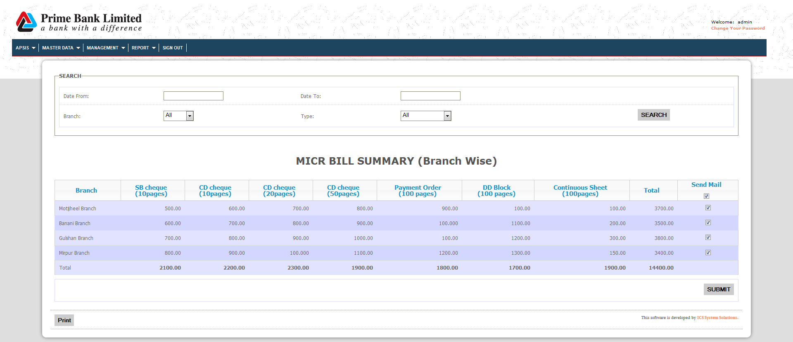
- SUMMERY REPORT (BRANCH WISE)

- SUMMERY REPORT (SUPPLIER WISE)
