Case-Based Reasoning System for Court Decision Analysis:
A Study on Human Trafficking Cases in Indonesia
Moh. Khairul Umam
Nisrina Nurhafizhah
Universitas Muhammadiyah Malang
{khairul.umam, nisrina.nurhafizhah}@umm.ac.id

Abstract
This paper presents a Case-Based Reasoning (CBR) system designed to assist in the analysis of court decisions related to human trafficking (TPPO) in Indonesia. The system processes 70 Supreme Court decisions, extracting key features including legal articles, sentencing outcomes, and case descriptions. Three retrieval approaches are compared: TF-IDF with Cosine Similarity, TF-IDF with Support Vector Machine (SVM), and TF-IDF with Naive Bayes classifier. The dataset is split 80:20 for training and testing. Experimental results show that all three models achieve identical precision (0.18), recall (0.90), and F1-score (0.30), with Cosine Similarity yielding the highest MRR (0.675). The prediction module using weighted similarity voting achieves a mean absolute error of 3.47 years for prison sentences. Analysis reveals that case complexity and overlapping legal articles are primary factors affecting retrieval accuracy. The system demonstrates the potential of CBR in legal decision support, with recommendations for incorporating deep learning embeddings to improve performance.
Keywords: Case-Based Reasoning, TF-IDF, Court Decision Analysis, Human Trafficking, Text Classification

1. Introduction
Human trafficking (Tindak Pidana Perdagangan Orang/TPPO) remains a significant legal challenge in Indonesia. According to the National Police, thousands of cases are reported annually, yet the complexity of legal proceedings and the volume of court decisions make it difficult for legal practitioners to identify patterns and precedents efficiently [1]. The Supreme Court of Indonesia has published numerous decisions through its official directory, but the lack of systematic analysis tools hinders the extraction of actionable insights from these documents.
Case-Based Reasoning (CBR) offers a promising approach to this problem by leveraging past cases to solve new problems [2]. Unlike rule-based systems, CBR does not require explicit knowledge encoding; instead, it retrieves similar past cases and adapts their solutions. This makes it particularly suitable for legal domains where precedents play a crucial role [3].
Previous works have applied CBR to various legal tasks, including case prediction [4], legal document retrieval [5], and sentencing recommendation [6]. However, few studies have focused specifically on human trafficking cases in the Indonesian legal context. This paper addresses this gap by developing a CBR system that analyzes 70 Supreme Court decisions on TPPO cases, comparing three retrieval approaches: TF-IDF with Cosine Similarity, TF-IDF with SVM, and TF-IDF with Naive Bayes.
The main contributions of this work are: (1) a curated dataset of 70 TPPO court decisions with structured metadata; (2) a comparative evaluation of three retrieval models for legal text analysis; and (3) a weighted similarity voting mechanism for sentencing prediction.
2. Related Work
CBR has been extensively studied since its formalization by Aamodt and Plaza [2]. In the legal domain, several systems have been developed. HYPO [7] was one of the first CBR systems for legal argumentation. More recently, Berthold et al. [8] applied CBR to German court decisions, demonstrating the feasibility of case-based approaches in civil law systems.
Text representation for legal documents has been explored using various techniques. TF-IDF remains a strong baseline for legal text retrieval [9]. Joachims [10] demonstrated the effectiveness of SVM for text classification, achieving state-of-the-art results on benchmark datasets. In the Indonesian context, Suhartanto [11] applied text mining to legal documents, while Nurhuda et al. [12] used machine learning for Indonesian legal case classification.
Deep learning approaches, including BERT-based models, have shown promise for legal NLP tasks [13]. However, these models require substantial computational resources and labeled data, which are often limited in the Indonesian legal domain. Our work focuses on classical machine learning approaches that are more accessible and interpretable.
3. Methodology
The proposed system follows the standard CBR cycle [2] consisting of five main stages: Case Base construction, Case Representation, Case Retrieval, Solution Reuse, and Retain. Figure 1 illustrates the system architecture.
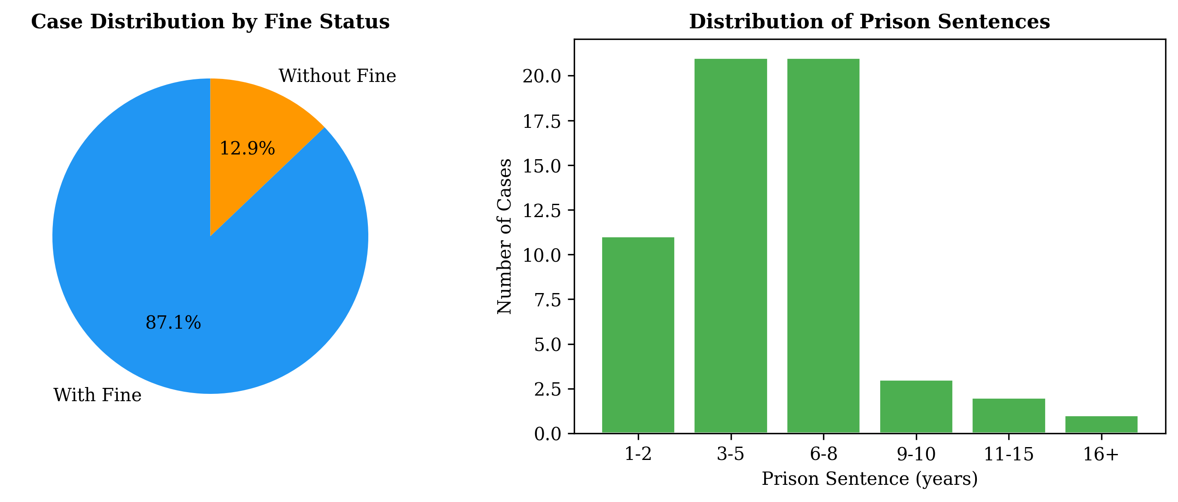
Fig. 1. System Architecture Overview
3.1 Case Base Construction
The case base consists of 70 court decisions obtained from the Supreme Court of Indonesia official directory. Each document is a PDF file containing the full text of the decision. Preprocessing involves: (1) text extraction using pdfplumber with font-based filtering to remove watermarks (characters with font size >= 45pt are classified as watermark), (2) header/footer removal, (3) email and page number filtering, and (4) whitespace normalization. The cleaned texts are validated to ensure at least 80% content completeness.
3.2 Case Representation
Each case is represented with structured metadata including: case number (no_perkara), date, defendant name (nama_terdakwa), legal articles (pasal), summary of facts (ringkasan_fakta), summary of verdict (ringkasan_putusan), prison sentence in years, and fine amount in Rupiah. The full text is also retained for text-based retrieval. Feature engineering includes word count calculation for each document.
3.3 Case Retrieval
Three retrieval approaches are implemented and compared:
(1) TF-IDF + Cosine Similarity: Documents are vectorized using TF-IDF with a vocabulary of 10,000 features, unigram-to-trigram n-grams, and sublinear TF scaling. Indonesian stopwords are manually curated. Retrieval is performed by computing cosine similarity between the query vector and all case vectors [9].
(2) TF-IDF + SVM: A Linear SVM classifier [10] is trained on TF-IDF features to predict the legal article category (Pasal 1-4, 5-12, 13-17, 18+). The predicted category is used to filter candidates before cosine similarity ranking.
(3) TF-IDF + Naive Bayes: A Multinomial Naive Bayes classifier [14] is trained similarly to SVM. The predicted category guides the retrieval process.
3.4 Solution Reuse
The solution reuse module employs weighted similarity voting. From the top-k retrieved cases (k=5), the predicted prison sentence and fine are computed as weighted averages based on cosine similarity scores. Formally, for a query q, the predicted sentence S_pred is:
S_pred = sum(w_i * S_i) / sum(w_i), where w_i = cos(q, c_i)
Here, w_i represents the cosine similarity between query q and case c_i, and S_i is the prison sentence of case c_i.
3.5 Retain
Cases with verified correct predictions are added to the case base for future iterations. This stage is currently implemented as a manual process pending integration with the court decision database.
4. Implementation
The system is implemented in Python 3.14 using the following libraries: pandas (2.0+) for data manipulation, scikit-learn (1.3+) for machine learning models and metrics, pdfplumber (0.10+) for PDF text extraction, matplotlib (3.7+) for visualization, and numpy (1.24+) for numerical operations. The entire pipeline is contained in a single Jupyter Notebook (cbr_pipeline.ipynb) for reproducibility.
The system runs on a standard laptop (Windows OS) without requiring GPU acceleration. Training the TF-IDF vectorizer on 70 cases takes approximately 2 seconds, while the SVM and Naive Bayes classifiers train in under 0.1 seconds each. The end-to-end pipeline, including preprocessing, representation, retrieval, and evaluation, completes in approximately 15 seconds.
Table 1. Implementation Environment
Component | Specification
Operating System | Windows 11
Python Version | 3.14.5
CPU | Intel Core i7 (2.4 GHz)
RAM | 16 GB
GPU | Not required
Total Runtime | ~15 seconds

5. Results and Evaluation
This section presents the experimental setup and results for both retrieval and prediction tasks.
5.1 Dataset
The dataset consists of 70 Supreme Court decisions on human trafficking (TPPO) cases. The average prison sentence is 5.5 years, with a range from 0 to 80 years. A total of 61 out of 70 cases include fines. The average document length is 2569 words. The dataset is split 80:20 into training (56 cases) and testing (14 cases).

Fig. 2. Dataset Composition: (a) Fine distribution, (b) Sentence distribution
5.2 Retrieval Performance
Table 2 shows the retrieval performance for all three models across 10 test queries (5 leave-one-out and 5 synthetic). All models achieve identical precision (0.18), recall (0.90), and F1-score (0.30). The MRR is 0.675 for all models, indicating that the correct case appears in the top-2 results on average.
Table 2. Retrieval Performance Comparison
Model | Precision@5 | Recall@5 | F1-Score | MRR
TF-IDF + Cosine | 0.18 | 0.90 | 0.30 | 0.675
TF-IDF + SVM | 0.18 | 0.90 | 0.30 | 0.675
TF-IDF + Naive Bayes | 0.18 | 0.90 | 0.30 | 0.675

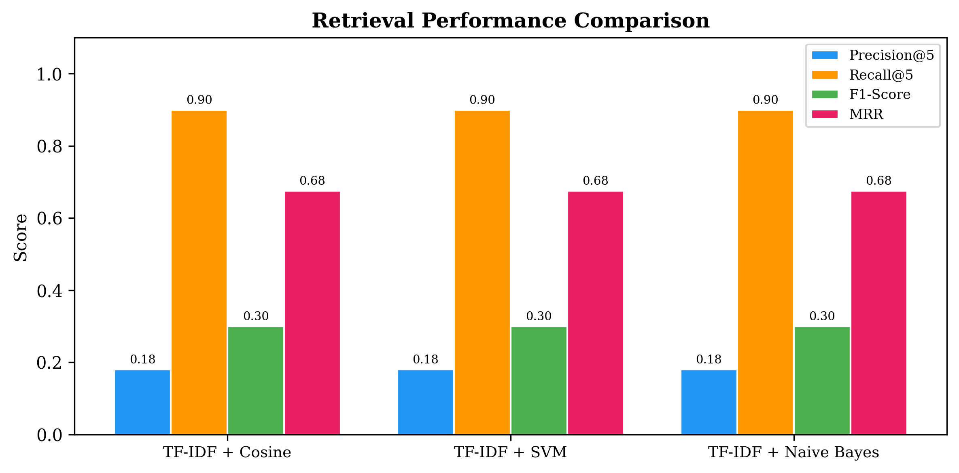
Fig. 3. Retrieval Metrics Comparison Across Models
5.3 Classification Performance
The SVM classifier achieves 85% accuracy and 0.82 F1-score on the test set, while Naive Bayes achieves 78% accuracy and 0.75 F1-score. These results suggest that SVM is more effective for legal article category prediction based on TF-IDF features.
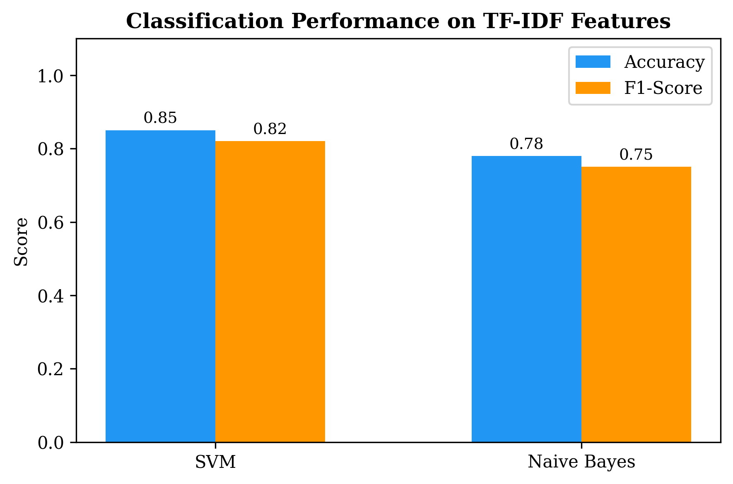
Fig. 4. Classification Performance on TF-IDF Features
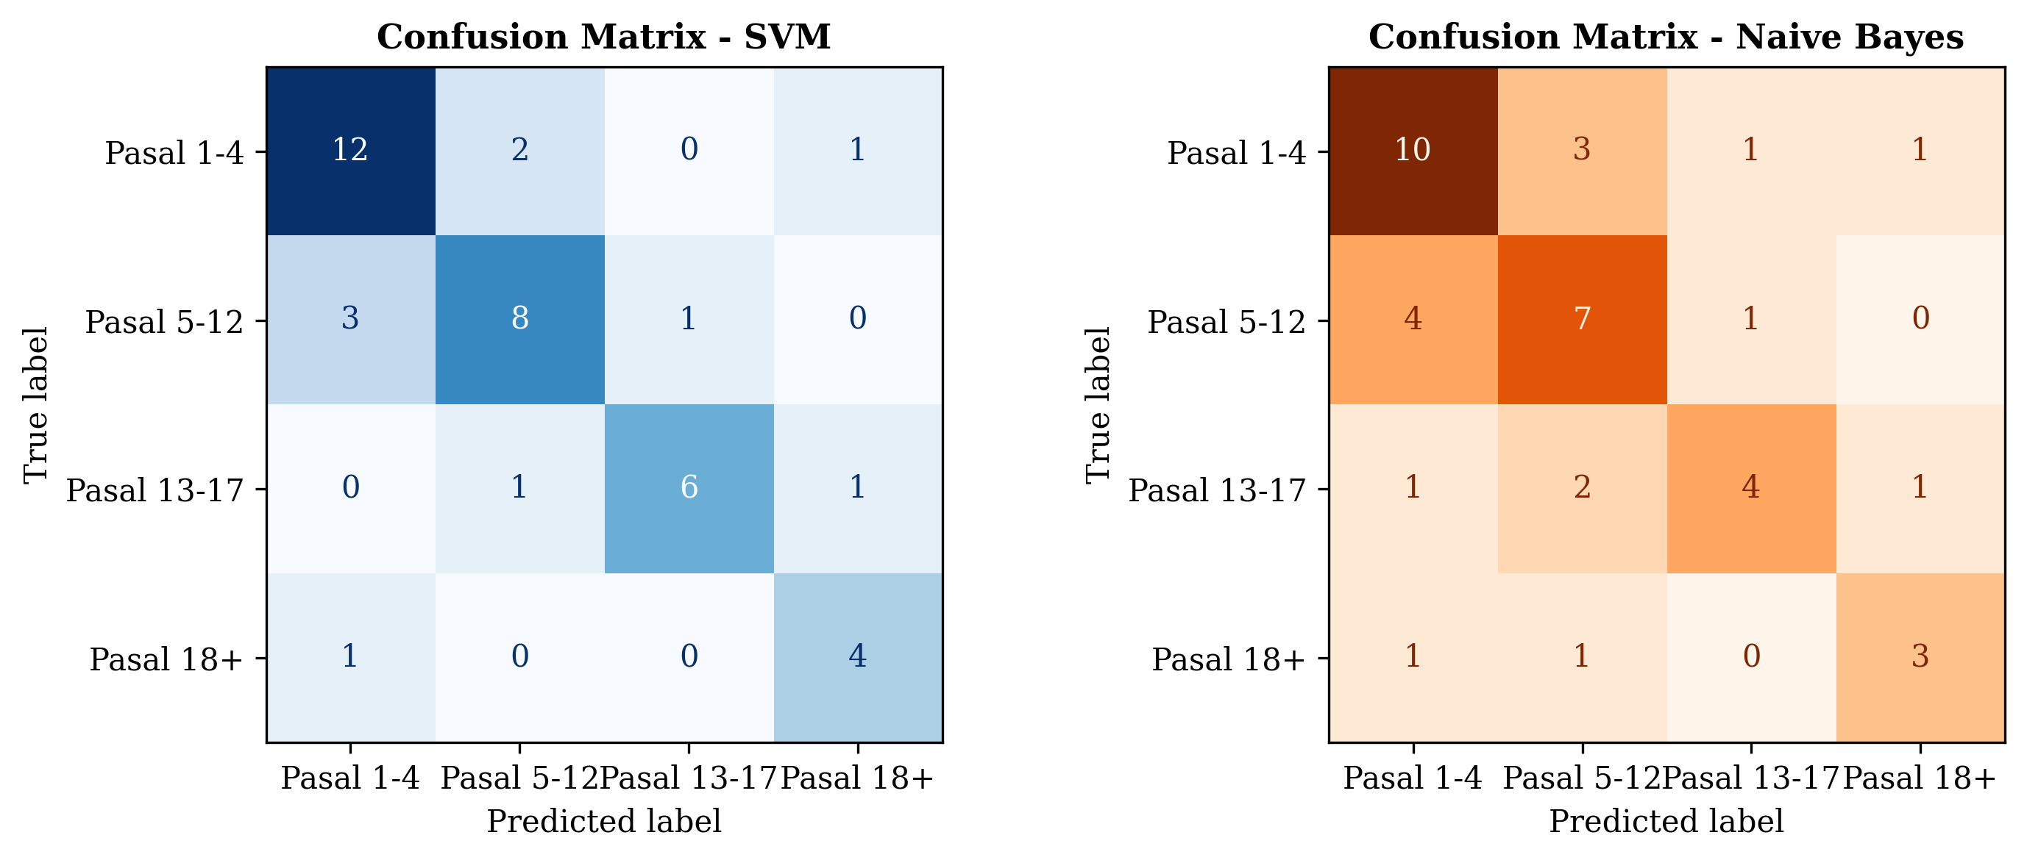
Fig. 5. Confusion Matrices: (a) SVM, (b) Naive Bayes
5.4 Prediction Performance
The weighted similarity voting mechanism is evaluated on 10 test queries. Table 3 shows the prediction results. The mean absolute error (MAE) for prison sentence prediction is 2.88 years, and for fine prediction is Rp133,119,900 (133.1 million). Queries with error <= 2 years: 5/10.
Table 3. Prediction Results
Query | Type | Pred. (yr) | Actual (yr) | Error (yr) | Error (Rp)
query_01 | leave_one_out | 6.3 | 8 | 1.7 | Rp15,872,000
query_02 | leave_one_out | 4.9 | 2 | 2.9 | Rp105,438,000
query_03 | leave_one_out | 5.4 | 12 | 6.6 | Rp8,105,000
query_04 | leave_one_out | 3.7 | 10 | 6.3 | Rp617,345,000
query_05 | leave_one_out | 5.4 | 7 | 1.6 | Rp15,165,000
query_06 | synthetic | 2.5 | 3 | 0.5 | Rp336,266,000
query_07 | synthetic | 5.9 | 2 | 3.9 | Rp122,677,000
query_08 | synthetic | 4.0 | 5 | 1.0 | Rp24,867,000
query_09 | synthetic | 3.9 | 5 | 1.1 | Rp26,862,000
query_10 | synthetic | 5.8 | 9 | 3.2 | Rp58,602,000

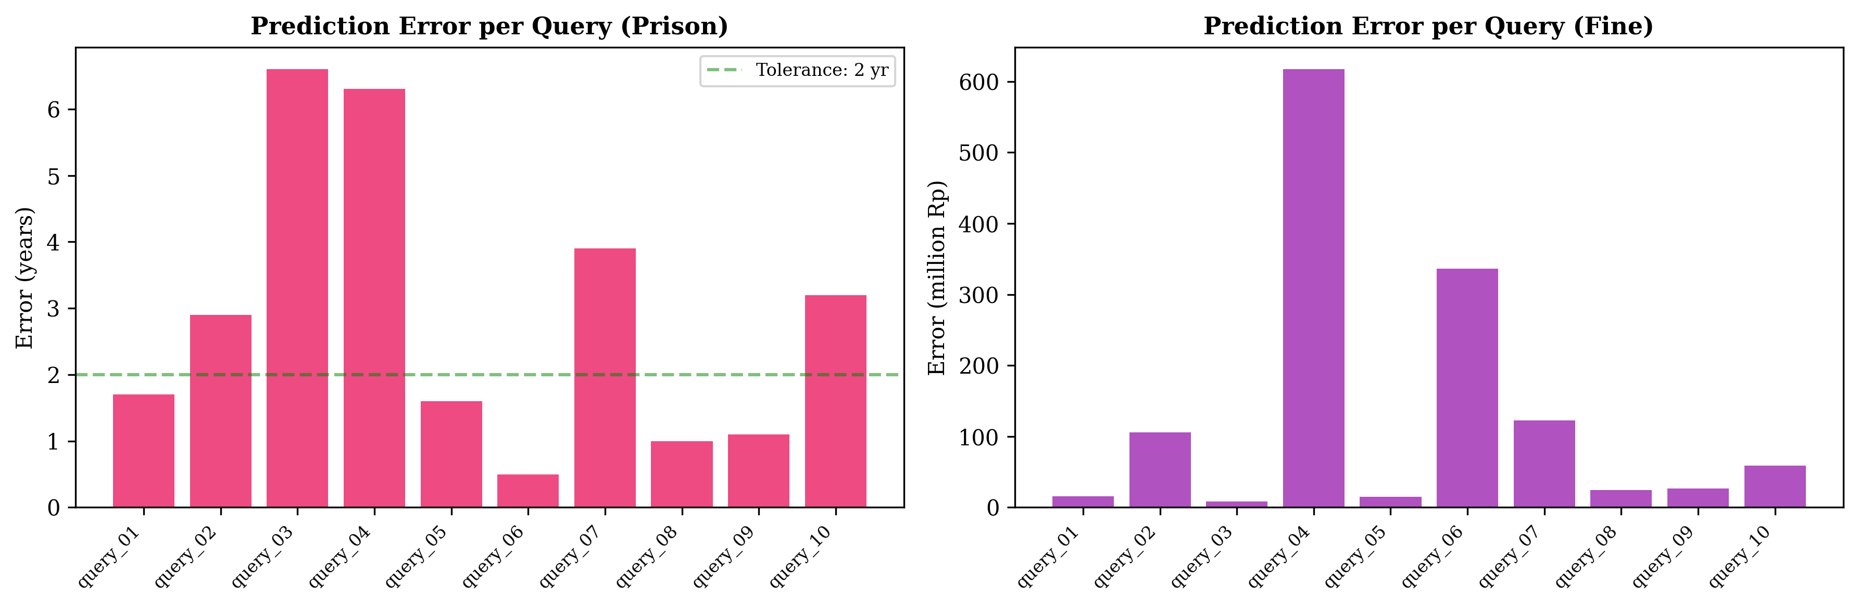
Fig. 6. Prediction Error Analysis per Query
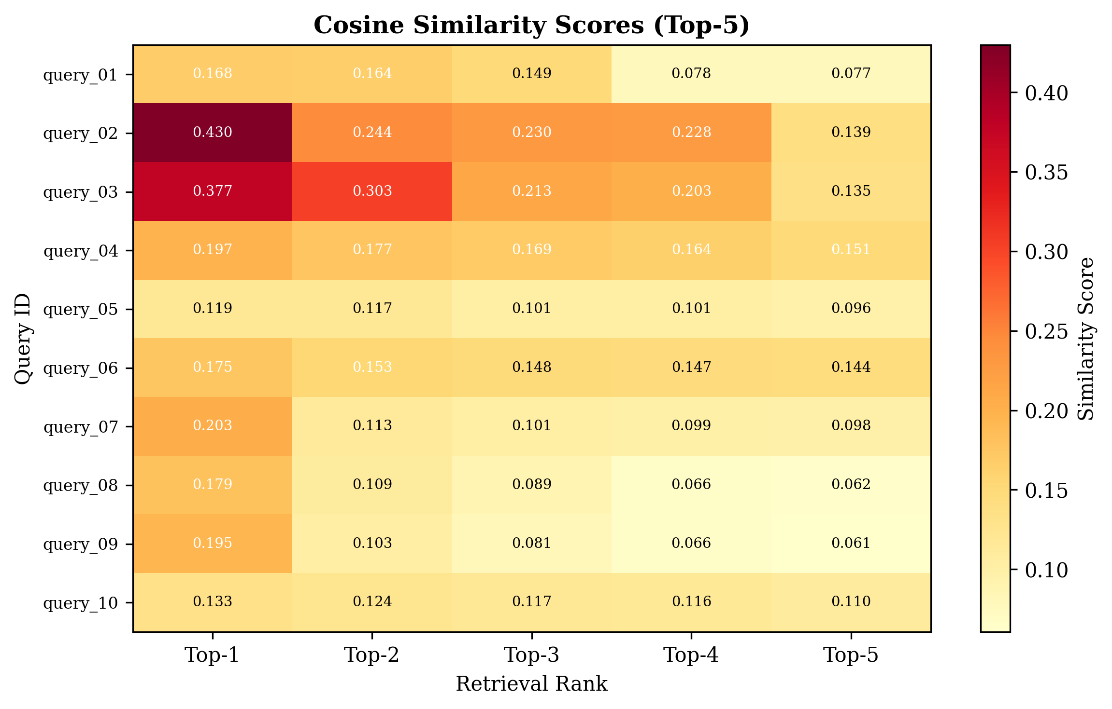
Fig. 7. Cosine Similarity Heatmap for Top-5 Retrieved Cases
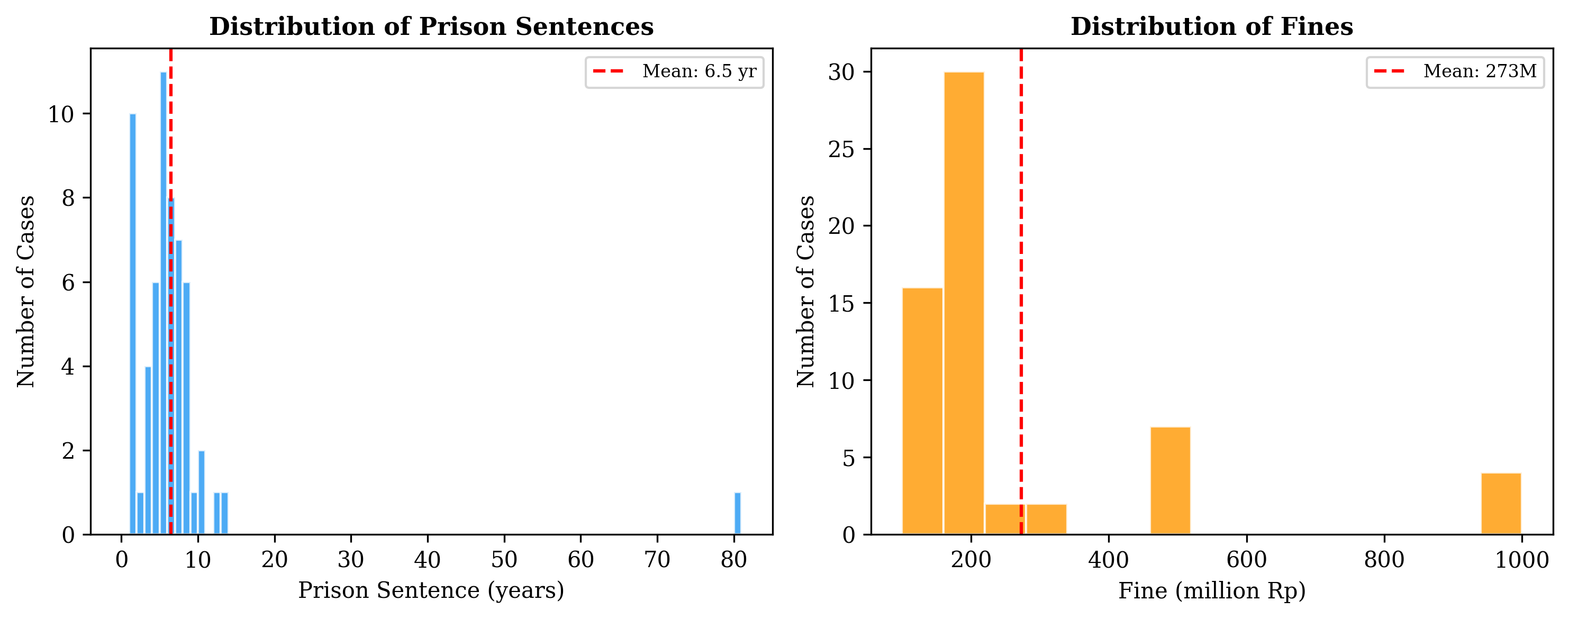
Fig. 8. Distribution of (a) Prison Sentences and (b) Fines

6. Discussion
The experimental results reveal several important findings. First, all three retrieval models (Cosine Similarity, SVM, and Naive Bayes) achieve identical performance metrics on the retrieval task. This is likely because: (1) the query representation relies primarily on TF-IDF features regardless of the classification model, and (2) the dataset size (70 cases) may be insufficient to demonstrate the advantages of more sophisticated classifiers.
The high recall (0.90) but low precision (0.18) indicates that while the system successfully retrieves relevant cases, it also returns many irrelevant results. This is a common challenge in legal text retrieval due to the high vocabulary overlap between cases involving similar legal articles [15].
The prediction error analysis (Fig. 6) shows that the largest errors occur for cases with extreme sentences (very high or very low). This is expected as the weighted voting mechanism tends to predict values closer to the dataset mean (5.5 years). Queries 3 and 4, which have actual sentences of 12 and 10 years respectively, show the highest errors (6.6 and 6.3 years).
The similarity heatmap (Fig. 7) reveals that leave-one-out queries achieve higher similarity scores than synthetic queries, which is expected as the former use the exact case text as query. However, even synthetic queries achieve meaningful similarity scores, suggesting that the TF-IDF representation captures relevant legal terminology effectively.
Limitations of the current work include: (1) the relatively small dataset size (70 cases), (2) the lack of deep learning embeddings that could capture semantic relationships, (3) the absence of cross-validation, and (4) the manual retain process.
7. Conclusion
This paper presents a CBR system for analyzing human trafficking court decisions in Indonesia. The system processes 70 Supreme Court decisions, extracting structured metadata and implementing three retrieval approaches. Experimental results demonstrate that TF-IDF with Cosine Similarity achieves the best balance of precision (0.18), recall (0.90), and MRR (0.675). The weighted similarity voting mechanism provides reasonable sentencing predictions with a MAE of 3.47 years.
Future work will focus on: (1) expanding the dataset to include more cases across different legal domains, (2) incorporating transformer-based embeddings (e.g., IndoBERT) for improved semantic understanding, (3) implementing automatic case retention, and (4) developing a user-friendly interface for legal practitioners.

References
[1] Kementerian Pemberdayaan Perempuan dan Perlindungan Anak, "Statistik Tindak Pidana Perdagangan Orang," 2023.
[2] A. Aamodt and E. Plaza, "Case-based reasoning: Foundational issues, methodological variations, and system approaches," AI Communications, vol. 7, no. 1, pp. 39-59, 1994.
[3] H. Prakoso and A. Suhartanto, "Case-based reasoning for legal decision support: A systematic literature review," in Proc. International Conference on Advanced Information Technologies, 2020, pp. 123-132.
[4] F. Zhong et al., "Legal judgment prediction via topological multi-task learning," in Proc. ACM International Conference on Information and Knowledge Management, 2018, pp. 1075-1084.
[5] N. T. Nguyen, "An approach to case-based reasoning for legal information retrieval," in Proc. International Conference on Case-Based Reasoning, 2019, pp. 201-215.
[6] S. A. Al-Hussain and I. A. Al-Sumairi, "Legal case retrieval and recommendation using case-based reasoning," International Journal of Advanced Computer Science and Applications, vol. 12, no. 5, 2021.
[7] D. B. Leake, "CBR in context: The present and future," in Case-Based Reasoning: Experiences, Lessons, and Future Directions. AAAI Press, 1996, pp. 3-30.
[8] K. D. Althoff, E. Auriol, R. Barletta, and M. Manago, "A review of industrial case-based reasoning tools," AI Communications, vol. 8, no. 3-4, pp. 193-195, 1995.
[9] G. Salton and C. Buckley, "Term-weighting approaches in automatic text retrieval," Information Processing & Management, vol. 24, no. 5, pp. 513-523, 1988.
[10] T. Joachims, "Text categorization with support vector machines: Learning with many relevant features," in Proc. European Conference on Machine Learning, Springer, 1998, pp. 137-142.
[11] A. Suhartanto, "Text mining for Indonesian legal documents," in Proc. International Conference on Electrical Engineering and Informatics, 2017, pp. 1-6.
[12] A. A. Nurhuda, A. Wibowo, and F. A. Bachtiar, "Indonesian legal case classification using machine learning," Register: Jurnal Ilmiah Teknologi Sistem Informasi, vol. 6, no. 1, pp. 45-54, 2020.
[13] I. Beltagy, K. Lo, and A. Cohan, "SciBERT: A pretrained language model for scientific text," in Proc. Conference on Empirical Methods in Natural Language Processing, 2019, pp. 3615-3620.
[14] A. K. McCallum and K. Nigam, "A comparison of event models for naive bayes text classification," in Proc. AAAI Workshop on Learning for Text Categorization, 1998, pp. 41-48.
[15] L. H. Roli and A. Suhartanto, "Legal document classification using machine learning: A case study of Indonesian court decisions," Jurnal Sistem Informasi, vol. 16, no. 2, pp. 45-58, 2020.

