UNIVERSITY OF HERTFORDSHIRE
MSc Artificial Intelligence and Robotics
INTERIM PROGRESS REPORT
MSc Advanced Computer Science Project, 7COM1039-0509-2025
Evidence-Driven Suspect Arrest
Using Reinforcement Learning in a Unity Simulation

Student Name : Muhammad Khais Chappangathil
Student ID : 24167911
Module Code : 7COM1039-0509-2025
Module Title : MSc Advanced Computer Science
Supervisor : Cheima Ali Bensaad

1. Background Research and Literature Review

1.1 Introduction and Project Overview
Artificial intelligence is becoming more important in solving real-world problems that involve decision-making in complex situations. Reinforcement learning has become one of the most important areas of artificial intelligence because of its ability to solve problems involving sequential decisions.
Reinforcement learning theory relies on the assumption that an agent acts upon an environment and learns which actions lead to better outcomes rather than following rigid instructions. Mnih et al. (2015) demonstrated that this trial-and-error process, when combined with deep neural networks, allows an artificial agent to learn complex behaviours directly from raw sensory input rather than from hand-crafted rules, which established the foundation for modern deep reinforcement learning research. The overwhelming majority of reinforcement learning research deals with applications such as navigation, path planning, robotics, and games, where the target location is already known and the problem is reduced to finding an efficient route towards it. Real-life investigative situations are considerably more complex, because a detective or security officer must gather evidence before making a decision. This type of reasoning is rarely modelled within reinforcement learning research.
This project investigates whether a reinforcement learning agent is capable of adopting the role of a detective rather than a tracker. The agent must be able to explore its surroundings, find pieces of evidence, estimate the position of the suspect, and attempt an arrest only once enough evidence has been gathered. This problem is therefore not simple navigation, but a sequential decision-making process that depends on the accumulation and interpretation of evidence.

1.2 Research Question and Aim

Research Question
How can a Proximal Policy Optimisation (PPO) based reinforcement learning agent learn to collect clues and successfully arrest a hidden suspect in a Unity environment?

Sub-Questions
- How can reward shaping encourage the agent to collect evidence instead of making random arrest attempts?
- Does curriculum learning improve the agent's performance?
- Can the trained agent perform better than simple approaches such as random movement or direct chasing?

Aim
Building directly on the research question above, the aim of this project is to develop a reinforcement learning agent using Unity ML-Agents (Juliani et al., 2020) and the Proximal Policy Optimisation algorithm (Schulman et al., 2017) that can investigate a simulated environment, collect clues, and successfully arrest a hidden suspect only after sufficient evidence has been collected. This project emphasises building an environment in which success depends more on the quality of the investigation performed by the agent than on simply locating the suspect.

Objectives
- Design and develop a Unity-based simulation environment that contains multiple levels of difficulty, allowing the detective agent to operate in increasingly complex scenarios.
- Develop an intelligent detective agent capable of navigating through the virtual environment, searching for and collecting important clues, analysing evidence and deciding whether to make an arrest.
- Create a reward system that motivates the detective agent to prioritise careful evidence collection and investigation before making an arrest, providing positive feedback for correctly identifying evidence and making correct decisions, and applying penalties for incorrect decisions.
- Train the detective agent using the Proximal Policy Optimisation (PPO) algorithm, a reinforcement learning method that helps the agent learn effective behaviours through repeated interaction with the simulation environment.
- Evaluate the performance of the detective agent using a range of evaluation metrics, including investigation success rate, amount of evidence collected, number of correct arrests, time taken to complete investigations, and overall reward achieved.
- Compare the performance of the trained PPO-based detective agent with simple baseline approaches to measure its effectiveness.

1.3 Literature Review

Reinforcement Learning Research
Reinforcement learning is one of the key branches of artificial intelligence due to its capability of solving sequential decision problems. Among the most influential works in this area is the research conducted by Mnih et al. (2015), who proposed Deep Q-Networks (DQN), combining reinforcement learning with deep neural networks. Their method learned to play Atari games using only raw image data as input and achieved performance comparable to that of a human player. This work demonstrated that it was possible to teach an artificial agent complex behaviour without manually programming every possible case. However, as Mnih et al. (2015) note, DQN-based algorithms become difficult to apply in environments with continuous action spaces or complicated reward schemes, since the method depends on discretised action selection.
To address these limitations, Schulman et al. (2017) developed Proximal Policy Optimisation (PPO). PPO achieves stability during training by constraining the magnitude of each policy update, which ensures that the model does not overwrite previously learned behaviour. Schulman et al. (2017) further report that this clipped-objective approach performs consistently well across both discrete and continuous control tasks, which makes it particularly suitable for simulation-based agents that must learn several interacting behaviours at once.
The choice of PPO for this project is guided by the fact that the detective task involves several interacting sub-tasks: the agent has to explore the environment, collect clues, navigate the correct path, and decide when to make an arrest. A stable and sample-efficient training algorithm is therefore critical, which is the primary reason PPO was selected as the main algorithm for this project.

Unity ML-Agents and Simulation-Based Learning
Training reinforcement learning models in a real-world environment can be costly and difficult, because generating a sufficiently large and varied training dataset typically requires physical devices and controlled real-world trials. Simulation environments present an alternative, allowing researchers to generate large numbers of training episodes quickly and safely. The decision to use Unity ML-Agents in this project is based on its established ability to support the training of embodied agents through machine learning. Juliani et al. (2020) note that Unity ML-Agents supports reinforcement learning experiments by providing a realistic three-dimensional environment alongside integrated machine learning algorithms, including PPO, and by exposing a Python API that communicates directly with the Unity engine.
The main advantage of using Unity is that the environment can be controlled fully. Clues, suspects, obstacles, and other objects can be placed randomly within the environment so that the agent gains varied experience during training. This randomisation is critical to ensure that the agent does not simply memorise the environment but instead learns a generalisable investigation strategy.

Curiosity-Driven Exploration and Sparse Rewards
A recurring challenge in reinforcement learning is that of sparse rewards, where an agent receives little or no feedback until a task is completed. Pathak et al. (2017) propose curiosity-driven exploration, in which an agent is given an intrinsic reward for visiting novel or unpredictable states, which encourages exploration even when extrinsic rewards are rare. Building on this idea, Li and Lan (2023) show that curiosity-driven exploration can be particularly effective in sparse-reward multi-agent settings, where agents must discover useful behaviour without frequent guidance from the environment. These findings are directly relevant to the current project, since the detective agent may go through many episodes before collecting a first clue or achieving a first successful arrest, and a curiosity module is identified in this report as a possible mitigation strategy should training fail to converge.

Pursuit, Evasion, and Patrol Planning
Most reinforcement learning research within the pursuit domain focuses on achieving a visible goal as quickly as possible. Zheng et al. (2021) apply deep reinforcement learning to multi-agent pursuit-evasion problems, teaching agents to chase targets under difficult and partially adversarial conditions, and find that reinforcement learning can outperform traditional rule-based pursuit methods. However, in their formulation the pursuing agent generally has access to some information about the target's position. In the present project, access to the suspect's location is denied directly to the agent: it must collect evidence about the location of the suspect and refine its own belief about that location incrementally, which introduces a further layer of decision-making under incomplete information.
Patrol planning research is also relevant background for this project. Nicosia et al. (2025) propose a spatiotemporal, risk-aware patrol planning method that combines value-based policy optimisation with sensor-integrated graph navigation to guide agents efficiently through urban environments. While patrolling of this kind is valuable for security applications and shares the exploratory character required by the detective agent, it does not include an explicit evidence-accumulation phase, and arrest or intervention decisions are not conditioned on the amount of evidence gathered — this is precisely the gap that the present project addresses.

Research Gap
Taken together, the literature reviewed above shows that reinforcement learning has been applied successfully to pursuit, evasion, patrol, and exploration problems, and that algorithms such as PPO and techniques such as curiosity-driven exploration and curriculum learning are effective tools for training agents in these settings. However, comparatively little research has examined situations in which an agent must deliberately gather and weigh evidence before acting, rather than moving directly towards a known or partially known target. This project addresses that gap by requiring the agent to justify an arrest decision with accumulated evidence, rather than rewarding proximity to the suspect alone.

Practical Application to the Current Project
This literature review has a direct impact on the technical aspects of the current project. The selection of Proximal Policy Optimisation is based on prior research demonstrating its stability in complex reinforcement learning scenarios (Schulman et al., 2017). Curriculum learning was chosen because of the effectiveness of gradually increasing task complexity, and a curiosity-driven exploration bonus (Pathak et al., 2017; Li and Lan, 2023) has been identified as a candidate mitigation strategy for sparse-reward episodes. The reward structure itself was designed according to these reinforcement learning principles: instead of the common approach of rewarding only the end of the task after an arrest, rewards are also provided for clue collection and other useful investigative behaviour, so that the agent learns to investigate the task rather than perform random actions. The research findings summarised above have therefore been useful not only for gaining theoretical knowledge, but also for informing the technical design decisions made throughout the project.

2. Summary of Progress to Date

2.1 Overview
This chapter summarises the work completed so far and shows how each development phase contributes to the overall aim of the project, which is to design an autonomous detective agent that can examine a virtual world, gather evidence, and make an arrest decision based on that evidence.
The project has been divided into several development phases: research, system planning, Unity environment development, agent development, reinforcement learning setup, and testing. Rather than developing the whole system at once, the project has been built incrementally, with each component designed, developed, and tested separately before being integrated into the wider system. By the time of writing this report, the project has completed the research, planning, and initial development phases; the training, evaluation, and performance analysis phases are still ongoing.

2.2 Specific Deliverables
Table 1 lists the deliverables completed during the current stage of the project.
Deliverable | Description | Status
Detailed Project Proposal (DPP) | Overview of the research problem, objectives, approach, evaluation strategy, timeline and outcomes; identifies the research gap and justifies the use of reinforcement learning. | Completed
Literature Review | Focused on reinforcement learning, PPO, Unity ML-Agents, pursuit-evasion systems, patrol planning and curiosity-driven exploration; critically analyses prior research and its limitations. | Completed
System Requirements Specification | Specifies functional and non-functional requirements of the detective agent. | Completed
Unity Simulation Environment | 3D simulation with multiple training environments of increasing complexity; includes buildings. | Completed
Detective Agent Implementation (Initial version) | Reinforcement learning agent built in C# using Unity ML-Agents; supports movement, environment interaction. | Completed
Observation and Sensor System | Twelve ray-casters plus clue, suspect-direction, clue-count and remaining-time observations, feeding the PPO policy. | Completed
Reward Function Design (Initial version) | Rewards evidence gathering and correct arrests; penalises collisions, unlawful arrests and inefficiency. | Completed
PPO Training Configuration | Hyperparameter configuration: learning rate, batch size, buffer size, discount factor, maximum training steps and network architecture. | Completed
Software Development Environment | Unity 2022 LTS, Unity ML-Agents toolkit, Python, PyTorch, TensorBoard, VS Code and GitHub, with Unity-Python compatibility verified. | Completed
Initial Functional Testing | Functional testing of the environment, agent, reward system, clue collection, episode reset and Unity-Python integration. | Ongoing
GitHub Repository | Version-controlled repository storing Unity project files, C# scripts, PPO configuration files and documentation, with regular commits. | Ongoing
Table 1. Project deliverables with current completion status.
The following deliverables are still in progress.

1. PPO Model Training
The reinforcement learning agent is currently being trained using the Proximal Policy Optimisation algorithm. Several rounds of training will be carried out across each of the three curriculum levels to progressively improve the agent's investigative performance.
Expected deliverables:
- Trained PPO model (.onnx)
- Learning curves from TensorBoard
- Training logs

2. Baseline Agent Design
Two baseline agents will be designed to evaluate how well the reinforcement learning approach performs in comparison with simpler approaches:
- Random walk agent
- Scripted direct-chase agent

2.3 Tools and Technologies
Tool | Purpose | Justification
Unity 2022 LTS | Build 3D simulation environment. | Provides a highly customisable and realistic world for reinforcement learning experiments; the LTS release is stable and compatible with Unity ML-Agents.
Unity ML-Agents Toolkit | Agent-environment interface. | Widely used in reinforcement learning research (Juliani et al., 2020); provides PPO, curriculum learning, raycast sensors and neural network training out of the box.
Python | Training and analysis. | The default language for AI/ML workflows; integrates well with reinforcement learning libraries and the Unity ML-Agents Python API.
PyTorch | Train neural network. | Popular research backend providing efficient neural network training and GPU acceleration; also the default backend used by Unity ML-Agents.
Proximal Policy Optimisation (PPO) | Train the detective agent. | Selected for stable learning with complex reward functions and strong performance in sequential decision-making (Schulman et al., 2017); the recommended algorithm within Unity ML-Agents.
TensorBoard | Training visualisation. | Visualises reward curves, policy loss and episode statistics, making convergence issues easier to identify.
GitHub | Version control. | Tracks all project changes, enables reverting to earlier versions, and provides evidence of development progress.
Windows Operating System | Platform for running all software. | Fully compatible with Unity and ML-Agents, giving stable support for development and experimentation.
Table 2. Tools and technologies with their purpose and justification.

2.4 Challenges Encountered and Solutions

Challenge 1: Designing an Effective Reward Function
Agents in reinforcement learning learn through rewards. In this project, the largest reward comes only from a successful arrest. The difficulty is that the agent can go through many episodes before receiving any positive feedback, which makes learning slow and unstable — a symptom of the sparse-reward problem discussed by Pathak et al. (2017).
Solution: the reward function was changed to give the agent smaller intermediate rewards for tasks such as finding clues. This gives the agent more frequent feedback during training rather than feedback only at the end of an episode.

Challenge 2: Unity and Python Integration Issues
This project depends on communication between Unity and Python through the Unity ML-Agents Toolkit. During initial setup, several compatibility problems occurred because of mismatched versions of Python, ML-Agents and Unity, which prevented the training environment from launching.
Solution: a new development environment was created using software versions confirmed as compatible in the official Unity ML-Agents documentation (Unity Technologies, 2024). A dedicated Python virtual environment was created to keep the project's dependencies isolated from other Python packages installed on the machine.

Challenge 3: Debugging Agent Behaviour
In the first implementation, the agent occasionally became stuck against walls or repeated the same movement, which limited its exploration.
Solution: additional collision penalties were added, and the movement logic was reviewed to improve navigation. A small penalty was also applied at each timestep to motivate exploration, and regular testing within the Unity Editor was used to detect and fix movement problems throughout development.

2.5 Project Management
The project has been managed using an Incremental Development Approach combined with weekly progress reviews. Rather than building the whole system before testing, each component has been developed and validated independently before being integrated with the rest of the system. This approach was chosen specifically because reinforcement learning projects tend to improve through repeated experimentation: if training results are unsatisfactory, it is possible to revisit a single component, for example the reward function or the observation system, rather than reworking the whole pipeline.
In practice, project management has followed a consistent weekly cycle so that progress could be tracked and problems caught early:
- Plan: at the start of each week, the specific component or task to be completed was identified from the remaining task list, together with the criteria that would define it as finished.
- Develop: the component was implemented in isolation, for example a single script, reward term, or curriculum level, so that its behaviour could be attributed clearly to that change.
- Test: the component was tested in the Unity Editor and, where relevant, through short ML-Agents training runs, to confirm that it behaved as intended before being combined with other parts of the system.
- Integrate and commit once verified, the component was merged into the main project and committed to the GitHub repository with a descriptive message, so that the repository history itself documents the order in which functionality was added.
- Review: progress, blockers and next steps were discussed with the project supervisor, and the remaining task list was updated accordingly.
This cycle is also how the remaining tasks described in Section 4.5 will be carried out: each week's task will be planned, developed against the relevant curriculum level or evaluation metric, tested against the existing agent and baseline scripts, and reviewed before the next task begins.
Completed milestones:
- Literature Review
- Project Planning
- Requirements Analysis
- Unity Environment
- Detective Agent
- Reward Function
- PPO Configuration
- Initial Testing
Remaining work:
- PPO training
- Curriculum learning
- Baseline implementation
- Experimental evaluation
- Statistical analysis
- Dissertation writing
- Final testing

2.6 Evidence of Progress
The following artefacts are included in the appendices as evidence of progress:
- Appendix A: Unity Training Environment screenshots and environment set-up explanation
- Appendix B: Detective Agent Code
- Appendix C: GitHub Repository

3. Ethical, Legal, Professional, and Social Consideration
This project does not involve human participants or real-world data collection; nevertheless, it is important to discuss the ethical, legal, professional and social issues that could arise during the creation of this project or in any future real-world implementation. This project is based on a Unity simulation only, with artificial environments, artificial clues and artificial suspects, so most ethical and legal issues connected with personal data do not currently apply. However, if this project were developed further for real-world security or law-enforcement applications, additional issues would need to be considered.

3.1 Ethical Consideration
Formal ethics approval is not required for this project, since it does not involve human participants, surveys, interviews or the collection of personal data. All experimental scenarios take place in a virtual world where every object is artificial, so there is no risk of physical, psychological or emotional harm arising from the research process.
Despite the simulated nature of the experiment, fairness remains relevant. The agent should learn to arrest the suspect only in accordance with the evidence gathered. The reward function has therefore been designed so that the agent receives a negative reward whenever it attempts an arrest without sufficient clues, so that its decisions are grounded in the evidence collected during the investigation. If a system of this kind were implemented in practice, for example in policing or surveillance, fairness would become critical, since incorrect decisions could affect real people's lives; in that scenario, validation and transparency of the decision-making process would be essential.
One limitation of reinforcement learning is that, because the agent learns behaviour from experience rather than fixed rules, it can be difficult to explain the reasoning behind some of its decisions. In this project, transparency is supported by logging key details for every episode, including clues obtained, rewards gained, and any collisions or arrest attempts. These logs support analysis of the agent's learning behaviour and help to explain why it acts in a particular way; future versions of the project could extend this with explainable AI methods.
This project has been created solely for academic purposes and is not intended for use in real decision-making or law-enforcement practice. Were such technology to be developed further, reinforcement learning should support human decision-making rather than replace it, since situations with legal or ethical implications will continue to require human judgement.

3.2 Legal Considerations
The current project does not involve the gathering, processing or storage of any personal data. Clues, suspects and training areas are generated automatically inside the Unity engine and therefore contain no personal information. Because no identifying data is used, the project is not currently subject to the UK General Data Protection Regulation (GDPR). If future versions of the system were to use CCTV footage, facial recognition technology or location tracking, compliance with GDPR and other data protection legislation would become essential, including proper authorisation for processing data and adequate protection of any stored information.
This project uses Unity, Unity ML-Agents, Python and PyTorch, all of which are publicly accessible pieces of software licensed under their respective agreements and are used here exclusively for academic purposes and within the terms of those licences. All software developed as part of this project in the Unity environment, C# scripts and reinforcement learning configuration is original work created specifically for this MSc project. Books, papers and other sources have been referenced using the Harvard referencing system, acknowledging the contributions of previous researchers and preventing plagiarism. Only licensed or open-source software has been used during development: Unity Personal is available for educational use, and Python, PyTorch and Unity ML-Agents are open-source tools widely used within the research community.

3.3 Professional Considerations
Professional ethics are significant in software engineering and artificial intelligence development. Throughout this project, recognised software engineering practices have been applied to improve the quality and reliability of the software produced. Source code versioning has been used to track changes and reduce the risk of losing work during development.
Incremental development has also been adopted throughout the project: each module is developed and tested separately before being integrated into the whole system, which makes problems easier to detect and helps to maintain software quality. Testing has been carried out continuously to confirm that agent movement, clue collection, reward assignment and environment resets function correctly before reinforcement learning training begins.
Professional ethics also require that researchers report their findings truthfully, regardless of whether results match initial expectations. All findings from the evaluation stage of this project will therefore be reported objectively, and careful documentation, good programming practice and accurate referencing are treated as part of the project's professionalism.

3.4 Social Considerations
Artificial intelligence can bring significant benefits across sectors such as security, medicine, transport and environmental monitoring. The reinforcement learning methods examined in this project could, in principle, support the development of intelligent systems for search-and-rescue operations, security patrols or emergency response.
There are, however, social implications to consider. If autonomous investigation systems were deployed without adequate human oversight, they could influence significant decisions affecting individual freedom and privacy. Law-enforcement decisions in almost all cases require human judgement, and artificial intelligence is not expected to make such decisions independently.
Future implementations of systems of this kind should therefore support human professionals rather than replace them. Public acceptance is another consideration: people are more likely to accept AI systems when they understand how decisions are made and are confident in their fairness, validity and transparency, which is why continued testing and documentation are important before technology of this kind is considered for real-world use.

3.5 Future Development
The ethical and legal risk associated with this project is currently minimal, since it takes place entirely within a virtual world using fabricated data. These factors would, however, become far more significant if the system were extended beyond an academic exercise. Future development using real surveillance cameras, facial recognition software, or public-safety applications would introduce additional obligations relating to privacy, data protection, algorithmic fairness and liability, and would require formal ethical clearance, GDPR compliance, and ongoing human testing and monitoring. Consideration of these future implications is treated here as part of responsible AI development.

4. Project Plan

4.1 Project Management Approach
The development process employs an incremental and iterative model in which, rather than building the whole system at once, the project is divided into smaller stages, each focused on a different aspect of the system, environment creation, agent development, reward function design, or training. Each stage is completed and tested before the next stage begins. This model was chosen because it suits reinforcement learning projects particularly well, since improvement is usually achieved through repeated experimentation and testing: if training results are unsatisfactory, it is possible to adjust a single aspect of the project, such as the reward function or a hyperparameter, rather than rebuilding the whole system. Regular meetings with the project supervisor have also been used to receive feedback and discuss technical and practical challenges as they arise.

4.2 Methodology and Justification of Methods and Tools
The methodology adopted for this project follows the incremental development approach described above, combined with an experimental evaluation methodology for the remaining stages of the work. Concretely, the training methodology will proceed in three steps: first, the PPO agent will be trained separately on each of the three curriculum levels, from the simplest environment to the most complex, so that the agent's competence builds gradually rather than being learned all at once; second, the reward function and hyperparameters will be tuned based on the resulting TensorBoard learning curves; and third, the trained agent will be evaluated against the two baseline agents using the metrics defined in Section 4.4 (Quality Assurance Strategy). This staged methodology is what the remaining project timeline in Section 4.5 is built around.
The methods and tools used to implement this methodology were selected based on the literature reviewed in Section 1.3 and their suitability for reinforcement learning applications of this kind. Proximal Policy Optimisation (PPO) was selected because of the stability of its policy updates and its effective performance in complex, continuous environments (Schulman et al., 2017); in comparison with DQN (Mnih et al., 2015), PPO is better suited to the continuous action spaces used in Unity simulations and is generally more stable to train.
Unity was chosen because of its three-dimensional, realistic environment, its flexibility for creating varied scenarios, and its direct integration with Unity ML-Agents, which allows rapid experimentation with different environments and reward structures. Unity ML-Agents was chosen because it provides ready-made communication between Unity and Python for reinforcement learning, together with built-in support for curriculum learning, raycast observations and TensorBoard logging (Juliani et al., 2020).
Python and PyTorch were selected as reliable, widely supported tools for training neural networks, and TensorBoard is used to continuously monitor the learning process, including reward curves, policy loss and episode statistics. GitHub was used to maintain version control throughout development. Together, this combination of methods and tools provides everything required to implement, test, validate and analyse the experiments planned for the remaining stages of the project, and their widespread use in both academic research and industry support the reliability and reproducibility of the work.

4.3 Risk Management
Several risks remain relevant to the remaining stages of this project. Table 3 sets out the identified risks along with their likelihood, impact and mitigation strategy.
Risk | Likelihood | Impact | Mitigation Strategy
PPO training does not converge | Medium | High | Modify reward values, tune hyperparameters and, if needed, enable the curiosity module.
Poor reward function design | Medium | High | Continue monitoring agent behaviour and fine-tune rewards according to test and training data.
Software compatibility issues | Low | Medium | Use compatible software versions, maintain a Python virtual environment, and update project dependencies regularly.
Software bugs in Unity scripts | Medium | Medium | Carry out debugging, unit testing and integration testing of new functionality periodically.
Loss of project files or source code | Low | High | Use GitHub for version control and take regular backups of files.
Long reinforcement learning training time | High | Medium | Test code under simple conditions first and optimise training parameters where possible.
Time constraints affecting dissertation writing | Medium | High | Write chapters of the report alongside the coding process.
Table 3. Risk management table with mitigation strategy.

4.4 Quality Assurance Strategy
Maintaining quality is essential for the project to produce a functional, reliable system and experimentally valid results. Several complementary strategies will be applied during the remaining stages of the project. First, individual components, the reward function, observation system and movement logic will be checked independently before being combined into the full system. Second, the reinforcement learning agent will be evaluated against the performance metrics defined in the project proposal, including arrest success rate, clue collection rate, patrol coverage, collision rate, illegal-arrest rate and generalisation performance across curriculum levels. Third, the trained PPO agent will be compared against the two baseline methods the random-walk agent and the scripted direct-chase agent to establish whether reinforcement learning provides a measurable improvement. Finally, TensorBoard logs and experimental results will be analysed systematically to ensure that conclusions are based on measurable evidence rather than informal observation.

4.5 Remaining Tasks and Project Timeline
Table 4 shows the project plan for the eight weeks remaining after submission of this Interim Progress Report. Activities are sequenced so that each activity builds on the successful completion of the previous one, following the methodology described in Section 4.2: training first, then optimisation and baseline comparison, then evaluation, analysis and write-up.
Week | Task | Deliverable | Target Completion
Week 1 | PPO Training | Trained reinforcement learning model with stable performance | Week 1
Week 2 | Reward Optimisation | Optimised reward function | Week 2
Week 3 | Baseline Agent Development | Baseline agents for performance evaluation | Week 2
Week 4 | Experimental Evaluation | Experimental results for analysis | Week 1-3
Week 5 | Performance Analysis | Graphs and statistical analysis | Week 4
Week 6 | Dissertation Writing | Complete final project draft | Week 5
Week 7 | Review and Refinement | Revised project report | Week 6
Week 8 | Final Review and Submission | Final project report | Week 7
Table 4. Eight-week project plan and timeline.

How each remaining task will be carried out
Each row of Table 4 corresponds to a distinct piece of work; the paragraphs below explain, in the same order, how each will actually be performed rather than simply what its deliverable is.
- PPO Training (Week 1): the existing PPO configuration will be run against each of the three curriculum levels in turn using the Unity ML-Agents Python trainer, with progress monitored live in TensorBoard. Training on a given level will be judged complete once the mean episode reward plateaus, after which the trained policy will be exported and archived before moving to the next level.
- Reward Optimisation (Week 2): the reward curves and episode logs produced in Week 1 will be reviewed to identify any reward term that is being exploited or ignored by the agent (for example, arrest attempts without sufficient clues, or excessive idling). Individual reward weights will then be adjusted one at a time and the affected curriculum level retrained on a short run to confirm the change has the intended effect before a full retrain is committed.
- Baseline Agent Development (Week 3): the random-walk agent will be implemented as a lightweight C# script that samples a random valid action each timestep; the scripted direct-chase agent will be implemented as a script that always moves directly towards the suspect's last known position with no evidence-gathering logic. Both will be built to expose the same observation and action interface as the PPO agent so that they can be dropped into the same evaluation environment without modification.
- Experimental Evaluation (Week 4): the trained PPO agent and the two baseline agents will each be run for a fixed number of episodes across all three curriculum levels, with per-episode metrics (arrest success, clues collected, collisions, illegal arrests, time taken, total reward) logged automatically to CSV files for later analysis.
- Performance Analysis (Week 5): the logged CSV data will be aggregated and summarised using Python (pandas/matplotlib), producing comparison charts and summary statistics for each metric across the three agents, so that any improvement attributable to reinforcement learning can be quantified rather than asserted.
- Dissertation Writing (Week 6): the results, charts and statistical summaries from Week 5 will be written up alongside the methodology and literature review already drafted in this report, producing a complete first draft of the dissertation.
- Review and Refinement (Week 7): the full draft will be reviewed against supervisor feedback and the marking criteria, with particular attention to consistency between the reported methodology, the actual implementation, and the results presented.
- Final Review and Submission (Week 8): final proofreading, formatting and reference checking will be carried out before the completed report is submitted.

4.6 Gantt Chart
The Gantt chart below sets out the same eight-week schedule visually, showing which tasks are sequential and confirming that no two tasks are scheduled to run in the same week; this reflects the methodology described in Section 4.2, where each stage (training, then evaluation, then write-up) depends on the previous stage being complete.
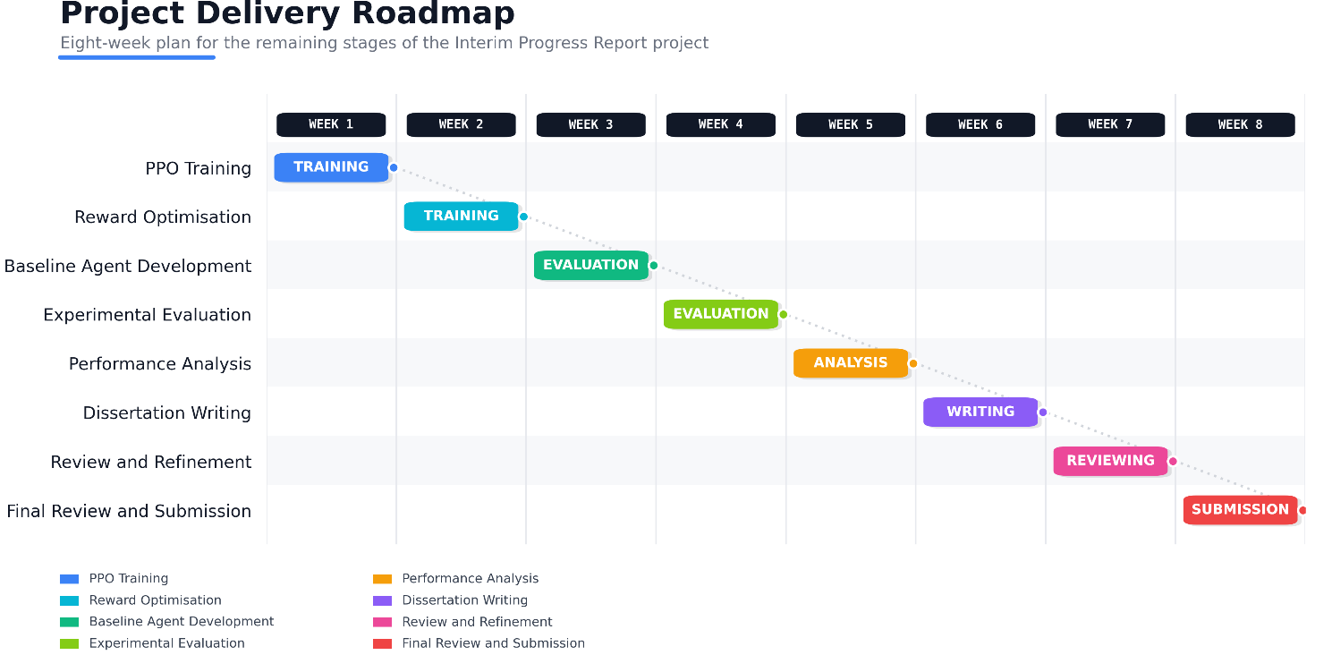Figure 1. Gantt chart of the eight-week project timeline.
Read as a schedule of work rather than a static picture, the chart shows a single active task per week, moving from the Training phase (Weeks 1-2, building and tuning the model), through the Evaluation phase (Weeks 3-4, building baselines and running experiments), the Analysis phase (Week 5, turning logged results into evidence), and finally the Writing/Submission phase (Weeks 6-8, producing and finalising the dissertation). Because each phase depends on the deliverable of the one before it evaluation needs a trained model, analysis needs experimental results, and writing needs the analysis the one-week buffer built into Weeks 7 and 8 is deliberately reserved to absorb any slippage from the training or evaluation stages, which Table 3 identifies as the highest-risk activities.

5. Level of the Project

5.1 Overview and Motivation
Artificial intelligence has become one of the most active research fields because of its ability to solve complex decision-making problems that are difficult to address with traditional programming. Reinforcement learning is one direction within AI that has received particular attention, because of its ability to learn optimal behaviour through interaction with an environment rather than by following predefined rules. This makes reinforcement learning applicable across robotics, autonomous navigation, intelligent surveillance and decision support.
The motivation for this project lies in a personal interest in artificial intelligence and autonomous systems, specifically in using reinforcement learning to address a realistic investigation problem. As discussed in Section 1.3, most reinforcement learning research in pursuit-style environments (for example Zheng et al., 2021) is devoted to chasing or capturing a target, whereas real investigations require evidence to be collected before acting. This motivated the development of an evidence-driven detective agent that learns to search for evidence before arresting a suspect.
This project also aligns with future career interests in artificial intelligence and machine learning; developing this system has extended both theoretical knowledge and practical skills in reinforcement learning, simulation development and intelligent decision-making.

5.2 Complexity
This project presents a challenge considerably more difficult than a standard navigation or path-finding problem. In addition to moving towards a target location, the agent must continuously make observations, gather clues, estimate the location of the suspect, and determine whether enough evidence has been collected to justify an arrest.
Because the rules of a hard-coded, rule-based system are unsuitable for this kind of judgement, the agent must learn its strategy through trial-and-error learning. This significantly increases the effective size of the decision problem, since every action affects future decisions and rewards. Reward engineering, observation design and environment setup all had to be carefully considered in order to encourage intelligent behaviour and discourage undesirable shortcuts, such as arresting without evidence.
This project therefore involves the application of several advanced concepts, including sequential decision-making, reinforcement learning, environment modelling, reward shaping and autonomous reasoning.

5.3 The Contribution of the Artefact
The primary artefact of this project is a Unity-based simulation in which an autonomous detective agent is trained using the Proximal Policy Optimisation reinforcement learning algorithm (Schulman et al., 2017). This artefact comprises several interacting parts: the simulation environment, the observation system, the reward function, the investigation mechanism, and the trained reinforcement learning model.
In contrast to most available reinforcement learning environments, in which an agent pursues a target immediately, this project introduces an investigation mechanism that requires the agent to collect clues before it is permitted to arrest the target. The agent is rewarded for collecting clues and penalised for attempting an arrest without sufficient evidence. Although the project is implemented within a simulated environment, it offers a distinct contribution to reinforcement learning research by demonstrating how evidence-based behaviour can be incorporated into an agent's decision-making process.

5.4 Depth and Investigation
Throughout this project, a substantial literature review has been carried out to understand the principles of reinforcement learning algorithms, Unity ML-Agents, autonomous navigation and evidence-based decision-making, and prior work has been critically evaluated rather than simply summarised. This review confirmed that PPO provides stable policy optimisation and strong performance on continuous tasks (Schulman et al., 2017), that Unity ML-Agents is a suitable tool for simulating reinforcement learning tasks (Juliani et al., 2020), and that curiosity-driven exploration can help agents cope with sparse rewards (Pathak et al., 2017; Li and Lan, 2023). At the same time, it revealed a lack of research on investigation-based environments in which evidence collection precedes the final decision.
This gap directly determined the choice of topic for this project. Rather than repeating work that has already been done, this project applies established reinforcement learning methods to a new problem domain and examines whether more realistic investigative behaviour can be generated through evidence-driven rewards. The practical implementation complements the theoretical research by implementing the ideas identified in the literature review within a working reinforcement learning environment.

6. References
Juliani, A., Berges, V.P., Teng, E., Cohen, A., Harper, J., Elion, C. and Lange, D. (2020) Unity: A general platform for intelligent agents. Available at: https://arxiv.org/abs/1809.02627 (Accessed: May 2025).
Li, J. and Lan, X. (2023) Curiosity-driven exploration in sparse-reward multi-agent reinforcement learning. Available at: https://arxiv.org/abs/2302.10825 (Accessed: May 2025).
Mnih, V., Kavukcuoglu, K., Silver, D., Rusu, A.A., Veness, J., Bellemare, M.G., Graves, A., Riedmiller, M., Fidjeland, A.K., Ostrovski, G. and Petersen, S. (2015) 'Human-level control through deep reinforcement learning', Nature, 518(7540), pp. 529-533. Available at: https://doi.org/10.1038/nature14236 (Accessed: May 2025).
Nicosia, G., Nicolosi, A., Nicosia, R. and Cantone, D. (2025) 'Spatiotemporal risk-aware patrol planning using value-based policy optimisation and sensor-integrated graph navigation in urban environments', Applied Sciences, 15(15), p. 8565. Available at: https://doi.org/10.3390/app15158565 (Accessed: May 2025).
Pathak, D., Agrawal, P., Efros, A.A. and Darrell, T. (2017) Curiosity-driven exploration by self-supervised prediction. Available at: https://arxiv.org/abs/1705.05363 (Accessed: May 2025).
Schulman, J., Wolski, F., Dhariwal, P., Radford, A. and Klimov, O. (2017) Proximal policy optimisation algorithms. Available at: https://arxiv.org/abs/1707.06347 (Accessed: May 2025).
Unity Technologies (2024) Unity ML-Agents Toolkit [Software]. Available at: https://github.com/Unity-Technologies/ml-agents (Accessed: May 2025).
Zheng, Y., Liu, S. and Chen, G. (2021) 'An improved approach towards multi-agent pursuit-evasion game decision-making using deep reinforcement learning', Entropy, 23(11), p. 1433. Available at: https://doi.org/10.3390/e23111433 (Accessed: May 2025).

Appendices

Appendix A: Unity Training Environment
This appendix presents the Unity training environment and explains how it was set up, so that the reasoning behind the environment's design is documented alongside the visual evidence.

A.1 Environment Set-Up Explanation
The training environment was built inside Unity 2022 LTS using the Unity ML-Agents toolkit. Set-up proceeded through the following stages:
- Scene construction: a house-based scene was modelled with surrounding grounds, trees and boundary walls, providing a bounded but visually varied space for the agent to explore (see Figure A1).
- Navigation mesh baking: a NavMesh was baked over the walkable surfaces of the scene (visible in Figure A1 under the AI Navigation panel), which is used both to validate reachable clue and suspect spawn points and to keep obstacle placement consistent between episodes.
- Agent and sensor placement: the detective agent was added as a Unity ML-Agents "Agent" component, with twelve ray-cast sensors arranged radially around the agent to detect walls, obstacles, clues and the suspect within its field of view.
- Randomisation logic: on every episode reset, clue objects, obstacle positions and the suspect's hiding location are re-randomised within the bounds of the NavMesh, so that the agent cannot memorise fixed positions and must instead learn a general investigation strategy.
- Curriculum configuration: three curriculum levels were defined by progressively increasing the number of obstacles, the size of the search area, and the number of clues required before an arrest is permitted, allowing training to proceed from a simple to a more complex version of the same task.
- Episode management: an episode ends either when the agent makes an arrest (correct or incorrect), when a maximum time limit is reached, or when a critical collision occurs; the environment then automatically resets using the randomisation logic above.
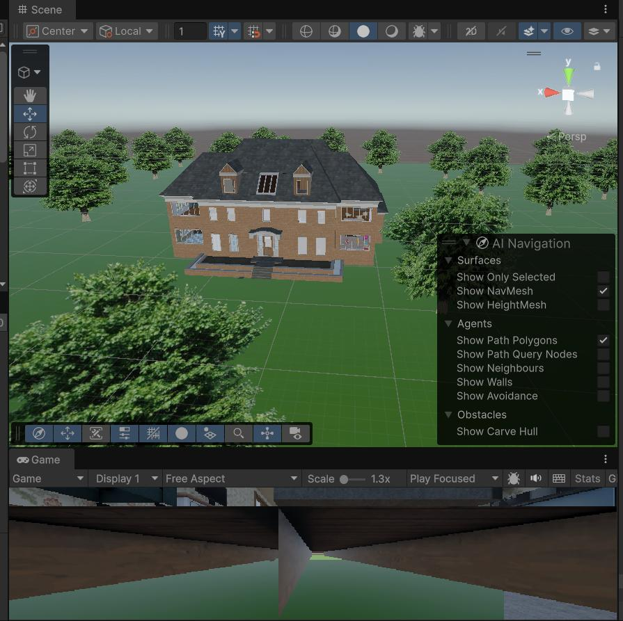
Figure 2. Unity Editor view of the training environment, showing the NavMesh AI Navigation panel used to validate walkable and obstacle-free areas.

Appendix B: Detective Agent
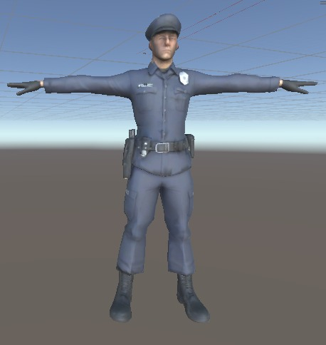
Figure 3. Inspector view.

Appendix C: GitHub Repository
This appendix should provide direct evidence of ongoing version control activity referenced in Section 2.2 and Section 3.3.
Note for student: add the repository URL and a screenshot of the commit history (showing commit messages and dates across the development period) to demonstrate the regular, incremental commits described in Sections 2.5 and 3.3. A short table listing key commits and the milestone each corresponds to (e.g. "Added reward shaping for clue collection" -> Challenge 1 solution) would strengthen the link between this evidence and the narrative in the main report.

