DEPARTMENT OF CSE, CS&IT, AI&DS
COURSE CODE: 24SDCS02 / 24SDCS02E / 24SDCS02P / 24SDCS02L
FULL STACK APPLICATION DEVELOPMENT
Name: SHAIK KHAJA AMEEN ID: 2400030234

SKILL - 4 Spring Dependency Injection – Constructor & Setter Injection

Prerequisites:
- Basic knowledge of Java
- General Idea on Spring Framework
- Basic Idea on DI & IoC

Problem Statement
A training institute wants to automate the management of student information in a Spring application.
The system should inject details such as studentId, name, course, and academic year into objects without manually assigning values.
This Skill demonstrates Constructor Injection and Setter Injection using both XML configuration and Annotation-based configuration.

SkillExp4DiApplication.java:-

package com.klu;

import org.springframework.boot.SpringApplication;
import org.springframework.boot.autoconfigure.SpringBootApplication;

@SpringBootApplication
public class SkillExp4DiApplication {

public static void main(String[] args) {
SpringApplication.run(SkillExp4DiApplication.class, args);
}

}

AppConfig.java:-
package com.klu.config;

import org.springframework.context.annotation.ComponentScan;
import org.springframework.context.annotation.Configuration;

@Configuration
@ComponentScan("com.klu.model")
public class AppConfig {

}
MainApp.java:-
package com.klu.main;

import org.springframework.context.ApplicationContext;
import org.springframework.context.annotation.AnnotationConfigApplicationContext;
import org.springframework.context.support.ClassPathXmlApplicationContext;

import com.klu.config.AppConfig;
import com.klu.model.Student;

public class MainApp {
public static void main(String args[]) {

ApplicationContext context=new ClassPathXmlApplicationContext("applicationContext.xml");
Student s=context.getBean(Student.class);
s.display();

ApplicationContext context1=new AnnotationConfigApplicationContext(AppConfig.class);
Student s2=context1.getBean(Student.class);
s2.display();

}

}
Student.java:-
package com.klu.model;

import org.springframework.beans.factory.annotation.Value;
import org.springframework.stereotype.Component;

@Component

public class Student {
private int id;
private String name;
private String course;
private int year;

public Student(@Value("859")int id,@Value("Rahul")String name) {
this.id=id;
this.name=name;
}

@Value("DBMS")
public void setCourse(String course) {
this.course=course;

}

@Value("4")
public void setYear(int year) {
this.year=year;
}

public void display() {
System.out.println("Student Id: "+id);
System.out.println("Student name: "+name);
System.out.println("Course: "+course);
System.out.println("year: "+year);
System.out.println(" ");

}
}
ApplicationContext.xml:-
<beans xmlns="http://www.springframework.org/schema/beans"
xmlns:xsi="http://www.w3.org/2001/XMLSchema-instance"
xsi:schemaLocation="
http://www.springframework.org/schema/beans
http://www.springframework.org/schema/beans/spring-beans.xsd">
<bean id="student" class="com.klu.model.Student">

<constructor-arg value="786"/>
<constructor-arg value="SHAIK KHAJA AMEEN"/>

<property name="course" value="FSAD"/>
<property name="year" value="2"/>

</bean>

</beans>

Outputs:
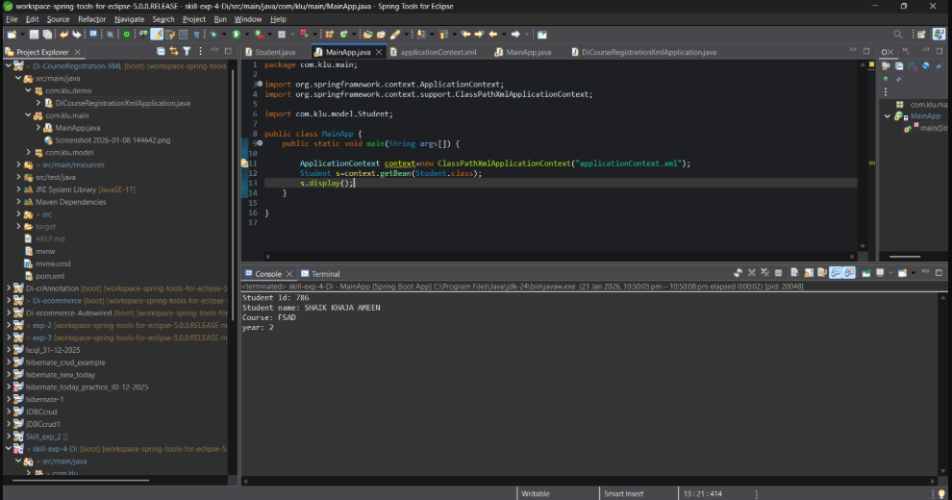
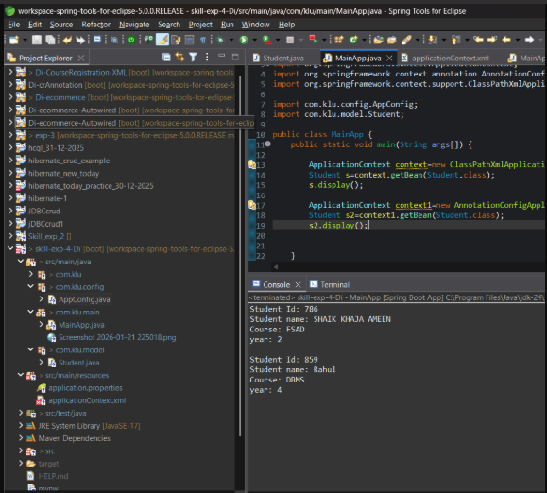

- Push the project into a single GitHub repository.

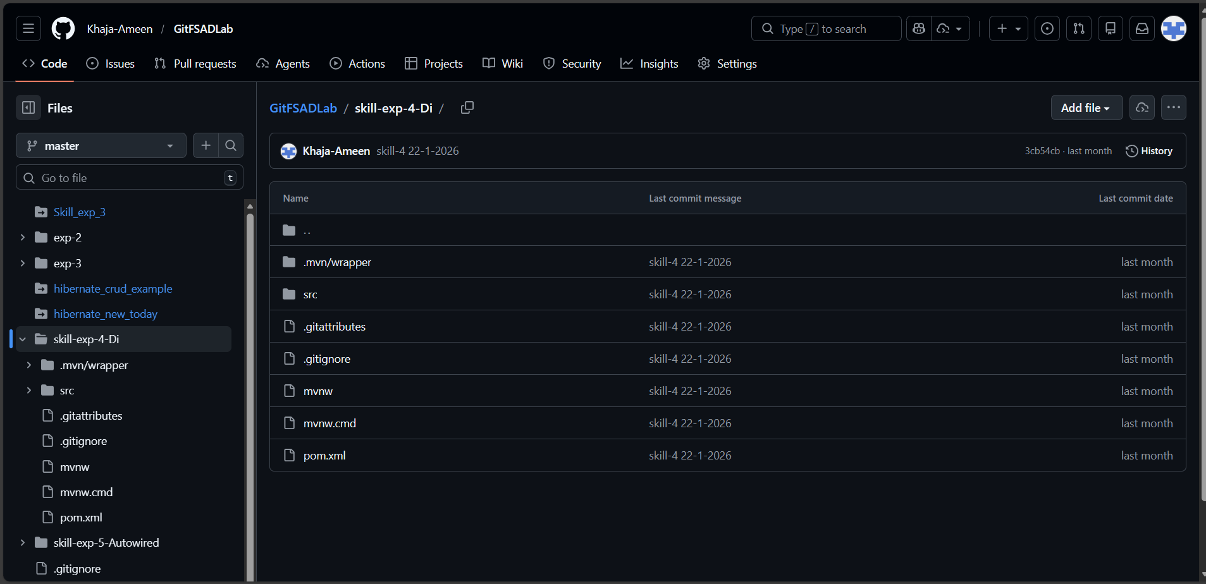

Viva Questions:-
1. What is Dependency Injection (DI) in Spring?
Dependency Injection is a design pattern where Spring provides required objects to a class instead of the class creating them.
2. What is the difference between Constructor DI and Setter DI?
Constructor DI injects dependencies at object creation, while Setter DI injects them after object creation.
3. What is the purpose of the IoC container?
The IoC container manages object creation, configuration, and dependency injection.
4. Why is DI preferred over manual object creation?
DI reduces tight coupling and improves maintainability and testability.
5. Can Constructor Injection and Setter Injection be used together?
Yes, both can be used together in the same class for different dependencies.

(For Evaluator’s use only)
Comment of the Evaluator (if Any)

Evaluator’s Observation
Marks Secured: out of
EMP ID & Full Name of the Evaluator:

Signature of the Evaluator Date of Evaluation

