DEPARTMENT OF CSE, CS&IT, AI&DS
COURSE CODE: 24SDCS02 / 24SDCS02E / 24SDCS02P / 24SDCS02L FULL STACK APPLICATION DEVELOPMENT
Name: SHAIK KHAJA AMEEN ID: 2400030234

SKILL - 2 ➔ Hibernate CRUD Operations
Prerequisites:
- Basic knowledge of Java
- Understanding of classes, objects, and OOP
- Familiarity with SQL basics

Problem Statement
A retail inventory system needs to store product details such as productId, name, description, price, and quantity.
The admin should be able to:
- Add new products
- Retrieve product information
- Update price or quantity
- Delete discontinued products
The task is to implement complete CRUD operations using Hibernate ORM with JPA annotation
1.Create a Product entity with fields: id (primary key), name, description, price, quantity.

package com.klu.model;

import javax.persistence.*;

@Entity
@Table(name="product")
public class Product {
@Id
@GeneratedValue(strategy=GenerationType.IDENTITY)
int id;
private String name;
private String description;
private double price;
private int quantity;

public Product() {

}

public void setName(String name ) {
this.name = name;
}

public String getName() {
return name;
}

public void setDescription(String description) {
this.description = description;
}

public String getDescription() {
return description;
}

public void setPrice(double price ) {
this.price = price;
}

public double getPrice() {
return price;
}

public void setQuantity(int quantity ) {
this.quantity = quantity;
}

public int getQuantity() {
return quantity;
}

}

2.Configure Hibernate and map the Product entity to a table using JPA annotations.
<hibernate-configuration>

<session-factory>

<property name="hibernate.connection.driver_class">com.mysql.cj.jdbc.Driver </property>

<property name="hibernate.connection.url">jdbc:mysql://localhost:3306/workbook</property>

<property name="hibernate.connection.username">root</property>
<property name="hibernate.connection.password">3945</property>

<property name="hibernate.dialect">org.hibernate.dialect.MySQL8Dialect</property>

<property name="hibernate.hbm2ddl.auto">update</property>
<property name="hibernate.show_sql">true</property>

<mapping class="com.klu.model.Product"/>

</session-factory>

</hibernate-configuration>
3. Insert multiple Product records into the database.
private static void insertProduct() {
Scanner sc = new Scanner(System.in);
Session session = factory.openSession();
Transaction tx = session.beginTransaction();

Product prod = new Product();
System.out.print("Enter the Name of the product: ");
String name=sc.nextLine();
prod.setName(name);

System.out.print("Enter the Description of the product: ");
String des=sc.nextLine();
prod.setDescription(des);

System.out.print("Enter the Price of the product: ");
double price=sc.nextDouble();
prod.setPrice(price);

System.out.print("Enter the Quantity of the product: ");
int quant=sc.nextInt();
prod.setQuantity(quant);

session.persist(prod);
tx.commit();
session.close();

System.out.println("A record has been successfully inserted into the product table");
}

4. Retrieve a product using its id.

private static void viewProduct() {
Scanner sc = new Scanner(System.in);
Session session = factory.openSession();

System.out.print("Enter the ID of the product to be viewed: ");
int id = sc.nextInt();

Product prod = session.get(Product.class ,id);

if(prod!=null) {
System.out.println("Name: "+prod.getName());
System.out.println("Description: "+prod.getDescription());
System.out.println("Price: "+prod.getPrice());
System.out.println("Quantity: "+prod.getQuantity());
}else {
System.out.println("Product not found!");
}
session.close();
}

5. Update the price or quantity of any selected product.

private static void updateProduct() {
Scanner sc = new Scanner(System.in);
Session session = factory.openSession();
Transaction tx = session.beginTransaction();

System.out.println("Enter the Product ID");
int id = sc.nextInt();
Product prod =session.get(Product.class, id);
if(prod!=null) {
System.out.println("Enter the product price");
prod.setPrice(sc.nextDouble());
tx.commit();
System.out.println("The Price is Updated");
}else {
System.out.println("Product not found!");
}
session.close();
}

6. Delete a product record by id if it is discontinued.
private static void deleteProduct() {
Scanner sc = new Scanner(System.in);
Session session = factory.openSession();
Transaction tx = session.beginTransaction();

System.out.print("Enter the ID of the product to be deleted: ");
int id = sc.nextInt();

Product prod =session.get(Product.class, id);
if(prod!=null) {
session.remove(prod);
tx.commit();
System.out.println("Product is deleted");
}else {
System.out.println("Product is not found");
tx.rollback();
}
session.close();
}

}

7. Note:
  - Implement Hibernate ID generation strategies (AUTO, IDENTITY, SEQUENCE) inside the entity to observe how primary key values differ.
  - The ID can be manual or auto generated, based on your chosen strategy.

@Entity
@Table(name="product")
public class Product {.
@Id
@GeneratedValue(strategy=GenerationType.IDENTITY)
int id;
private String name;
private String description;
private double price;
private int quantity;

8. Push the Hibernate project into a single GitHub repository.


OUTPUT
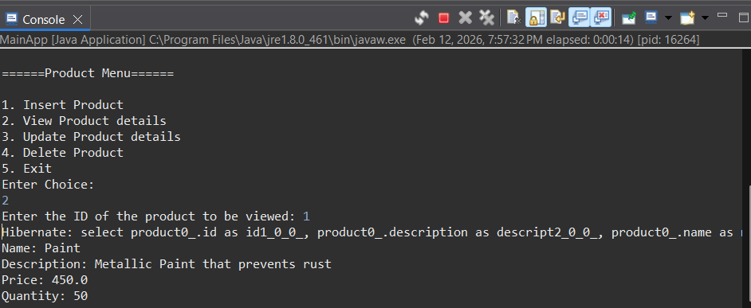

VIVA QUESTIONS (One-Line Answers)
1. What is ORM and why is it used in application development?
ORM maps Java objects to database tables to simplify database interaction.
2. Which annotation is used to mark a class as a JPA entity?
@Entity annotation is used.
3. Why must every Hibernate entity have a primary key?
A primary key uniquely identifies each record in the database.
4. How do you update an existing record using Hibernate?
Retrieve the object, modify its fields, and commit the transaction.
5. What is the difference between get() and load() in Hibernate?
get() returns null if object not found, while load() throws an exception.

(For Evaluator’s use only)

 | Comment of the Evaluator (if Any) |  | Evaluator’s Observation  Marks Secured: out of  EMP ID & Full Name of the Evaluator:  Signature of the Evaluator Date of Evaluation:

