DEPARTMENT OF CSE, CS&IT, AI&DS
COURSE CODE: 24SDCS02 / 24SDCS02E / 24SDCS02P / 24SDCS02L
FULL STACK APPLICATION DEVELOPMENT
Name: SHAIK KHAJA AMEEN ID: 2400030234

SKILL – 6 Spring MVC Web Request Handling Demo

Prerequisites
- Basic knowledge of Spring Boot
- Understanding of HTTP methods (GET/POST)
- General idea of Spring MVC

Problem Statement
An online library system needs to provide REST-based web services that allow users to interact with book data through different types of HTTP requests. The system should enable users to:
- View a welcome message.
- Check the total number of books available.
- View sample book pricing information.
- Retrieve a list of available book titles.
- Fetch details of a specific book using its ID.
- Search for books using a title parameter.
- View books written by a specific author.
- Add new book details using JSON data via POST request.
- View all added books from an in-memory collection.
To implement this functionality, a Spring Boot application must be developed using Spring MVC annotations such as @RestController, @GetMapping, @PostMapping, @PathVariable, and @RequestParam to handle different types of web requests and responses.

Book.java:-

package com.klu.model;

public class Book {

private int id;
private String name;
private String author;
private double price;
public Book() {

}

public Book(int id, String name,String author,double price) {
this.id=id;
this.name=name;
this.author=author;
this.price=price;
}

public void setId(int id) {
this.id=id;
}
public void setName(String name) {
this.name=name;
}
public void setAuthor(String author) {
this.author=author;
}
public void setPrice(double price) {
this.price=price;
}

public int getId() {
return id;
}
public String getName() {
return name;
}
public String getAuthor() {
return author;
}
public double getPrice() {
return price;
}

}
LibraryController.java:-
package com.klu.controller;

import java.util.ArrayList;
import java.util.List;

import org.springframework.beans.factory.annotation.Autowired;
import org.springframework.web.bind.annotation.GetMapping;
import org.springframework.web.bind.annotation.PathVariable;
import org.springframework.web.bind.annotation.PostMapping;
import org.springframework.web.bind.annotation.RequestBody;
import org.springframework.web.bind.annotation.RestController;

import com.klu.model.Book;

@RestController
public class LibraryController {

private List<Book>bookList=new ArrayList<>();
@GetMapping("/library")
public String getMessage() {
return "Welcome to Library";
}

@GetMapping("/count")
public int getCount() {
return bookList.size();
}

@GetMapping("/price")
public double getPrice() {
return 499.99;
}

@GetMapping("/books")
public List<Book> getBooks(){
return bookList;
}

@GetMapping("/books/{id}")
public Book getBook(@PathVariable int id) {
for(Book b:bookList) {
if(b.getId()==id)
{
return b;
}

}
return null;
}

@GetMapping("/author/{name}")
public String getAuthor(@PathVariable String name) {

return "books written by "+name;
}

@PostMapping("/addbook")
public String addBook(@RequestBody Book book)
{
bookList.add(book);
return "book is added ";
}

@GetMapping("/viewbooks")
public List<Book> viewBooks(){
return bookList;
}

}
application.properties:-
spring.application.name=Exp-6-Spring-MVC-Library
server.port=8080

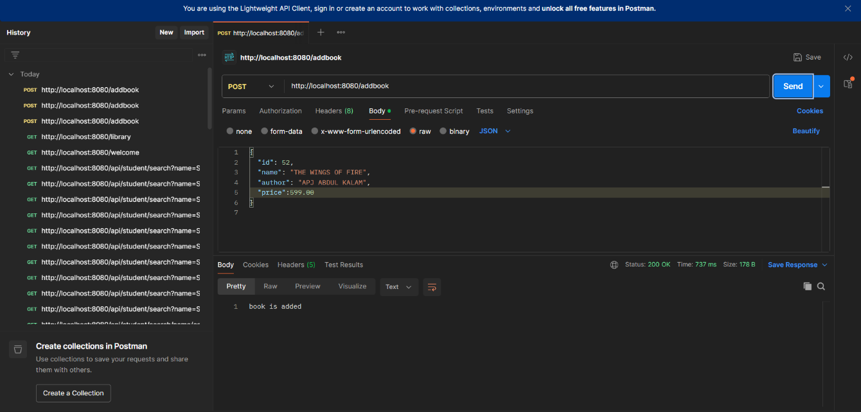
Outputs:-
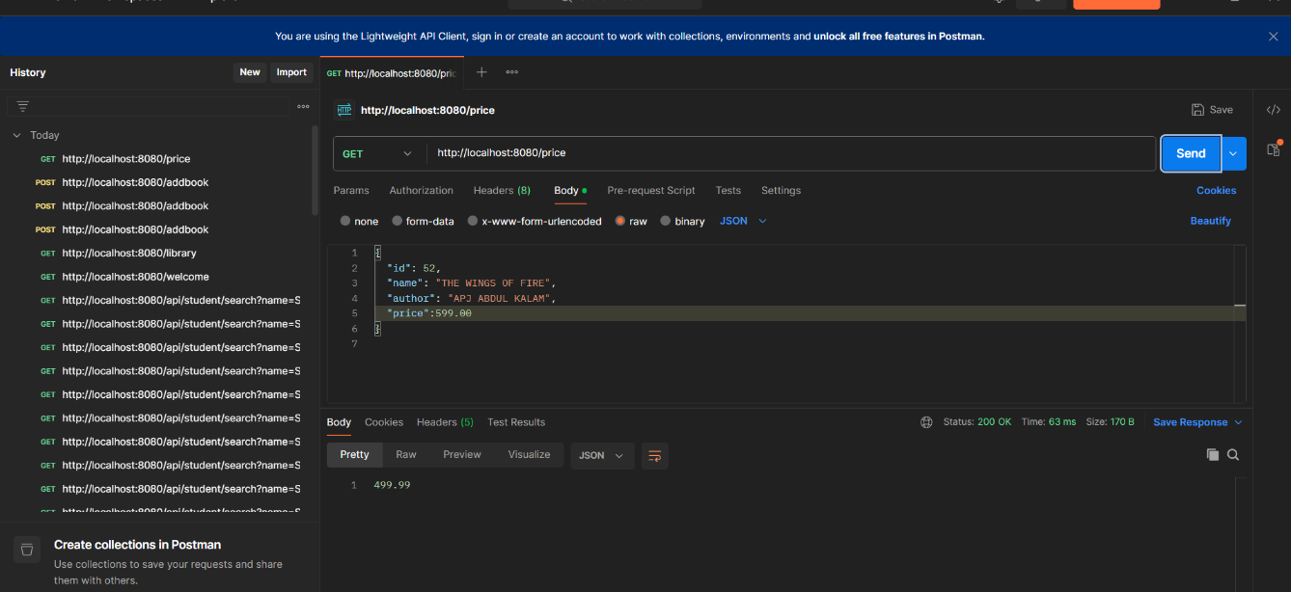
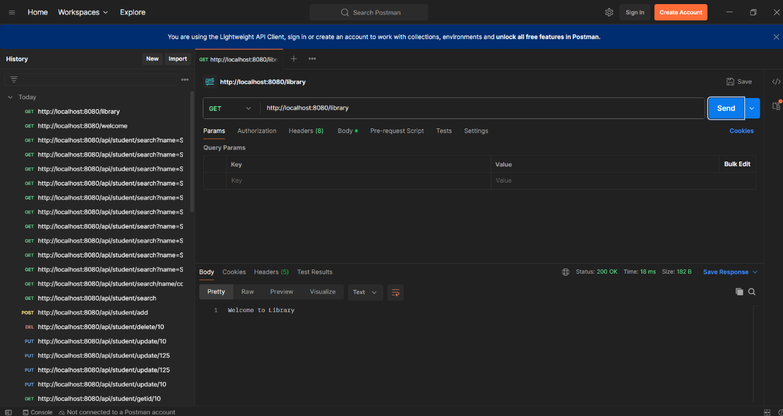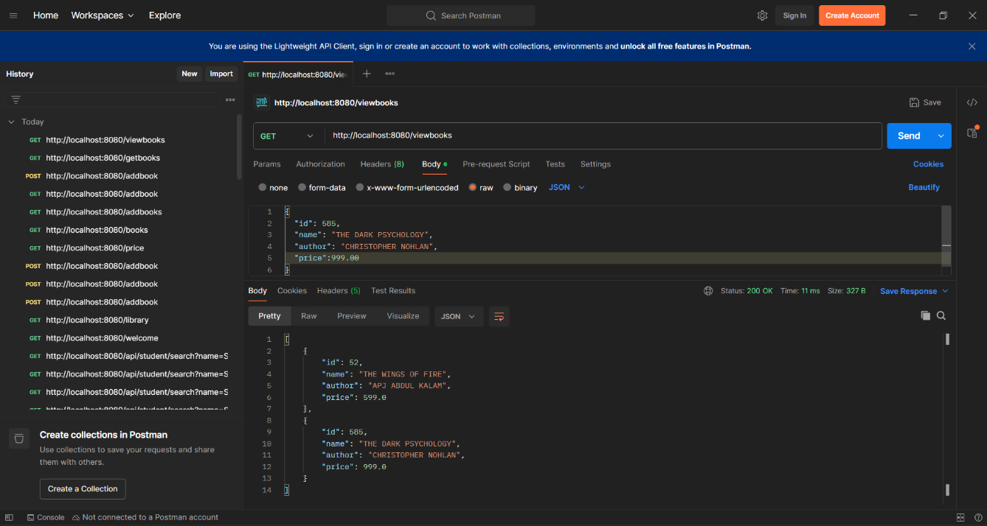

1.Push the project into a single GitHub repository.

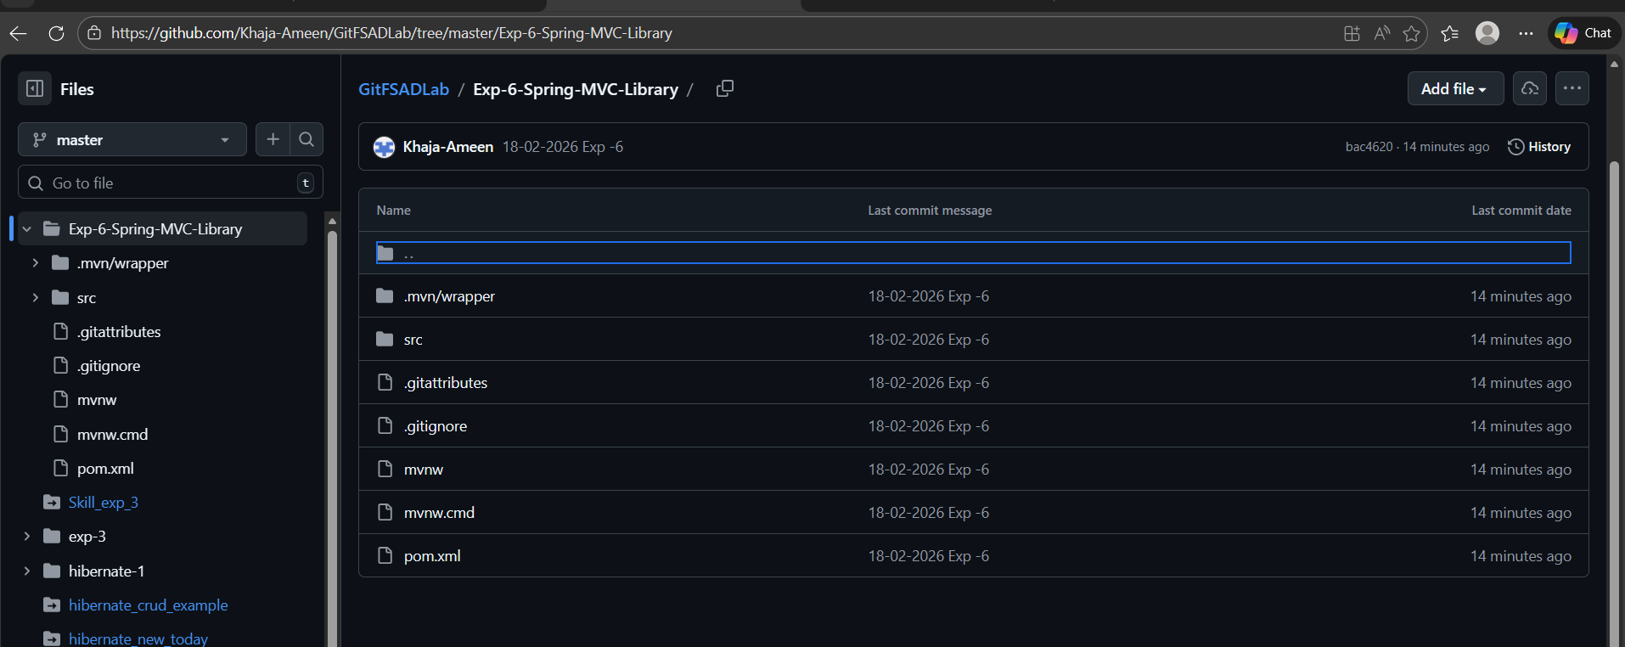

VIVA QUESTIONS:-
1.What is the role of @RestController in Spring MVC?
@RestController is a combination of @Controller and @ResponseBody.
It is used to create REST APIs that return data (JSON/text) directly instead of rendering a view.

2. What is the difference between @GetMapping and @PostMapping?
- @GetMapping → Used to retrieve data from the server.
- @PostMapping → Used to send data to the server (create/add resource).

3.How does @PathVariable help in handling dynamic URLs?
@PathVariable extracts values from the URL and binds them to method parameters.
Example: /books/{id} → captures the book ID dynamically.

4. When do we use @RequestParam?
@RequestParam is used to read query parameters from the URL.
Example: /search?title=Java

5. Can one controller contain multiple request-mapped methods?
Yes. A single controller class can contain multiple methods mapped to different URLs.

(For Evaluator’s use only)
Comment of the Evaluator (if Any)

Evaluator’s Observation
Marks Secured: out of
EMP ID & Full Name of the Evaluator:

Signature of the Evaluator Date of Evaluation

