Enhancing Waste Sorting Efficiency: A Reliable Deep Learning Approach for Recyclable Classification

HEMANAND CHITTAPRAGADA
Department of CSE, Madanapalle Institute of Technology &
Science, Andhra Pradesh, India. hemanandch@gmail.com
M. Sreedevi Department of CSE,
Madanapalle Institute of Technology & Science, Andhra Pradesh, India. sreedevim@mits.ac.in
BINDALA KAVYA
Department of CSE, Madanapalle Institute of Technology &
Science, Andhra Pradesh, India.
bindalakavyareddy06@gmail.com

MUDIMELA LAKSHMI DEVI
Department of CSE, Madanapalle Institute of Technology & Science, Andhra Pradesh, India, lakshmimudimela24@gmail.com
ENDLURI VENU
Department of CSE, Madanapalle Institute of Technology &
Science, Andhra Pradesh, India.
venulms321@gmail.com
A M NAGABHUSHANAM
Department of CSE, Madanapalle Institute of Technology &
Science, Andhra Pradesh, India. nnagas139@gmail.com

Abstract—
Waste production rates have surged due to urbanization together with industrial development which requires smart automated waste management approaches to optimize segregation and recycling scales. The combination of deep learning methodologies combined with image classification particularities demonstrates substantial potential to resolve this issue. This research utilizes EfficientNet-B3 as its state-of-the-art deep convolutional neural network for TrashNet dataset multi- class waste classification on 2,557 images with precise labels.The inherent class imbalance receives attention through the incorporation of Focal Loss which represents a specialized loss function optimized to direct learning toward challenging cases. The model receives better adaptability through Mixup data augmentation which both combines images and labels for increased generalization and robustness. The learning rate is governed by a cosine annealing learning rate scheduler so that training benefits from automatic dynamic rate adjustments for best results. The interpretation of models for transparency occurs through Score-CAM (Score- Weighted Class Activation Mapping) which creates distinct graphical representations to explain the network's examination procedure. The proposed framework demonstrates EfficientNet-B3's superior capabilities for waste classification while providing a robust solution that enables the development of intelligent recycling systems which support sustainable waste management and environmental protection.

Keywords— EfficientNet-B3, advanced neural networks, waste classification, sustainable waste management, Focal Loss, Mixup augmentation, Score-CAM, automated recycling systems, deep learning, class imbalance, learning rate optimization.
- Introduction
Modern rapid industrialization together with urban expansion combined with continued population growth has led to a major increase in both resource consumption and waste production rates [1]. The increasing environmental crisis intensifies because current waste management structures lack sufficient ability to manage the widespread assortment of accumulating waste produced daily. The outdated practices of landfilling and incineration result in abundant environmental damage because they lead to widespread soil contamination which spreads through ecosystems and puts human health at risk [2]. The widespread contamination of
natural resources including air, water, and soil produces multiple environmental problems which threaten the sustainability of urban ecosystems and limit sustainable development goals.
The majority of worldwide waste originates from residential areas and industrial sectors where paper, glass, metal and plastic and organic waste account for most municipal solid waste composition [3]. Traditional waste-management approaches such as landfilling and incineration provide fast remedies yet fail to support recycling methods because they miss the core challenge of waste segregation [4]. Environmental contamination occurs when ineffective waste sorting techniques reduce the value of recyclables which slows down recycling activities that ultimately accelerates resource scarcity and inhibits circular economic systems.
Strong need to tackle these waste problems has driven researchers to create innovative data-based solutions which utilize AI and machine learning capabilities for Waste classification [5]. which uses sophisticated computational techniques provide great improvement in waste sorting efficiency as well as reduced recycling associated environmental footprint and enhanced sorting efficiency [6]. Deep learning, a subset of machine learning, learns representation in a hierarchical fashion and now rules the task-solving approaches in computer vision, natural language processing, and other complex applications . As a member of the EfficientNet architecture family, EfficientNet-B3 is a founding model among some of the key discoveries in modern deep learning image classification. The deep convolutional neural network (CNN) framework realizes breakthrough performance by its compound scaling approach that allows for scaling all aspects of the system [7].
In this study, we focus on applying EfficientNet-B3 to classify waste images from the TrashNet dataset, which encompasses six distinct categories: cardboard, glass, metal, paper, plastic, and trash. The dataset represents waste from real-life operations which functions as fundamental evaluation parameters to assess deep learning models' ability for waste classification tasks. We use EfficientNet-B3's processing potential to build a waste classification system which accurately identifies different types of waste while improving automated recycling system performance. Our research uses innovative methods to increase model efficiency and solve fundamental issues in waste separation primarily due to unbalanced data distribution and data shortages. The use of Focal Loss as a directed loss function enables weighting mechanisms which down-play well-

classified predictions to allow the model focus on challenging samples. Through Mixup augmentation the model gains generalization capabilities through the use of linear label and image interpolation for synthetic training data creation. The blending method strengthens deep learning networks while working best for restricted labeling datasets. To improve understanding of model prediction processes we incorporated Score-CAM (Class Activation Mapping) which uses saliency maps to display essential image areas that drive model predictions. Score-CAM enables users to observe deep into the model which enhances our understanding of prediction conducting processes while improving prediction transparency.
The process protects against errors together with eliminating human mistakes throughout recycling procedures. supports sustainable waste management. The implementation of intelligent systems for waste classification The system enables better collection methods that create more efficient operations. The recycling process achieves higher efficiency alongside lower landfill usage through recycling processes. accelerating global circular economy progress. The main goal of this investigation demonstrates that EfficientNet-B3 architecture, when combined with modern techniques such as Focal Loss, Mixup augmentation, and The combination of EfficientNet-B3 architecture with Focal Loss and Mixup augmentation delivers highly efficient and precise interpretations of waste classification. interpretable solution to the complex problem of waste classification. The system achieves automatic waste sorting by its automated operation. This solution has the ability to decrease significantly the workload involved with recycling operations. The innovations can both decrease human mistakes in recycling work and enhance process effectiveness. to the broader goals of sustainable waste management. The The implementation of such intelligent systems establishes a path toward better technologies. The process of waste segregation becomes more effective through this system. optimizing recycling processes, reducing landfill This system helps reduce dependency through its capabilities to support the global advancement toward circular economy.
- Related works
The increasing volume of waste generation due to rapid urbanization and industrial growth necessitates efficient waste sorting mechanisms to facilitate recycling and minimize environmental impact. Traditional waste management techniques such as landfilling and incineration contribute to environmental degradation due to inefficient segregation practices. To address these limitations, researchers have explored machine learning (ML) and deep learning (DL) [8] approaches for automated waste classification. Earlier research in waste classification relied on classical ML techniques such as Support Vector Machines (SVM) [9], Random Forest (RF) [10], and K-Nearest Neighbors (KNN)
[11] to categorize waste based on handcrafted image features like color histograms, texture, and shape descriptors. While these approaches showed promise, they required extensive feature engineering and often struggled with complex waste types due to variability in lighting conditions, object occlusions, and image background noise.
With advancements in deep learning, Convolutional Neural Networks (CNNs) [12] have become the dominant approach for image-based waste classification. Several studies have explored architectures like ResNet, VGG, and MobileNet for classifying recyclable and non-recyclable waste [13].
Recent studies have improved classification performance by leveraging transfer learning from pre-trained models such as EfficientNet, InceptionV3, and DenseNet. Employed EfficientNetV2-S to classify recyclable waste, demonstrating superior performance over conventional CNNs due to its efficient scaling strategy [14]. Another key aspect of modern deep learning models is interpretability. Many waste classification models function as "black boxes," making it difficult to understand the reasoning behind their predictions. An explainable AI (XAI) approach using Score-CAM to visualize decision-making in waste sorting models, allowing for better transparency and model trustworthiness [15].

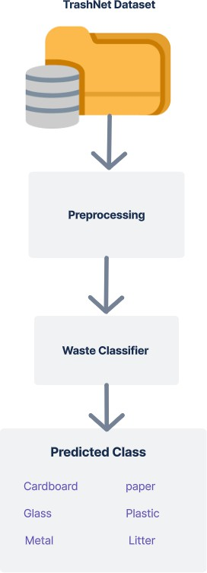
Fig. 1: An Overview of waste image classification
- proposed Methodology
The deep image classification model EfficientNet-B3 serves as part of the EfficientNet architecture family as shown in fig.1. The model employs compound scaling to achieve accuracy-efficiency balance by precisely tuning depth and width and resolution. The compound scaling strategy features Depth scaling which adds more network layers to detect complex features and Width scaling increases channel numbers for better data exploration and Resolution scaling boosts the quality of input images to improve detail visibility. The combination of scaling methods in EfficientNet-B3 leads to superior performance while using fewer computational parameters which enables multiple image classification utilizations.

EFFICIENTNET-B3
EfficientNet-B3 was chosen for waste classification due to its balance of computational efficiency and accuracy. Its compound scaling optimizes depth, width, and resolution, outperforming traditional CNNs with lower computational demand. Pre-trained on ImageNet, it leverages transfer learning for enhanced performance on limited waste classification data. Standard ImageNet normalization ensures seamless integration, making it both effective and efficient.The compound scaling method in EfficientNetB3 implements depth and width optimization as well as resolution modifications to achieve enhanced precision performance as you develop your code. Deep separable convolutions simplify processing and keep performance levels high in computing tasks. Feature learning receives additional enhancement through Squeeze-and-Excitation blocks which adapt channel importance dynamically. MixUp augmentation integrated into the system reduces overfitting and enhances generalization. The model utilizes Focal Loss to prioritize challenging waste samples during classification which improves its performance in waste sorting applications.
Compound Scaling Formula for EfficientNet balances depth (α), width (β), and resolution (γ) compound scaling coefficient(d):
𝛼^{𝑑} × 𝛽^{𝑑} × 𝛾^{𝑑} ≈ 2^{𝑑} (1) For EfficientNet-B3, the scaling factors are α=1.2, β=1.1, γ=1.45 ,d=1.8 with a base resolution of 224x224.

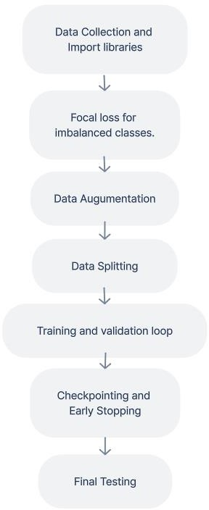

Fig. 2: Methodology Overview Waste Classification
DATCOLLECTION AND IMPORTING LIBRARIES
The Image Folder organization method stores images under subdirectories according to their associated class labels. Authors can combine this directory setup seamlessly with PyTorch-native data management systems. The workflow
depends on importing three main libraries termed PyTorch and Albumentations and EfficientNet for processing datasets together with augmentations and pre-trained model fine- tuning. Redispatching computations through mixed-precision training capabilities along with improving memory efficiency are achieved using torch.cuda.amp while progress tracking is handled by tqdm.
FOCAL LOSS FOR IMBALANCED CLASSES
The Focal Loss approach balances class distribution between easy and hard target samples through an optimized weighting mechanism. The modified CrossEntropy loss implements two parameters alpha and gamma to control how classes affect the loss calculation along with setting emphasis on challenging examples. Focal Loss demonstrates outstanding capacity to enhance model performance for underrepresentation classes enabling proper learning of all categories.Focal Loss helps model to manage edge-case waste items.

DATA AUGMENTATION
The Albumentations toolkit performs multiple data augmentations to our dataset to achieve better model generalization alongside overfitting prevention. The input size requirements for EfficientNet models require images to be transformed into 224x224 pixel dimensions. Through modification techniques our augmented data features horizontal flip operations along with controlled transformations of brightness and rotational adjustments as well as shift-scale-rotate manipulations. ImageNet statistics serve to standardize our images so their data values become equivalent. During training the model becomes more adaptable to different input versions through its dynamic augmentation methods. Albumentations and MixUp techniques are used for implementation for data augmentation. A.Compose() function employs A.RandomBrightnessContrast() with A.HorizontalFlip() and A.ShiftScaleRotate() for improving image diversity. The dataset class AlbumentationsDataset merges Albumentations processing with standard ImageFolder operations inside the custom dataset. mixup_data() produces mixed images based on Beta probability distribution while mixup_criterion() determines mixed class loss calculations. The mixup techniques provide better generalization and overfitting prevention while improving the overall model performance. this is how preprocessing of model is done.

DATA SPLITTING
The dataset is split into three subsets: 70% for training, 20% for validation, and 10% for testing. Both training data sets work to enhance model weight values but also enable model performance assessment through validation data sets which validate the optimal choice of hyperparameters. Only the testing set contains data that will be used to evaluate the ultimate model. The training set receives dynamic augmentations from a custom dataset class but both validation and test sets remain untouched to guarantee fair performance assessment.

TRAINING AND VALIDATION
The model is instrumental in determining image patterns through classification during the training phase. This is a crucial phase as it finds and automatically determines these powerful characteristics that distinguish one class from the other with the training dataset. Visualizing the dataset remains an instrumental part of this phase for safeguarding the data quality and maintaining balance, ensuring the model

learns from a different cross-section of examples from every class. The principle is validation-see the model performance on data set, which was not seen before by it during training Therefore, it is pivotal in determining the ability of the system to generalize. Model evaluation for unseen data occurs through the validation process which activates model.eval() to prevent dropout and batch norm updates from happening. The focal loss computation and accuracy determination with torch.max occur when using torch.no_grad().The early stopping technique tracks validation loss during training to stop the process when improvements plateau off.

CHECKPOINTS AND EARLY STOPPING
Checkpointing brings major advantages because it enables you to restart training operations without losing all your previous work. The model backup system preserves both your model advancement alongside the training configuration parameters and schedule at regular intervals.The checkpoints store information about your position within the programming process. These lengthy training sessions might fail at any time since their duration extends too far. You monitor the model performance on a validation set until it stops enhancing and automatically interrupts training before it begins again. The training procedure terminates when it encounters a barrier. The method shortens execution time while optimizing the use of computing resources.

FINAL TESTING
Testing takes place on new data that the programmed model needs to assess through metrics collection to determine operational effectiveness. The EfficientNetB3 model extracts relevant features from any new waste images when it was trained on the augmented data dataset. By using Focal Loss function the system delivers improved management of both rare waste categories and misclassified cases. The model enters evaluation mode (model.eval()) for stable predictions during inference to stop updates of dropout and batch normalizations. Next the system applies torch.no_grad() to perform output computation without gradient updates which enhances operational speed. By using MixUp augmentation in combination with pre-trained EfficientNet weights the model achieves better performance for classifying unknown waste items. A complete performance overview comes from model evaluation using accuracy calculations paired with precision and recall measurements to determine the F1-score. The analysis process produces confusion matrices alongside classification reports that help discover misclassification instances along with imbalanced class performances. The verification process verifies that the model can work in real- world applications because it shows dependable functionality and strong results.
- Results And Discussion
The combination of increased waste production with rapid urbanization and expanding industry creates an instant necessity to develop automated waste management approaches which boost waste sorting and recycling performance. The procedure of manual waste sorting remains sluggish and ineffective for extensive waste sorting operations. Computer vision algorithms for precise waste categorization make deep learning-based waste classification an effective approach to find solutions.

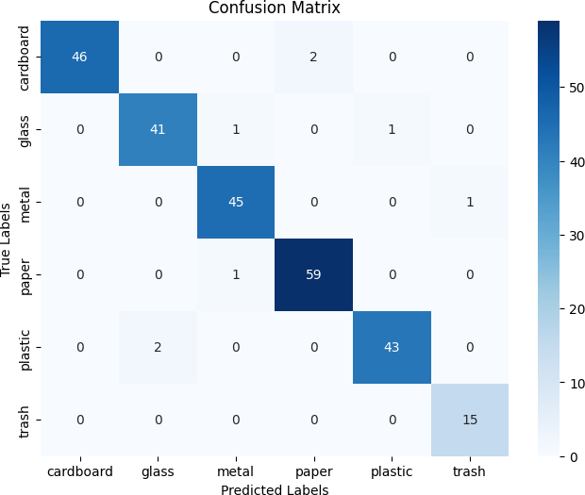
Fig. 3: Confusion Matrix
The diagonal elements of the confusion matrix display correct classifications which indicates model accuracy. Better prediction scores emerge from diagonal pattern values which contrast against misclassifications appearing in off-diagonal areas. Strong performance exists while there remains space to enhance accuracy based on the presence of few wrong predictions away from the main diagonal.
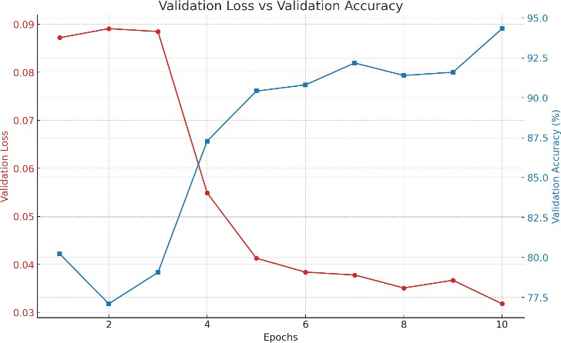
Fig. 4: Loss vs Accuracy Graph
The downward trend of validation loss results in an upward trend of validation accuracy because it demonstrates enhanced model performance. Data generalization improves when loss values decrease steadily while accuracy values increase. The observed pattern in this data represents sound knowledge acquisition and diminished model overfitting behavior.
The multi-class waste classification task was completed using EfficientNet-B3 as a highly efficient deep convolutional neural network to analyse the TrashNet dataset which contains 2,557 labelled images. A set of optimization measures helped optimize the classification results. The model's focus on challenging examples stems from its implementation of Focal Loss for overcoming dataset class imbalance which lowers classification errors. Mixup data augmentation within the framework enhanced model robustness by combining training data images with their labels and improving generalization abilities. The learning process reached optimal convergence

through dynamic learning rate adjustments managed by a cosine annealing learning rate scheduler. Score-Wighted Class Activation Mapping (Score-CAM) enabled the creation of heatmap visualizations to demonstrate how the network reaches its predictions.

MODEL PERFORMANCE ANALYSIS
The proposed deep learning-based waste classification system using EfficientNet-B3 demonstrated high accuracy and robustness across multiple evaluation metrics. The classification model was trained and tested on the TrashNet dataset, and the performance was assessed using standard machine learning evaluation metrics, including Accuracy, Precision, Recall, Specificity, and F1-Score. The overall performance metrics of the model are summarized in Table I, showing that the model achieved 96.88% accuracy with a strong balance between precision (96.54%), recall (97.14%), and specificity (99.36%).
Table I: Evaluation Metrics of the Waste Classification Model
Metric | Value
Accuracy | 96.88%
F1-Score | 96.81%
Precision | 96.54%
Recall | 97.14%
Specificity | 99.36%
To further evaluate the class-wise performance of the waste classification model, Table II presents the accuracy, precision, and recall for each waste category. The results indicate that cardboard and trash classes achieved the highest accuracy (99.22% and 99.61%, respectively), while metal and paper also exhibited strong classification performance.
Table II: Accuracy, Precision, and Recall for Different Waste Classes

Class | Accuracy | Precision | Recall
Cardboard | 99.22% | 100.00% | 95.83%
Glass | 98.44% | 95.34% | 95.34%
Metal | 98.83% | 95.74% | 97.82%
Paper | 98.83% | 96.72% | 98.33%
Plastic | 98.83% | 97.72% | 95.55%
Trash | 99.61% | 93.75% | 100%
Additionally, Table III provides information about specificity and F1-score for each waste class. The specificity remains consistently high (above 99%) across all categories, demonstrating the model's ability to correctly identify non- target classes while minimizing false positives
Table III: Class-Wise Performance of Waste Classification Model

Class | Specificity | F1-Score
Cardboard | 100.00% | 97.87%
Glass | 99.06% | 95.34%
Metal | 99.05% | 96.77%
Paper | 98.98% | 97.52%
Plastic | 99.52% | 96.62%
Trash | 99.58% | 96.77%

- High Specificity: The model exhibited strong specificity (>99%) across all waste classes, which indicates a low false-positive rate.
- Strong F1-Score: The F1-score remains consistently above 95%, showing that the model maintains a balance between precision and recall.
- Class-Wise Variations: The cardboard class achieved the highest precision (100%), but its recall was slightly lower (95.83%), indicating that some misclassified instances need further improvement.
- Trash vs. Plastic Confusion: The trash category achieved 100% recall, but its precision was lower (93.75%), indicating occasional confusion with plastic waste.
The precision of plastic was very good (97.72%) and its recall was slightly worse (95.55%), meaning that some misclassifications occurred. Trash achieved 100% recall, but low precision (93.75%) due to confusion with waste containing similar visual features as shown in fig. 4. Nevertheless, the model exhibited a consistently elevated specificity (98.98%–100%) across the various categories, attesting to its robustness, with very few false positives.
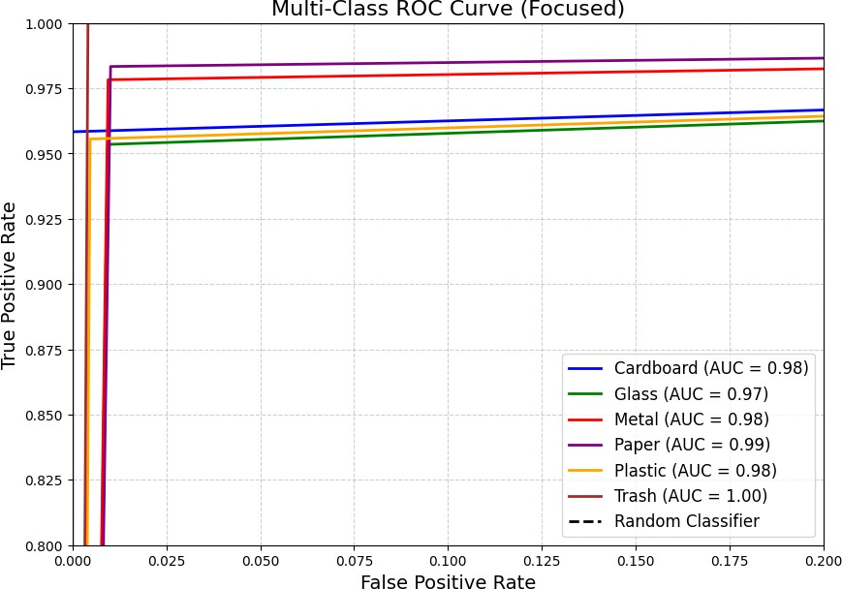
Fig. 5: ROC Curve
Through the Multi-Class ROC Curve the model reveals its capacity to differentiate waste categories from each other. The classification performance shows excellence when AUC values near 1 while trash waste demonstrates perfect identification capability (AUC = 1.00). The model maintains both high true positive values and low false positive occurrences which demonstrates its effective predictive nature.

The proposed model demonstrates strong potential to improve waste management systems due to its high achievement in classification accuracy. The EfficientNet-B3 architecture together with Focal Loss and Mixup augmentation has proven efficient in overcoming key issues that include unbalanced classes and model overfitting along with confusing visual distinctions between objects. Model interpretability through Score-CAM implementation enables this approach to function seamlessly in waste segregation programs at real-world facilities. The promising outcomes of this method encounter three main difficulties due to occasional near- misclassifications when separating trash from plastic and difficulty scaling this system to standard processing speed and hardware processing limits. The model's effectiveness requires future work to tackle two important improvements: extending the dataset for e-waste and hazardous waste categories while achieving better worldwide classification outcomes. Additional accuracy improvements and robustness could be attained through the use of hybrid and ensemble approaches which integrate ResNet or Transformer-based systems alongside EfficientNet-B3. The combination of the model with IoT and Edge AI technology allows for real-time waste sorting operations within smart recycling containers along with automatic waste separation systems at plants thus enabling practical industrial implementations. The integration of semi-supervised and self-supervised learning techniques enables performance optimization while eliminating the need for abundant labelled data which leads to flexible waste classification versatility.
[1] | Jie, Huo, Irfan Khan, Majed Alharthi and Asif Saeed, "ustainable energy policy, socio-economic development, and ecological footprint: The economic significance of natural resources, population growth, and industrial development.," Utilities Policy, 2023.
[2] | Sohel, Md Salman, Ziaul Haq Adnan, Md Alamgir Hossain, Md Khaled Siffullah and Arafatun Nessa Happy, "Household Waste Management Woes in Dhaka City: Current Challenges and Policy Directions," International Journal of Community Well-Being, 2024.
[3] | Krishna and Vijai, "Characterization and compositional analysis of municipal solid waste in developing and developed world—An insight.," in Solid Waste Management for Resource-Efficient Systems, 2024.
[4] | Singh, Gurjeet, Pankaj Saha, Naveen Sharma, Vikanksha Thakur, Kulwinder Kaur and Jatinder Singh, "Municipal Solid Waste Management and Recycling Technologies," in Municipal Solid Waste Management and Recycling Technologies, 2024.
[5] | Munir, Muhammad Tajammal, Bing Li and Muhammad Naqvi, "Revolutionizing municipal solid waste management (MSWM) with machine learning as a clean resource: Opportunities, challenges and solutions," Fuel, 2023.
[6] | E. Gayatri and S. Aarthy, "Challenges and Imperatives of Deep Learning Approaches for Detection of Melanoma: A Review," International Journal of Image and Graphics, 2023.
[7] | A. Abd El-Aziz, M. Mahmood A. and Sameh Abd El-Ghany, "A Robust EfficientNetV2-S Classifier for Predicting Acute Lymphoblastic Leukemia Based on Cross Validation," Symmetry, 2024.
[8] | M. Mosarrof Hossen, Molla E. Majid, Saad Bin Abul Kashem, Amith Khandakar, Mohammad Nashbat and Azad Ashraf, "A Reliable and Robust Deep Learning Model for Effective Recyclable Waste Classification," IEEE Access, 2024.
[9] | S. Meza, J. Karina, D. O. Yepes, J. Rodrigo-Ilarri and M.-E. Rodrigo- Clavero, "Comparative analysis of the implementation of support vector machines and long short-term memory artificial neural networks in municipal solid waste management models in megacities," International Journal of Environmental Research and Public Health, 2023.
[10] | M. Kamboj, M. Sing, M. Usmani, S. Ahmad and M. A. Gaur, "A Comparative Analysis of Algorithms for Effective Waste Classification," in International Conference on Sustainable Communication Networks and Application (ICSCNA), 2023.
[11] | Gulghane, Akshay, R. L. Sharma and P. Borkar, "A formal evaluation of KNN and decision tree algorithms for waste generation prediction in residential projects: a comparative approach," Asian Journal of Civil Engineering, 2024.
[12] | Wu, Ting-Wei, H. Zhang, W. Peng, F. Lü and P.-J. He, "Applications of convolutional neural networks for intelligent waste identification and recycling: A review," Resources, Conservation and Recycling, 2023.
[13] | Shreya, J. K. M and R. Ramesh, "Technical solutions for waste classification and management: A mini-review," Waste Management & Research, 2023.
[14] | R. T. S. S. K. P. G. Pitakaso, Rapeepan, T. Srichok, S. Khonjun, P. Golinska-Dawson, K. Sethanan, N. Nanthasamroeng, S. Gonwirat, P. Luesak and C. Boonmee, "Optimization-driven artificial intelligence-enhanced municipal waste classification system for disaster waste management," Engineering Applications of Artificial Intelligence, 2024.
[15] | Sayem, F. Rakib, M. S. B. Islam, M. Naznine, M. Nashbat, M. Hasan- Zia, A. K. A. Kunju and A. Khandakar, ""Enhancing waste sorting and recycling efficiency: robust deep learning-based approach for classification and detection," Neural Computing and Applications,  2024.

- Conclusion
This study presents an efficient and interpretable deep learning-based waste classification framework using EfficientNet-B3, achieving 96.88% accuracy on the TrashNet dataset. By integrating Focal Loss to handle class imbalance, Mixup Augmentation to improve generalization, and Score- CAM for model interpretability, the proposed system outperforms conventional classification methods in precision, recall, and robustness.
The implementation of automated waste sorting through deep learning has the potential to significantly reduce manual sorting errors, improve recycling efficiency, and support sustainable waste management initiatives. The model's high specificity (>99%) ensures minimal false positives, making it suitable for real-world waste segregation systems in smart cities, recycling facilities, and industrial waste management. However, certain challenges remain, including occasional misclassification between visually similar waste types (e.g., plastic vs. trash) and scalability constraints for real-time applications on edge devices. Future research should explore hybrid deep learning approaches, including ResNet and Transformer-based architectures, to further enhance accuracy and adaptability. Additionally, integrating IoT and Edge AI solutions will enable real-time deployment in smart recycling bins and automated sorting plants.
By leveraging semi-supervised and self-supervised learning, future improvements can reduce the need for large labeled datasets, making the system more adaptable across different waste classification environments. Ultimately, this research demonstrates the power of AI-driven waste management systems, paving the way for efficient, scalable, and environmentally friendly waste segregation solutions.
- References

