Employee-Department-App

API Methods:

Application URL:

Post: http://localhost:8080/employee/create

GET:  http://localhost:8080/employee/department/HR

GET:  http://localhost:8080/employee/empname/K

GET:  http://localhost:8080/employee/sort/deptAndEmpId

GET:  http://localhost:8080/employee/HR/sort/empName

GET:  http://localhost:8080/employee/department/empid/1

HR Department Employee:

-----------------------

{

    "departmentName":"HR",

    "employeeNames":["Khaja","Vali"]

}

HR Department Employee:

-----------------------

{

    "departmentName":"Engineering",

    "employeeNames":["Ram","Sam"]

}

HR Department Employee:

-----------------------

{

    "departmentName":"QA",

    "employeeNames":["Jack","Euvin","Pitor"]

}

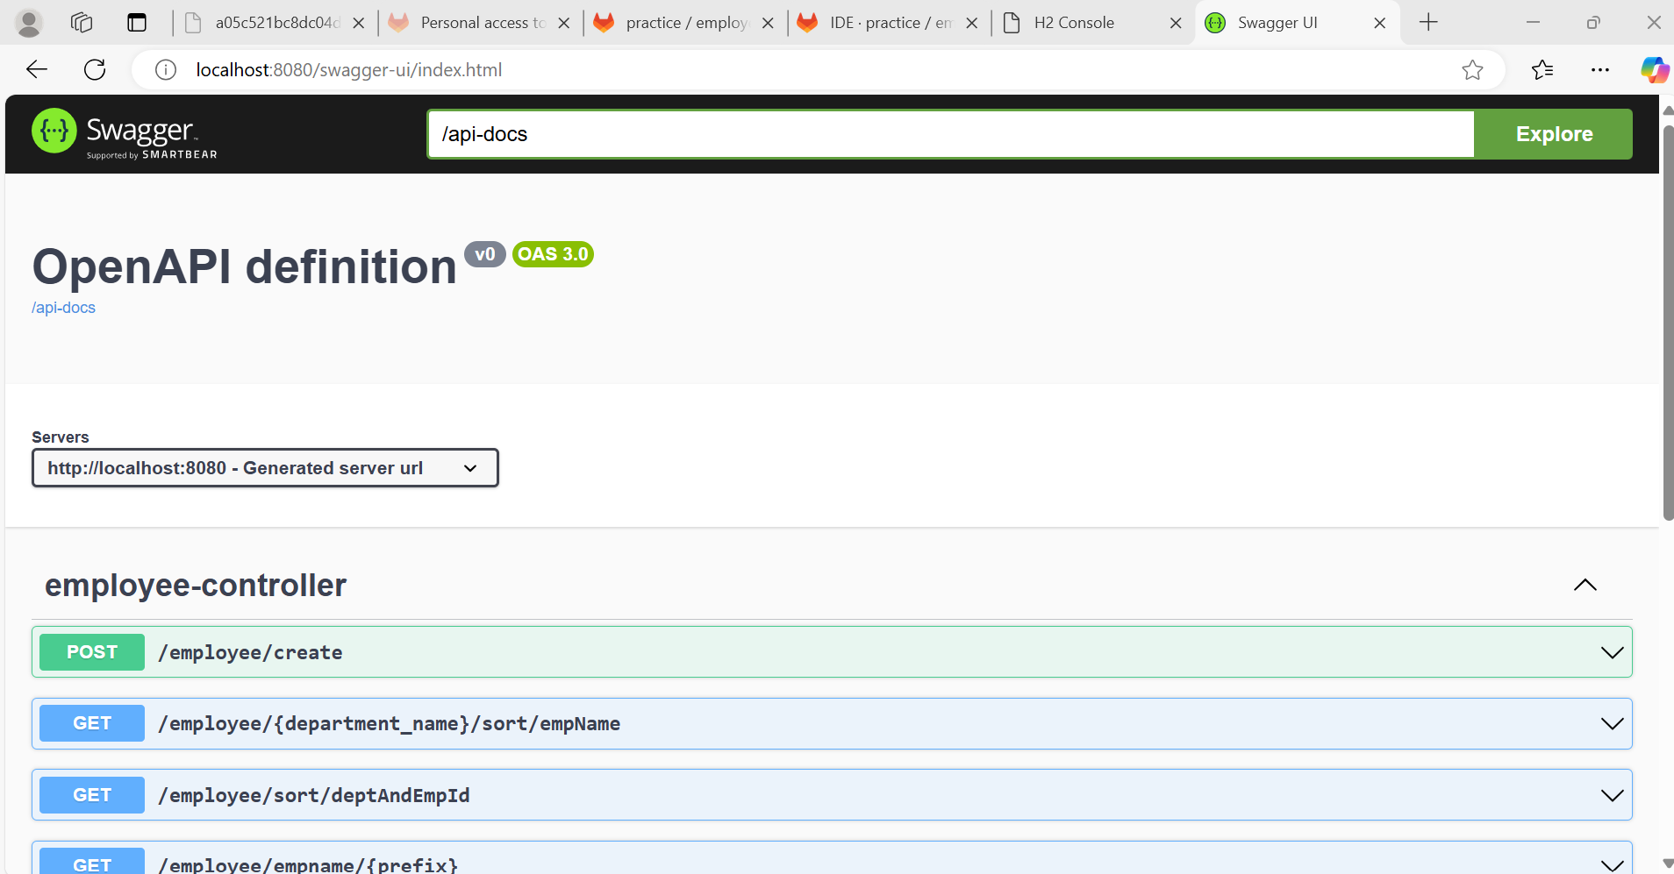

**Adding Employee:**

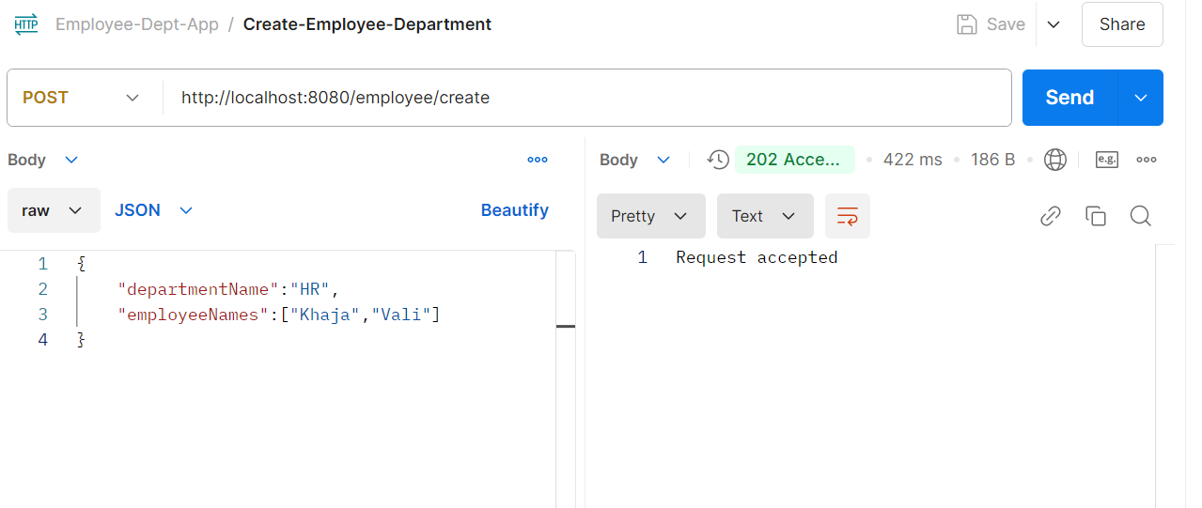

**Find_Employees_Department_Sort_Employee_ID:**

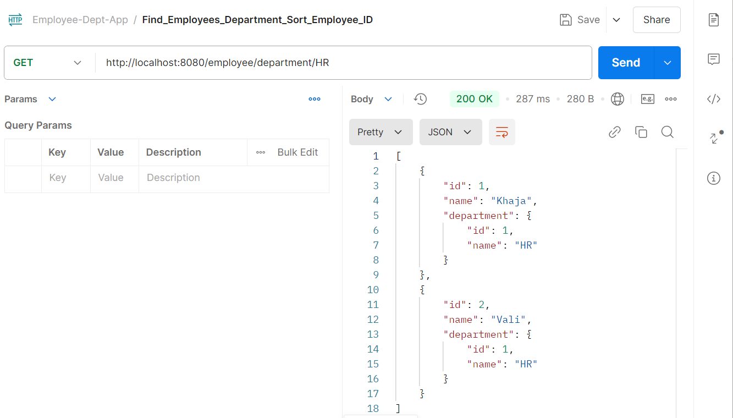

**Find_Employees_Name_StartsWith:**

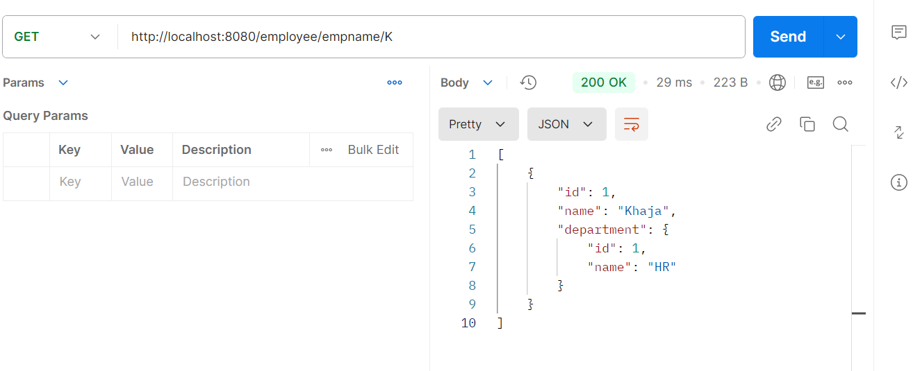

**findAllEmployeesSortByDeptNameAndEmpId:**

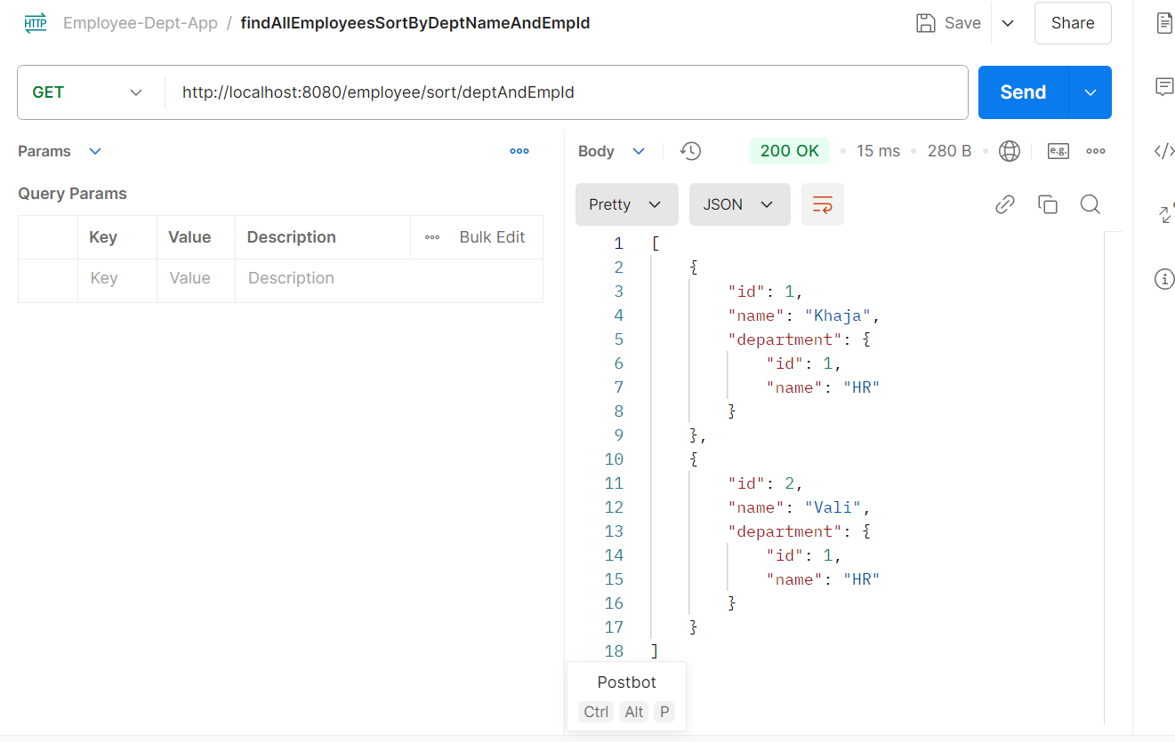

**findEmployeesByDeptNameSortByEmpId:**

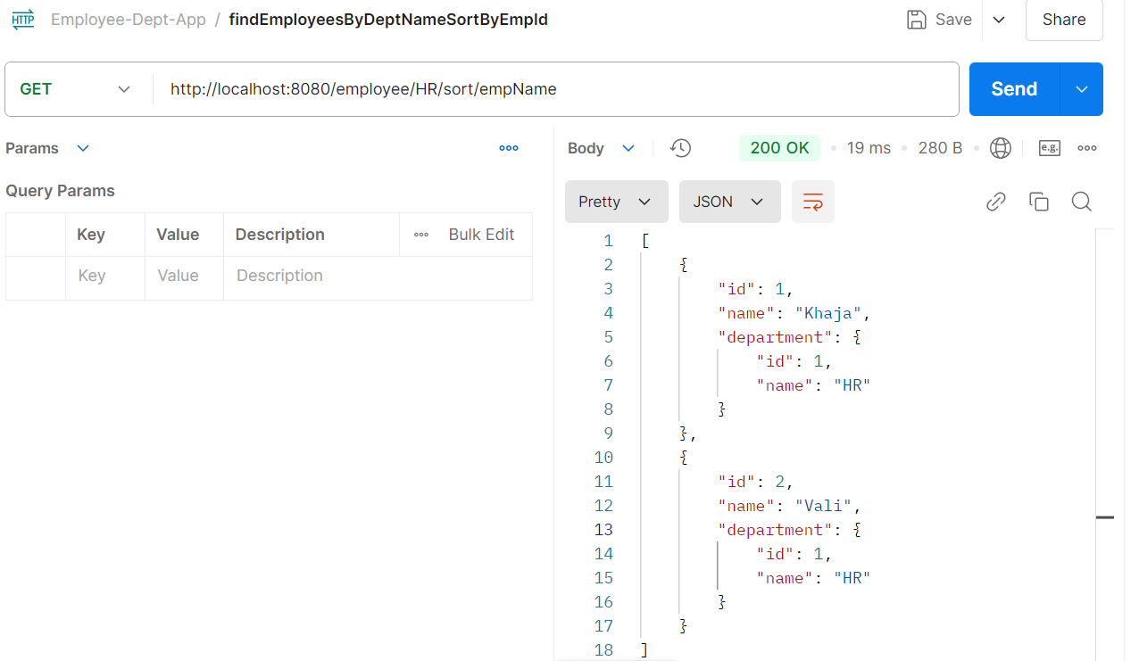

**findDeptOfEmployee:**

