Mini-Project 3: Country Development & Economic Performance Analysis
Prepared by: Atef Khalaf (Junior BI Analyst) — Complete Project Documentation: Data Cleaning Log, Data Modeling, DAX Measures Reference, Interactive Dashboard Screenshots, and Executive Business Insights Report.
1. Data Cleaning & Preparation Documentation (Part 1 — 20%)
The raw Country Data Comparison.csv dataset (263 records across 45 socio-economic columns) was imported into Microsoft Power BI Power Query Editor and systematically cleaned to resolve six structural data quality issues prior to modeling:
Step | Identified Issue in Raw CSV | Power Query Transformation Applied
1 | Non-standard semicolon (;) delimiter | Configured CSV import delimiter as Semicolon (;) and promoted Row 1 as headers.
2 | Row 2 schema metadata (String;double;...) | Applied Remove Top Rows (1) to eliminate the schema row and executed Detect Data Type across all 45 columns.
3 | Aggregate #European Union record | Filtered out #European Union from Country to prevent double-counting $11.65T in GDP and 457M in population.
4 | Uninhabited territories & null GDP rows | Filtered out null/empty records on Population and GDP, retaining 229 populated countries and territories.
5 | Inconsistent country naming conventions | Applied Replace Values and Trim to standardize 11 country names (e.g., Bahamas The -> Bahamas, Korea South -> South Korea, Burma -> Myanmar) for 100% Azure Maps recognition.
6 | Missing geographical Region dimension | Executed Merge Queries with Region_Mapping.csv on Country to append the 7 global regions and renamed key indicator columns.

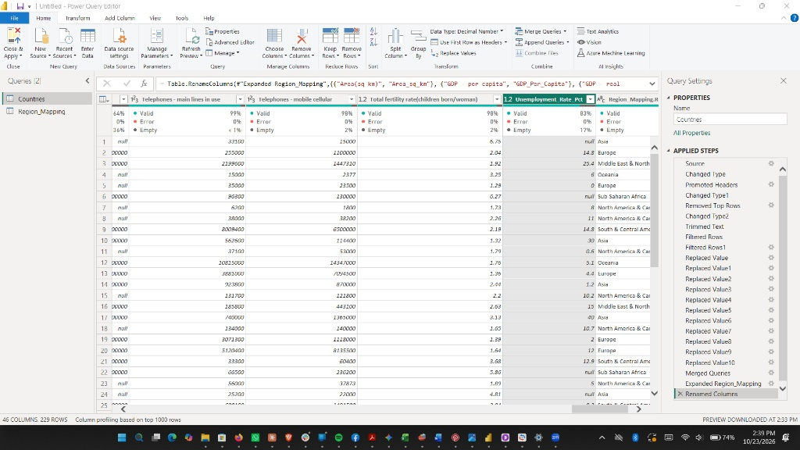
Figure 1: Power Query Editor showing the 229 cleaned country records, 46 columns, and Applied Steps pipeline.
2. Data Modeling & Calculated Columns (Part 2 — 15%)
In the Power BI Data Model, Country was categorized as Country/Region and Region as Continent. A Region Hierarchy (Region -> Country) was constructed to support drill-down analysis, and four DAX calculated columns were created to classify countries by economic scale, population size, development tier, and real growth rate:
Calculated Column | Classification Logic & Thresholds | DAX Formula
GDP Category | High (>= $500B), Medium ($50B - $500B), Low (< $50B) | SWITCH(TRUE(), 'Countries'[GDP]>=5e11, "High GDP (>=$500B)", 'Countries'[GDP]>=5e10, "Medium GDP ($50B-$500B)", "Low GDP (<$50B)")
Population Category | Large (>= 50M), Medium (10M - 50M), Small (< 10M) | SWITCH(TRUE(), 'Countries'[Population]>=5e7, "Large Population (>=50M)", 'Countries'[Population]>=1e7, "Medium Population (10M-50M)", "Small Population (<10M)")
Development Level | Developed (GDP/Capita >= $15K & Life Exp >= 75), Developing, Least Developed | SWITCH(TRUE(), 'Countries'[GDP_Per_Capita]>=15000 && 'Countries'[Life_Expectancy_Years]>=75, "Developed", 'Countries'[GDP_Per_Capita]>=4000 || 'Countries'[Life_Expectancy_Years]>=65, "Developing", "Least Developed")
Growth Indicator Category | High (>= 5%), Moderate (2% - 5%), Low (0% - 2%), Negative (< 0%) | SWITCH(TRUE(), ISBLANK('Countries'[GDP_Growth_Rate_Pct]), "No Data", 'Countries'[GDP_Growth_Rate_Pct]>=5, "High Growth (>=5%)", 'Countries'[GDP_Growth_Rate_Pct]>=2, "Moderate Growth (2%-5%)", 'Countries'[GDP_Growth_Rate_Pct]>=0, "Low Growth (0%-2%)", "Negative Growth (<0%)")

3. KPI & DAX Measures Documentation (Part 3 — 25%)
All analytical measures were organized inside a dedicated _Measures table using SUM, AVERAGE, CALCULATE, DIVIDE, IF, FILTER, and RANKX:
Measure Name | DAX Expression | Global Baseline Result
Average GDP | AVERAGE('Countries'[GDP]) | $244.02B ($242.97B across 229 countries)
Total Population | SUM('Countries'[Population]) | 6.44B (6,445,865,730)
Average Life Expectancy | AVERAGE('Countries'[Life_Expectancy_Years]) | 67.7 Years
Highest GDP Country | CALCULATE(MAX('Countries'[Country]), TOPN(1, ALLSELECTED('Countries'), CALCULATE(SUM('Countries'[GDP])), DESC)) | United States ($11.75T)
Lowest Inflation Country | CALCULATE(MAX('Countries'[Country]), TOPN(1, FILTER(ALLSELECTED('Countries'), NOT(ISBLANK('Countries'[Inflation_Rate_Pct]))), CALCULATE(MIN('Countries'[Inflation_Rate_Pct])), ASC)) | Nauru (-3.6%)
Average GDP Growth (%) | AVERAGE('Countries'[GDP_Growth_Rate_Pct]) | 4.79%
GDP Growth Indicator | VAR AvgG = [Average GDP Growth (%)] RETURN IF(ISBLANK(AvgG), "No Data", IF(AvgG>=5, "High Growth ("&FORMAT(AvgG,"0.0")&"%)", IF(AvgG>=2, "Moderate Growth ("&FORMAT(AvgG,"0.0")&"%)", IF(AvgG>=0, "Low Growth ("&FORMAT(AvgG,"0.0")&"%)", "Contraction ("&FORMAT(AvgG,"0.0")&"%)")))) | Dynamic Text Status
Population Density | DIVIDE(SUM('Countries'[Population]), SUM('Countries'[Area_sq_km]), 0) | 47.66 people / sq km
Average Birth Rate | AVERAGE('Countries'[Birth_Rate_Per_1000]) | 22.20 births / 1,000
Average Death Rate | AVERAGE('Countries'[Death_Rate_Per_1000]) | 9.37 deaths / 1,000
Trade Balance ($) | SUM('Countries'[Exports]) - SUM('Countries'[Imports]) | Net Exports minus Imports
Trade Balance Indicator | IF([Trade Balance ($)]>=0, "Surplus (+"&FORMAT([Trade Balance ($)]/1e9,"$#,##0.0B")&")", "Deficit ("&FORMAT([Trade Balance ($)]/1e9,"$#,##0.0B")&")") | Dynamic Surplus/Deficit Label
Country GDP Rank | IF(HASONEVALUE('Countries'[Country]), RANKX(FILTER(ALLSELECTED('Countries'), NOT(ISBLANK('Countries'[GDP]))), CALCULATE(SUM('Countries'[GDP])), , DESC, Dense)) | 1 (US), 2 (China), 3 (Japan)...
Dynamic Dashboard Title | "Country Analytics — " & SELECTEDVALUE('Countries'[Region], "All Regions") | Dynamic Header Title

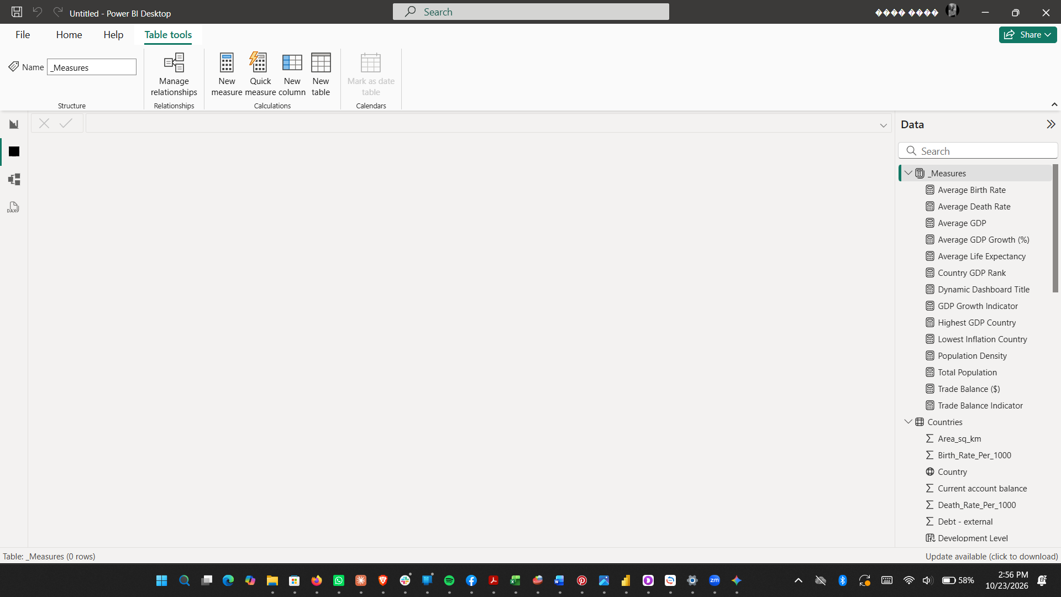
Figure 2: Dedicated _Measures table and geographic field configuration in Power BI Desktop.
4. Interactive Dashboard Screenshots (Parts 4 & 5 — 25%)
The dashboard features a modern SaaS executive layout with a dark navigation sidebar, dynamic header bar, three global slicers (Country, Region, GDP Category), five color-coded KPI cards, and four spacious analytical containers per page.
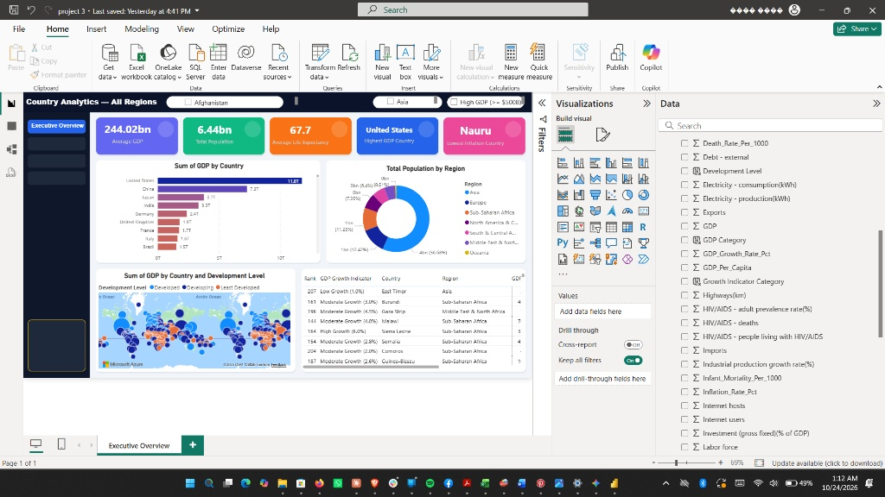
Figure 3: Page 1 — Executive Overview (KPI Cards, Top 10 GDP Bar Chart, Regional Population Donut, Development Level Azure Map, and Ranked Country Table).
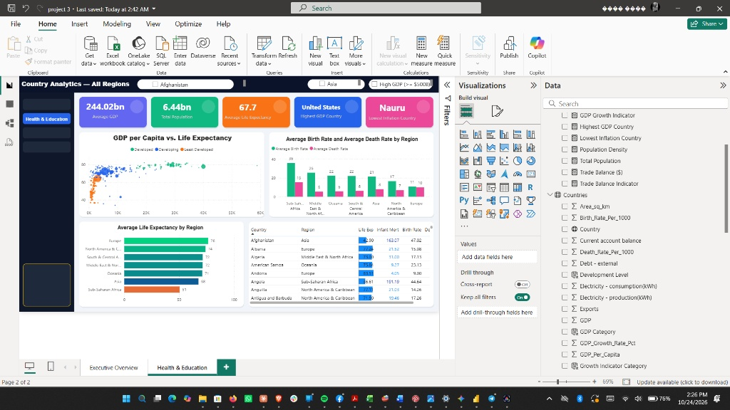
Figure 4: Page 2 — Health & Education Analysis (GDP per Capita vs. Life Expectancy Scatter Plot, Regional Birth vs. Death Rates, Life Expectancy Gradient Bar Chart, and Health Indicator Matrix).
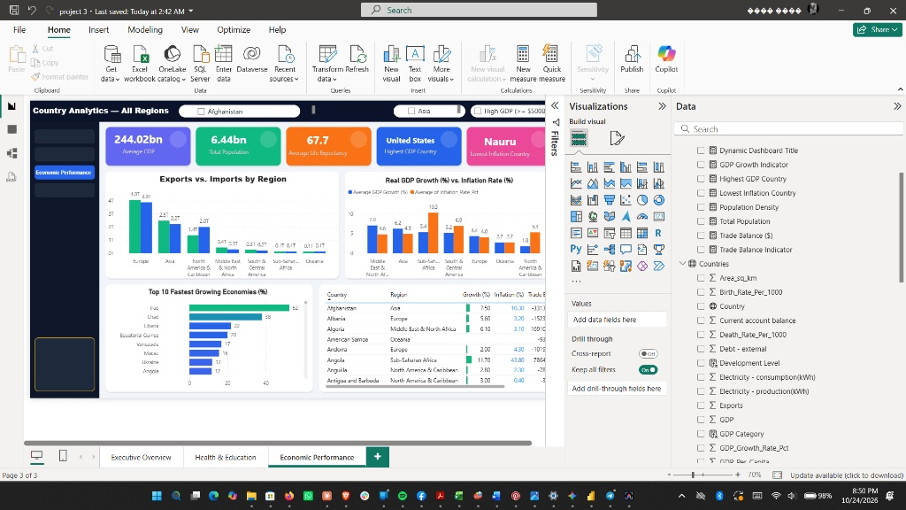
Figure 5: Page 3 — Economic Performance Analysis (Regional Exports vs. Imports, Real GDP Growth vs. Inflation, Top 10 Fastest Growing Economies, and Trade Balance Table).
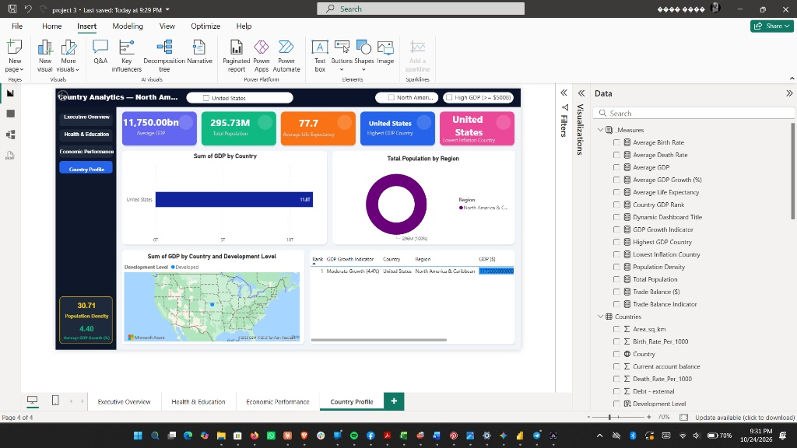
Figure 6: Page 4 — Country Profile Drill-Through Page (Filtered dynamically on United States via right-click Drill-through).
5. Business Insights & Strategic Recommendations (Part 6 — 15%)
Five Data-Driven Analytical Insights
- 1. Extreme Global Economic Concentration: Out of 229 populated countries and territories totaling $55.64 trillion in global GDP, just 20 economies in the High GDP tier (>= $500B) generate about 79% of world output, led by the United States ($11.75T), China ($7.26T), Japan ($3.75T), and India ($3.32T).
- 2. Strong Positive Link Between Income and Longevity (r = +0.60): Cross-country scatter analysis confirms that GDP per capita strongly drives life expectancy at birth. Europe averages $21,391 GDP per capita and 76.45 years of life expectancy, whereas Sub-Saharan Africa averages $2,454 GDP per capita and 50.48 years.
- 3. Divergent Demographic Transition Across Regions: Developed regions exhibit near-zero natural population growth alongside high economic output (Europe records 10.88 births vs. 10.07 deaths per 1,000), while Sub-Saharan Africa experiences both the highest birth rate (35.79 per 1,000) and highest death rate (15.42 per 1,000).
- 4. High Inflation Is Linked to Weaker Health Outcomes (r = -0.32 with life expectancy): Economies with severe price instability tend to have shorter life expectancy; Zimbabwe records the highest inflation rate globally (133.0%) alongside the deepest real GDP contraction (-8.2%) and a 36.67-year life expectancy.
- 5. Structural Trade Imbalances Between Manufacturing Exporters and Consumer Importers: Industrial and energy exporters record substantial trade surpluses—led by Germany (+$176.6B), Japan (+$137.0B), and Saudi Arabia (+$76.8B)—whereas consumption-led economies such as the United States (-$681.0B) and the United Kingdom (-$92.2B) run large structural trade deficits.
Three Actionable Strategic Recommendations
- 1. Prioritize Maternal, Infant, and Infectious Disease Healthcare in Sub-Saharan Africa: Because infant mortality exhibits a -0.89 correlation with life expectancy, targeted international healthcare funding for infant survival and HIV/AIDS treatment in Southern and Central Africa offers the highest immediate return on human capital and workforce longevity.
- 2. Anchor Development Financing to Monetary Stabilization in High-Inflation Economies: Policy institutions should condition structural adjustment loans in high-inflation nations (inflation > 15%, such as Zimbabwe, Angola, Haiti, and the Dominican Republic) on fiscal discipline, external debt restructuring, and central bank inflation targeting.
- 3. Expand Infrastructure and Fixed Capital Investment in High-Growth Emerging Regions: To sustain rapid real GDP growth in the Middle East & North Africa (7.04% avg. growth) and Asia (6.23% avg. growth), governments should channel export surpluses into electricity generation, broadband connectivity, and transport networks.

