Chapter 10 – Chapter 9 in the Book – Network Protocols

OSI

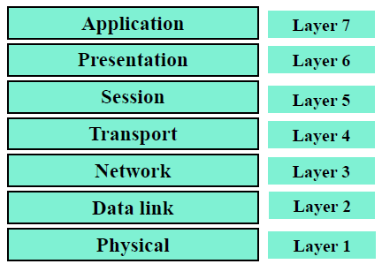

Physical and Data link layers are responsible for communicating with the actual network hardware (e.g., the Ethernet card). Data received from the physical medium are handed over to the network layer, and data received from the network layer are sent to the physical medium.

TCP/IP protocol consists of five layers.

OSI layer 1-4 = TCP/IP layer 1-4

OSI layer 5-7 = TCP/IP Application layer

TCP

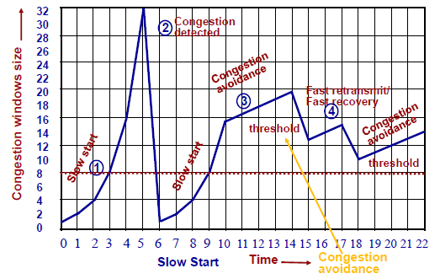

Congestion window limits the number of packets in flight

Once congestion is detected, send three duplicate ACKs for fast retransmit and recovery

Start slowly retransmitting after timer expires

Routing

Application layer uses Bellman-Ford algorithm to calculate the best known distance and next hop to get there (each additional hop counts as one iteration)

Solutions for Wireless

Problems

Wired – Only packet on the same link “compete”

Wireless – all close-by devices compete

End-to-End solutions

TCP-SACK: sends request to sending (SACK) for only missing segment of data

WTCP: BS keeps buffering data from the fixed host while separately checking for congestion in MS, hiding the errors from the fixed sender

Freeze-TCP Protocol: MS detects impending handoff and advertises Zero Window Size to force the sender into Zero Window Probe mode so that temporarily lost connection will still be accounted in the congestion window.

Explicit band state notification (EBSN): sends EBSN message to the source during recovery so that the source doesn’t timeout.

.Fast retransmission approach: MS sends a certain number of duplicate ACK to the sender immediately after completing a handoff, which then TCP reduces its congestion window size and immediately starts retransmitting from when the ACK was received.

Link Layer Protocols

Transport Unaware Link Improvement Protocol (TULIP): Provides reliable service for TCP and unreliable service for UDP. Using a link layer, it provides local recovery of all lost packets in order to prevent unnecessary retransmission, reducing TCP’s congestion window.

AIRMAIL Protocol: Combines FEC and ARQ for loss recovery in Link layer

Snoop Protocol: Using the snoop agent at BS, loss detected by duplicate ACKs from MS or local time-out. Local retransmission of missing segment. Suppresses the duplicate ACKs.

Split TCP Approach

Indirect-TCP

One side is wired, and the other is wireless

Wired side is left unchanged – specialized support for mobile applications

M-TCP Protocol

One side is wired, and the other is wireless

In case of frequent disconnections, receiver can signal sender to enter in persist mode by advertising Zero Window Size

Internet Routing Protocols

Best-effort: No error checking or tracking done for the sequence of packets (datagrams)

Datagrams may differ in routes

Fragmentation and reassembly supported to handle data links with different maximum transmission unit (MTU) sizes

ICMP

Companion protocol to IP

Provides error reporting and querying mechanisms to check and report router status

IGMP

Maintains multicast group membership by querying and replying to router join messages

DHCP

Dynamically assign IP addresses that Helps in saving IP address space by using same IP address to occasionally connecting hosts

Intradomain Routing

Routing Information Protocol (RIP)

Distance information about all the nodes is conveyed to the neighbors using the Bellman-Form algorithm (calculating the shortest distance to reach the destination in hops).

Open Shorted Path First (OSPF)

Update routing information to all neighbors according to the Shortest Path Algorithm (Dijkstra)

Border Gateway Protocol (BGP)

Use Path Vector routing protocol to communicate among systems

Internet Protocol Version 6 (IPv6)

Designed to make IPv4 more scalable (more space, better allocation with flow label, more security)

Chapter 11 – Chapter 10 in the Book – Existing Wireless Systems

AMPS

IS-41

GSM

IS95

IMT-2000