**Name**/ خالد عبدالغني محمد عبدالغني

**B.N**/ 315

**Topic**/ database system

**Edu mail/** [khaled195345@feng.bu.edu.eg](mailto:khaled195345@feng.bu.edu.eg)

**GitHub pages** / <https://khaled-abdelghani.github.io/ece001/>

**GitHub** /

**Application /**

A database is a collection of data or records. Database management systems are designed to manage databases.

A database is a collection of data or records. Database management systems are designed to manage databases.

**Screenshot** /

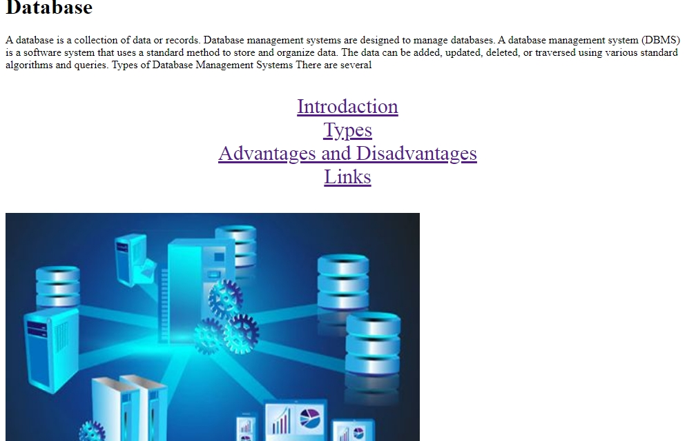

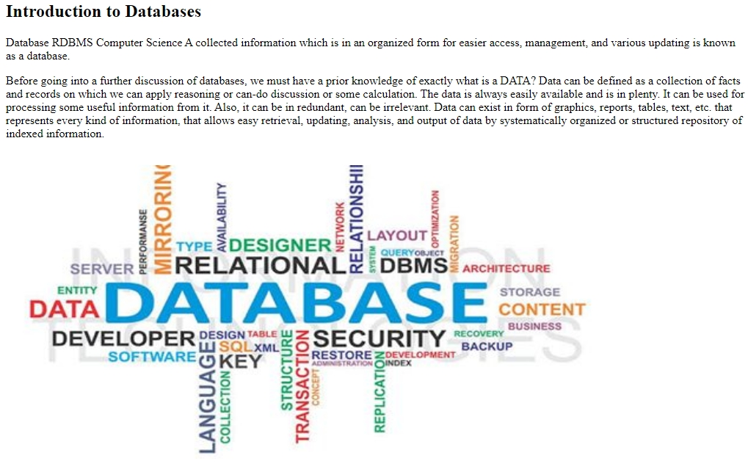

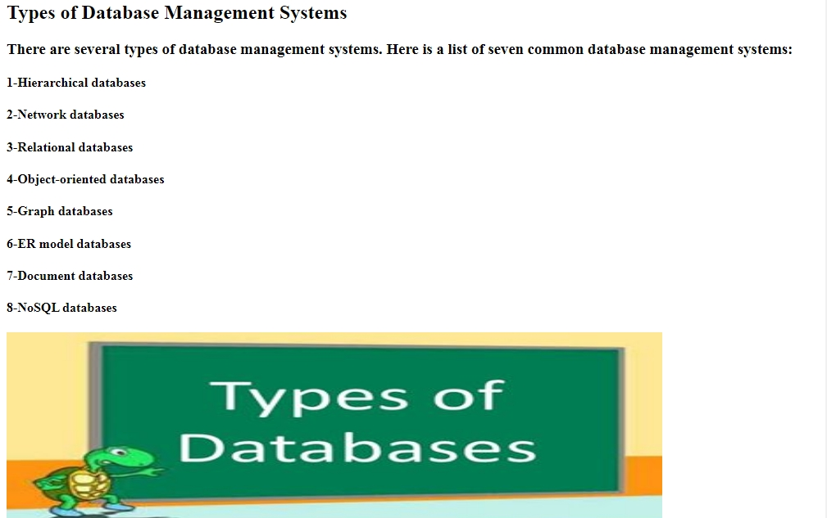

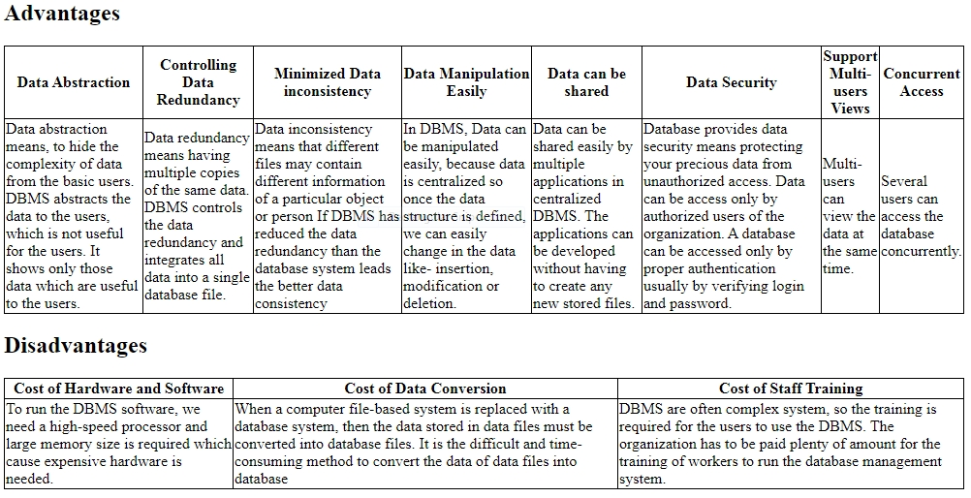

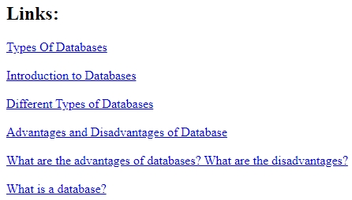

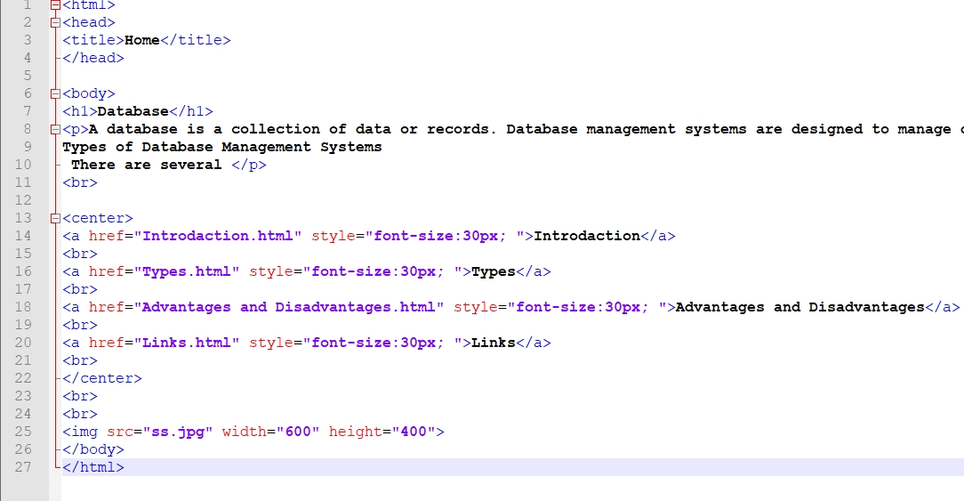 **Source code/**

