Khaled Osama 201600515
Moustafa Elsayed 201600848

Servo controlled Using IMU readings

objective

we want to develop a 1 Degree of freedom gesture control system for handicapped using a servo motor and an IMU. The user should control the angle the angle the servo goes to using the IMU readings. If the user had his hand raised with an angle higher than 45° ,the servo should stop moving regardless of the IMU reading.

Implementation

we used the following components:
- Raspberry pi : the main controller
- Servo motor : the actuators
- IMU: we took the gyroscope values to know the angle.
- Rainbow cable : it’s an extension for raspberrypi just to make wiring more convenient.
- Breadboard : to mount all the components on it

All the code was written on our personal laptops .we have created a repository on GitHub to manage the code from our PCs and the Raspberrypi. Sometimes we used the SSH communication when it was more convenient.

We used ready Kalman filter python library from GitHub and embedded the servo code with the readings of the Gyroscope.

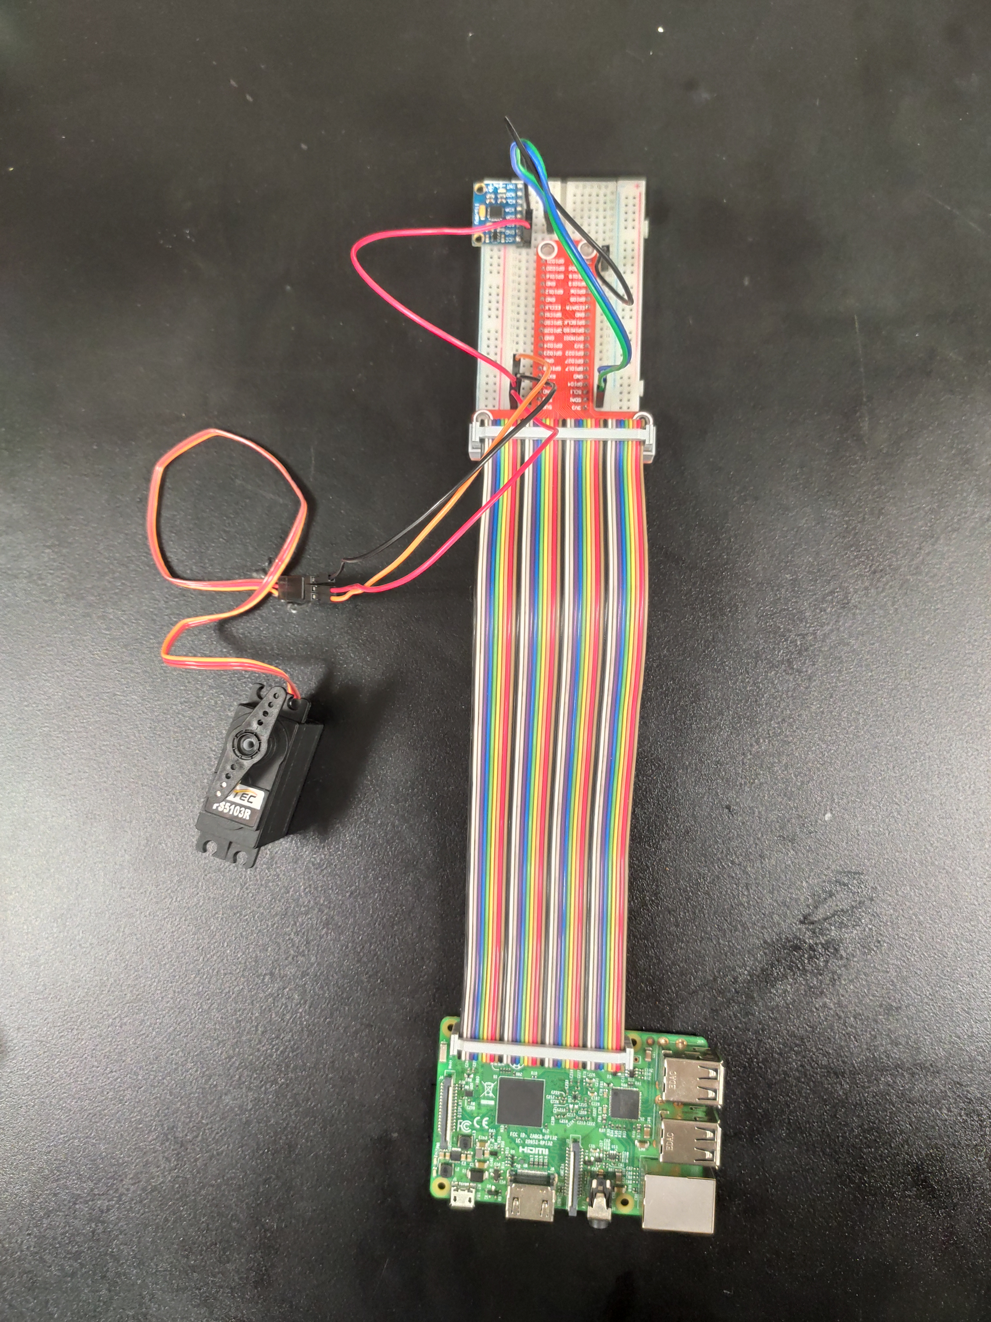
Schematic
Links

our GitHub Repo : https://github.com/KhaledOsama98/Raspberrypi
Kalman Filter Repo : https://github.com/rocheparadox/Kalman-Filter-Python-for-mpu6050

