

**Yarmouk University**

**Faculty of information technology & computer sciences**

**Department of computer sciences**

**Smart wheelchair for disabled people**

**Students Name:**

|  |  |
| --- | --- |
| **2015901142** | **Mohamed Al-Tamimi** |
| **2015801013** | **Islam Hasan** |
| **2015901108** | **Ahmad Al-Wadi** |

**Supervisor:  
Dr. Noor Al-deen Alawad**

**1. Introduction**

**1.1 Overview**

A wheelchair is a chair with wheels, used when walking is difficult or impossible due to disability person who can’t move any part of their body (Quadriplegia), Wheelchairs depend on technology to meet their needs.

They may include specialized seating adaption, individualized controls to make their life as a natural people.

This wheelchair is special because it suite all kind of disable persons because it use head movement technology.

**1.2 Approach**

All people can do all their works naturally, that make us focus on disable people in order to make them feel like that they have not any movement problem.

In this project we want to focus in disability people that can’t move their legs and hands (Quadriplegia), usually they need someone to help them in transfer from place to another using wheelchair independently.

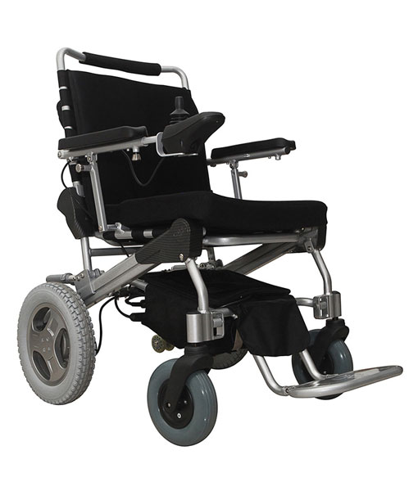

Figure (1)Smart Disable wheelchair

**1.3 Objective**

The main objective of this Smart Disable Wheelchair project is:

* Makes disable people, who can’t move their hands and legs, able to move.
* Make them depend in themselves, in moving from place to another.
* Protect them from crashing in any solid object.
* Allow families of disable people to know where they are.

**2. Literature Review**

Y. Kunoet al.proposed an intelligent wheelchair which can be controlled by turning one's face in the direction one would like to go. Although it can be used easily, there is a problem that unintentional movements of one's face may interfere with wheelchair motion. This paper presents there new intelligent wheelchair improved by observing its interior and exterior, i.e., the user and the environment. It effectively integrates autonomous capabilities and the interface by face direction. It uses sensor information obtained for autonomous navigation to solve the problem of control using face direction. Also, if it can understand the user's intentions from observing the face, it chooses an appropriate autonomous navigation function to reduce the user's burden of operation. When the user is off the wheelchair, they become a part of the exterior. In this case, it detects the user by recognizing his/her face. Then it can move according to the user's commands indicated by hand gestures.[1]

P.Gokulsrinath et al. Most of us do not know about this but there is a type of disability in person who was not use any of their limbs. This kind of disability is called quadriplegia and the person with this disability is called quadriplegics. This kind of reason person have disability like stoke, high blood pressure, degenerative disease of bones and joints and cases of paralysis and birth defect. Sometimes it is also due to accidents. The person with that type of disabilities who cannot perform his/her daily tasks. According to the level of disability a person can get his ability of movement by using medical equipment’s [2].

Tarun Debnath et al. Human being is the most beautiful creation of the universe, but much unexpected accidental disabilities or autistic by born have to carry through the tenure of life. Such a disable person feels helpless and becomes disappointed to lead their life. The physically disable, and paralyzed individuals accomplish their movement through manual or powered wheelchair. While manual wheelchair operation involves other’s help, the power wheelchair can be operated using joystick, touch screen, voice gesture based or any other control technologies . As many of the

wheelchair users do not feel comfortable with joystick and speech recognition is often creates problems and difficulties when we target more than a single user Researchers are developing sophisticated control technologies for physically disables. An android controller can be a better substitution of joystick and voice-controlled. Like a touch screen button, a person can control his wheelchair by pressing the android button. Besides that, it is also possible to control the devices using the tilt of the mobile. Tilting feature can be supportive of one-sided paralyzed patients who do not

get enough strength in their fingers. Biometrics feature also has been implemented in the system.[3]

**3. Background:**

We've been hearing a lot about robots that invaded the world a little while ago, and we were wondering how they were produced and designed, and how they were programmed, in addition to sensors that control movement of wheelchair and keep tracking it and sensor that prevent them from crashing.

And the famous tool that we've been hearing about that and it’s belong to the internet of things (IOT) is the Arduino which is used to build such simple robots and other projects which we know that the Arduino is a microcomputer that handles a set of commands based on specific

programming.

**4. Functional requirements**

1. The system shall give the disable people the ability to move using their heads.
2. The system shall allow their families to keep tracking them using GPS capability.
3. The system shall provide the most common places they visited.
4. The system shall protect the disable people from crashing in any soiled object.

**5. Equipment’s, HW**

**5. Hardware’s:**

**5.1 Arduino NANO**

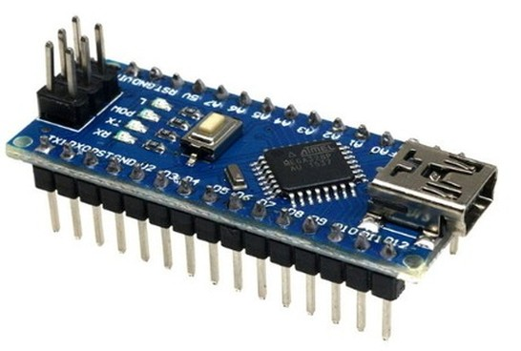

**Figure 2: Arduino NANO**

**Figure 2:** It is a Microcontroller board developed by Arduino, Arduino boards are widely used in robotics, embedded systems, and electronic projects where automation is an essential part of the system.

**5.2 MPU6050 sensor:**

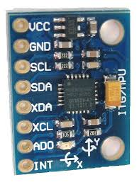

**Figure 3: MPU6050 sensor**

**Figure 3:** is a Micro Electro-Mechanical Systems (MEMS) which consists of a 3-axis Accelerometer and 3-axis Gyroscope inside it. also, we will use (VCC,GND) for power supply and (SCL,SDA,INT) for the three dimension .

**5.3 Ultrasonic sensor**

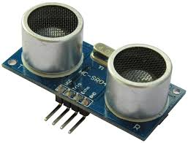

**Figure 4:** **Ultrasonic sensor**

**Figure 4:** is an instrument that measures the distance to an object using ultrasonic sound waves. The range of these waves are 400cm

* 1. **GPS NEO-6M**

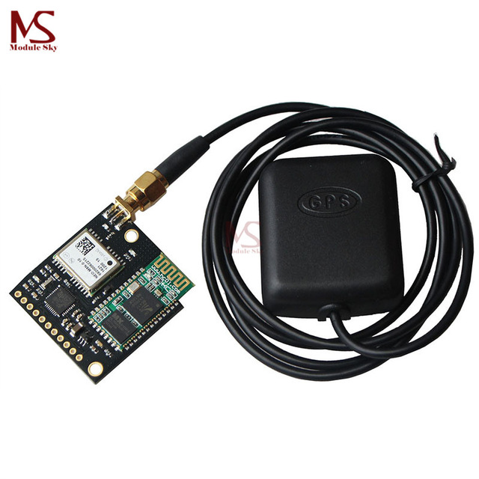

**Figure 5: GPS NEO-6M**

**Figure 5:** The NEO-6M GPS module is a well-performing complete GPS receiver with a built-in 25 x 25 x 4mm ceramic antenna, which provides a strong satellite search capability. With the power and signal indicators, you can monitor the status of the module .

**6.**  **General framework**

**6.1 The smart chair:**

The chair will automatically move when the system send a signals to it. the chair should make the movement of the user easier and make him feel comfortable when he use it, and the chair is also can protect the user by prevent him from crashing in any solid object .

**6.2 The user:**

The user will use the chair for moving because he can’t move

**6.3 Location and tracking:**

By using GPS capability the system will keep tracking the user where he go and save the common places he will go.

**7. Data flow diagram (DFD)**

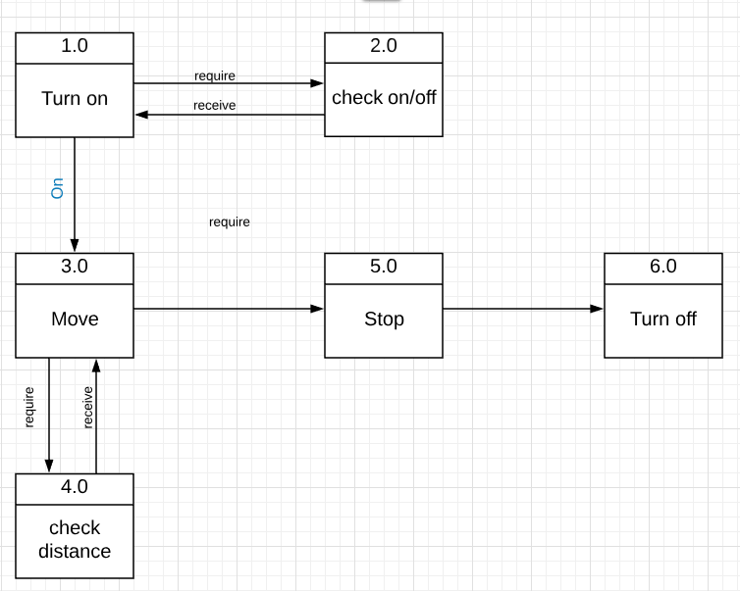

**Figure 6: DFD for smart wheelchair**

**Figure 6:**

1. **turn on** : in a particular move the wheelchair will turn on.

1. **check on\off:** the system will check if the wheelchair is on or not.
2. **move :** by using his head he can move in all direction when he moves his head to the right the chair will response signals from the MPU sensor and move to the right side and this process will done for all direction.

**4.0 Check distance:** the distance sensor will check if the chair is close from any solid object if it’s the sensor will send a signal to the chair to make it stop.

1. **Stop:** the user can stop the chair by moving his head in a particular move.
2. **Turn off:** in a particular move the chair will turn off.

**8. pseudocode**

While (SystemON)

If (chair near threshold)

System Stop

Else

If (head == turn left)

The motion sensor will send a signal to the chair to move left

If (head == turn right)

The motion sensor will send a signal to the chair to move right

If (head == backward)

The motion sensor will send a signal to the chair to move back

If (head == forward)

The motion sensor will send a signal to the chair to move front

If (place visited)

GPS send signal and count number of time the place is visited

**9. References**

**[1]** [Y. Kuno](https://ieeexplore.ieee.org/search/searchresult.jsp?searchWithin=%22First%20Name%22:%22Y.%22&searchWithin=%22Last%20Name%22:%22Kuno%22&newsearch=true), [S. Nakanishi](https://ieeexplore.ieee.org/search/searchresult.jsp?searchWithin=%22First%20Name%22:%22S.%22&searchWithin=%22Last%20Name%22:%22Nakanishi%22&newsearch=true), T. Murashima, N. Shimada, Y. Shirai , IEEE

Date of Conference: Nov. 1999

https://ieeexplore.ieee.org/document/810287/figures#figures

**[2]** P.Gokulsrinath1, A.Koilraj2, Kavitha B Kumar3, Arun.R4,Dharmadurai.R5,

Anna University Nehru Institute of Engineering and Technology

Date of Conference: MAR. 2017

https://www.ijraset.com/fileserve.php?FID=6410

**[3]** Tarun Debnath , Zainul Abadin , Anwar Hossain , Global Journals.

Date of Conference: 2018

file:///C:/Users/user/Downloads/1679-1-1658-1-10-20180508%20(1).pdf