
"بسم الله الرحمن الرحيم"
Faculty of Engineering & Technology
Electrical & Computer Engineering Department
ENCS5341, Machine Learning and Data Science
Assignment 2
Non-Linear Regression and Logistic Regression

Prepared by:
Khaled Hammad ID: 1220857 Sec: 1
Mohammad Shamasneh ID: 1220092 Sec: 1

Instructor: Dr. Yazan Abu Farha
Date of submission: 10/23/2025

Task 2

Introduction to logistic Regression
Logistic Regression is a supervised machine-learning algorithm used for classification problems, where the dependent (target) variable is categorical rather than continuous. Unlike linear regression which predicts a numerical value, Logistic Regression uses a linear combination of input features and then applies the logistic (sigmoid) function to map that value to a probability between 0 and 1, representing the likelihood that the input belongs to a given class. Based on a threshold often 0.5, the output probability is converted into a class label (e.g. yes/no, 0/1). The model’s parameters are typically estimated using statistical techniques (such as maximum likelihood estimation), making Logistic Regression both interpretable and computationally efficient, which is why it remains among the most widely used classification methods across domains such as finance, healthcare, and social sciences.[1]
Logistic regression is inherently a linear classifier: by default it builds a decision boundary as a straight hyperplane in feature space. However, if we transform the original input features for example by adding polynomial features or interaction terms then logistic regression can capture more complex, non-linear relationships between features and the target variable. In that case, although the model inside the transformed feature space remains linear, when you map the decision boundary back to the original feature space it becomes non-linear (a curve, circle, ellipse, or more complex shape depending on the transformations).[2]

In this assignment, we will apply logistic regression to predict customer churn status. The task involves training and evaluating several logistic regression models, comparing their performance using accuracy, precision, and recall. Specifically, we will work with the following models:
- Logistic Regression with a Linear Decision Boundary: This is the standard logistic regression model.
- Logistic Regression with Non-Linear Decision Boundaries: We will transform the feature space using polynomial features of various degrees (2, 5, and 9) to model non-linear relationships.
We will evaluate how these models perform in terms of accuracy, precision, and recall on a test dataset. Additionally, we will explore the impact of overfitting and generalization on model performance as the polynomial degree increases. Specifically, we'll examine how increasing the degree of polynomial features can lead to models that overfit the training data, potentially reducing their ability to generalize to new, unseen data.

Code
The first part of the code begins by importing several essential Python libraries, where import pandas for handle data loading and cleaning, from sklearn.preprocessing import StandardScaler for data normalization, import matplotlib.pyplot as plt and from matplotlib.pyplot import title for plotting, from sklearn.model_selection import train_test_split split the dataset into train, validation, and test sets, from sklearn.preprocessing import PolynomialFeatures creates polynomial (non-linear) features, from sklearn.linear_model import LogisticRegression Imports the Logistic Regression, from sklearn.metrics import accuracy_score, precision_score, recall_score, roc_curve, auc Imports evaluation metrics
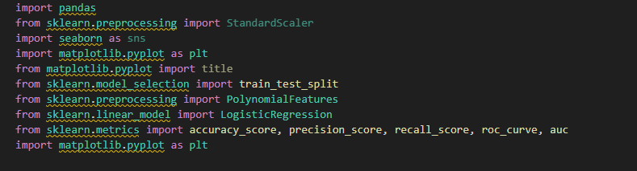

The second part of code we load the customer data set, we handling the missing data by filling them with the median, especially since the data contains outliers that could skew other methods like the mean, For the missing values in the Income column, we rely on the ProductType column to fill the gaps. We group the data by ProductType (which has two categories: Basic and Premium) and compute the median Income for each group, then we handle the outlier by change its variable not by ignore it I see that this is the best because we suppose that there is an important data in file and if we want to ignore each data, they have outlier we will lose this data that its important.
After we handle missing data and outliers’ data we want now to normalized data. We know that Min-Max algorithm is sensitive to outliers but because we cleaned the data from outliers above, we will use it instead of using standardization because it will work as it so they will not be affected.
Note that we normalized the data range between 0-1.
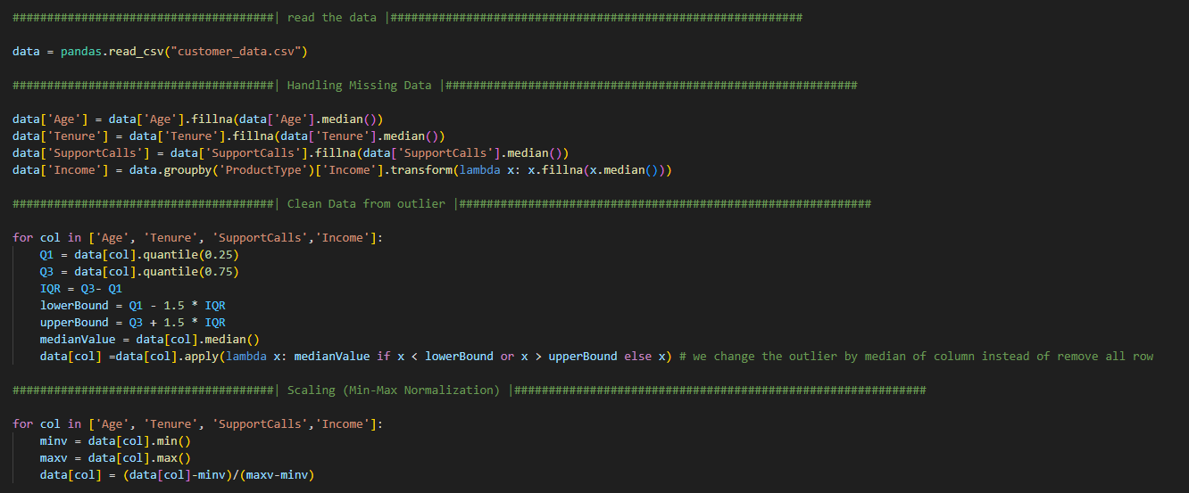
At this part, we creates the input matrix X by removing the target and ID, and Creates the target vector y (0 = stay, 1 = churn), then we split the data set to: 2500 samples for train, 500 samples for validation, and 500 samples for test.
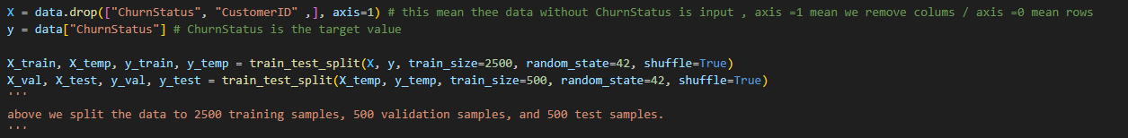
There we definition function for evaluate model performance by using accuracy, precision, and recall for each train data , validation data and test data .
- Accuracy is the percentage of correct predictions (both true positives and true negatives) out of all predictions.
- Precision measures how many of the predicted positives were actually correct.
- Recall measures how many of the actual positives the model correctly identified.
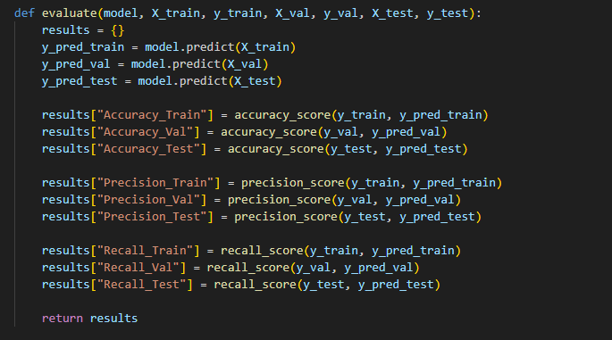
Print Function to print the model’s Accuracy, Precision, and Recall for the Train, Validation, and Test sets in a clean, organized way.
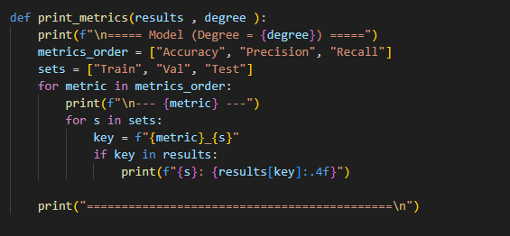

This code trains a linear logistic regression model and checks how well it performs. It first creates the model and trains it on the training data. Then, using the evaluate function, it calculates the model’s Accuracy, Precision, and Recall on the train, validation, and test sets. Finally, print_metrics displays these results, showing the performance of the degree-1 (linear) model.
This code trains logistic regression models with polynomial features of degrees 2, 5, and 9 to capture non-linear patterns in the data. For each degree:
- Polynomial transformation: PolynomialFeatures(d) creates new features up to the specified degree, expanding the feature set for non-linear modeling.
- Transform datasets: The training, validation, and test sets are transformed to include these polynomial features.
- Train the model: A logistic regression model is trained on the transformed training data with a higher max_iter=2000 to ensure convergence.
- Store models and metrics: Both the trained model and its polynomial transformer are saved in models_poly, and performance metrics (Accuracy, Precision, Recall) on training, validation, and test sets are calculated and stored in metrics_poly.
- Display results: The print_metrics function prints the metrics for each degree, allowing comparison of how increasing polynomial degree affects performance and overfitting.
In short: this loop trains and evaluates non-linear logistic regression models with increasing polynomial complexity and prints their performance for analysis.
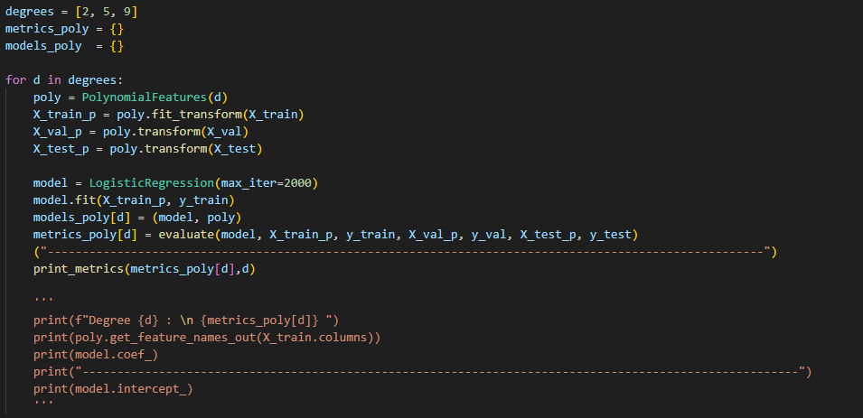

First, the metrics for the linear model (degree 1) are added to the metrics_poly dictionary. Then, the code identifies the best model degree by selecting the model with the highest combined validation Accuracy and Recall. Using this best_degree, it retrieves the corresponding trained model and polynomial transformer from models_poly. Finally, it prints the degree of the best model and its performance metrics, allowing you to see which model best balances performance and generalization.
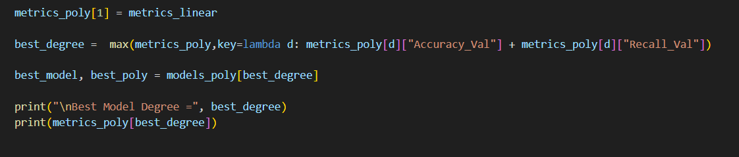
This code plots the ROC curve for the best logistic regression model. First, the test set is transformed using the best model’s polynomial features. Then, the model predicts probabilities of churn (predict_proba), and the false positive rate (FPR) and true positive rate (TPR) are calculated using roc_curve. The AUC (Area Under the Curve) is computed to summarize the model’s overall performance. Finally, the ROC curve is plotted, showing the trade-off between TPR and FPR, with a diagonal line as a reference for random guessing. The plot title includes the polynomial degree, and the AUC is displayed in the legend to indicate model quality.
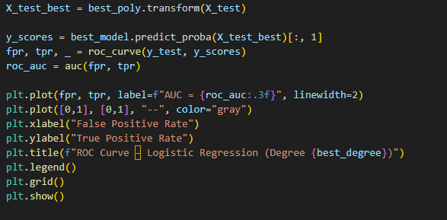

Result and discussion

in this experiment, we evaluated the performance of Logistic Regression with a linear decssion boundary models and a non-linear decssion boundary models with varying degrees of polynomial complexity (Degree 2, 5, and 9) to predict customer churn. The goal was to determine how model complexity affects the ability to generalize to unseen data, specifically focusing on the trade-off between bias and variance.
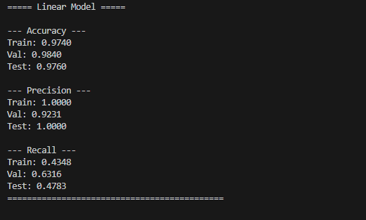

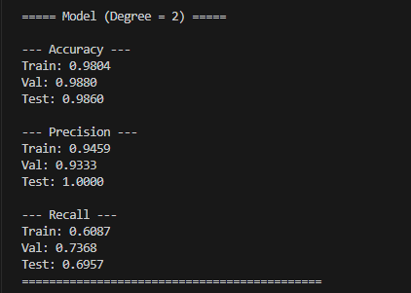

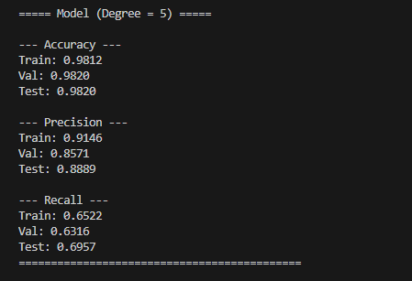
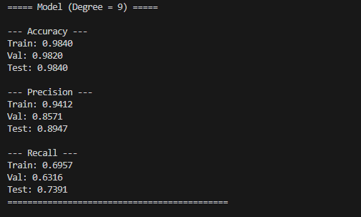

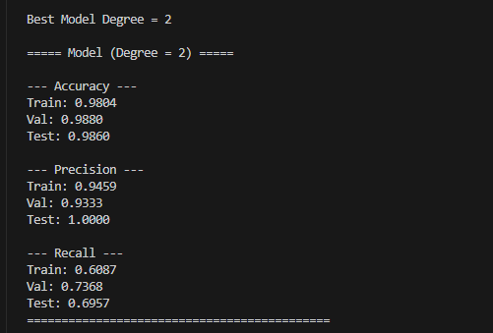

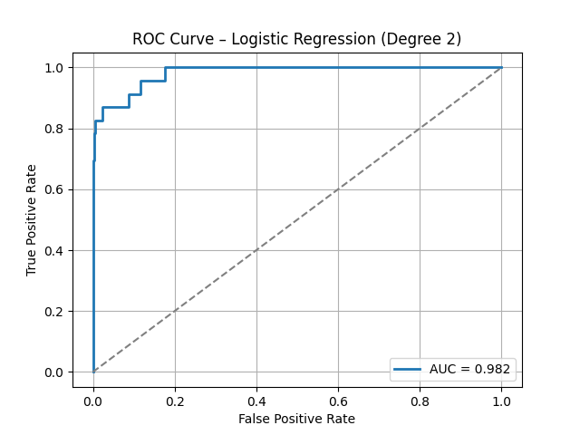

https://www.ibm.com/think/topics/logistic-regression?utm_source=chatgpt.com
https://www.geeksforgeeks.org/machine-learning/logistic-regression-with-polynomial-features/?utm_source=chatgpt.com

