Mano SUNDAR

saminnx@gmail.com

<https://sites.google.com/site/samsoninfinite/>

CoNTINUOUS BEAM STRUCTURAL analysis

Finite element analysis software tools

Contents

A. Stiffness matrix of beam element 1

B. Virtual work principle & stiffness matrix of 1D elements 10

C. Principle of minimum potential energy and stiffness matrix of bar element 12

D. Deriving shape function and stiffness matrix of beam element 14

References 22

## Stiffness matrix of beam element

Stiffness matrix for beam element in this section is derived using Euler – Bernoulli beam theory. The unknowns for a beam element is its end rotation and displacement which is resisted by the beam’s bending stiffness. Euler – Bernoulli beam theory relates the deflection of a flexure member to its superimposed load.

|  |  |  |
| --- | --- | --- |
|  | $$EI\left(\frac{d^{2}y}{dx^{2}}\right)=M$$ | Eq. B1 |

Let’s find the displacement and rotation caused by a Force F acting at the free end of a cantilever beam

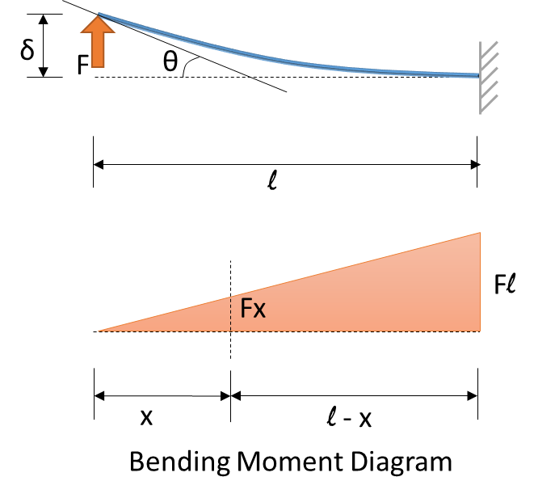

|  |  |  |
| --- | --- | --- |
|  | $$EI\left(\frac{d^{2}y}{dx^{2}}\right)=M$$ | From  Eq. B1 |
|  | From the bending moment diagram, $$EI\left(\frac{d^{2}y}{dx^{2}}\right)=Fx$$ |  |
|  | $$EI\left(\frac{dy}{dx}\right)=\frac{Fx^{2}}{2}+c_{1}$$ | Eq. B2 |
|  | $$EIy=\frac{Fx^{3}}{6}+c_{1}x+c_{2}$$ | Eq. B3 |
|  | Applying the boundary conditions, (i) at fixed end $$\left(\frac{dy}{dx}\right)=0 at x=l$$ |  |
|  | $$c_{1}=\frac{- Fx^{2}}{2}$$ | Eq. B4 |
|  | (ii) at the fixed end $$y=0 at x=l$$ $$\frac{Fl^{3}}{6}-\frac{Fl^{3}}{2}+c_{2}=0$$ |  |
|  | $$c_{2}=\frac{Fl^{3}}{3}$$ | Eq. B5 |
|  | Applying c1 & c2 to Eq. D2 & Eq. D3 |  |
|  | $$EIθ_{xF}=\frac{Fx^{2}}{2}-\frac{Fl^{2}}{2}$$ | Eq. B6 |
|  | $$EIδ_{xF}=\frac{Fx^{3}}{6}-\frac{Fxl^{2}}{2}+\frac{Fl^{3}}{3}$$ | Eq. B7 |
|  | The displacement and Slope at x = 0 caused by the force F is |  |
|  | $$δ_{0F}=\frac{Fl^{3}}{3EI}$$ | Eq. B8 |
|  | $$θ_{0F}=-\frac{Fl^{2}}{2EI}$$ | Eq. B9 |
|  |  |  |

Similarly we find the displacement and rotation caused by a Moment M acting at the free end of a cantilever beam

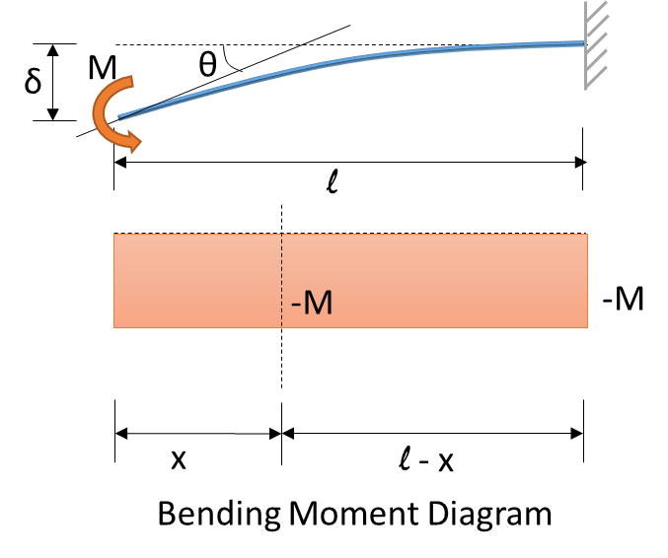

|  |  |  |
| --- | --- | --- |
|  | $$EI\left(\frac{d^{2}y}{dx^{2}}\right)=-M$$ | Eq. B10 |
|  | $$EI\left(\frac{dy}{dx}\right)=-Mx+c_{1}$$ | Eq. B11 |
|  | $$EIy=-\frac{Mx^{2}}{2}+c_{1}x+c_{2}$$ | Eq. B12 |
|  | Applying the boundary conditions, (i) at fixed end $$\left(\frac{dy}{dx}\right)=0 at x=l$$ |  |
|  | $$c_{1}=Ml$$ | Eq. B13 |
|  | (ii) at the fixed end $$y=0 at x=l$$ |  |
|  | $$-\frac{Ml^{2}}{2}+Ml^{2}+c_{2}=0$$ |  |
|  | $$c_{2}=-\frac{Ml^{2}}{2}$$ | Eq. B14 |
|  | Applying c1 & c2 to Eq. D11 & Eq. D12 |  |
|  | $$EIθ_{xM}=-Mx+Ml$$ | Eq. B15 |
|  | $$EIδ_{xM}=-\frac{Mx^{2}}{2}+Mxl-\frac{Ml^{2}}{2}$$ | Eq. B16 |
|  | The displacement and Slope at x = 0 caused by the moment M is |  |
|  | $$δ_{0M}=-\frac{Ml^{2}}{2EI}$$ | Eq. B17 |
|  | $$θ_{0M}=\frac{Ml}{EI}$$ | Eq. B18 |
|  |  |  |

So far we have found the end displacement and end rotation caused by Force acting on the free end and moment acting on the free end separately.

We can now find the stiffness by deriving the force and moment required to cause unit displacement and unit rotation.

Phase: 1 => Force and Moment required to cause unit displacement

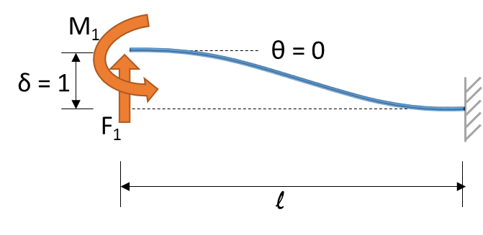

|  |  |  |
| --- | --- | --- |
|  | Form the above beam diagram, the conditions are |  |
|  | $$δ_{0F1}+δ_{0M1}=1$$ | Eq. B19 |
|  | $$θ_{0F1}+θ_{0M1}=0$$ | Eq. B20 |
|  | Using equations D8 & D17 in D19 |  |
|  | $$\frac{F_{1}l^{3}}{3EI}-\frac{M_{1}l^{2}}{2EI}=1$$ | Eq. B21 |
|  | Using equations D9 & D18 in D20 |  |
|  | $$-\frac{F_{1}l^{2}}{2EI}+\frac{M_{1}l}{EI}=0$$ | Eq. B22 |
|  | Solving the Equation D21 & D22 for F1 and M1 |  |
|  |  |  |
|  | Subsitituting the above in D21 |  |
|  | $$\frac{F_{1}l^{3}}{3EI}-\frac{F_{1}l^{2}}{2EI}\left(\frac{l}{2}\right)=1$$ |  |
|  | $$F_{1}=\frac{12EI}{l^{3}}$$ | Eq. B23 |
|  | Substituting the above in D22 |  |
|  | $$\frac{M_{1}l}{EI}=\frac{l^{2}}{2EI}\left(\frac{12EI}{l^{3}}\right)$$ |  |
|  | $$M_{1}=\frac{6EI}{l^{2}}$$ | Eq. B24 |

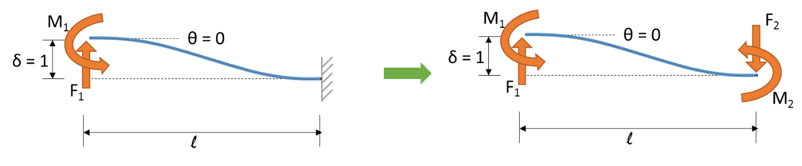

|  |  |  |
| --- | --- | --- |
|  | Now we find the F2 and M2 |  |
|  | F1 + F2 = 0 and M2 = F1l – M1 |  |
|  |  | Eq. B25 |
|  |  |  |
|  |  | Eq. B26 |
|  | Now a partial (incomplete) beam stiffness matrix will look like below, using eqns D23, D24, D25, D26 |  |
|  | $$\left[\begin{matrix}\frac{12EI}{l^{3}} & \frac{6EI}{l^{2}} & -\frac{12EI}{l^{3}} & \frac{6EI}{l^{2}} \\ \frac{6EI}{l^{2}} & XX & XX & XX \\ -\frac{12EI}{l^{3}} & XX & XX & XX \\ \frac{6EI}{l^{2}} & XX & XX & XX\end{matrix}\right]\left[\begin{matrix}δ_{1}=1 \\ θ_{1}=0 \\ δ_{2}=0 \\ θ_{2}=0\end{matrix}\right]= \left[\begin{matrix}F_{1} \\ M_{1} \\ F_{2} \\ M_{2}\end{matrix}\right]$$ | Eq. B27 |
|  | XX - Not derived yet |  |

Phase: 2 => Force and Moment required to cause unit rotation

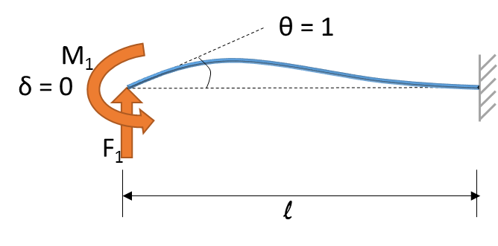

|  |  |  |
| --- | --- | --- |
|  | We do the same exercise as phase 1 for unit rotation |  |
|  | Form the above beam diagram, the conditions are |  |
|  | $$δ_{0F1}+δ_{0M1}=0$$ | Eq. B28 |
|  | $$θ_{0F1}+θ_{0M1}=1$$ | Eq. B29 |
|  | Using equations D8 & D17 in D28 |  |
|  | $$\frac{F_{1}l^{3}}{3EI}-\frac{M_{1}l^{2}}{2EI}=0$$ | Eq. B30 |
|  | Using equations D9 & D18 in D29 |  |
|  | $$-\frac{F_{1}l^{2}}{2EI}+\frac{M_{1}l}{EI}=1$$ | Eq. B31 |
|  | Solving the Equation D30 & D31 for F1 and M1 |  |
|  |  |  |
|  |  |  |
|  | Substituting the above in Eq. D31 |  |
|  | $$-\left(\frac{1}{2}\right)\frac{3M_{1}l}{2EI}+\frac{M_{1}l}{EI}=1$$ |  |
|  | $$M_{1}=\frac{4EI}{l}$$ | Eq. B32 |
|  | Substituting the above in Eq. D31 |  |
|  | $$F_{1}=\frac{6EI}{l^{2}}$$ | Eq. B33 |
|  |  |  |

|  |  |  |
| --- | --- | --- |
|  | Now we find the F2 and M2 |  |
|  | F1 + F2 = 0 and M2 = F1l – M1 |  |
|  |  | Eq. B34 |
|  |  |  |
|  |  | Eq. B35 |
|  | Now a partial (incomplete) beam stiffness matrix will look like below, using eqns D23, D24, D25, D26 |  |
|  | $$\left[\begin{matrix}\frac{12EI}{l^{3}} & \frac{6EI}{l^{2}} & -\frac{12EI}{l^{3}} & \frac{6EI}{l^{2}} \\ \frac{6EI}{l^{2}} & \frac{4EI}{l} & -\frac{6EI}{l^{2}} & \frac{2EI}{l} \\ -\frac{12EI}{l^{3}} & -\frac{6EI}{l^{2}} & XX & XX \\ \frac{6EI}{l^{2}} & \frac{2EI}{l} & XX & XX\end{matrix}\right]\left[\begin{matrix}δ_{1}=0 \\ θ_{1}=1 \\ δ_{2}=0 \\ θ_{2}=0\end{matrix}\right]= \left[\begin{matrix}F_{1} \\ M_{1} \\ F_{2} \\ M_{2}\end{matrix}\right]$$ | Eq. B36 |
|  | XX - Not derived yet |  |

Either we can do the same derivation for δ2 and θ2 unit displacement & rotation or we can arrive at their stiffness by visualizing their free-body diagram.

For δ2 =1, the force and moment will be the same but opposite direction from the derivation of δ1 =1 and for θ2 =1, the moment value is interchanged whereas the force values remains the same.

This leaves us with the stiffness matrix of a beam element,

|  |  |  |
| --- | --- | --- |
|  | $$\left[\begin{matrix}\frac{12EI}{l^{3}} & \frac{6EI}{l^{2}} & -\frac{12EI}{l^{3}} & \frac{6EI}{l^{2}} \\ \frac{6EI}{l^{2}} & \frac{4EI}{l} & -\frac{6EI}{l^{2}} & \frac{2EI}{l} \\ -\frac{12EI}{l^{3}} & -\frac{6EI}{l^{2}} & \frac{12EI}{l^{3}} & -\frac{6EI}{l^{2}} \\ \frac{6EI}{l^{2}} & \frac{2EI}{l} & -\frac{6EI}{l^{2}} & \frac{4EI}{l}\end{matrix}\right]\left[\begin{matrix}δ_{i} \\ θ_{i} \\ δ_{j} \\ θ_{j}\end{matrix}\right]= \left[\begin{matrix}F_{i} \\ M_{i} \\ F_{j} \\ M_{j}\end{matrix}\right]$$ | Eq. B37 |
|  | $$\left(\frac{EI}{l^{3}}\right)\left[\begin{matrix}12 & 6l & -12 & 6l \\ 6l & 4l^{2} & -6l & 2l^{2} \\ -12 & -6l & 12 & -6l \\ 6l & 2l^{2} & -6l & 4l^{2}\end{matrix}\right]\left[\begin{matrix}δ_{i} \\ θ_{i} \\ δ_{j} \\ θ_{j}\end{matrix}\right]= \left[\begin{matrix}F_{i} \\ M_{i} \\ F_{j} \\ M_{j}\end{matrix}\right]$$ | Eq. B38 |

The above equation is the basis for beam analyzer software tool. For the frame analyzer the same element stiffness with the axial stiffness and transformation included as below

|  |  |  |
| --- | --- | --- |
|  | Element stiffness matrix in local coordinate for frame element |  |
|  | $$\left[\begin{matrix}\frac{AE}{l} & 0 & 0 & -\frac{AE}{l} & 0 & 0 \\ 0 & \frac{12EI}{l^{3}} & \frac{6EI}{l^{2}} & 0 & -\frac{12EI}{l^{3}} & \frac{6EI}{l^{2}} \\ 0 & \frac{6EI}{l^{2}} & \frac{4EI}{l} & 0 & -\frac{6EI}{l^{2}} & \frac{2EI}{l} \\ -\frac{AE}{l} & 0 & 0 & \frac{AE}{l} & 0 & 0 \\ 0 & -\frac{12EI}{l^{3}} & -\frac{6EI}{l^{2}} & 0 & \frac{12EI}{l^{3}} & -\frac{6EI}{l^{2}} \\ 0 & \frac{6EI}{l^{2}} & \frac{2EI}{l} & 0 & -\frac{6EI}{l^{2}} & \frac{4EI}{l}\end{matrix}\right]\left[\begin{matrix}u_{i} \\ δ_{i} \\ θ_{i} \\ u_{j} \\ δ_{j} \\ θ_{j}\end{matrix}\right]= \left[\begin{matrix}P_{i} \\ F_{i} \\ M_{i} \\ P_{j} \\ F_{j} \\ M_{j}\end{matrix}\right]$$ | Eq. B39 |
|  | The transformation matrix for the global coordinate system is |  |
|  | $$L=\left[\begin{matrix}l & m & 0 & 0 & 0 & 0 \\ -m & l & 0 & 0 & 0 & 0 \\ 0 & 0 & 1 & 0 & 0 & 0 \\ 0 & 0 & 0 & l & m & 0 \\ 0 & 0 & 0 & -m & l & 0 \\ 0 & 0 & 0 & 0 & 0 & 1\end{matrix}\right]$$ |  |
|  | $$k_{g}=L^{T}k_{l}L$$ |  |
|  | All the elements in Frame analyzer is stored in global coordinate system |  |

## Virtual work principle & stiffness matrix of 1D elements

Strain Energy

In mechanics of material it is shown that the strain energy at a point of a linear elastic material subjected to one dimensional state of stress σ & strain ϵ is

$$strain energy dU=\frac{1}{2}σϵ dV$$

Total strain energy integrated on the total volume V of the bar

|  |  |  |
| --- | --- | --- |
|  | $$W_{I}= \int_{V}{\frac{1}{2}σϵ dV}$$ | Eq C1 |

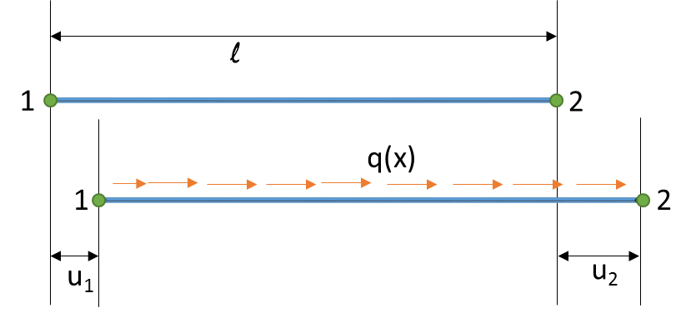

|  |  |  |
| --- | --- | --- |
|  | $$σ= Eϵ$$ Uniform area throughout the length of the bar |  |
|  | $$dV= Adx$$ |  |
|  | Eq. E1 becomes |  |
|  | $$W_{I}= \int_{V}{\frac{1}{2}ϵEϵ Adx}$$ | Eq. C2 |
|  | Strain and displacements are linked by the relation |  |
|  | $$ϵ\left(x\right)=\frac{d}{dx}(u\left(x\right))$$ |  |

The real variation of displacement along the bar is not known. Instead we will interpolate the value of u(x) from the values of the displacements at the nodes u1 and u2.

*The above statement is the fundamental idea behind finite element analysis. A structure’s behavior under an external loading is predicted by discretizing it into small elements and summing their individual elements. The accuracy of the prediction is directly proportional to the equations (shape functions) with which the elements are represented. There are lot of pitfalls in using finite element analysis where the picturesque post processing results from commercial software might overshadow the accuracy aspect. I will discuss these topic in the final section.*

*Now let’s continue with selecting a shape function which might rightly represent a bar element. I will discuss only the first order elements in the following sections, the user can extend these idea to utilizing higher order elements. Note that higher order elements doesn’t means accurate results. Whichever element closely represents the physical behavior of the structure is the right element which in my opinion none. But with the powerful tool of finite element analysis we can arrive at a solution to make a better design choice.*

|  |  |  |
| --- | --- | --- |
|  | $$u\left(x\right)=N_{1}\left(x\right)u_{1}+N_{2}\left(x\right)u_{2}$$ | Eq. C3 |
|  | Where N1(x) and N2(x) are the shape functions |  |

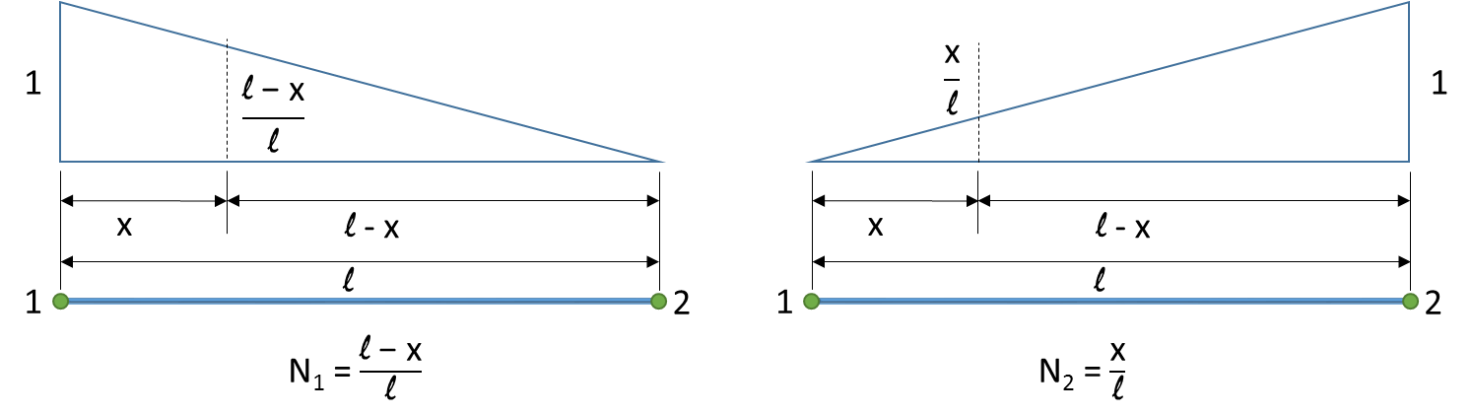

|  |  |  |
| --- | --- | --- |
|  | Eq E3 becomes |  |
|  | $$u\left(x\right)=\left(\frac{l-x}{l}\right)u_{1}+\left(\frac{x}{l}\right)u_{2}$$ | Eq. C4 |
|  | $$u\left(x\right)=\left[\begin{matrix}\frac{l-x}{l} & \frac{x}{l}\end{matrix}\right]\left[\begin{matrix}u_{1} \\ u_{2}\end{matrix}\right]$$ |  |
|  | $$u\left(x\right)=\left[N\right][u]$$ |  |
|  | $$∈\left(x\right)=\frac{d}{dx}\left[N\right][u]$$ |  |
|  | $$∈\left(x\right)=\left[B\right][u]$$ | Eq. C5 |
|  | where $$[B]=\frac{d}{dx}\left[N\right]$$ Is called the strain – displacement matrix | Eq. C6 |
|  | $$\left[B\right]=\frac{d}{dx}\left[\begin{matrix}\frac{l-x}{l} & \frac{x}{l}\end{matrix}\right]= \left[\begin{matrix}\frac{-1}{l} & \frac{1}{l}\end{matrix}\right]$$ | Eq. C7 |
|  |  |  |

## Principle of minimum potential energy and stiffness matrix of bar element

For conservative systems, of all kinematically admissible displacement fields, those corresponds to equilibrium extremize the total potential energy. If the extreme condition’s total potential energy is minimum, the equilibrium state is stable. In other words, from a super imposed external loading, a structure will lose its potential energy by deforming to a new position to attain equilibrium. The deformed state’s potential energy will be minimum.

|  |  |  |
| --- | --- | --- |
|  | Total Potential energy $$π=W_{I}-W_{E}$$ |  |
|  | From principle of minimum potential energy |  |
|  | $$∂π={∂W}_{I}-{∂W}_{E}= 0$$ | Eq. C8 |
|  |  |  |
|  | External work done |  |
|  | $$W_{E}= \int_{L}{q\left(x\right)u\left(x\right)dx}$$ | Eq. C9 |
|  | Internal work done |  |
|  | $$W_{I}= \int_{L}{\frac{1}{2}ϵEϵAdx}$$ | Eq. C10 |
|  |  |  |
|  | Applying Eq.8 & Eq.9 in Eq.7 |  |
|  | $$∂\int_{L}{\frac{1}{2}ϵEϵAdx}= ∂\int_{L}{q\left(x\right)u\left(x\right)dx}$$ |  |
|  | $$\frac{1}{2}\int_{L}{((∂ϵ)Eϵ+ ϵE(∂ϵ))Adx}=\int_{L}{q\left(x\right) ∂u\left(x\right)dx}$$ |  |
|  | Note that the loading q(x) is not changing from the initial state to final state, where there is a potential energy change |  |
|  | $$\int_{L}{ ϵE(∂ϵ)Adx}=\int_{L}{q\left(x\right) ∂u\left(x\right)dx}$$ |  |
|  | $$\int_{L}{ {\left[B\right]}^{T}\left[u\right]E\left[B\right][∂u]Adx}=\int_{L}{q\left(x\right) ∂(\left[N\right]\left[u\right])dx}$$ |  |
|  | $$[∂u]AE\int_{L}{ {\left[B\right]}^{T}\left[u\right]\left[B\right]dx}=\left[∂u\right]\int_{L}{q\left(x\right) \left[N\right]dx}$$ |  |
|  | $$AE\int_{L}{ {\left[B\right]}^{T}\left[B\right]dx}\left[u\right]=\int_{L}{q\left(x\right) \left[N\right]dx}$$ | Eq. C11 |
|  | $$\left[K\right]\left[u\right]=[F]$$ | Eq. C12 |
|  | Now the element stiffness matrix of 1D bar element is given by |  |
|  | $$\left[k\right]=AE\int_{L}{ {\left[B\right]}^{T}\left[B\right]dx}$$ | Eq. C13 |
|  | Using Eq.7 in Eq. E13 |  |
|  | $$\left[k\right]=AE\int_{L}{ \left[\begin{matrix}\frac{-1}{l} \\ \frac{1}{l}\end{matrix}\right]\left[\begin{matrix}\frac{-1}{l} & \frac{1}{l}\end{matrix}\right]dx}$$ |  |
|  | $$\left[k\right]=AE\int_{L}{ \left[\begin{matrix}\frac{1}{l^{2}} & -\frac{1}{l^{2}} \\ -\frac{1}{l^{2}} & \frac{1}{l^{2}}\end{matrix}\right]dx}$$ |  |
|  | $$\left[k\right]=AE\left[\begin{matrix}\frac{1}{l} & -\frac{1}{l} \\ -\frac{1}{l} & \frac{1}{l}\end{matrix}\right]$$ |  |
|  | The element stiffness matrix of 1D bar element is |  |
|  | $$\left[k\right]=\frac{AE}{l}\left[\begin{matrix}1 & -1 \\ -1 & 1\end{matrix}\right]$$ | Eq. C14 |
|  | Note that the above matrix is the same as Eq. C1 |  |
|  |  |  |

## Deriving shape function and stiffness matrix of beam element

We shall do the above exercise to derive the stiffness matrix of beam element. Note that the derivation of shape function is the fundamental behind formulating the finite element.

Hermite Splines

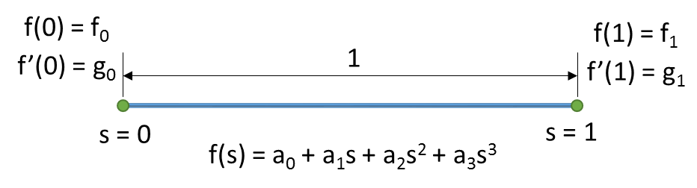

|  |  |  |
| --- | --- | --- |
|  | A cubic polynomial s[0,1] is |  |
|  | $$f\left(s\right)=a_{0}+a_{1}s+a_{2}s^{2}+a_{3}s^{3}$$ | Eq. C15 |
|  | $$f'(s)=a_{1}+{2a}_{2}s+{3a}_{3}s^{2}$$ | Eq. C16 |
|  | Let |  |
|  | $$f\left(0\right)=a_{0}=f_{0}$$ | Eq. C17 |
|  | $$f'\left(0\right)=a_{1}=g_{0}$$ | Eq. C18 |
|  | And |  |
|  | $$f\left(1\right)=a_{0}+a_{1}+a_{2}+a_{3}=f_{1}$$ | Eq. C19 |
|  | $$f^{'}(1)=a_{1}+2a_{2}+3a_{3}=g_{1}$$ | Eq. C20 |
|  | Note that i) f0 & f1 are displacement at s = 0 & 1  ii) g0 and g1 are slope at s = 0 & 1 |  |
|  | Our aim is to express the cubic polynomial coefficients in terms of slope and deflection at the end nodes |  |
|  | Now solving for a2 and a3, rewriting Eq. E19 and Eq. E20 |  |
|  | $$a_{2}+a_{3}=f_{1}-f_{0}-g_{0}$$ | Eq. C21 |
|  | $$2a_{2}+3a_{3}=g_{1}-g_{0}$$ | Eq. C22 |
|  | Solving Eq. E21 and E1. E22 for a2 and a3 |  |
|  |  | Eq. C23 |
|  |  | Eq. C24 |
|  | Using Eq. E23 and Eq. E24 we can write the cubic polynomial equation in terms of |  |
|  | $$f\left(s\right)=f_{0}+g_{0}s+({3f}_{1}-{3f}_{0}-{2g}_{0}-g_{1})s^{2}+({2f}_{0}-{2f}_{1}+g_{0}+g_{1})s^{3}$$ | Eq. C25 |
|  | We can re-arrange Eq. E25 to |  |
|  | $$f\left(s\right)={(1-3s^{2}+2s^{3})f}_{0}+{(s-2s^{2}+s^{3})g}_{0}+\left(3s^{2}-2s^{3}\right)f_{1}+\left(-s^{2}+s^{3}\right)g_{1}$$ | Eq. C26 |
|  | The above equation is a cubic polynomial in interval [0,1] in terms of end displacement and rotation |  |
|  | Now using Eq. E26, we can write a generic cubic polynomial in interval [0,L], where s = x/l and g0, g1 becomes g0L, g1L  The reason why g0, g1 becomes g0L, g1L is |  |
|  |  |  |
|  |  |  |
|  |  |  |
|  |  |  |
|  | The generic cubic polynomial in interval [0,L] with end displacement |  |
|  | $$f\left(x\right)={\left(1-\frac{3x^{2}}{l^{2}}+\frac{2x^{3}}{l^{3}}\right)f}_{0}+{\left(x-\frac{2x^{2}}{l}+\frac{x^{3}}{l^{2}}\right)g}_{0}+\left(\frac{3x^{2}}{l^{2}}-\frac{2x^{3}}{l^{3}}\right)f_{1}+\left(-\frac{x^{2}}{l}+\frac{x^{3}}{l^{2}}\right)g_{1}$$ | Eq. C27 |
|  |  |  |

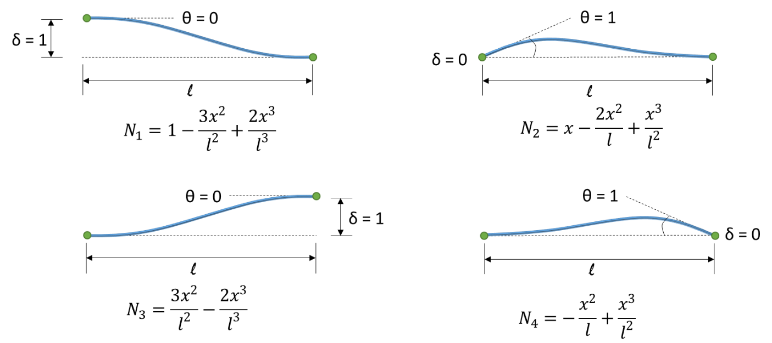

|  |  |  |
| --- | --- | --- |
|  | Strain energy, using Eq. E1 |  |
|  | $$dU=\frac{1}{2}σϵ dV$$ |  |
|  | Internal strain energy under pure bending is |  |
|  | $$W_{I}= \int_{V}{\frac{1}{2}σ_{xx}ϵ_{xx} dV}$$ | Eq. C28 |
|  | From Euler – Bernoulli the normal stress on a cross- sectional element of area dA at a distance y from neutral axis is |  |
|  | $$σ_{xx}=\frac{My}{I}$$ |  |
|  | And |  |
|  | $$ϵ_{xx}=\frac{σ_{xx}}{E}$$ |  |
|  | Using the above equations in Eq. E.28 |  |
|  | $$W_{I}= \int_{V}{\frac{1}{2}\left(\frac{M^{2}y^{2}}{EI^{2}}\right)dV}$$ | Eq. C29 |
|  | $$W_{I}= \int_{l}{\frac{1}{2}\left(\frac{M^{2}}{EI^{2}}\right)\iint_{A}{y^{2}dA} dx}$$ |  |
|  | $$W_{I}= \int_{l}{\frac{1}{2}\left(\frac{M^{2}}{EI}\right) dx}$$ | Eq. C30 |
|  | Once again using Euler-Bernoulli’s beam theory $$EI\left(\frac{d^{2}δ}{dx^{2}}\right)=M$$ Eq. E30 becomes |  |
|  | $$W_{I}= \int_{l}{\frac{1}{2}EI{\left(\frac{∂^{2}δ}{∂x^{2}}\right)}^{2}dx}$$ | Eq. C31 |
|  | Remember, the displacement δ(x) is unknown and we use the shape function and end displacement to represent it |  |
|  | Now the external work done is |  |
|  | $$W_{E}= F_{1}δ_{1}+M_{1}θ_{1}+F_{2}δ_{2}+M_{2}θ_{2}$$ | Eq. C32 |
|  | For minimum potential energy at the final state |  |
|  | $$∂\int_{l}{\frac{1}{2}EI{\left(\frac{∂^{2}δ}{∂x^{2}}\right)}^{2}dx}= ∂(F_{1}δ_{1}+M_{1}θ_{1}+F_{2}δ_{2}+M_{2}θ_{2})$$ |  |
|  | $$\left(\frac{1}{2}EI\right) ∂\int_{l}{\left[\begin{matrix}δ_{1} & θ_{1} & δ_{2} & θ_{2}\end{matrix}\right]\left[\begin{matrix}N_{1}^{''} \\ N_{2}^{''} \\ N_{3}^{''} \\ N_{4}^{''}\end{matrix}\right]\left[\begin{matrix}N_{1}^{''} & N_{2}'' & N_{3}'' & N_{4}''\end{matrix}\right]\left[\begin{matrix}δ_{1} \\ θ_{1} \\ δ_{2} \\ θ_{2}\end{matrix}\right]dx}= ∂ \left[\begin{matrix}δ_{1} & θ_{1} & δ_{2} & θ_{2}\end{matrix}\right]\left[\begin{matrix}F_{1} \\ M_{1} \\ F_{2} \\ M_{2}\end{matrix}\right]$$ | Eq. C33 |
|  | The above equation can be written in short form as shown below |  |
|  | $$\left.\frac{1}{2}EI ∂\int_{l}{\left[ δ \right]{\left[N^{''}\right]}^{T}\left[N^{''}\right]{\left[ δ \right]}^{T}dx}\right.= ∂ \left[ δ \right]{\left[ q \right]}^{T}$$ |  |
|  | $$\left.EI ∂\left[ δ \right]\int_{l}{{\left[N^{''}\right]}^{T}\left[N^{''}\right]{\left[ δ \right]}^{T}dx}\right.= ∂ \left[ δ \right]{\left[ q \right]}^{T}$$ |  |
|  | $$\left.EI\int_{l}{{\left[N^{''}\right]}^{T}\left[N^{''}\right]dx}\right.\left[\begin{matrix}δ_{1} \\ θ_{1} \\ δ_{2} \\ θ_{2}\end{matrix}\right]= \left[\begin{matrix}F_{1} \\ M_{1} \\ F_{2} \\ M_{2}\end{matrix}\right]$$ | Eq. C34 |
|  | The beam element stiffness matrix is |  |
|  | $$k= EI\int_{l}{{\left[N^{''}\right]}^{T}\left[N^{''}\right]dx}$$ | Eq. C35 |
|  |  |  |

The below table shows the double derivatives of the beam shape functions Eq. E27

|  |  |  |  |
| --- | --- | --- | --- |
|  | N | N’ | N’’ |
| 1 | $$1-\frac{3x^{2}}{l^{2}}+\frac{2x^{3}}{l^{3}}$$ | $$-\frac{6x}{l^{2}}+\frac{6x^{2}}{l^{3}}$$ | $$-\frac{6}{l^{2}}+\frac{12x}{l^{3}}$$ |
| 2 | $$x-\frac{2x^{2}}{l}+\frac{x^{3}}{l^{2}}$$ | $$1-\frac{4x}{l}+\frac{{3x}^{2}}{l^{2}}$$ | $$-\frac{4}{l}+\frac{6x}{l^{2}}$$ |
| 3 | $$\frac{3x^{2}}{l^{2}}-\frac{2x^{3}}{l^{3}}$$ | $$\frac{6x}{l^{2}}-\frac{6x^{2}}{l^{3}}$$ | $$-\left(-\frac{6}{l^{2}}+\frac{12x}{l^{3}}\right)$$ |
| 4 |  |  |  |

|  |  |  |
| --- | --- | --- |
|  | Multiplying ${\left[N^{''}\right]}^{T}\left[N^{''}\right]$ yields |  |
|  | $$\int_{l}{\left[\begin{matrix}N_{1}^{''} \\ N_{2}^{''} \\ N_{3}^{''} \\ N_{4}^{''}\end{matrix}\right]\left[\begin{matrix}N_{1}^{''} & N_{2}^{''} & N_{3}^{''} & N_{4}^{''}\end{matrix}\right]}=\int_{l}{\left[\begin{matrix}N_{1}^{''2} & N_{1}^{''}N_{2}^{''} & N_{1}^{''}N_{3}^{''} & N_{1}^{''}N_{4}^{''} \\ - & N_{2}^{''2} & N_{2}^{''}N_{3}^{''} & N_{2}^{''}N_{4}^{''} \\ - & - & N_{3}^{''2} & N_{3}^{''}N_{4}^{''} \\ - & - & - & N_{4}^{''2}\end{matrix}\right]}$$ |  |
|  | The lower triangle on the matrix is symmetrical to the upper triangle |  |
|  | Further simplification gives |  |
|  | $$\int_{l}{\left[\begin{matrix}N_{1}^{''2} & N_{1}^{''}N_{2}^{''} & -{N_{1}^{''}}^{2} & N_{1}^{''}N_{4}^{''} \\ - & N_{2}^{''2} & -N_{1}^{''}N_{2}^{''} & N_{2}^{''}N_{4}^{''} \\ - & - & N_{1}^{''2} & -N_{1}^{''}N_{4}^{''} \\ - & - & - & N_{4}^{''2}\end{matrix}\right]}$$ |  |
|  | Solving individual elements of the matrix  We need to find the elements (1,1) (1,2) (1,4) (2,2) (2,4),(4,4) |  |
|  | Matrix element - (1,1) |  |
|  |  |  |
|  |  |  |
|  |  |  |
|  |  |  |
|  |  | Eq. C36 |
|  |  |  |
|  | Matrix element - (1,2) |  |
|  |  |  |
|  |  |  |
|  |  |  |
|  |  |  |
|  |  | Eq. C37 |
|  |  |  |
|  | Matrix element - (1,4) |  |
|  |  |  |
|  |  |  |
|  |  |  |
|  |  |  |
|  |  | Eq. C38 |
|  |  |  |
|  | Matrix element - (2,2) |  |
|  |  |  |
|  |  |  |
|  |  |  |
|  |  |  |
|  |  | Eq. C39 |
|  |  |  |
|  | Matrix element - (2,4) |  |
|  |  |  |
|  |  |  |
|  |  |  |
|  |  |  |
|  |  | Eq. C40 |
|  |  |  |
|  | Matrix element - (4,4) |  |
|  |  |  |
|  |  |  |
|  |  |  |
|  |  |  |
|  |  | Eq. C41 |
|  |  |  |
|  | Now the element stiffness matrix by substituting Eq. E36, E37, E38, E39, E40, E41 in Eq. E35 gives us |  |
|  | $$EI \left[\begin{matrix}\frac{12}{l^{3}} & \frac{6}{l^{2}} & -\frac{12}{l^{3}} & \frac{6}{l^{2}} \\ \frac{6}{l^{2}} & \frac{4}{l} & -\frac{6}{l^{2}} & \frac{2}{l} \\ -\frac{12}{l^{3}} & -\frac{6}{l^{2}} & \frac{12}{l^{3}} & -\frac{6}{l^{2}} \\ \frac{6}{l^{2}} & \frac{2}{l} & -\frac{6}{l^{2}} & \frac{4}{l}\end{matrix}\right]\left[\begin{matrix}δ_{i} \\ θ_{i} \\ δ_{j} \\ θ_{j}\end{matrix}\right]= \left[\begin{matrix}F_{i} \\ M_{i} \\ F_{j} \\ M_{j}\end{matrix}\right]$$ | Eq. C42 |
|  | Note that the above equation is same as that of Eq. B37 |  |
|  | $$\left(\frac{EI}{l^{3}}\right)\left[\begin{matrix}12 & 6l & -12 & 6l \\ 6l & 4l^{2} & -6l & 2l^{2} \\ -12 & -6l & 12 & -6l \\ 6l & 2l^{2} & -6l & 4l^{2}\end{matrix}\right]\left[\begin{matrix}δ_{i} \\ θ_{i} \\ δ_{j} \\ θ_{j}\end{matrix}\right]= \left[\begin{matrix}F_{i} \\ M_{i} \\ F_{j} \\ M_{j}\end{matrix}\right]$$ | Eq. C43 & Eq. B38 |

# References

1. Concepts and Application of finite element analysis (Fourth Edition) – Robert D. Cook, David S. Malkus, Michael E. Plesha, Robert J. Witt
2. Introduction to Finite Elements in Engineering (Third Edition) – Tirupathi R. Chandrupatla, Ashok D. Belegundu
3. A First course in the finite element method – Fourth Edition – Daryl L. Logan
4. MATLAB Codes for finite element analysis – A. J. M. Ferreira
5. Finite Element Procedures (Second Edition) – [Klaus-Jürgen Bathe](https://www.google.com.sg/search?sa=X&rlz=1C1CHBF_enSG732SG732&q=Klaus-J%C3%BCrgen+Bathe&stick=H4sIAAAAAAAAAOPgE-LSz9U3MMuoyDArUgKzTYsrLYuKtGSyk630k_Lzs_XLizJLSlLz4svzi7KtEktLMvKLAKzV3bc4AAAA&ved=0ahUKEwib0bfvpf7WAhUBN48KHUHmBJ0QmxMIvQIoATAR)
6. NPTEL :: Civil Engineering Finite Element Analysis