Campus EventHub — System Design
Unit: ICT203 Web Application Development
Assessment: Assessment 3 — Full-Stack Web Application with Responsible AI Integration
Project: Campus EventHub
Team Members:
- Khaled Hasan (CIHE250337)
- Sunir (CIHE240723)
- Salman Shoshe (CIHE231333)

1. Architecture Diagram
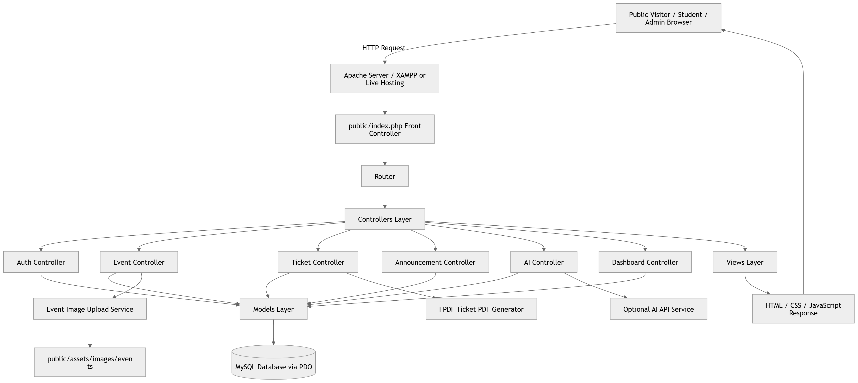Figure 1:System Architecture Diagram

2. ERD / Database Schema
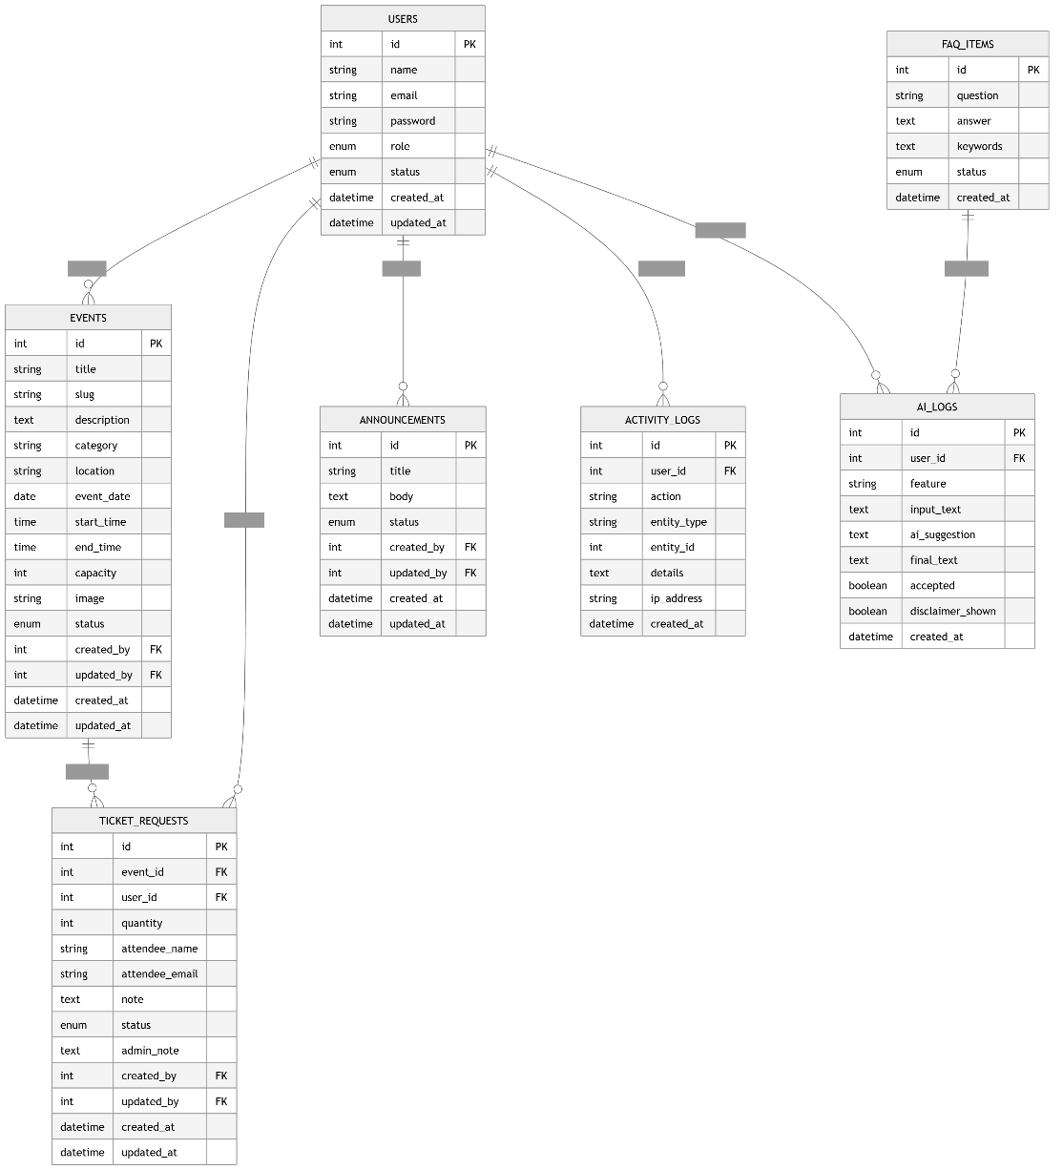
Figure 2: Entity Relationship Diagram

3. API Endpoints / Routes List
Route | Method | Access Level | Purpose
/ | GET | Public | Landing page
/login | GET/POST | Public | Show login form and process login
/register | GET/POST | Public | Show registration form and create user account
/logout | GET | Logged-in User | Logout user and destroy session
/dashboard | GET | Admin/User | Show role-based dashboard
/events | GET | Public | Show published events listing
/events/{slug} | GET | Public | Show event detail page
/events/{id}/request-ticket | POST | Standard User | Submit ticket request
/my-tickets | GET | Standard User | View user ticket requests
/tickets/{id}/download | GET | User/Admin | Download approved ticket PDF
/announcements | GET | Public | View published announcements
/help-assistant | GET/POST | Public/User | Use Smart Help Assistant
/admin/events | GET | Admin | View and manage events
/admin/events/create | GET | Admin | Show create event form
/admin/events/store | POST | Admin | Store new event
/admin/events/{id} | GET | Admin | View event details
/admin/events/{id}/edit | GET | Admin | Show edit event form
/admin/events/{id}/update | POST | Admin | Update event
/admin/events/{id}/delete | POST | Admin | Delete event
/admin/tickets | GET | Admin | View ticket requests
/admin/tickets/{id} | GET | Admin | View ticket request detail
/admin/tickets/{id}/status | POST | Admin | Approve, reject, or cancel ticket request
/admin/announcements | GET | Admin | View and manage announcements
/admin/announcements/create | GET | Admin | Show create announcement form
/admin/announcements/store | POST | Admin | Store new announcement
/admin/announcements/{id}/edit | GET | Admin | Show edit announcement form
/admin/announcements/{id}/update | POST | Admin | Update announcement
/admin/announcements/{id}/delete | POST | Admin | Delete announcement
/admin/ai-draft | GET/POST | Admin | Generate and review AI event draft
/admin/ai-logs | GET | Admin | View AI usage logs
/admin/activity-logs | GET | Admin | View system activity logs

