Test Evidence

Campus EventHub
Unit: ICT203 Web Application Development
Assessment: Assessment 3: Full-Stack Web Application with Responsible AI Integration
Team Members:
- Khaled Hasan (CIHE250337)
- Sunir (CIHE240723)
- Salman Shoshe (CIHE231333)

1. Test Environment
Item | Details
Application | Campus EventHub
Backend | PHP 8+
Database | MySQL
Server | XAMPP / Apache
Browser | Google Chrome
Testing Type | Manual functional testing
Test Users | Admin and Standard User

2. Test Cases
Test ID | Feature | Test Steps | Expected Result | Status
TC01 | Admin Login | Login with valid admin credentials. | Admin dashboard opens. | Pass
TC02 | User Login | Login with valid user credentials. | User dashboard opens. | Pass
TC03 | Invalid Login | Login with wrong password. | Error message shown. | Pass
TC04 | Registration Validation | Submit register form with invalid data. | Validation errors shown. | Pass
TC05 | Admin Create Event | Admin creates event with required details. | Event is saved successfully. | Pass
TC06 | Event Image Upload | Upload valid event image. | Image displays on event pages. | Pass
TC07 | Event Search/Filter | Search or filter event listing. | Matching events are displayed. | Pass
TC08 | Ticket Request | User submits ticket request. | Request is saved as pending. | Pass
TC09 | Duplicate Ticket | Submit duplicate request for same event. | Duplicate request is blocked. | Pass
TC10 | Ticket Approval | Admin approves pending ticket. | Ticket status becomes approved. | Pass
TC11 | PDF Download | User downloads approved ticket. | Ticket PDF downloads correctly. | Pass
TC12 | Admin Access Protection | User opens admin route. | Access denied page appears. | Pass
TC13 | AI Draft Assistant | Admin generates and reviews AI draft. | Draft requires human review. | Pass
TC14 | Help Assistant | Ask system-related question. | Help answer is displayed. | Pass

3. Screenshot Evidence
Screenshot 1: Login Page / Admin Login
Evidence for: TC01, TC02, TC03
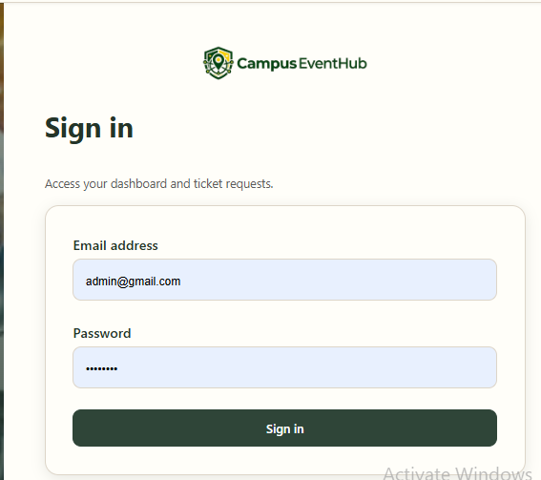
Screenshot 2: User Registration Validation
Evidence for: TC04
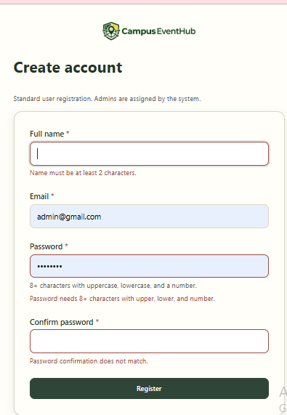

Screenshot 3: Admin Dashboard
Evidence for: TC01
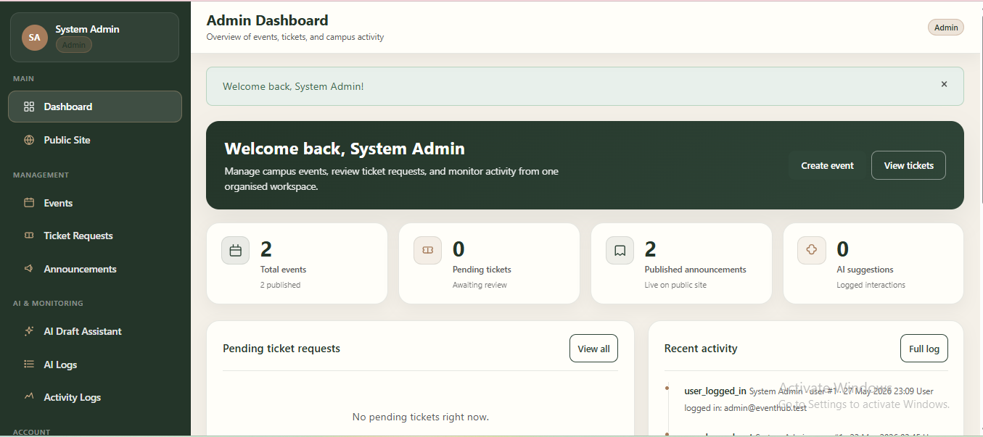
Screenshot 4: Admin Create Event Form
Evidence for: TC05, TC06
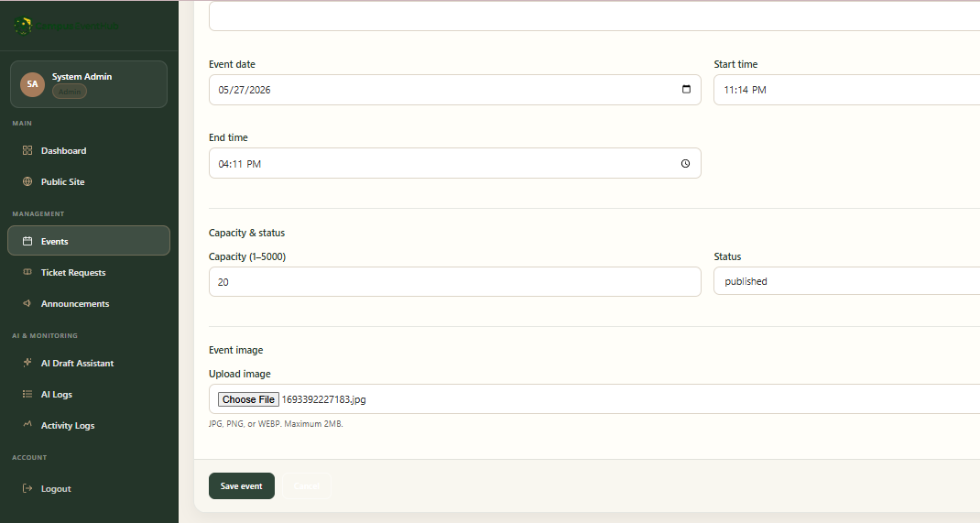
Screenshot 5: Events Listing with Search/Filter
Evidence for: TC07
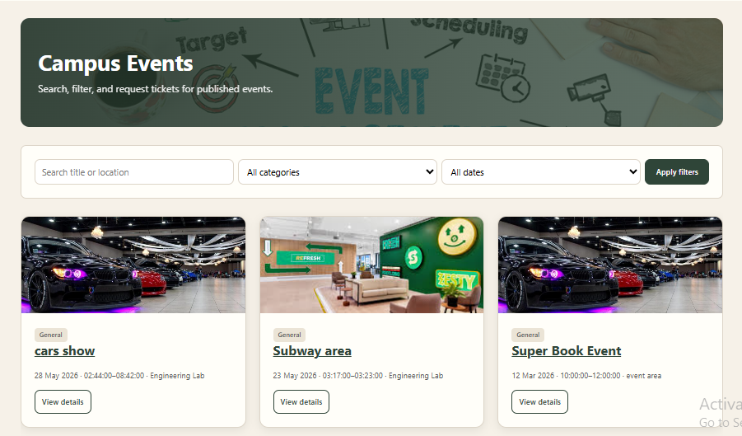
Screenshot 6: Event Detail and Ticket Request Form
Evidence for: TC08
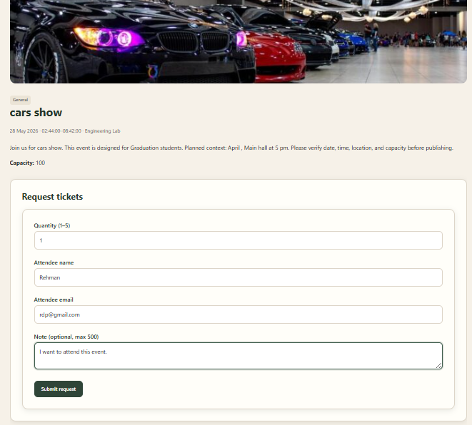
Screenshot 7: My Tickets Page
Evidence for: TC08, TC10, TC11
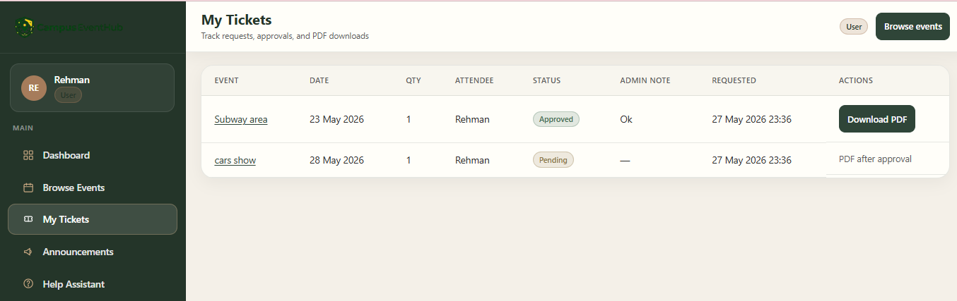
Screenshot 8: Admin Ticket Review Page
Evidence for: TC10
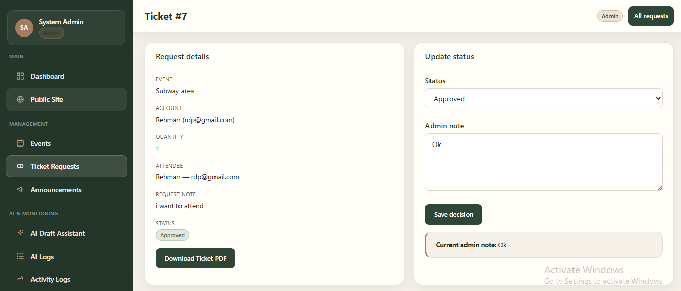
Screenshot 9: Ticket PDF
Evidence for: TC11
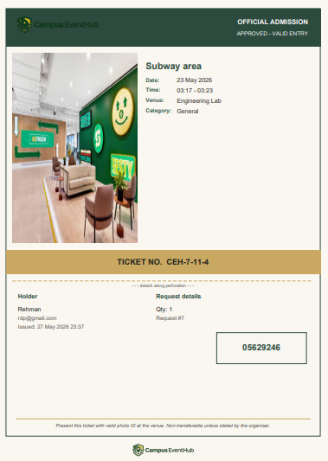
Screenshot 10: 403 / Access Denied Page
Evidence for: TC12
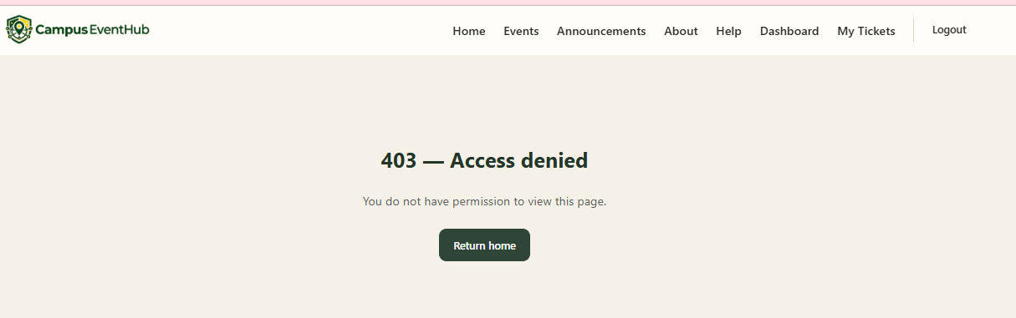
Screenshot 11: AI Event Draft Assistant
Evidence for: TC13
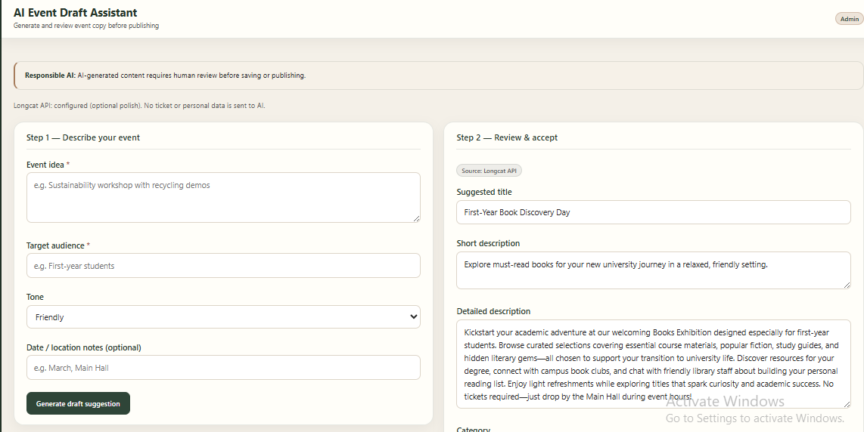
Screenshot 12: Help Assistant
Evidence for: TC14
