**(**OSPF)

Khaled Ail Alghamdi

441226880

**Open Shortest Path First Protocol**

**(OSPF)**

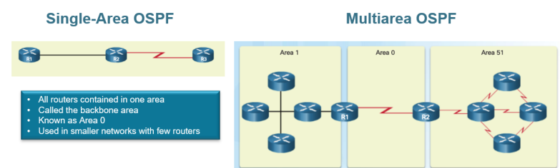

▪ Support large network → (Unlimited Hop Count)

▪ Any OSPF design must contain (Area 0) → called the backbone area.

▪ An OSPF network can be divided into sub-domains called areas (Multiple Areas): o To divide large networks → To reduce processing and memory overhead. o A failure in one area does not affect other areas.

▪ All the areas must connect to (Area 0).

▪ Routers on the edge of areas called Area Border Router (ABR) share summarized information between areas

▪ Shares routing information through Link State Advertisements (LSAs)

▪ Neighbors are discovered by Hello Packets

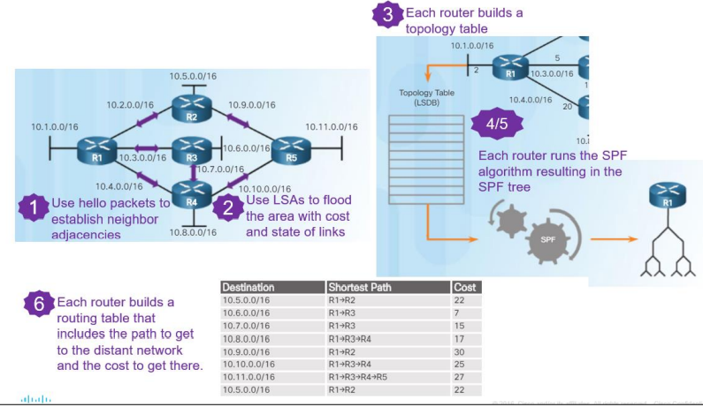

▪ Hello packets are sent every 10 seconds & Dead interval 40 seconds.

▪ Updates are sent through Multicast IP address 224.0.0.5

▪ The OSPF use the cost as metric → Cost =108 /Bandwidth in bps

**صورة تحتوي على نص

تم إنشاء الوصف تلقائياً** ▪ Administrative distance is 110

Configuring Single-Area OSPF on IPv4

Router(config) # **router ospf <Process-ID)**

Router(config-router) # **network < network- ID> <wildcard Mask> area- ID**

**-**

**-**

Router(config-router)# **network < network- ID> <wildcard Mask> area- ID**

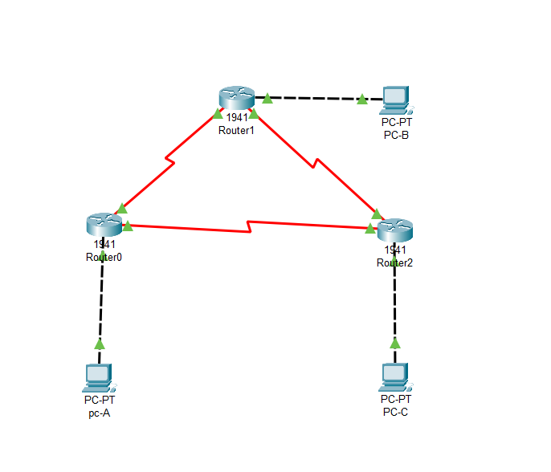

**صورة تحتوي على منضدة

تم إنشاء الوصف تلقائياً**

**Objectives**

**Part 1: Build the Network and Configure Basic Device Settings**

**Step 1: Cable the network as shown in the topology.**

**Step 2: Initialize and reload the routers as necessary.**

**Step 3: Configure basic settings for each router.**

a. Disable DNS lookup.

b. Configure device name as shown in the topology.

c. Assign class as the privileged EXEC password.

d. Assign cisco as the console and vty passwords.

e. Configure a message of the day (MOTD) banner to warn users that unauthorized access is prohibited.

f. Configure logging synchronous for the console line

g. Configure the IP address listed in the Addressing Table for all interfaces.

h. Set the clock rate for all DCE serial interfaces at 128000.

i. Copy the running configuration to the startup configuration.

**Step 4: Configure PC hosts**.

**Step 5: Test connectivity**.

The routers should be able to ping one another, and each PC should be able to ping its default gateway.

The PCs are unable to ping other PCs until OSPF routing is configured. Verify and troubleshoot if necessary

**Part 2: Configure and Verify OSPF Routing**

**Step 1: Configure OSPF on R1.**

a. Use the router ospf command in global configuration mode to enable OSPF on R1.

R1(config) # **router ospf 1**

b. Configure the **network** statements for the networks on R1. Use an area ID of 0

R1(config-router) # **network 192.168.1.0 0.0.0.255 area 0**

R1(config-router) # **network 192.168.12.0 0.0.0.3 area 0**

R1(config-router) # **network 192.168.13.0 0.0.0.3 area 0**

**Step 2: Configure OSPF on R2 and R3**

Use the router ospf command and add the network statements for the networks on R2 and R3. Neighbor adjacency messages display on R1 when OSPF routing is configured on R2 and R3.

**Step 3: Verify OSPF neighbors and routing information**.

a. Issue the show ip ospf neighbor command to verify that each router lists the other routers in the network as neighbors.

R1# **show ip ospf neighbor**

Neighbor ID Pri State Dead Time Address Interface 192.168.23.2 0 FULL/ - 00:00:33 192.168.13.2 Serial0/0/1 192.168.23.1 0 FULL/ - 00:00:30 192.168.12.2 Serial0/0/0

b. Issue the show ip route command to verify that all networks display in the routing table on all routers.

R1# **show ip route**

صورة تحتوي على نص

تم إنشاء الوصف تلقائياً

**Step 4: Verify OSPF protocol settings**

The **show ip protocols** command is a quick way to verify vital OSPF configuration information. This information includes the OSPF process ID, the router ID, networks the router is advertising, the neighbors the router is receiving updates from, and the default administrative distance, which is 110 for OSPF.

**صورة تحتوي على نص

تم إنشاء الوصف تلقائياً**

**Step 5: Verify OSPF process information**

Use the show ip ospf command to examine the OSPF process ID and router ID. This command displays the OSPF area information, as well as the last time the SPF algorithm was calculated.

**Step 6: Verify OSPF interface settings**

a.Issue the **show ip ospf interface brief** command to display a summary of OSPF-enabled interfaces

b. For a more detailed list of every OSPF-enabled interface, issue the **show ip ospf interface** command.

**Step 7: Verify end-to-end connectivity**

Each PC should be able to ping the other PCs in the topology. Verify and troubleshoot if necessary

**Part 3: Change Router ID Assignments**

The OSPF router ID is used to uniquely identify the router in the OSPF routing domain. Cisco routers derive the router ID in one of three ways and with the following precedence:

1) IP address configured with the OSPF router-id command, if present

2) Highest IP address of any of the router’s loopback addresses, if present

3) Highest active IP address on any of the router’s physical interfaces

1) IP address configured with the OSPF router-id command, if present 2) Highest IP address of any of the router’s loopback addresses, if present 3) Highest active IP address on any of the router’s physical interfaces

a. Assign an IP address to loopback 0 on R1.

b. Assign IP addresses to Loopback 0 on R2 and R3. Use IP address 2.2.2.2/32 for R2 and 3.3.3.3/32 for R3.

c. Save the running configuration to the startup configuration on all three routers.

d. You must reload the routers in order to reset the router ID to the loopback address. Issue the reload command on all three routers. Press Enter to confirm the reload.

e. After the router completes the reload process, issue the **show ip protocols** command to view the new router ID

f. Issue the show **ip ospf neighbor** command to display the router ID changes for the neighboring routers

**Step 2: Change the router ID on R1 using the router-id command**.

The preferred method for setting the router ID is with the router-id command.

a. Issue the router-id 11.11.11.11 command on R1 to reassign the router ID. Notice the informational message that appears when issuing the router-id command

b. You will receive an informational message telling you that you must either reload the router or use the **clear ip ospf process** command for the change to take effect. Issue the clear ip ospf process command on all three routers. Type yes to reply to the reset verification message, and press ENTER.

c. Set the router ID for R2 to **22.22.22.22** and the router ID for R3 to **33.33.33.33**. Then use **clear** **ip ospf** **process** command to reset ospf routing process.

d. Issue the **show ip protocols** command to verify that the router ID changed on R1

e. Issue the **show** **ip ospf neighbor** command on R1 to verify that new router ID for R2 and R3 is listed.

**Part 4: Configure OSPF Passive Interfaces**

a. Issue the **show ip ospf interface g0/0** command on R1. Notice the timer indicating when the next Hello packet is expected. Hello packets are sent every 10 seconds and are used between OSPF routers to verify that their neighbors are up

b. Issue the **passive-interface** command to change the G0/0 interface on R1 to passive

c. Re-issue the **show ip ospf interface g0/0** command to verify that G0/0 is now passive.

d. Issue the **show ip route** command on R2 and R3 to verify that a route to the 192.168.1.0/24 network is still available

**Step 2: Set passive interface as the default on a router**.

a. Issue the **show ip ospf neighbor** command on R1 to verify that R2 is listed as an OSPF neighbor

b. Issue the **passive-interface default** command on R2 to set the default for all OSPF interfaces as passive.

c. Re-issue the **show ip ospf neighbor** command on R1. After the dead timer expires, R2 will no longer be listed as an OSPF neighbor

d. Issue the **show ip ospf interface S0/0/0** command on R2 to view the OSPF status of interface S0/0/0

e. If all interfaces on R2 are passive, then no routing information is being advertised. In this case, R1 and R3 should no longer have a route to the 192.168.2.0/24 network. You can verify this by using the **show ip route** command

. f. On R2, issue the **no passive-interface** command so the router will send and receive OSPF routing updates. After entering this command, you will see an informational message that a neighbor adjacency has been established with R1.