

الاسم : خالد أحمد عبد الجليل عبد الغفار منصور

سكشن 4

رقم الجلوس : 13224

Ain Shams University

Faculty of Engineering

1st Year Electrical

C++ Programming Project

Some notes

1. redundant cases that can be detected using my code

* The starting point and the ending point are the same (I neglect the last point)
* repeated points
* points on the same straight line
* The starting point is on the same straight line as the last two points
* The last point is on the same straight line as the first two points

1. Operations done without removing the redundant :

* **Point_Polygons**
* **List_Points_Polygons More(Less OR Equal)**

Data input 1 for test 1:

Polygons=[(4,8),(4,3),(4,3),(10,3),(13,3),(13,8),(13,8);(-1,5),(-4,11),(2,18),(2,18),(2,18),(8,6);(17,14),(9,9),(14,5),(17,14);(-13,-1),(-6,3),(2,-11),(-5,-15),(-9,-8),(-9,-8);(7,-14),(4,-17),(4,-17),(-1,-14),(-2,-9),(3,-6),(10,-7),(6,-11);(-7,12),(-6.5,13),(3,4),(3,4),(-8,10);(19,-8),(19,-8),(16,-3),(10,-4),(7,-8),(10,-11),(13,-8),(14,-12),(19,-8),(19,-8);(7,-4),(5,-5),(3,-6),(5,-1);(3,-6),(1,-2),(-1,-4)]

|  |  |  |
| --- | --- | --- |
| Level | Operation | Output |
| 1 | **Number_Polygons** | 9 |
| |  | | --- | | **Total_Number_Points** | | 53 |
| |  | | --- | | **Minimum_X** | | -13 |
| |  | | --- | | **Maximum_X** | | 19 |
| |  | | --- | | **Minimum_Y** | | -17 |
| **Maximum_Y** | 18 |
| |  | | --- | | **Enclosing_Rectangle** | | (-13,-17),(19,-17),(19,18),(-13,18) |
| **Total_Redundant_Points** | 15 |
| 2 | **Polygon_Points 1** | (4,8),(4,3),(13,3),(13,8) |
| **Polygon_Points 4** | (-13,-1),(-6,3),(2,-11),(-5,-15) |
| **Polygon_Points 5** | (7,-14),(4,-17),(-1,-14),(-2,-9),(3,-6),(10,-7),(6,-11) |
| **Polygon_Points 7** | (19,-8),(16,-3),(10,-4),(7,-8),(10,-11),(13,-8),(14,-12) |
| **Point_Polygons (3,-6)** | 5,8,9 |
| **Point_Polygons (9,9)** | 3 |
| **Point_Polygons (-9,-8)** | 4 |
| **List_Polygons_Points More 3** | 1,2,4,5,7 |
| **List_Polygons_Points Less 7** | 1,2,3,4,6,8,9 |
| **List_Polygons_Points Equal 7** | 5,7 |
|  | **List_Points_Polygons More 3** | None |
| **List_Points_Polygons Less 3** |  |
| **List_Points_Polygons Equal 3** | (3,-6) |
| **Polygon_Perimeter 1** | 28 |
| **Polygon_Perimeter 2** | 38.3995 |
| **Polygon_Perimeter 6** | 28.9703 |
| **Polygon_Perimeter 5** | 36.8938 |
| **List_Triangles** | 3,6,8,9 |
| **List_Rectangles** | 1,4 |
| **List_Trapezoid** | 2 |
| 3 | **Inside_Rectangle (-5,19),(11,19),(11,-18),(-5,-18)** | 2,5,8,9 |
| **Inside_Circle (3,0),7** | 8,9 |
| **Polygon_Area 1** | 45 |
| **Polygon_Area 6** | 21 |
| **Polygon_Area 4** | 130 |
| **Polygon_Area 8** | 8 |
| **Polygons_Area_Range 10,50** | 1,3,6 |
| **Polygons_Enclosing_Point (5,7)** | 1,2 |
| **Polygons_Enclosing_Point (0,-10)** | 4,5 |
| **Polygons_Enclosing_Point (3,-6)** | 5,8,9 |
| **Is_Intersecting 1,6** | FALSE |
| **Is_Intersecting 1,3** | TRUE |
| **Is_Intersecting 1,2** | TRUE |
| **Is_Intersecting 2,3** | FALSE |
| **Intersecting_Group 5,8,9** | TRUE |
| **Intersecting_Group 4,5,7** | FALSE |
| **Largest_Intersecting_Pair** | 4,5 |

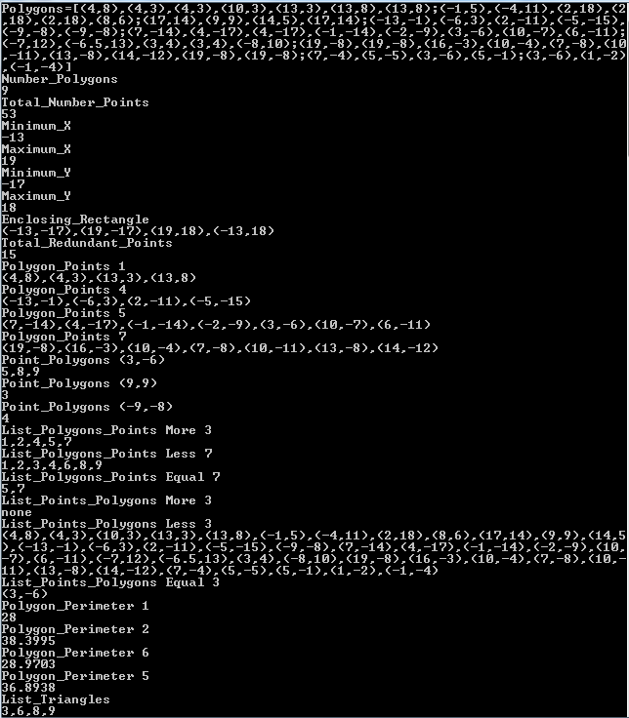

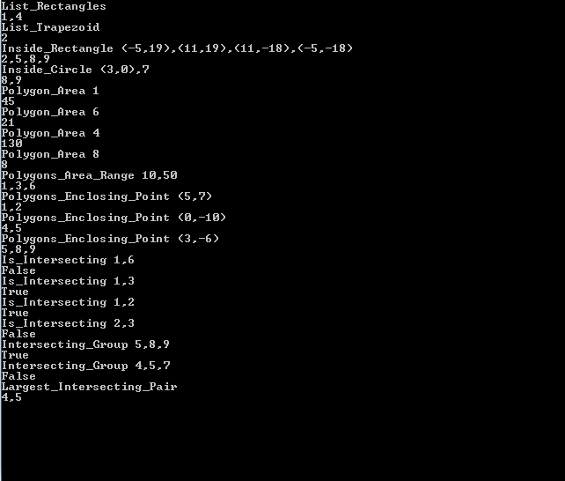

Data input 2 for test 2 :

Polygons=[(1,1),(2,2),(1,3),(0,2);(0,1),(3,3),(1,6),(-2,4);(2,3),(5,3),(4,8);(7,7),(6,8),(4,11),(3,10),(2,5),(3,3),(3,3),(5,5),(5,5),(7,7);(4,5),(7,8),(6,11),(3,8);(2,6),(5,8),(5,13),(1,11);(0,6),(2,10),(2,12),(-1,13),(-2,11),(-2,7);(-5,5),(-1,5),(-1,10),(-1,10),(-5,12);(-4,4),(-1,8),(-2,10),(-4,4);(-5,3),(-3,3),(-1,3),(-3,7),(-5,6);(-2,-1),(-4,-4),(-4,-7),(-2,-9),(-2,-4),(-2,-1);(-2,-7),(-4,-10),(-1,-12);(-1,-6),(-3,-6),(-2,-9),(1,-11),(3,-6),(0,-6),(-1,-6);(1,-9),(4,-2),(7,-5),(4,-11);(5,-5),(1,-3),(4,1),(7,2),(7,-6);(-1,1),(-2,2),(3,5),(4,4)]

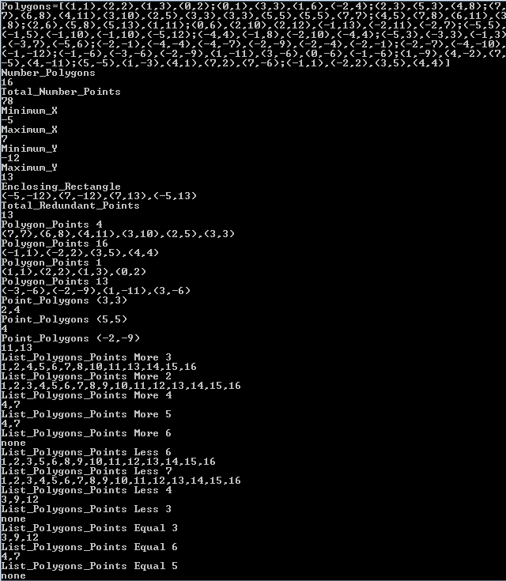

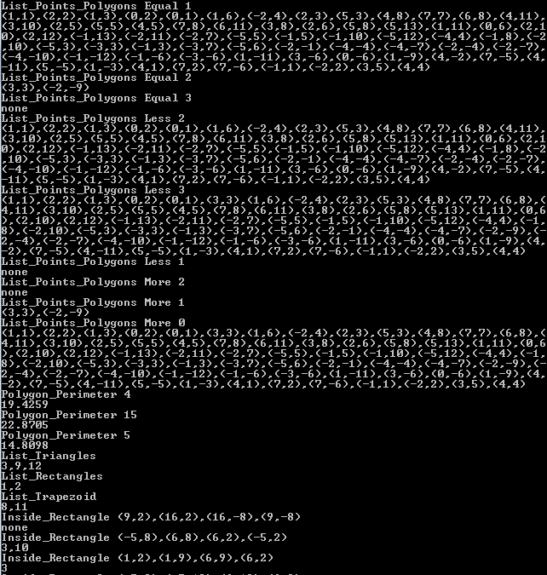

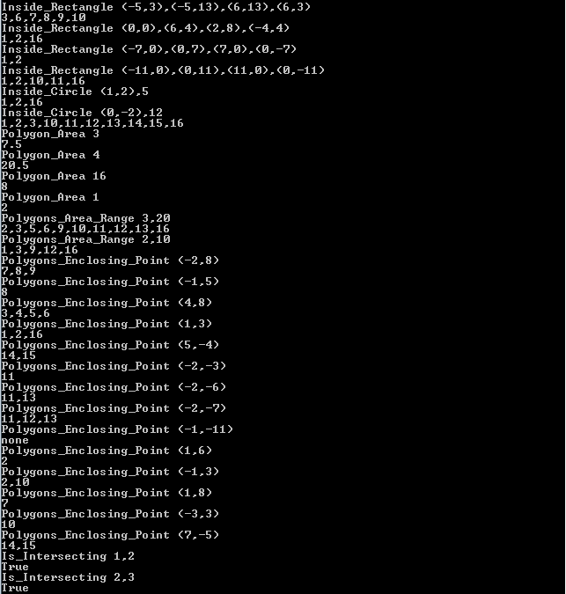

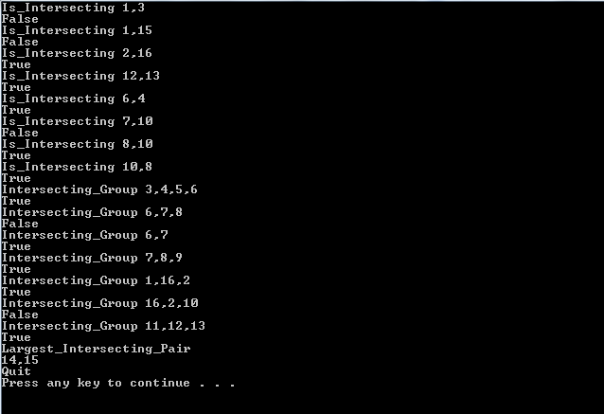

Plot of input 2

