**Cars Application**

**User documentation:**

* **How to import the program:** 
  + Open eclipse → file → import → General → Existing Projects into Workspace → Select Archive File → cars_app_eclipse.zip
* **How to start the program:** 
  + Open the CarsApp.java class then click on the run button in eclipse

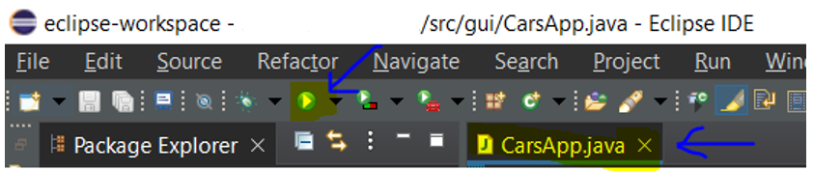

* **How to use the program:** 
  + The side bar on the left side has 3 buttons (Add a car, Import csv file and Export to CSV File)
  + To add a car object click on “Add a car” button and enter all the required information to add a car.

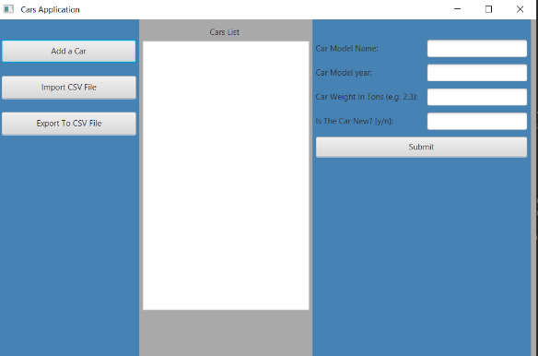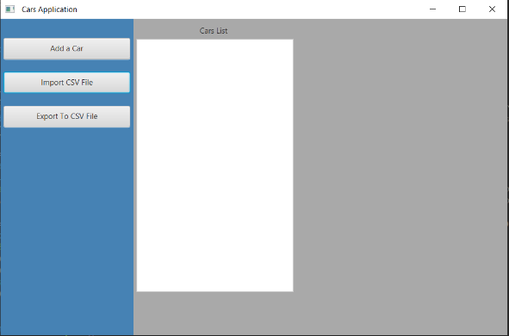

* + 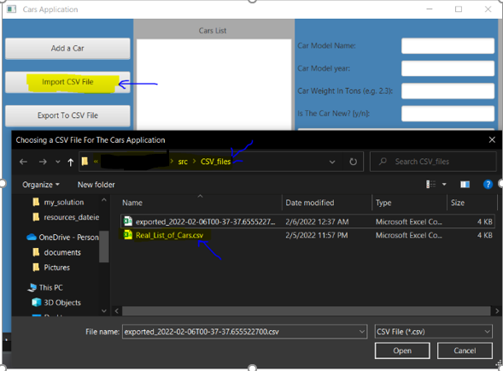 To import a csv file that has many cars objects click on “Import csv file” Button.  
    The file chooser would automatically go the following path:

……\Cars_App\src\CSV_files  
In this Directory there is a csv file named “Real_List_of_Cars.csv” ready to be imported.

* + 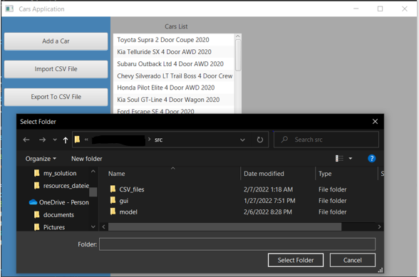 To export all the cars objects to a csv click on “Export To CSV File” Button.  
    The directory chooser would automatically go the following path:

……\ Cars_App\src   
Then select “CSV_files” directory.  
Afterwards csv file will automatically be created in the following path:

……\Cars_App\src\CSV_files

The Name of the exported csv file would be:

exported_<<current_date>>.csv

e.g. exported_2022-03-10T01-30-18.982383300.csv

**Description of the file format for saving objects:**

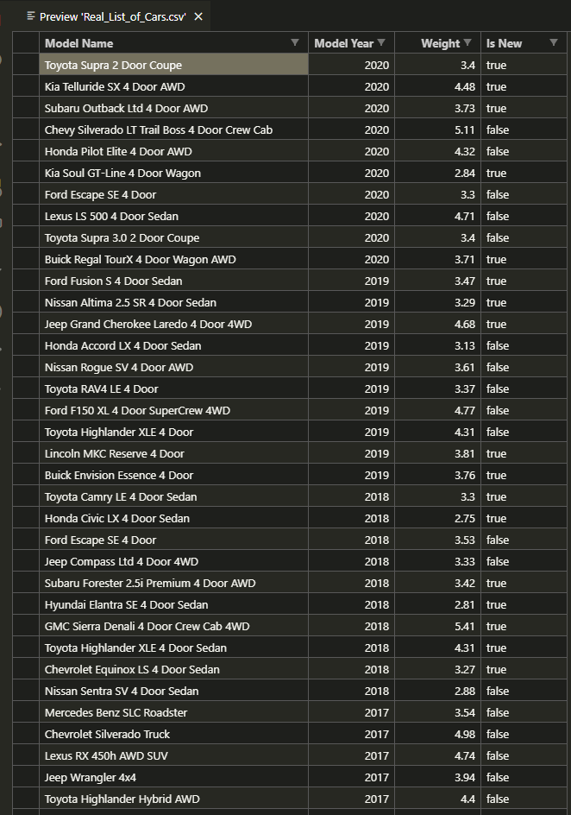The file format for saving and loading objects is *.csv file.  
The car objects can be imported and exported as a *.csv file.

CSV stand for “Comma-Separated Values”  
I opted for CSV files because they are easy to organize, are widely used with data bases, and can easily be printed using any printer.

**libraries used in this Project:**

* **javafx:** for GUI “Graphical User Interface”
* **java.io:** to be able to read and write from and to csv files
* **java.util:** to be able to use an ArrayList
* **java.time:** to be able to rename the exported csv files based on the current time.