Lab 8 – Docker and Containers
Khaled Kanawati | AUB username: ksk20
Activity 1 – Docker commands
docker ps -a
Lists all Docker containers, including running and stopped containers. The lab8-hello container appears in the output.
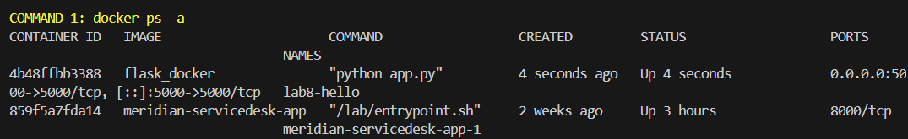
Figure 1. docker ps -a output
docker stop lab8-hello
Stops the container named lab8-hello. Docker returns its name, and the container status changes to Exited; the image is not deleted.
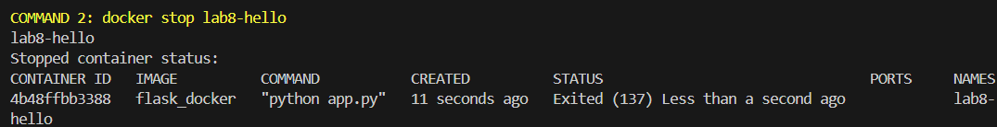
Figure 2. docker stop result
docker logs lab8-hello
Shows the standard output and error from the container, including the Flask startup messages and the HTTP request recorded by the app. Logs remain available after the container stops.
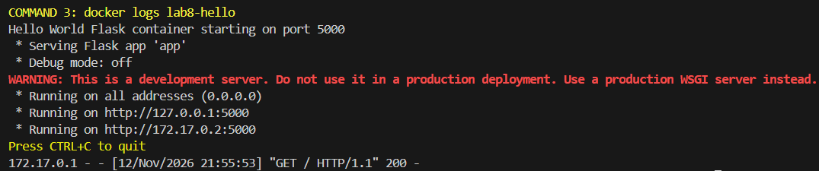
Figure 3. docker logs output

Activity 2 – Docker images and APIs
Two images were built using the Lab 5 user-management API and an additional Flask endpoint that returns the names stored in the same SQLite database.
Docker image | Port | API
ksk20/lab8-khaled_kanawati:0.0.1.RELEASE | 5000 | GET /api/users (Lab 5 API)
ksk20/lab8-khaled_kanawati:0.0.2.RELEASE | 3000 | GET /get_users (names only)
Docker Desktop images
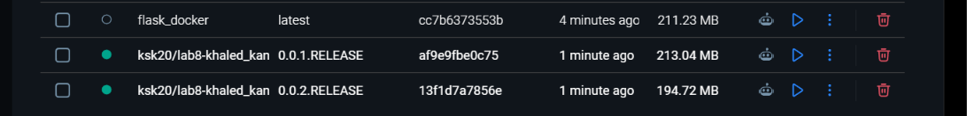
Figure 4. Docker Desktop showing both RELEASE image tags
Shared-database check
The Lab 5 API created a user, then GET /get_users returned the new name from the second container. Both running containers and their exposed ports are visible in the terminal result.
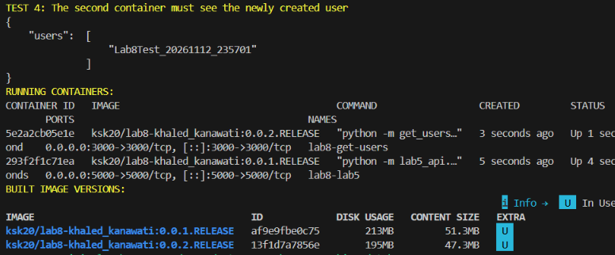
Figure 5. GET /get_users result and running container/image versions

