Al-Ahliyya Amman University
Faculty of Technical Education
BTEC Higher National Diploma in Computing — Software Engineering

Hyper Max Store
Snacks and Chips Database System
Technical and User Documentation Manual

Prepared by:
Khaled
Student ID: 202514084
Unit 4: Database Design & Development
Unit Tutor: Dr. Mutaz Makhatreh
Academic Year 2025 – 2026

Table of Contents
1. System Overview 1
2. System Requirements 1
3. Database Structure 1
4. Tables and Columns 1
4.1 Category 1
4.2 Supplier 1
4.3 Product 1
4.4 Customer 1
4.5 Basket 1
4.6 BasketItem 1
5. Relationships 1
6. Security 1
7. Maintenance Procedures 1
8. Troubleshooting 1
9. Getting Started 1
10. Logging In 1
11. Adding a New Product 1
12. Updating a Product 1
13. Deleting a Product 1
14. Viewing Reports 1
15. Closing the Application 1
16. Data Flow Diagram (DFD) 1
Process flow: 1
17. System Flowcharts 1
17.1 Login Process Flowchart 1
17.2 Add Product Flowchart 1
17.3 Record Sale Flowchart 1

PART A
Technical Documentation
This section is intended for developers, IT staff, and system administrators. It explains the internal structure of the system, the database design, security setup, and maintenance procedures.

1. System Overview
The Hyper Max Store Snacks and Chips Module is a relational database system that manages products, suppliers, categories, customers, and sales transactions. The system was built using Microsoft SQL Server for the back-end database and Microsoft Visual Studio Windows Forms (C#) for the front-end interface. It replaces the manual spreadsheet method used before, making daily store work faster and more reliable.
Purpose: Store and manage product, customer, and sales data for the Snacks and Chips department.
Target users: Store Managers (full access) and Cashiers (limited access).
Key features:
• 6 normalized tables connected by primary and foreign keys
• Full CRUD operations through Windows Forms application
• SQL queries with JOIN for reports
• User role-based security
• Data validation through constraints

2. System Requirements
The system requires the following minimum environment to run properly:
Item | Requirement
Operating System | Windows 10 or 11
Database | Microsoft SQL Server 2019 or higher
Tools | SQL Server Management Studio, Visual Studio 2022
Framework | .NET Framework 4.7.2 or higher
RAM | 4 GB minimum
Disk Space | 500 MB free
Screen | 1280×720 or higher

3. Database Structure
The database is named HyperMax_Snacks_And_Chips_Module and contains 6 tables connected through primary and foreign keys.
Table | Purpose
Category | Stores product categories
Supplier | Stores supplier names
Product | Stores product details (FK to Category and Supplier)
Customer | Stores customer info with contact details
Basket | Stores sale transactions
BasketItem | Stores items in each basket (junction table)

Figure (1), ERD Diagram:
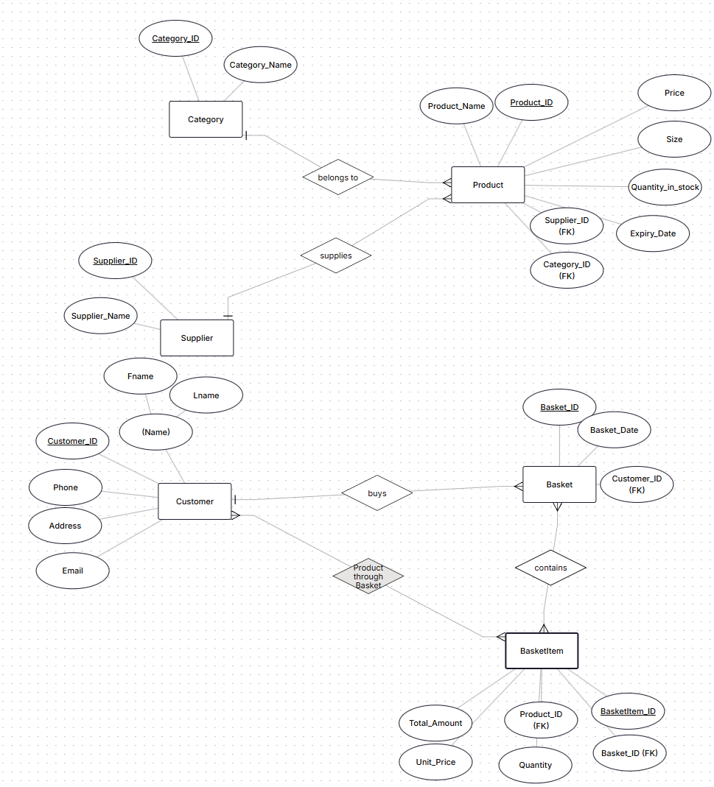
Figure: Entity
[ Insert Schema
Figure:
Database Schema Diagram
Figure (2) Schema Diagram:
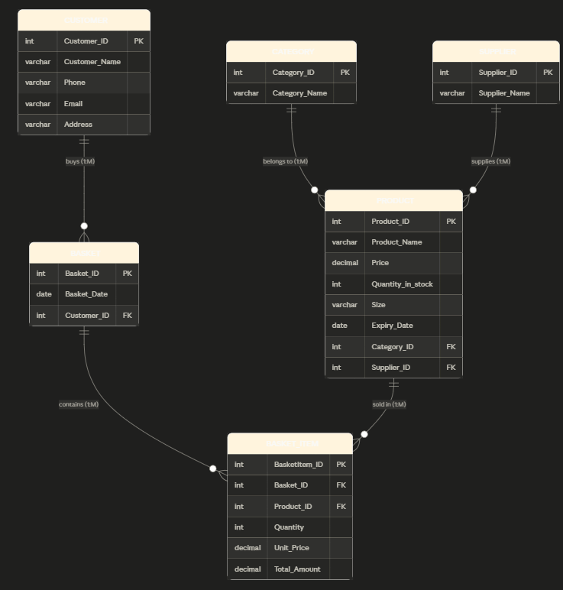

4. Tables and Columns

4.1 Category
Column | Type | Constraint
Category_ID | INT | PRIMARY KEY, IDENTITY
Category_Name | VARCHAR(50) | NOT NULL

4.2 Supplier
Column | Type | Constraint
Supplier_ID | INT | PRIMARY KEY, IDENTITY
Supplier_Name | VARCHAR(100) | NOT NULL

4.3 Product
Column | Type | Constraint
Product_ID | INT | PRIMARY KEY, IDENTITY
Product_Name | VARCHAR(100) | NOT NULL
Price | DECIMAL(10,2) | CHECK > 0
Quantity_in_stock | INT | CHECK >= 0
Size | VARCHAR(30)
Expiry_Date | DATE
Category_ID | INT | FOREIGN KEY
Supplier_ID | INT | FOREIGN KEY

4.4 Customer
Column | Type | Constraint
Customer_ID | INT | PRIMARY KEY, IDENTITY
Customer_Name | VARCHAR(100) | NOT NULL
Phone | VARCHAR(20)
Email | VARCHAR(100)
Address | VARCHAR(200)

4.5 Basket
Column | Type | Constraint
Basket_ID | INT | PRIMARY KEY, IDENTITY
Basket_Date | DATE | NOT NULL
Customer_ID | INT | FOREIGN KEY

4.6 BasketItem
Column | Type | Constraint
BasketItem_ID | INT | PRIMARY KEY, IDENTITY
Basket_ID | INT | FOREIGN KEY
Product_ID | INT | FOREIGN KEY
Quantity | INT | CHECK > 0
Unit_Price | DECIMAL(10,2)
Total_Amount | DECIMAL(10,2)

5. Relationships
The database tables are linked through the following relationships:
Relationship | Type
Category → Product | One-to-Many (1:M)
Supplier → Product | One-to-Many (1:M)
Customer → Basket | One-to-Many (1:M)
Basket → BasketItem | One-to-Many (1:M)
Product → BasketItem | One-to-Many (1:M)
Customer ↔ Product (through Basket and BasketItem) | Many-to-Many (M:N)

6. Security
User roles and permissions are defined as follows:
Role | Username | Password | Access Level
Store Manager | StoreManager | HyperMax2026! | Full CRUD on all tables
Cashier | Cashier | Cashier2026! | Read products/customers, Insert baskets only

GRANT and REVOKE commands control the permissions on each user role.
Figure (3) Grant and revoke from Microsoft SQL server code:
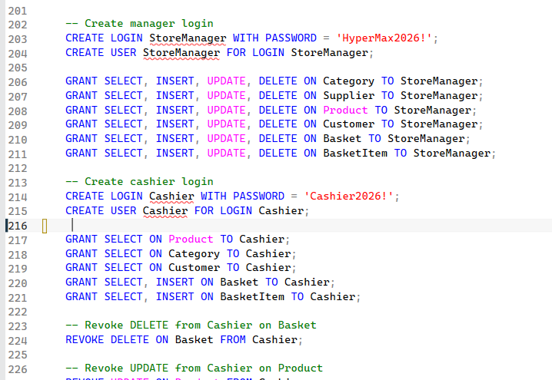

7. Maintenance Procedures
To keep the database running properly we need regular maintenance:
Procedure | Frequency | Purpose
Backup database | Daily | Protect data from loss
Check data integrity | Weekly | Verify FK and constraints
Update statistics | Weekly | Keep queries fast
Review user permissions | Monthly | Maintain security

Backup command:
BACKUP DATABASE HyperMax_Snacks_And_Chips_Module TO DISK = 'C:\Backup\HyperMax.bak';

8. Troubleshooting
Common problems and their solutions:
Problem | Solution
Cannot connect to database | Check SQL Server service is running
Application crashes on Save | Make sure all required fields are filled
Login fails | Verify username and password are correct
Foreign key error | Make sure related records exist first
Database does not exist error | Verify database name is correct

PART B
User Documentation
This section is intended for the store staff (managers and cashiers). It explains step by step how to use the application to manage products, customers, and sales.

9. Getting Started
Follow these simple steps to start using the application:
Step 1: Find the Hyper Max application icon on the desktop.
Step 2: Double-click the icon to open the application.
Step 3: The Login screen will appear.

10. Logging In
To log in to the system:
1. Type your username in the Username field
2. Type your password in the Password field
3. Click the Login button
Figure (1) Login Screen:
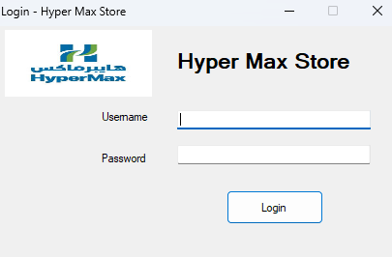
Figure (4) Successful login as Store Manager
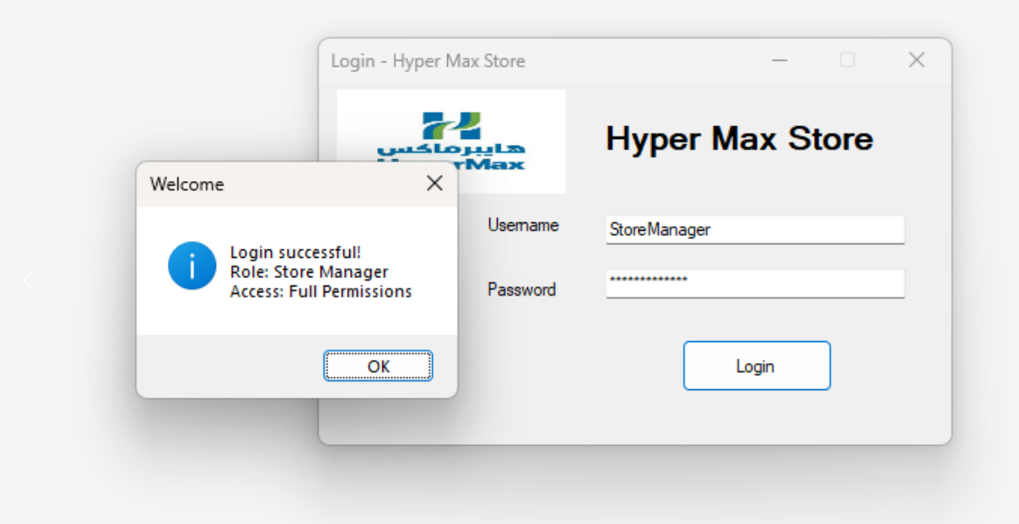
If your details are correct you will see the main screen. If not, you will see an error message.
Figure (5) Error message for wrong password
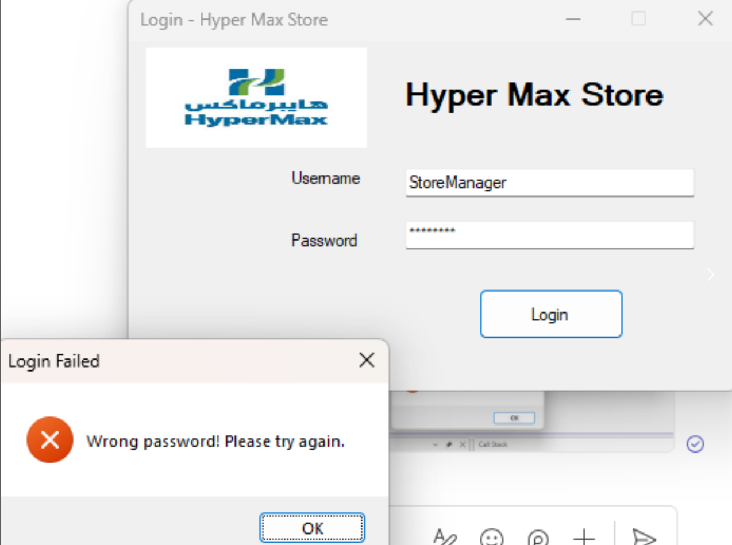

11. Adding a New Product
To add a new product to the database, follow these steps:
Step 1: Type the product name (example: Lays Classic)
Step 2: Type the price in JD (example: 0.75)
Step 3: Type the quantity in stock (example: 120)
Step 4: Type the size (example: 150g)
Step 5: Choose the expiry date from the date picker
Step 6: Select the category from the dropdown
Step 7: Select the supplier from the dropdown
Step 8: Click the Save button

Figure:(2) Filled product form before clicking Save
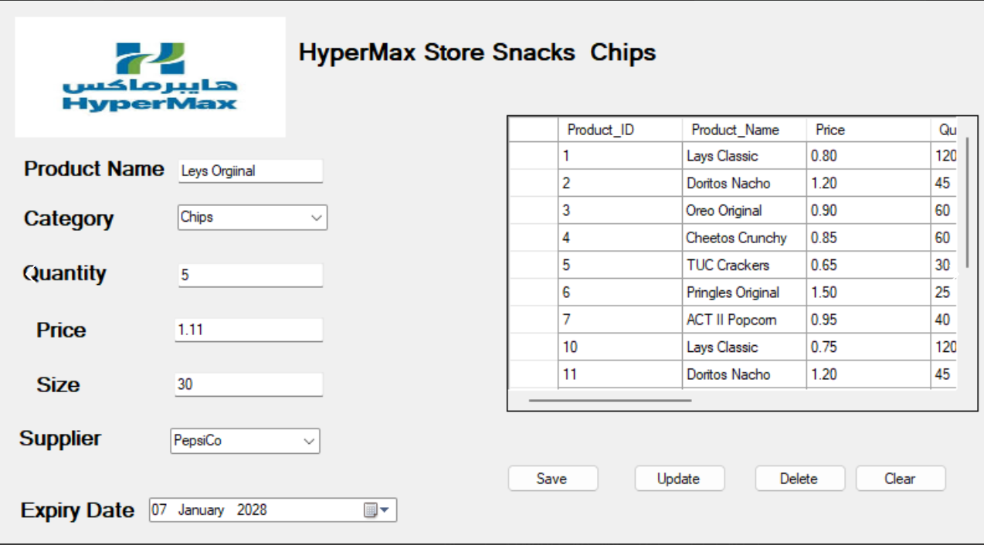
Figure (3): Success message after saving the product
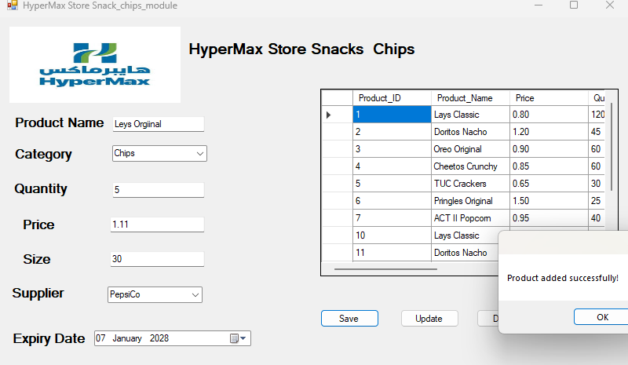

12. Updating a Product
To update an existing product:
Step 1: Click on the product row in the grid (the fields fill automatically)
Step 2: Change any field that needs updating
Step 3: Click the Update button
Figure (4): Updating a product
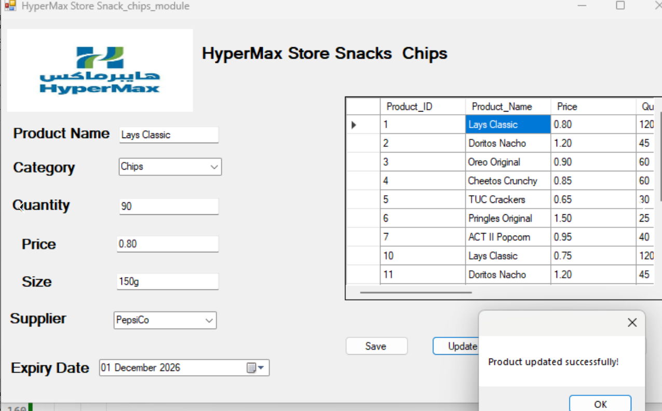

13. Deleting a Product
To remove a product from the database:
Step 1: Click on the product row you want to delete
Step 2: Click the Delete button
Warning: Deleted products cannot be recovered easily. Always double-check before deleting.
Figure (5): Deleting a product
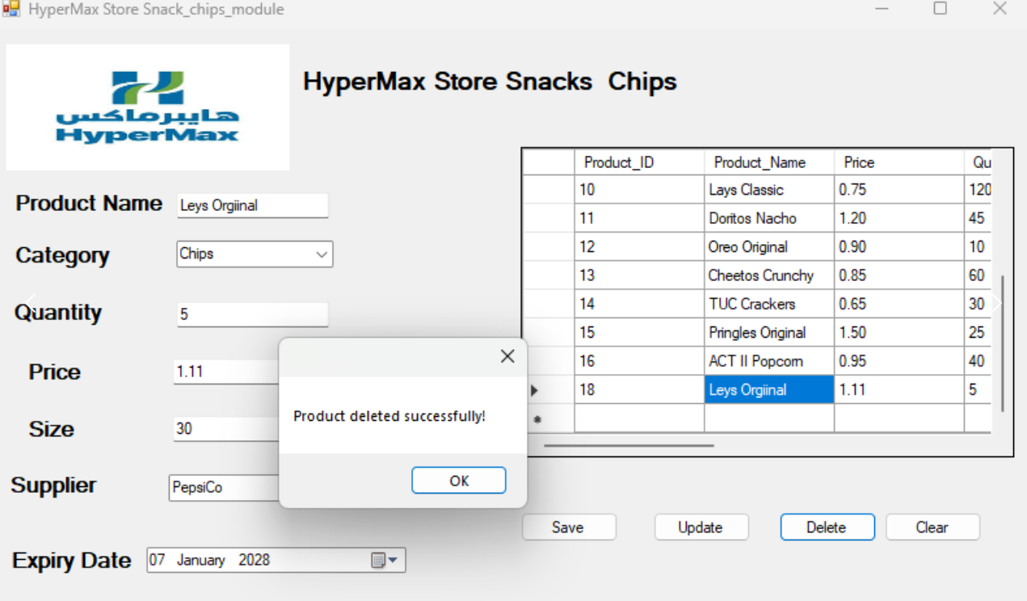

14. Viewing Reports
The DataGridView at the bottom always shows all products with category and supplier names. Other reports are generated using SQL queries:
• All products with categories and suppliers
• Low stock products (quantity below 20)
• Full sales report with customer details
• Total spending per customer
Figure (6): Product list shown in DataGridView
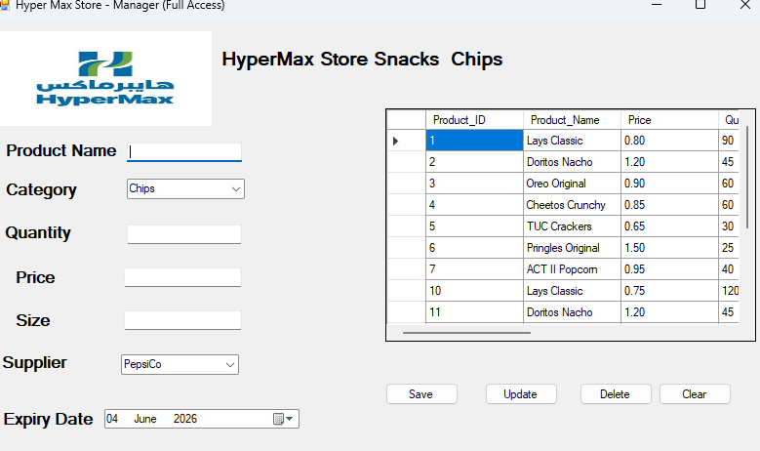

15. Closing the Application
Close the application by clicking the X at the top-right corner. Your data stays safe in SQL Server.

PART C
System Diagrams
This section shows the data flow diagram (DFD) and flowcharts that illustrate how the system operates and how data moves through key processes.

16. Data Flow Diagram (DFD)
The DFD shows how data moves through the Hyper Max system.
Figure: Data Flow Diagram of the Hyper Max system
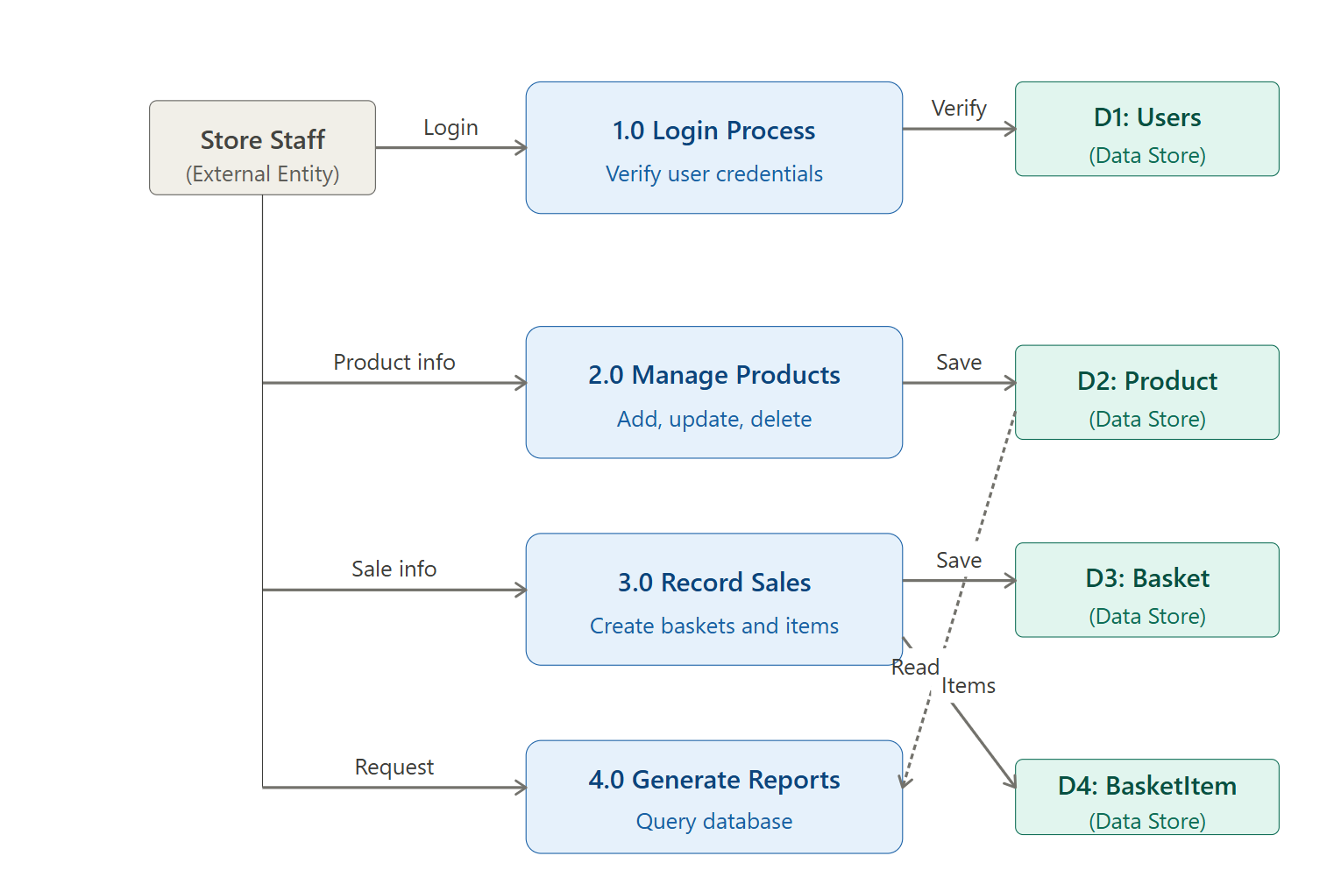

Process flow:
1. Staff enters product details through the application form
2. The application sends the data to SQL Server using the connection string
3. SQL Server validates the data with constraints (NOT NULL, CHECK, FOREIGN KEY)
4. Valid data is stored in the database tables
5. When reports are requested, the application sends a SELECT query
6. SQL Server returns the matching data
7. The application displays results in the DataGridView

17. System Flowcharts
The flowcharts show the step-by-step processes for the main operations of the system.

17.1 Login Process Flowchart
Figure: Flowchart of the Login Process
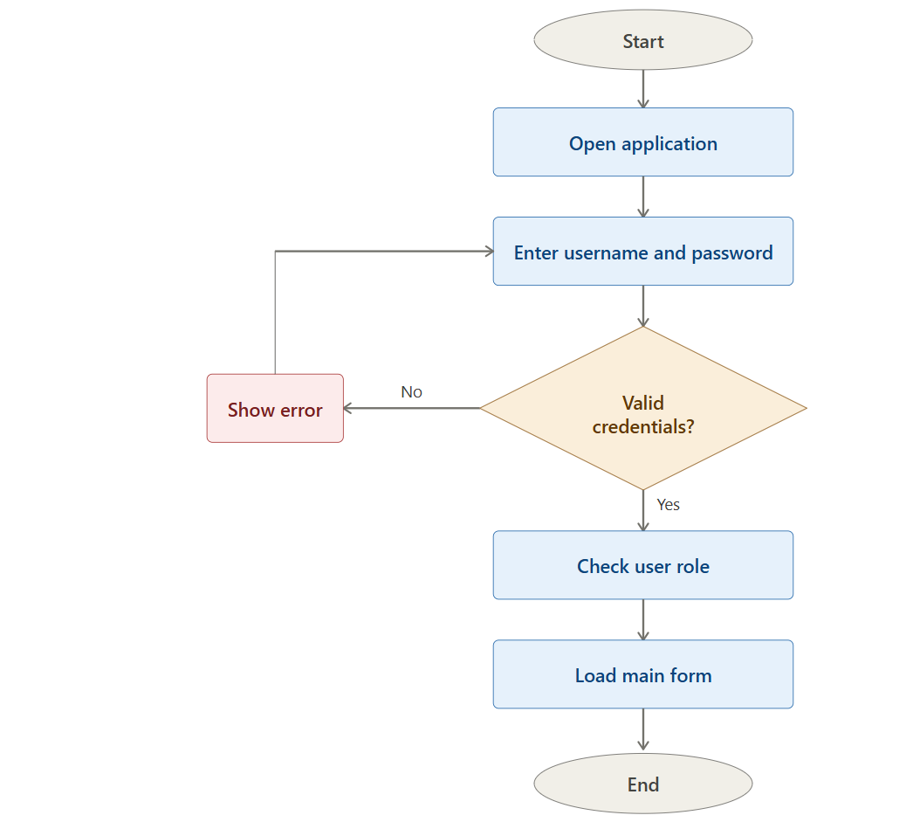

17.2 Add Product Flowchart
Figure: Flowchart of Adding a New Product
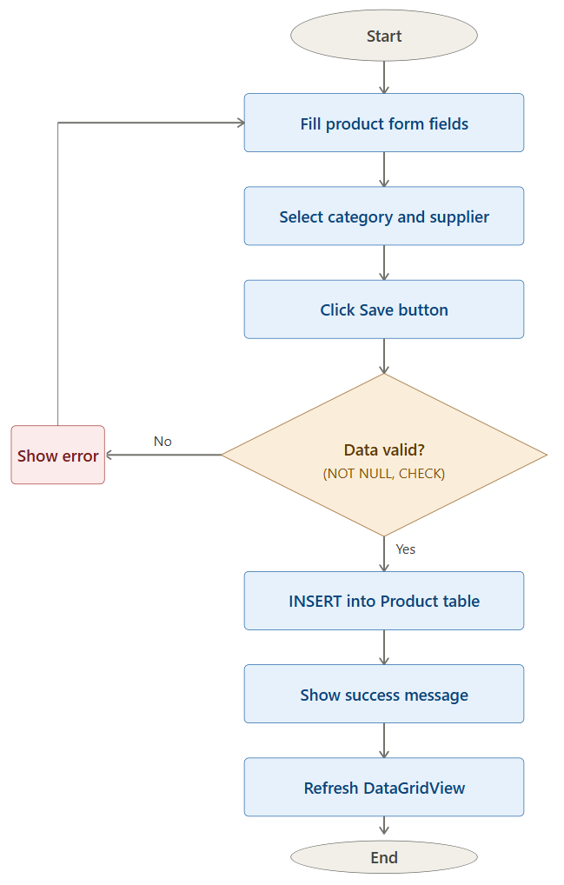

17.3 Record Sale Flowchart
Figure: Flowchart of Recording a Sale
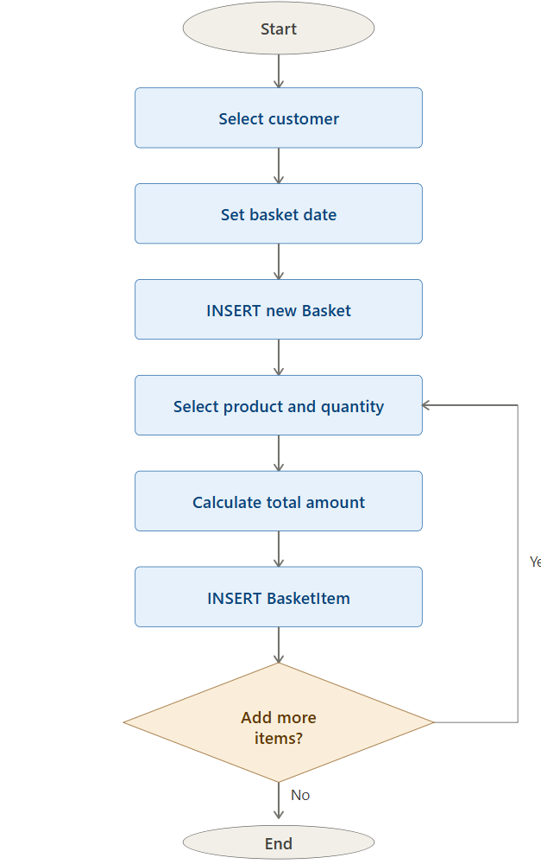

End of Manual
Hyper Max Store — Snacks and Chips Database System
Prepared by Khaled
Al-Ahliyya Amman University, 2026

