**(Insert Name Here) LOGO**

•**HOME PAGE** – Displays the Home page with a banner and some Categories.



SHOP BY CATEGORY

BANNER

RINGS

NECKLACES

WATCHES

SIGN IN/REGISTER

SEARCH

LOGO

•**PRODUCT GRID PAGE** – Display all the products and allow the user to filter products.



PRODUCTS

SIGN IN/REGISTER

SEARCH

LOGO

•**PRODUCT PAGE** – Displays the product in detail with options to add it to the basket or like it.



DIFFERENT ANGLES



SIGN IN/REGISTER

WATCH – BERNARDO LECADO

£149

COLOUR: BLACK



• Comes In A Box  
• 2 Year Warranty.

SHIPPING/RETURNS

SIMILAR WATCHES DISPLAYED ACROSS

ADD TO BASKET

CATEGORIES LISTED ALL THE WAY ACROSS

SEARCH

LOGO

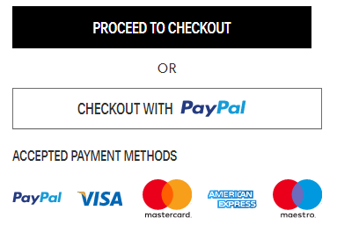•**BASKET PAGE** - showing items that have been added to the customer's basket

£145.00

£350.00

RING – BLACK DIAMOND

COLOUR: GOLD

SIZE: ONE SIZE

QUANTITY:1

RING – DIAMOND CRYSTAL

COLOUR: SILVER

SIZE: ONE SIZE

QUANTITY:1

OVERVIEW

Subtotal: £298.00

Standard delivery: FREE

Got a promotion code?

TOTAL: £298.00

SIGN IN/REGISTER

CATEGORIES LISTED ALL THE WAY ACROSS

SEARCH

LOGO

•**LOGIN / REGISTER PAGE** – Sign in page with an option to go to the homepage or to register.



LOGO

SIGN IN

EMAIL:

ENTER USER EMAIL

PASSWORD:

ENTER USER PASSWORD

FORGOT PASSWORD

SIGN IN

REGISTER

•**CUSTOMER REGISTRATION PAGE** – Registration page with the option to go to the Home page.

USERNAME:

ENTER CUSTOM USERNAME



**NB**: ALL CUSTOMER DETAILS TO BE COLLECTED UPON FIRST ORDER

REGISTER

ENTER USER EMAIL

CONFIRM USER PASSWORD

ENTER USER PASSWORD

PASSWORD:

EMAIL:

LOGO

NEW CUSTOMER

•**CHECKOUT** – Allows the user to enter the details for the order to be placed including the name and address and gives the user a summary of their order along with the total.

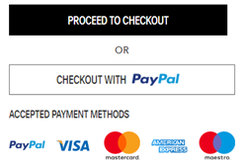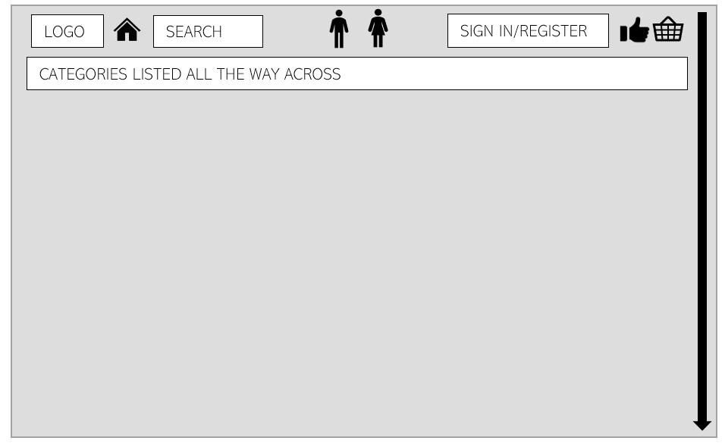

NAME:

SURNAME:

ADDRESS:

PHONE NUMBER:

CITY:

OVERVIEW

Subtotal: £298.00

Standard delivery: FREE

Got a promotion code?

TOTAL: £298.00

LIST OF ITEMS ACROSS

CONTACT US

**•CONFIRMATION PAGE** - shows your order number etc. when you have submitted your order.

ORDER NUMBER: 767GD43G

YOUR SHIPMENT IS ON THE WAY

**BILLING**

FULL NAME:

ADDRESS:

CITY:

POSTCODE:

COUNTRY:

**DELIVERY METHOD:**

24 HOUR DELIVERY

CONFIRMATION EMAIL SENT

**SHIPPING**

FULL NAME:

ADDRESS:

CITY:

POSTCODE:

COUNTRY:

**PAYMENT METHOD:**

VISA **** ***** *****

**FONTS, FONT STYLES AND WEIGHTS, IMAGES & COLOUR CODES**

The website has 2 sections, one for the Gents and one for the Ladies. The Gentlemen’s page of the website will have a **Dark wooden** or **brownish** theme, a colour associated with gentlemen a lot along with wood to give it an old school theme, collaborated with **White**. This colour scheme will be on the grey parts (on the design).

The fonts will be a combination of Abadi Extra light and Univers Condensed light, timeless and professional fonts which will be clear enough and give a manly feel to the design of the website. There will be very little use of bold text to give off a clean design. The bold will only be used to highlight the important information on pages just to make the interface clear and easy to understand. The colours of fonts will be **Grey** and **Black** throughout the pages on the Gents sections.

When it comes to the Ladies page, the theme will be light and Coral to make it fit for the Ladies and the font will be Vijaya which is a vogue type of font which will blend with the **Coral** theme collaborated with white. This is a theme that can be associated with a lot of ladies' magazines this being because Coral blended with the right colours, in this case, white, is an appealing look to the ladies, therefore, it will be suitable for attracting a female audience.

The Vijaya will be used along the Univers light font to create a soft and clean theme. the Vijaya will be used for the description and display of products to give a vibrant and exciting look whereas the Univers Light will be used for the login pages, entry of information, checkout and order details and for important details on pages it will be in **bold**. The colours for the fonts on the ladies’ section will be **Teal** and **White** to blend in with the coral background making sure that the text is clear and clean.

Images of ladies’ watches will be displayed along with slideshows of models wearing the watches with suiting outfits to catch the eye.

The images on the first page will be that of the most popular watches in the store and those the store votes to be their best, so they attract more customers. The animation will be smooth and clean transitions to make the website more enjoyable along with some slideshows of some of the watches they have to offer.