Site pokemon _ Route

- Créer un composant DetailPockemonComponent

ng g c DetailPokemon --skipTests=true

- Créer un composant ListPockemonComponent

ng g c ListPokemon --skipTests=true

- Créer un composant PageNotFoundComponent

ng g c PageNotFound --skipTests=true --inlineStyle=true --inlineTemplate=true

- Configurer le routeur

Copier le contenu de app.component.html dans list-pokemon.component.html du répertoire list-pokemon

list-pokemon.component.html

<h1 class='center'>Pokémons</h1>
<div class='container'>
<div class="row">
<div *ngFor='let pokemon of pokemons' class="col s6 m4">
<div class="card horizontal" (click)="selectPokemon(pokemon)" pkmnBorderCard>
<div class="card-image">
<img [src]="pokemon.picture">
</div>
<div class="card-stacked">
<div class="card-content">
<p>{{ pokemon.name }}</p>
<p><small>{{ pokemon.created | date:'dd/MM/yyyy' }}</small></p>
<!-- on utilise la directive ngFor pour afficher tous les types
d'un pokémon donnée -->
<span *ngFor='let type of pokemon.types' class="{{ type | pokemonTypeColor }}">{{ type }}</span>
</div>
</div>
</div>
</div>
</div>
</div>

Changer le contenu du fichier app.component.html du répertoire app

app.component.html

<nav>
<div class="nav-wrapper teal">
<a href="#" class="brand-logo center">pokemon-app</a>
</div>
</nav>

<router-outlet></router-outlet>

Editer le fichier detail-pokemon.component.ts du répertoire detail-pokemon

import { Component, OnInit } from '@angular/core';
import { ActivatedRoute, Router, Params } from '@angular/router';

import { POKEMONS } from '../model/mock-pokemons';
import { Pokemon } from '../model/pokemon';

@Component({
selector: 'detail-pokemon',
templateUrl: './detail-pokemon.component.html'
})
export class DetailPokemonComponent implements OnInit {

pokemons: Pokemon[] = null;
pokemon: Pokemon = null;

constructor(private route: ActivatedRoute, private router: Router) {}

ngOnInit(): void {
this.pokemons = POKEMONS;

let id = +this.route.snapshot.paramMap.get('id');
for (let i = 0; i < this.pokemons.length; i++) {
if (this.pokemons[i].id == id) {
this.pokemon = this.pokemons[i];
}
}
}

goBack(): void {
this.router.navigate(['/pokemons']);
}
}

Editer le fichier detail-pokemon.component.html du répertoire detail-pokemon

<div *ngIf="pokemon" class="row">
<div class="col s12 m8 offset-m2">
<h2 class="header center">{{ pokemon.name }}</h2>
<div class="card horizontal hoverable">
<div class="card-image">
<img [src]="pokemon.picture">
</div>
<div class="card-stacked">
<div class="card-content">
<table class="bordered striped">
<tbody>
<tr>
<td>Nom</td>
<td><strong>{{ pokemon.name }}</strong></td>
</tr>
<tr>
<td>Points de vie</td>
<td><strong>{{ pokemon.hp }}</strong></td>
</tr>
<tr>
<td>Dégâts</td>
<td><strong>{{ pokemon.cp }}</strong></td>
</tr>
<tr>
<td>Types</td>
<td>
<span *ngFor="let type of pokemon.types" class="{{ type | pokemonTypeColor }}">{{ type }}</span>
</td>
</tr>
<tr>
<td>Date de création</td>
<td><em>{{ pokemon.created | date:"dd/MM/yyyy" }}</em></td>
</tr>
</tbody>
</table>
</div>
<div class="card-action">
<a (click)="goBack()">Retour</a>
</div>
</div>
</div>
</div>
</div>
<h4 *ngIf='!pokemon' class="center">Aucun pokémon à afficher !</h4>

Editer le fichier list-pokemon.component.ts du répertoire list-pokemon

list-pokemon.component.ts

import { Component, OnInit } from '@angular/core';

import { POKEMONS } from '../model/mock-pokemons';
import { Router } from '@angular/router';
import { Pokemon } from '../model/pokemon';

@Component({
selector: 'list-pokemon',
templateUrl: './list-pokemon.component.html'
})
export class ListPokemonComponent implements OnInit {

pokemons: Pokemon[] = null;

constructor(private router: Router) { }

ngOnInit(): void {
this.pokemons = POKEMONS;
}

selectPokemon(pokemon: Pokemon): void {
console.log('Vous avez selectionné ' + pokemon.name);
let link = ['/pokemon', pokemon.id];
this.router.navigate(link);
}
}

Editer le fichier page-not-found.component.ts du répertoire app

page-not-found.component.ts

import { Component } from '@angular/core';

@Component({
selector: 'page-404',
template: `
<div class='center'>
<img src="http://assets.pokemon.com/assets/cms2/img/pokedex/full/035.png"/>
<h1>Hey, cette page n'existe pas !</h1>
<a routerLink="/pokemons" class="waves-effect waves-teal btn-flat">
Retourner à l' accueil
</a>
</div>
`
})
export class PageNotFoundComponent { }

Créer un fichier app-routing.module.ts dans app

app-routing.module.ts

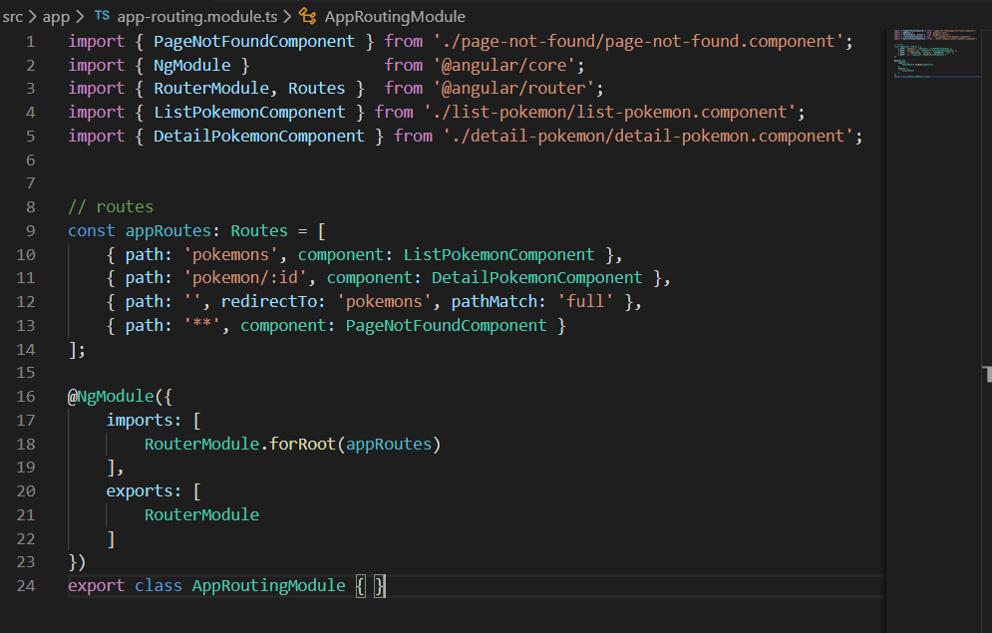

Editer le fichier app.module.ts du répertoire app

...
import { AppRoutingModule } from './app-routing.module';

@NgModule({
declarations: [
...
],
imports: [
BrowserModule,
AppRoutingModule
],
providers: [],
bootstrap: [AppComponent]
})
export class AppModule { }

Test

