Site pokemon _ Composant

- Créer un projet pokemon en ligne de commande

ng new pokemon

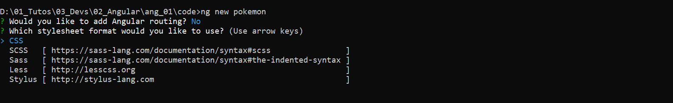

Ouvrir un terminal dans le dossier pokemon

Test

ng serve

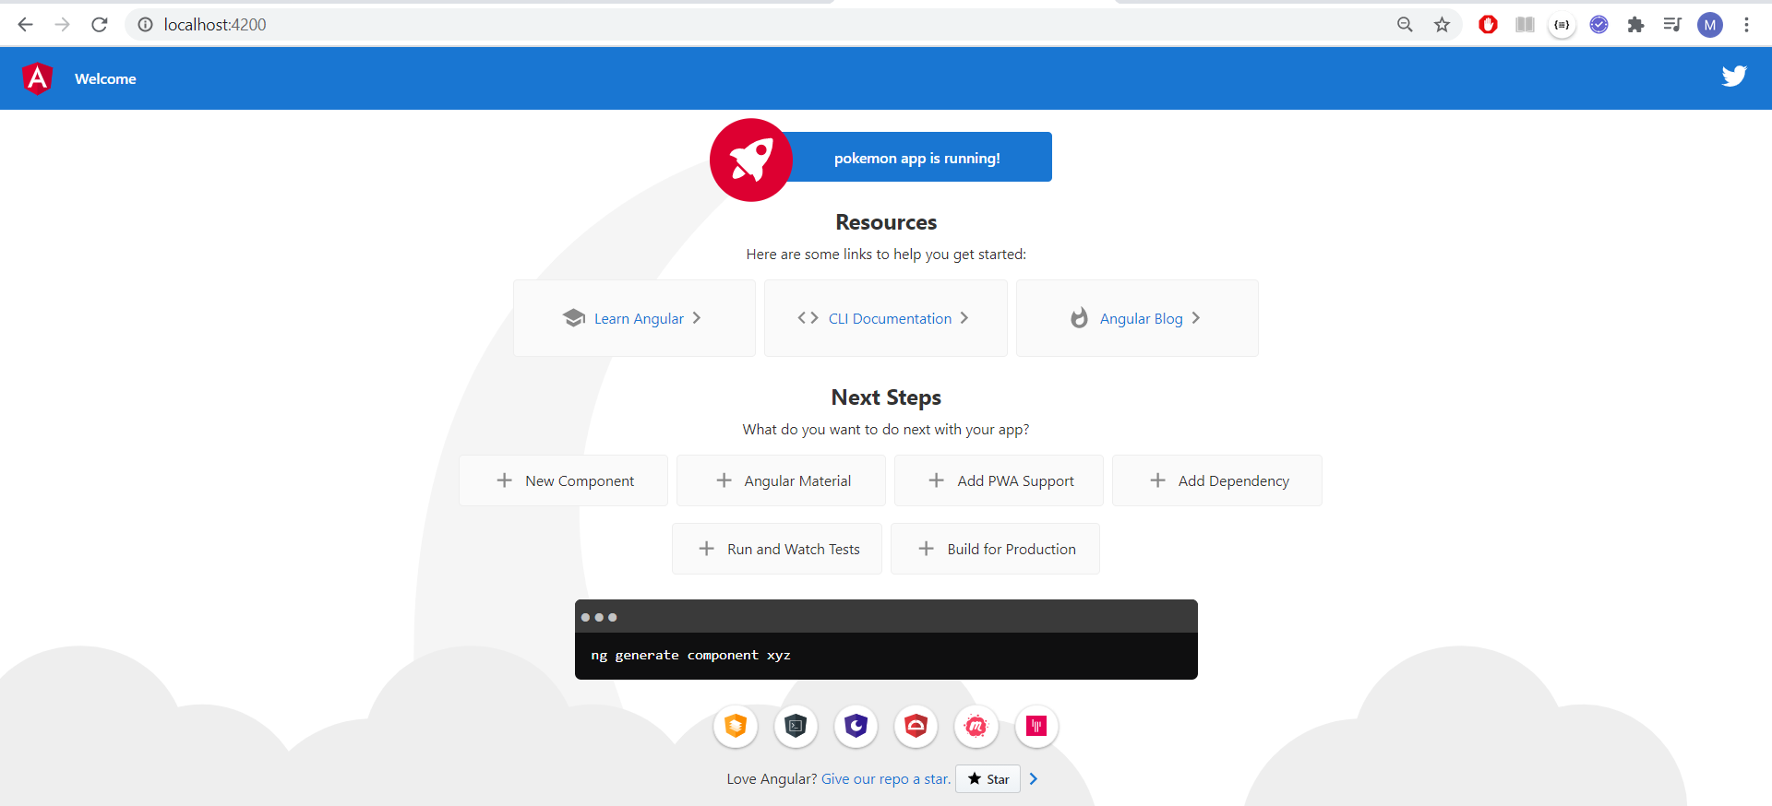

- Modèle

Dans app, créer un dossier model

Créer un fichier pokemon.ts dans model

pokemon.ts

export class Pokemon {
id: number;
hp: number;
cp: number;
name: string;
picture: string;
types: Array<string>;
created: Date;
}

Créer un fichier mock-pokemons.ts dans model

mock-pokemons.ts

import { Pokemon } from './pokemon';

export const POKEMONS: Pokemon[] = [
{
id: 1,
name: "Bulbizarre",
hp: 25,
cp: 5,
picture: "https://assets.pokemon.com/assets/cms2/img/pokedex/detail/001.png",
types: ["Plante", "Poison"],
created: new Date()
},
{
id: 2,
name: "Salamèche",
hp: 28,
cp: 6,
picture: "https://assets.pokemon.com/assets/cms2/img/pokedex/detail/004.png",
types: ["Feu"],
created: new Date()
},
{
id: 3,
name: "Carapuce",
hp: 21,
cp: 4,
picture: "https://assets.pokemon.com/assets/cms2/img/pokedex/detail/007.png",
types: ["Eau"],
created: new Date()
},
{
id: 4,
name: "Aspicot",
hp: 16,
cp: 2,
picture: "https://assets.pokemon.com/assets/cms2/img/pokedex/detail/013.png",
types: ["Insecte", "Poison"],
created: new Date()
},
{
id: 5,
name: "Roucool",
hp: 30,
cp: 7,
picture: "https://assets.pokemon.com/assets/cms2/img/pokedex/detail/016.png",
types: ["Normal", "Vol"],
created: new Date()
},
{
id: 6,
name: "Rattata",
hp: 18,
cp: 6,
picture: "https://assets.pokemon.com/assets/cms2/img/pokedex/detail/019.png",
types: ["Normal"],
created: new Date()
},
{
id: 7,
name: "Piafabec",
hp: 14,
cp: 5,
picture: "https://assets.pokemon.com/assets/cms2/img/pokedex/detail/021.png",
types: ["Normal", "Vol"],
created: new Date()
},
{
id: 8,
name: "Abo",
hp: 16,
cp: 4,
picture: "https://assets.pokemon.com/assets/cms2/img/pokedex/detail/023.png",
types: ["Poison"],
created: new Date()
},
{
id: 9,
name: "Pikachu",
hp: 21,
cp: 7,
picture: "https://assets.pokemon.com/assets/cms2/img/pokedex/detail/025.png",
types: ["Electrik"],
created: new Date()
},
{
id: 10,
name: "Sabelette",
hp: 19,
cp: 3,
picture: "https://assets.pokemon.com/assets/cms2/img/pokedex/detail/027.png",
types: ["Normal"],
created: new Date()
},
{
id: 11,
name: "Mélofée",
hp: 25,
cp: 5,
picture: "https://assets.pokemon.com/assets/cms2/img/pokedex/detail/035.png",
types: ["Fée"],
created: new Date()
},
{
id: 12,
name: "Groupix",
hp: 17,
cp: 8,
picture: "https://assets.pokemon.com/assets/cms2/img/pokedex/detail/037.png",
types: ["Feu"],
created: new Date()
}
];

Editer le fichier app.component.ts du répertoire app

app.component.ts

import { Component, OnInit } from '@angular/core';
import { Pokemon } from './model/pokemon';
import { POKEMONS } from './model/mock-pokemons';

@Component({
selector: 'app-root',
templateUrl: './app.component.html',
styleUrls: ['./app.component.css']
})
export class AppComponent implements OnInit{

ngOnInit(): void {
this.pokemons = POKEMONS;
}

title = 'pokemon';

pokemons: Pokemon[] = null;

selectPokemon(pokemon: Pokemon) {
console.log('Vous avez selectionné ' + pokemon.name);
}

}

Editer le fichier app.component.html du répertoire app

<h1 class='center'>Pokémons</h1>
<div class='container'>
<div class="row">
<div *ngFor='let pokemon of pokemons' class="col s6 m4">
<div class="card horizontal" (click)="selectPokemon(pokemon)">
<div class="card-image">
<img [src]="pokemon.picture">
</div>
<div class="card-stacked">
<div class="card-content">
<p>{{ pokemon.name }}</p>
<p><small>{{ pokemon.created }}</small></p>
</div>
</div>
</div>
</div>
</div>
</div>

Test

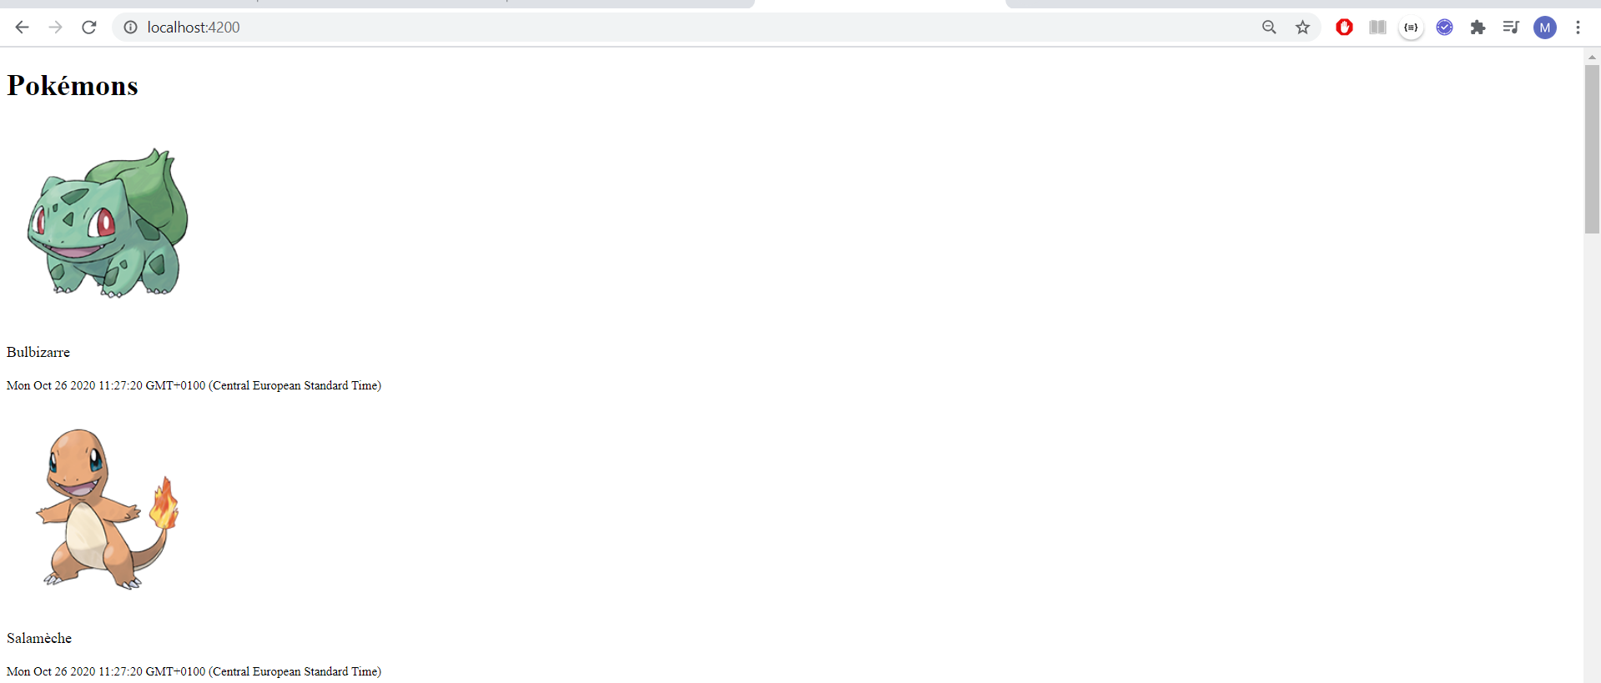

Installer MaterialiseCSS

Faire
npm install materialize-css –save

Ajoutez ce qui suit à angular.json

"styles": [
"src/styles.css",
"node_modules/materialize-css/dist/css/materialize.css"
],
"scripts": [
"node_modules/materialize-css/dist/js/materialize.js"
]

Test

