Site pokemon _ Directive

Créer un fichier border-card.directive.ts dans app

border-card.directive.ts

import { Directive, ElementRef, HostListener } from '@angular/core';

@Directive({
selector: '[pkmnBorderCard]'
})
export class BorderCardDirective {
constructor(private el: ElementRef) {
this.setBorder('#f5f5f5');
this.setHeight(180);
}

@HostListener('mouseenter')
onMouseEnter(){
this.setBorder('#009688');
}

@HostListener('mouseleave')
onMouseLeave(){
this.setBorder('#f5f5f5');
}

private setBorder(color: string) {
let border = 'solid 4px ' + color;
this.el.nativeElement.style.border = border;
}

private setHeight(height: number) {
this.el.nativeElement.style.height = height + 'px';
}
}

Déclarer la directive

Editer le fichier app.module.ts du répertoire app

app.module.ts

...
import { BorderCardDirective } from './border-card.directive';

@NgModule({
declarations: [
AppComponent,
BorderCardDirective
],
...
})
export class AppModule { }

Editer le fichier app.component.html du répertoire app

<h1 class='center'>Pokémons</h1>
<div class='container'>
<div class="row">
<div *ngFor='let pokemon of pokemons' class="col s6 m4">
<div class="card horizontal" (click)="selectPokemon(pokemon)" pkmnBorderCard>
...
</div>
</div>
</div>
</div>

Test

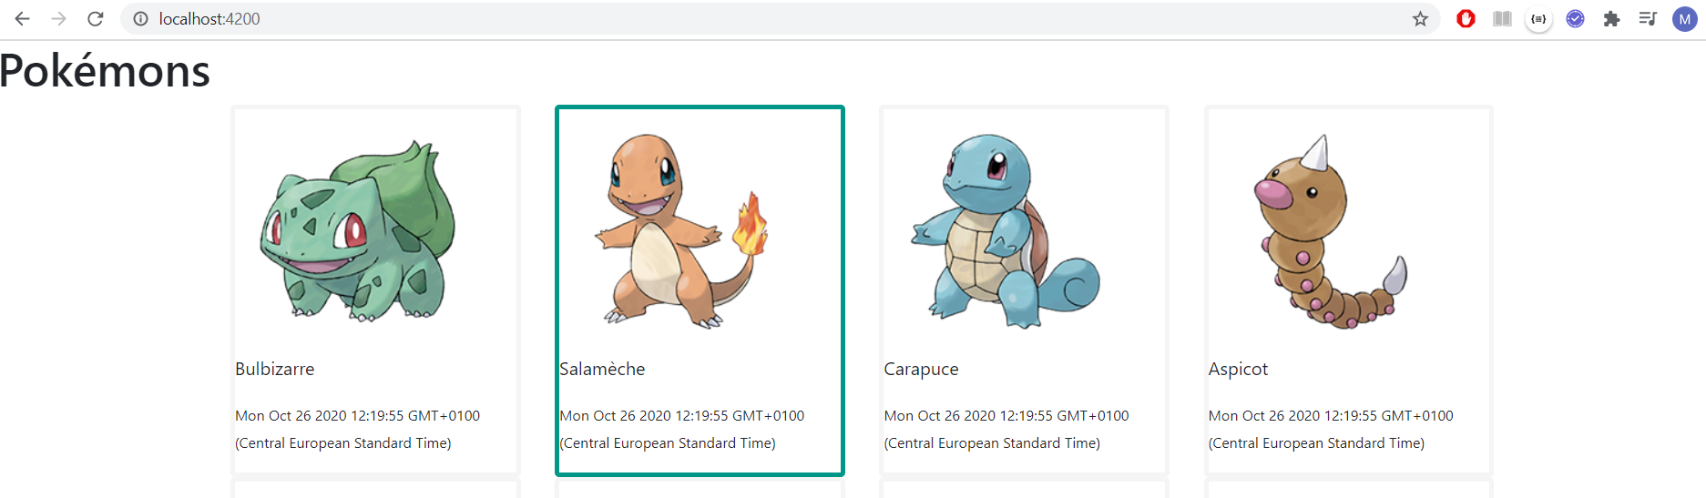

Site pokemon _ Pipe

Ex : Formater la date

Editer le fichier app.component.html du répertoire app

...
<div *ngFor='let pokemon of pokemons' class="col s6 m4">
...
<div class="card-stacked">
...
<p><small>{{ pokemon.created | date }}</small></p>
...
</div>
...

Test

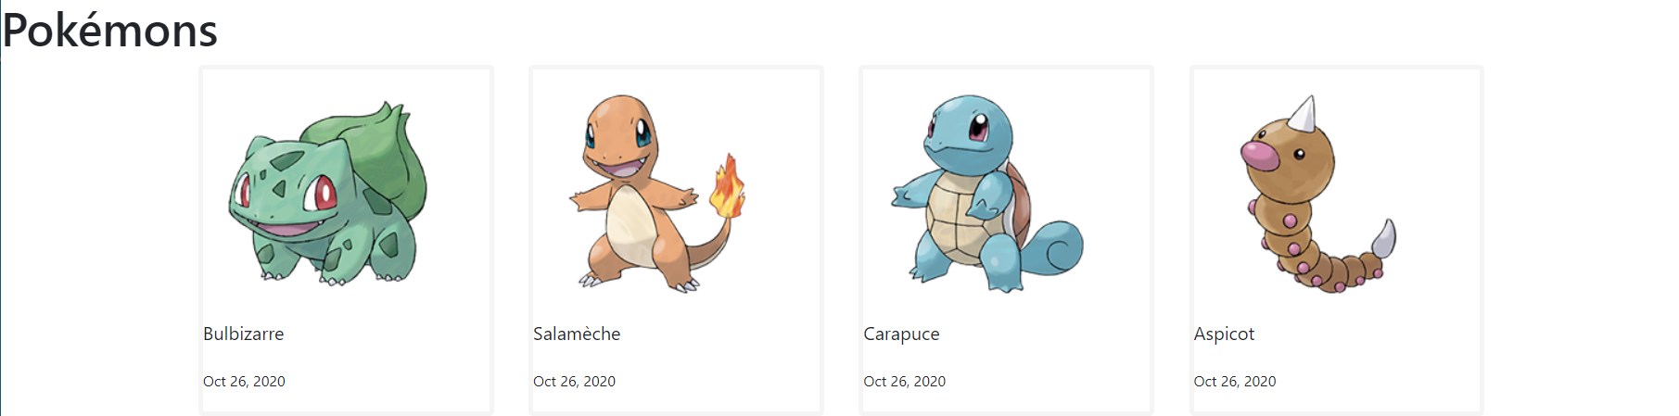

Par défaut : https://angular.io/guide/pipes

Combiner les pipes

...
<div *ngFor='let pokemon of pokemons' class="col s6 m4">
...
<div class="card-stacked">
...
<p><small>{{ pokemon.created | date | uppercase }}</small></p>
...
</div>
...

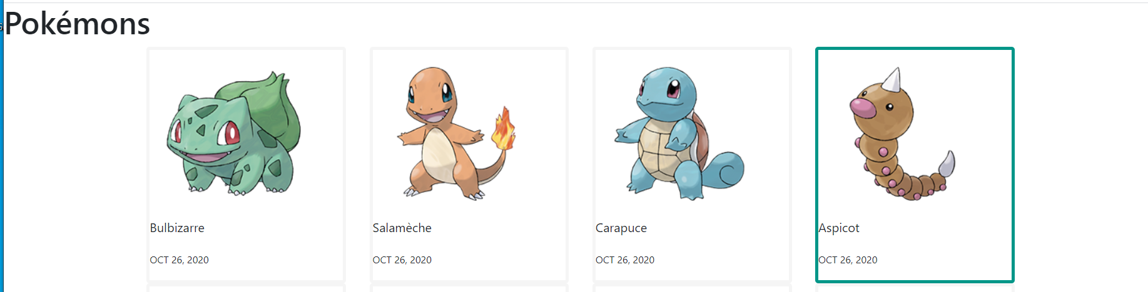

Paramétrer les pipes

...
<div *ngFor='let pokemon of pokemons' class="col s6 m4">
...
<div class="card-stacked">
...
<p><small>{{ pokemon.created | date :’dd/MM/yyyy }}</small></p>
...
</div>
...

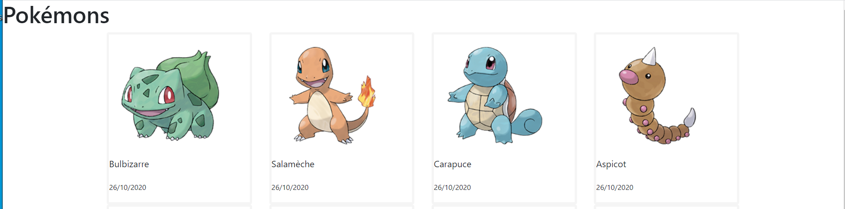

Créer une pipe personnalisée

Créer un fichier pokemon-type-color.pipe.ts dans app

pokemon-type-color.pipe.ts

import { Pipe, PipeTransform } from '@angular/core';

/*
* Affiche la couleur correspondant au type du pokémon.
* Prend en argument le type du pokémon.
* Exemple d'utilisation:
* {{ pokemon.type | pokemonTypeColor }}
*/
@Pipe({name: 'pokemonTypeColor'})
export class PokemonTypeColorPipe implements PipeTransform {
transform(type: string): string {

let color: string;

switch (type) {
case 'Feu':
color = 'red lighten-1';
break;
case 'Eau':
color = 'blue lighten-1';
break;
case 'Plante':
color = 'green lighten-1';
break;
case 'Insecte':
color = 'brown lighten-1';
break;
case 'Normal':
color = 'grey lighten-3';
break;
case 'Vol':
color = 'blue lighten-3';
break;
case 'Poison':
color = 'deep-purple accent-1';
break;
case 'Fée':
color = 'pink lighten-4';
break;
case 'Psy':
color = 'deep-purple darken-2';
break;
case 'Electrik':
color = 'lime accent-1';
break;
case 'Combat':
color = 'deep-orange';
break;
default:
color = 'grey';
break;
}

return 'chip ' + color;

}
}
Editer le fichier app.module.ts du répertoire app

...
import { PokemonTypeColorPipe } from './pokemon-type-color.pipe';

@NgModule({
declarations: [
AppComponent,
BorderCardDirective,
PokemonTypeColorPipe
],
imports: [
BrowserModule
],
providers: [],
bootstrap: [AppComponent]
})
export class AppModule { }

Editer le fichier app.component.html du répertoire app

...
<div class="card-content">
<p>{{ pokemon.name }}</p>
<p><small>{{ pokemon.created | date:'dd/MM/yyyy' }}</small></p>
<!-- on utilise la directive ngFor pour afficher tous les types
d'un pokémon donnée -->
<span *ngFor='let type of pokemon.types' class="{{ type | pokemonTypeColor }}">{{ type }}</span>
</div>
...

Test
