Site Pokemon _ Formulaire

Créez un composant EditPokemon dans le répertoire pokemon

ng g c pokemon/EditPokemon --skipTests=true --inlineStyle=true --inlineTemplate=true

Créez un composant PokemonForm dans le répertoire pokemon

ng g c pokemon/PokemonForm --skipTests=true

Editer le fichier pokemons.service.ts du répertoire pokemon

import { Injectable } from '@angular/core';
...
@Injectable()
export class PokemonsService {

...

//Retourne tous les types de pokémon
getPokemonTypes(): string[] {
return ['Plante','Feu','Eau', 'Insecte','Electrik','Poison','Fée','Vol']
}
}

Editer le fichier pokemon-form.component.ts du répertoire pokemon/pokemon-form

import { Component, OnInit, Input } from '@angular/core';
import { Pokemon } from '../model/pokemon';
import { PokemonsService } from '../pokemons.service';
import { Router } from '@angular/router';

@Component({
selector: 'pokemon-form',
templateUrl: './pokemon-form.component.html',
styleUrls: ['./pokemon-form.component.css']
})
export class PokemonFormComponent implements OnInit {

@Input() pokemon: Pokemon; // propriété d'entrée du composant
types: Array<string>; // types disponibles pour un pokémon : 'Eau', 'Feu', etc ...
constructor(
private pokemonsService: PokemonsService,
private router: Router) { }

ngOnInit(): void {
// Initialisation de la propriété types
this.types = this.pokemonsService.getPokemonTypes();
}

// Détermine si le type passé en paramètres appartient ou non au pokémon en cours
hasType(type: string): boolean {
let index = this.pokemon.types.indexOf(type);
if (index > -1) return true;
return false;
}

// Méthode appelée lorsque l'utilisateur ajoute ou retire un type au pokémon en cours
selectType($event: any, type: string): void {
let checked = $event.target.checked;
if (checked) {
this.pokemon.types.push(type);
} else {
let index = this.pokemon.types.indexOf(type);
if (index > -1) {
this.pokemon.types.splice(index, 1);
}
}
}

// Valide le nombre de types pour chaque pokémon
isTypesValid(type: string): boolean {
if (this.pokemon.types.length === 1 && this.hasType(type)) {
return false;
}
if (this.pokemon.types.length >= 3 && !this.hasType(type)) {
return false;
}

return true;
}

// La méthode appelée lorsque le formulaire est soumis.
onSubmit(): void {
console.log("Submit form !");
let link = ['/pokemon', this.pokemon.id];
this.router.navigate(link);
}
}

Editer le fichier pokemon-form.component.html du répertoire pokemon/pokemon-form

<form *ngIf="pokemon" (ngSubmit)="onSubmit()" #pokemonForm="ngForm">
<div class="row">
<div class="col s8 offset-s2">
<div class="card-panel">

<!-- Pokemon name -->
<div class="form-group">
<label for="name">Nom</label>
<input type="text" class="form-control" id="name"
required
pattern="^[a-zA-Z0-9àéèç]{1,25}$"
[(ngModel)]="pokemon.name" name="name"
#name="ngModel">

<div [hidden]="name.valid || name.pristine"
class="card-panel red accent-1">
Le nom du pokémon est requis (1-25).
</div>
</div>

<!-- Pokemon hp -->
<div class="form-group">
<label for="hp">Point de vie</label>
<input type="number" class="form-control" id="hp"
required
pattern="^[0-9]{1,3}$"
[(ngModel)]="pokemon.hp" name="hp"
#hp="ngModel">
<div [hidden]="hp.valid || hp.pristine"
class="card-panel red accent-1">
Les points de vie du pokémon sont compris entre 0 et 999.
</div>
</div>

<!-- Pokemon cp -->
<div class="form-group">
<label for="cp">Dégâts</label>
<input type="number" class="form-control" id="cp"
required
pattern="^[0-9]{1,2}$"
[(ngModel)]="pokemon.cp" name="cp"
#cp="ngModel">
<div [hidden]="cp.valid || cp.pristine"
class="card-panel red accent-1">
Les dégâts du pokémon sont compris entre 0 et 99.
</div>
</div>

<!-- Pokemon types -->
<form class="form-group">
<label for="types">Types</label>
<p *ngFor="let type of types">
<label>
<input type="checkbox"
class="filled-in"
id="{{ type }}"
[value]="type"
[checked]="hasType(type)"
[disabled]="!isTypesValid(type)"
(change)="selectType($event, type)"/>
<span [attr.for]="type">
<div class="{{ type | pokemonTypeColor }}"> {{ type }} </div>
</span>
</label>
</p>
</form>

<!-- Submit button -->
<div class="divider"></div>
<div class="section center">
<button type="submit"
class="waves-effect waves-light btn"
[disabled]="!pokemonForm.form.valid">
Valider</button>
</div>

</div>
</div>
</div>
</form>
<h3 *ngIf="!pokemon" class="center">Aucun pokémon à éditer...</h3>

Editer le fichier pokemon-form.component.css du répertoire pokemon/pokemon-form

.ng-valid[required], .ng-valid.required {
border-left: 5px solid #42A948; /* bordure verte */
}

.ng-invalid:not(form) {
border-left: 5px solid #a94442; /* bordure rouge */
}

Editer le fichier edit-pokemon.component.ts du répertoire pokemon/edit-pokemon

import { Component, OnInit } from '@angular/core';
import { Pokemon } from '../model/pokemon';
import { ActivatedRoute } from '@angular/router';
import { PokemonsService } from '../pokemons.service';

@Component({
selector: 'edit-pokemon',
template: `
<h2 class="header center">Editer {{ pokemon?.name }}</h2>
<p class="center">
<img *ngIf="pokemon" [src]="pokemon.picture"/>
</p>
<pokemon-form [pokemon]="pokemon"></pokemon-form>
`,
styles: [
]
})
export class EditPokemonComponent implements OnInit {

pokemon: Pokemon = null;

constructor(
private route: ActivatedRoute,
private pokemonsService: PokemonsService) {}

ngOnInit(): void {
let id = +this.route.snapshot.params['id'];
this.pokemon = this.pokemonsService.getPokemon(id);
}

}

Editer le fichier pokemons.module.ts du répertoire pokemon

import { PokemonsService } from './pokemons.service';
import { NgModule } from '@angular/core';
import { CommonModule } from '@angular/common';
import { FormsModule } from '@angular/forms';

...

@NgModule({
imports: [
CommonModule,
FormsModule,
PokemonRoutingModule
],
declarations: [
...
],
providers: [PokemonsService]
})
export class PokemonsModule { }

Editer le fichier pokemons-routing.module.ts du répertoire pokemon

import { NgModule } from '@angular/core';
import { RouterModule, Routes } from '@angular/router';

import { ListPokemonComponent } from './list-pokemon/list-pokemon.component';
import { DetailPokemonComponent } from './detail-pokemon/detail-pokemon.component';
import { EditPokemonComponent } from './edit-pokemon/edit-pokemon.component';

// les routes du module Pokémon
const pokemonsRoutes: Routes = [
{ path: 'pokemons', component: ListPokemonComponent },
{ path: 'pokemon/edit/:id', component: EditPokemonComponent},
{ path: 'pokemon/:id', component: DetailPokemonComponent }
];

@NgModule({
imports: [
RouterModule.forChild(pokemonsRoutes)
],
exports: [
RouterModule
]
})
export class PokemonRoutingModule { }

Editer le fichier detail.component.ts du répertoire pokemon/detail-pokemon

...

@Component({
selector: 'detail-pokemon',
templateUrl: './detail-pokemon.component.html'
})
export class DetailPokemonComponent implements OnInit {

pokemons: Pokemon[] = null;
pokemon: Pokemon = null;

constructor(private route: ActivatedRoute, private router: Router, private pokemonsService: PokemonsService) {}

ngOnInit(): void {
...
}

goBack(): void {
this.router.navigate(['/pokemons']);
}

goEdit(pokemon: Pokemon): void {

let link = ['/pokemon/edit',pokemon.id]
this.router.navigate(link);
}
}

Editer le fichier detail.component.html du répertoire pokemon/detail-pokemon

<div *ngIf="pokemon" class="row">
<div class="col s12 m8 offset-m2">
<h2 class="header center">{{ pokemon.name }}</h2>
<div class="card horizontal hoverable">
<div class="card-image">
<img [src]="pokemon.picture">
</div>
<div class="card-stacked">
...
</div>
<div class="card-action">
<a (click)="goBack()">Retour</a>
<a (click)="goEdit(pokemon)">Editer</a>
</div>
</div>
</div>
</div>
</div>
<h4 *ngIf='!pokemon' class="center">Aucun pokémon à afficher !</h4>

Tester

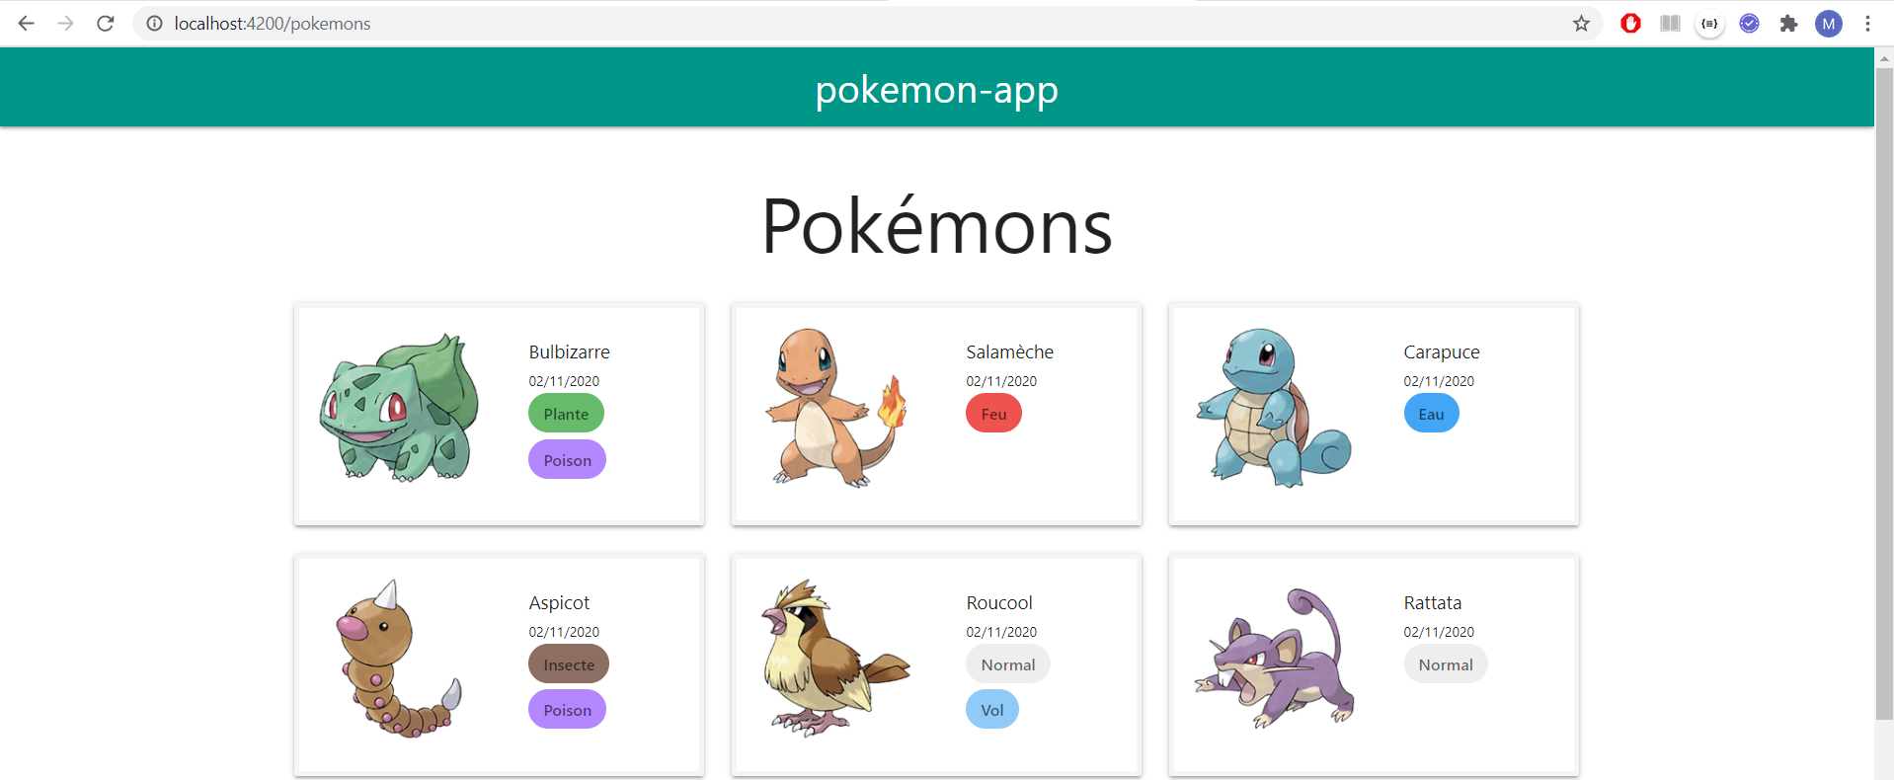

➔

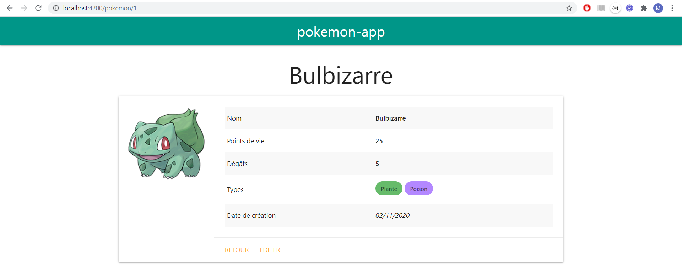

➔ Editer

