

Ain Shams University

Faculty of Engineering

Computer and Systems Engineering Department

CSE411: Distributed Computer Systems

Project “EZBUY”

BY:

KHALED ELSAYED RAMADAN 1600500

KHALED TAREK ABDELFATTAH 1700477

AHMED ATEF MOHAMMED SAID 1700106

# Table of Contents

## Introduction:

* This project is for clients to sell and buy items in their inventory.

# ii. Target Beneficiaries of the Project

- This project can be used in e-commerce systems and in-game purchases in online games.

# iii. Adopted Programming Language

- We used Node js, dart and html.

# iv. System Architecture

* The system uses a 3-Tier architecture to provide responsivity and accuracy.

# v. Application Level Protocol

* HTTP protocol is used for application.

# vi. Distributed Database Design

Database schemas are all in folder (“modules”).

# vii. Time Plan

Phase 1 of the project is not fully complete so there will be some delay in work but overall we expect it to be completed by new year.

# viii. Testing

- Testing and debugging was part of the development the was no testing period, just module testing while writing the code.

# ix. End-User Guide

# Graphical user interface Description automatically generatedThis is the home page and when pressing on Sign Up it opens register.

# After opening it opens a form to register.

# Graphical user interface, text, application Description automatically generatedAnd after filling the form press Sign Up button and it registers you as a nuw user and logs you in.

# After logging in you can see other links to your wallet and inventory etc.

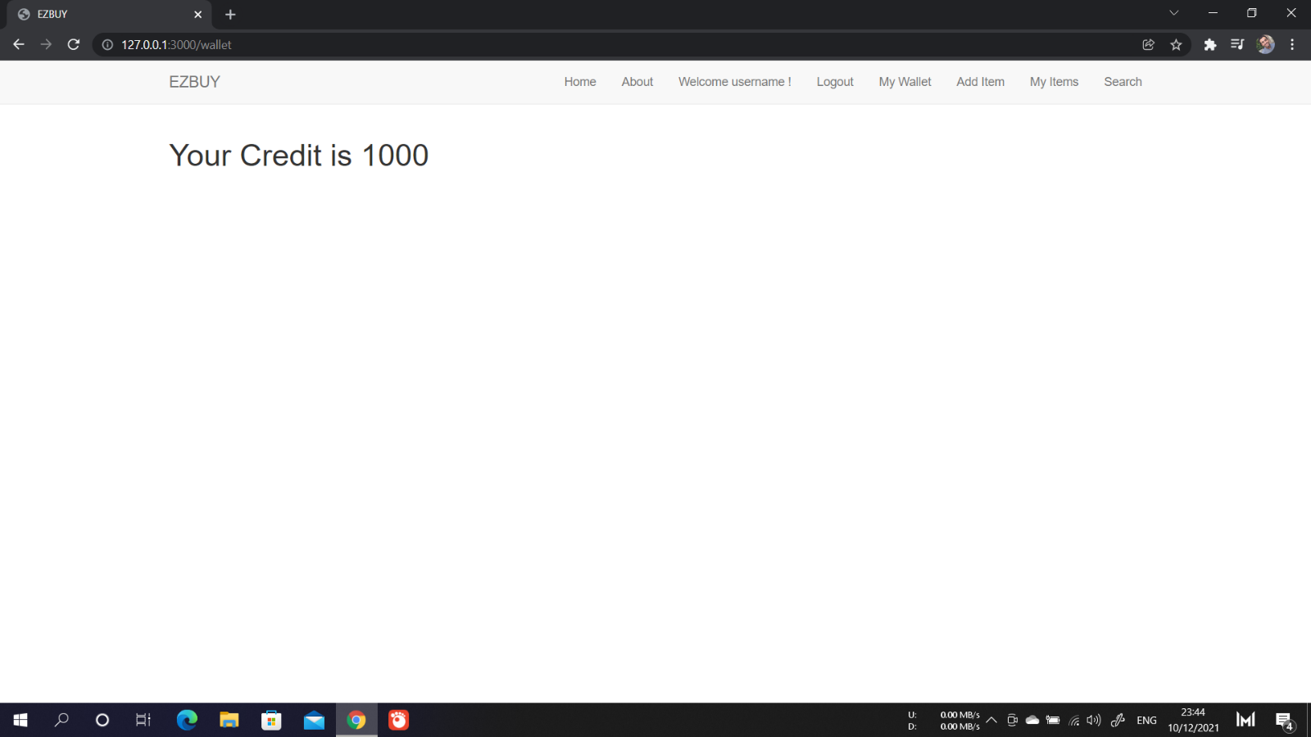

# When pressing the search link a search panel opens with a search input and a button and when searching it searches for all items that are similar to the search input.

# Then you can purchase any item buy pressing on the purchase button in each item box.

# And after purchasing the item moves to your inventory and its price is deducted from your balance and added to the seller’s.

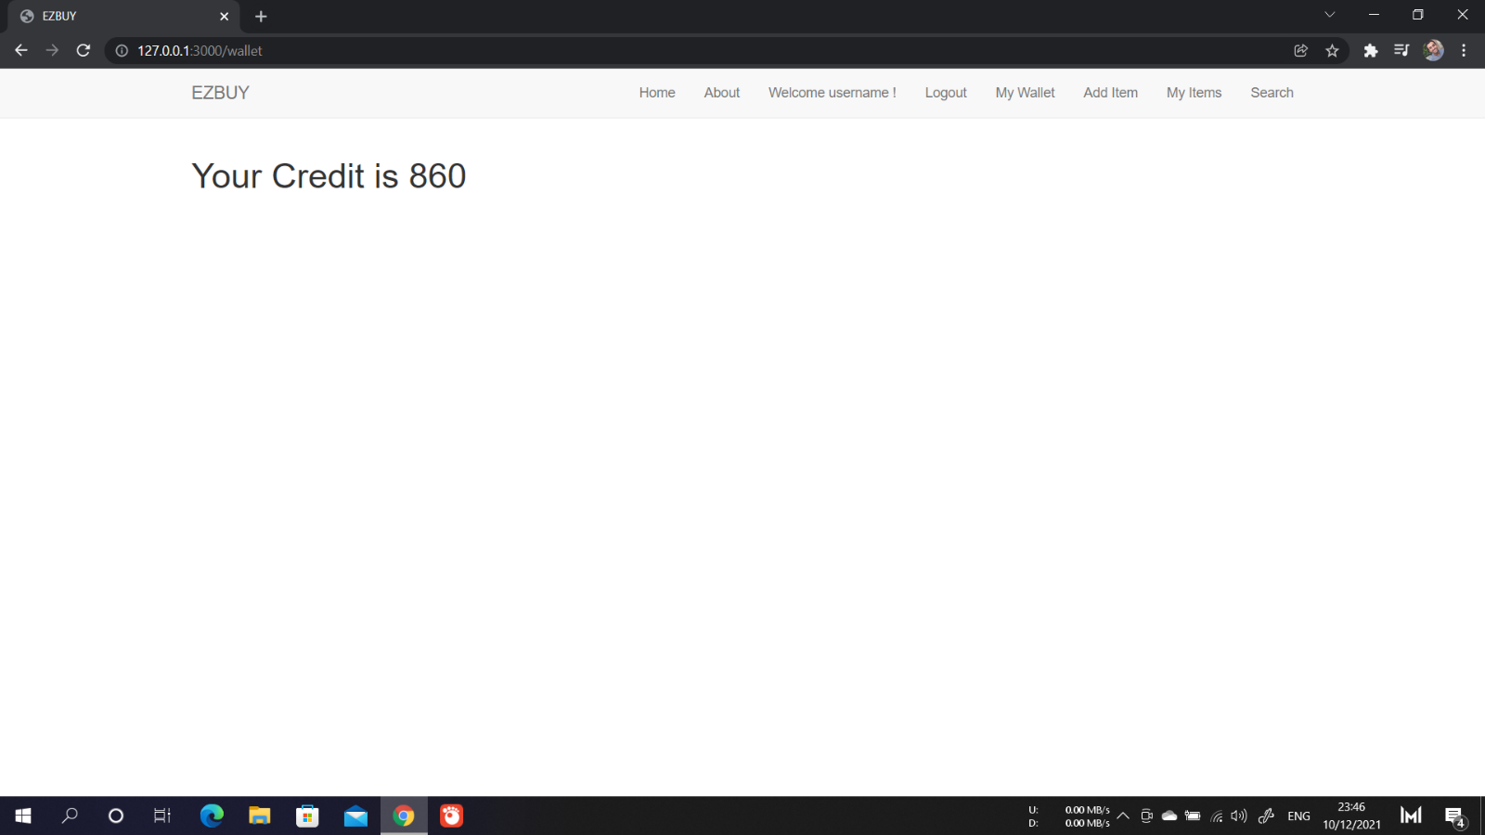

# x. Role of Each Member

A description of the role of each team member in the project should be provided in this section.

# xi. Appendices

# xv. References