|  |  |
| --- | --- |
| **Name** | Khaled Sarhan |

## Interface:

## Design:

Bugs:

* Reset Value is Added for “overflow”, “wr_ack”, “memory” and “data_out”.
* “underflow” is turned from combinational output into Sequential output.

## Do File:

## Top Module:

## Monitor:

## Testbench:

## Transaction Class:

## Coverage Class:

## Scoreboard Class:A computer screen shot of a program Description automatically generatedA computer screen shot of a program code Description automatically generatedA computer screen shot of a program code Description automatically generated

## Assertions:A computer screen shot of a program Description automatically generatedA screen shot of a computer program Description automatically generatedA computer code on a black background Description automatically generatedA computer code on a black background Description automatically generated

## Coverage Report:

* Toggle Coverage:

* Branch Coverage:

* Statement Coverage:

## Assertion Report:

## Waveform:

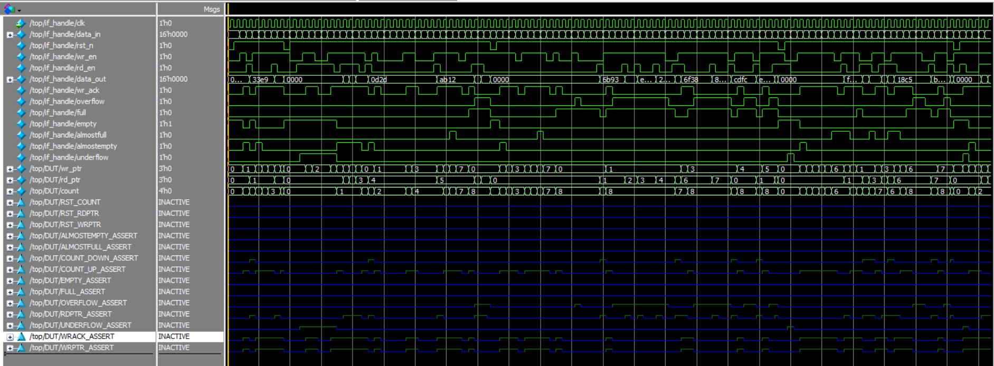

## Transcript:

