Name: Khaled Soliman

Student ID: 900162031

Embedded Project Option 4

# Project Prompt

In this project we are going to utilize the ESP8266 module to create a small IoT application that can enable the user to perform I/O operations with the STM32 module through a web interface. The I/O operations include:

• Retrieving the date/time from RTC module connected to the STM32 module

Control the STM32 module LEDs status to build this application:

• The ESP8266 module will be programed to act as a WiFi Access Point and run a simple HTTP server.

• The ESP8266 module communicates with the STM32 module using Asynchronous Serial link (using UART)

• The STM32 module runs code that receives commands from the ESP8266 module to control the LEDs and to retrieve the current time/date from the i2c RTC module attached to it

# Architectural Components:

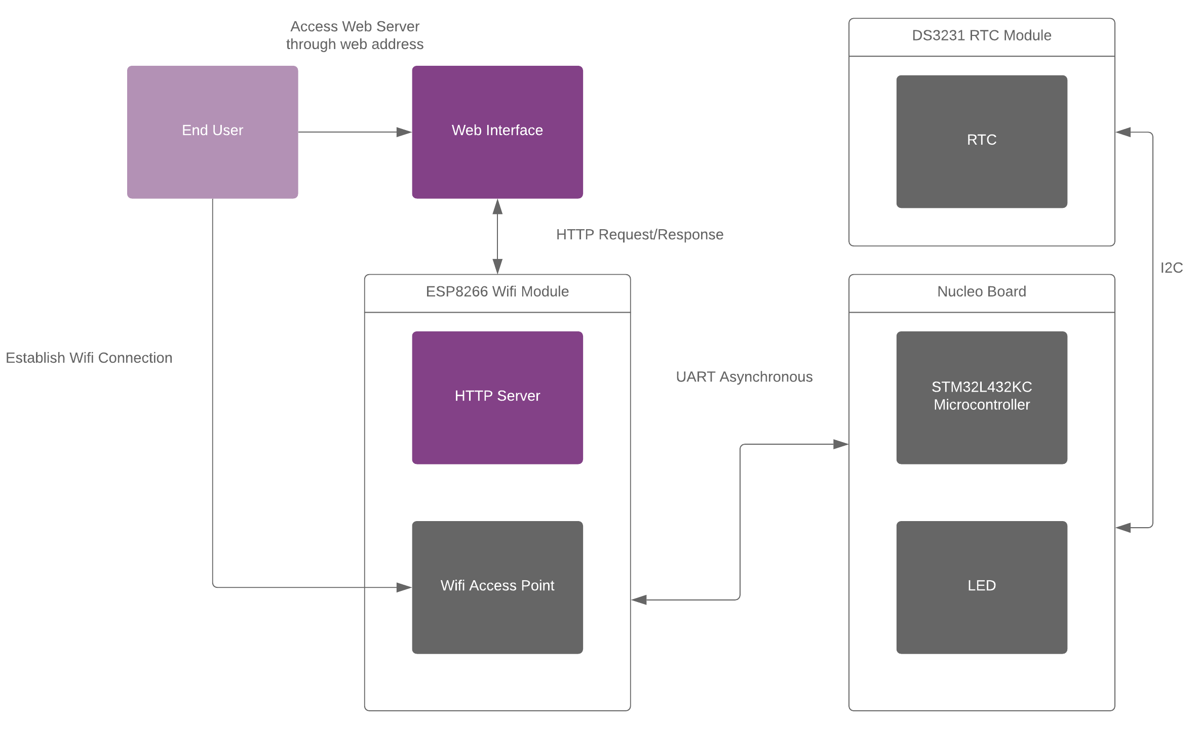

# Plan

**Monday 5/4**

* **Identifying Project Hardware Components [Detailed in a later section]**
* **Installing Prerequisite Software [Detailed in a later section]**

**Thursday 5/7**

* **Configuring HTTP Server on Wifi Module**
* **Establish UART Communication between HTTP Server and uC**
* **Estbalish I2C Bus Communication between RTC and uC**
* **Build 2 APIs:**
  + **Retrieve Time/Date Information**
  + **Toggle LED**

**Identifying Project Hardware Components:**

**STM32 Microcontroller:**

Model:

* STM32L432KC

User Manual:

* <https://www.st.com/resource/en/user_manual/dm00231744-stm32-nucleo32-boards-mb1180-stmicroelectronics.pdf>

Datasheet:

* <https://www.st.com/resource/en/datasheet/stm32l432kc.pdf>

**Wifi Module:**

Model:

* ESP8266MOD

User Manual:

* <http://wiki.ai-thinker.com/_media/esp8266/esp8266_series_modules_user_manual_v1.1.pdf>

Datasheet:

* <https://datasheet.lcsc.com/szlcsc/1811141522_Ai-Thinker-ESP-12F-ESP8266MOD_C82891.pdf>

Version:

* The Wemos D1 mini

Documentation:

* <https://arduino-esp8266.readthedocs.io/en/2.7.0/>

**RTC Module:**

Model:

* DS3231

Datasheet:

* <https://components101.com/sites/default/files/component_datasheet/DS3231%20Datasheet.pdf>

**Installing Prerequisite Software:**

**Arduino IDE:**

* <https://downloads.arduino.cc/arduino-1.8.12-windows.exe>

**Python:**

* <https://www.python.org/downloads/>

**CH340 Driver:**

* <https://github.com/wemos/ch340_driver/raw/master/CH341SER_WIN_3.5.ZIP>

**Installing the esp8266 platform with Arduino Boards Manager:**

* Starting with 1.6.4, Arduino allows installation of third-party platform packages using Boards Manager. We have packages available for Windows, Mac OS, and Linux (32 and 64 bit).
* Install the current upstream Arduino IDE at the 1.8.7 level or later. The current version is on the Arduino website.
* Start Arduino and open the Preferences window.
* Enter https://arduino.esp8266.com/stable/package_esp8266com_index.json into the Additional Board Manager URLs field. You can add multiple URLs, separating them with commas.
* Open Boards Manager from Tools > Board menu and install esp8266 platform (and don't forget to select your ESP8266 board from Tools > Board menu after installation).

**Microcontroller Flashing and Debugging IDE Options:**

* Free Version of ARM uKeil (Max 32 KB Debugging)
* STM32CubeIDE

**Configuring STM32 Nucleo Board:**

* STM32CubeMX